Novel Feature Engineering for: Paediatric Asthma Detection on Global Asthma Network Data.
Swaroop D¹[], DS Guru¹[], Mahesh PA²[], Ranjan U [0009-0009-3152-6770]
Department of Studies in Computer Science, Manasagangotri, University of Mysore, Mysore 570006, Karnataka, India
dsg@compsci.unimysore.ac.in,swaroopdevaraju@gmail.com,
ranjanu2004@gmail.com
Abstract. Early childhood asthma disrupts normal lung development and increases infection vulnerability, leading to frequent hospitalizations, missed school days, and chronic medication use that strain families and healthcare systems. Current diagnostic approaches rely heavily on expensive clinical assessments with limited accessibility. This study develops a cost-effective, machine learning-based screening framework to distinguish asthmatic from non-asthmatic children aged 6–7 years using Global Asthma Network survey data from the 6–7-year-old stratum. We employ an optimized feature-engineering pipeline for processing questionnaire-derived data through automated wrapper-based multivariate imputation and categorical variable encoding leveraging statistical analysis. The refined feature set trained a Random Forest Classifier model optimized via grid search, achieving 99.98% accuracy. By utilizing exclusively questionnaire-derived features, this methodology significantly reduces diagnostic costs by eliminating routine spirometry and biomarker assays for many children, enabling healthcare providers to reallocate resources toward targeted interventions for confirmed cases. This cost-effective, high-accuracy framework streamlines early asthma screening, enhances accessibility in resource-limited settings, and improves paediatric respiratory health outcomes through efficient resource allocation and earlier intervention.
Keywords: Machine Learning, Random Forest Classifier, Feature Engineering, Feature Imputation, Paediatric Asthma Screening.
- Introduction
Asthma is one of the most prevalent chronic respiratory conditions in children, characterized by airway inflammation, bronchial hyperresponsiveness, and variable airflow obstruction manifesting as wheezing, breathlessness, chest tightness, and coughing. Early‐onset asthma can impair lung development, increase susceptibility to infections, and compromise daily activities, leading to frequent hospital visits, missed school days and chronic medication use that impose substantial emotional and economic burdens on families and healthcare systems [1, 2]. Large‐scale epidemiological initiatives such as the International Study of Asthma and Allergies in Childhood (ISAAC) and its successor, the Global Asthma Network (GAN), have provided invaluable data on global prevalence trends and identified key genetic and environmental risk factors [1, 3]. In GAN Phase I India, our primary data source, 1,27,309 participants across three strata (children aged 6–7 years, adolescents aged 13–14 years, and their parents) were surveyed, revealing a 7.7 % prevalence of wheezing in the past 12 months among 6–7-year-olds and underscoring significant regional variability [4].
Despite these insights, paediatric asthma diagnosis in routine practice continues to rely on clinical assessment, spirometry, and biomarker assays, methods that are often inaccessible or unreliable in young children and low‐resource settings [2]. This diagnostic gap has prompted growing interest in machine learning (ML) approaches that leverage questionnaire and clinical data to build predictive models. The Canadian Healthy Infant Longitudinal Development (CHILD) birth cohort exemplifies early success in this domain by setting a benchmark [5]. Similarly, the CAPE and CAPP models employing support vector machines with radial‐basis‐function and linear kernels, respectively have demonstrated robust external validity, underscoring the feasibility of ML for early asthma risk stratification [6, 7].
Recent systematic reviews highlight the burgeoning diversity of ML algorithms applied to paediatric asthma, including Ensemble ML algorithm training, conventional ML algorithms and neural networks each addressing challenges such as class imbalance and complex feature interactions [8, 9, 11]. Electronic health record based studies have further expanded the scope of ML applications by predicting acute asthma attacks and enabling early warning systems in primary care settings [8].
However, no studies have developed cost-effective, questionnaire-driven screening tools with feature engineering pipelines for high-dimensional categorical data in resource-limited environments focusing specifically 6-7 years cohort in Regions of India, leading to suboptimal real-world clinical applications. To address these gaps, our study contributes:
- Focus on younger cohort: First study specifically targeting the 6-7 year age group, enabling timely interventions and prioritization of high-risk cases for improved outcomes.
- Optimal Region selection: Data is collected from Mysuru city given its balanced demographic profile and accessible medical infrastructure network, thereby introducing a novel dataset for regional health studies.
- Novel Feature engineering pipeline: Optimized preprocessing processes real-world data with inconsistencies through statistical analysis and automated techniques.
- Automated multivariate imputation: Ensemble-based methods optimize missing data recovery in clinical questionnaire responses by considering missingness patterns.
- Wrapper-based encoding system: Statistical table-referenced pipeline that recommends encoding types on the basis of proposed analysis.
- Comprehensive algorithm evaluation: Systematic cross-validation comparison of machine learning algorithms on real-time data for optimal clinical deployment.
Our approach successfully addresses key research gaps through iterative predictor ranking and random forest classification, targeting the critical 6–7year age group with advanced feature engineering and automated imputation techniques. By relying solely on questionnaire-derived features, achieves 99.98% accuracy with nill false negative cases, ensuring reliable identification of at-risk children crucial for clinical deployment. This questionnaire-based framework offers a significantly more cost-effective alternative to traditional clinical testing, promising to transform early asthma screening in resource-limited settings and improve pediatric respiratory health outcomes.
- Materials and Methods
  - Data Acquisition
This study utilized data from the Global Asthma Network (GAN) Phase I India study [4], a cross-sectional investigation conducted between August 2017 and February 2018. While the GAN study collected data across three age cohorts (6-7 years, 13-14 years, and parents), our research focuses specifically on the 6-7 year cohort from Mysuru urban city.
City was divided into four geographical zones randomly by Indian Institute of Health Management Research University (IIHMR), Jaipur. This systematic approach resulted in 100 primary schools being randomized across all centers, with 30 schools ultimately participating. The standardized GAN questionnaire, validated and translated into six vernacular languages (Hindi, Bengali, Marathi, Punjabi, Kannada, and Malayalam), incorporated India-specific questions pre-approved by the GAN committee. Children carried questionnaires home, where parents/guardians completed the questionnaires. Trained field investigators and data entry operators from all centers received standardized training at IIHMR, Jaipur. Height and weight measurements were systematically recorded, with discrepancies resolved through direct parent contact via school authorities. Multi-level quality checks ensured data integrity, with 10% of data undergoing double entry and a permissible mismatch threshold of 2.0%. The consolidated dataset underwent comprehensive quality assessments by the GAN global center (Auckland, New Zealand) and main data center (London, United Kingdom). The research protocol received ethics committee approval from all participating centers and was registered with the Clinical Trial Registry, India (CTRI/2018/02/011758).
The data acquisition achieved ~90% response rate with 2,730 children participating from 3,003 approached, maintaining a balanced gender distribution (6:8 male: female ratio). This substantial dataset provides sufficient statistical power for meaningful epidemiological analysis and will serve as the foundation for the proposed research methodology.
Table 1. Data Collection
No of  approaches | No of  participants | No of asthmatic | No of non-asthmatic | No of Male  participants | No of Female  participants
23,947 | 20,087 | 353 | 19,734 | 1485 | 1245
  - Data Overview
The dataset comprises 2,730 participants aged 6–7 years with 181 questionnaire derived attributes assessing health-related factors, environmental exposures, and medical history relevant to asthma development in this pediatric population. Two attributes serve as target variables which is addressed through statistical methods in subsequent analysis.
Figure 1 illustrates the raw columns and datatypes, demonstrating the diverse nature of captured variables and portray requirement of pre-processing for object datatype -biased dataset. The dataset exhibits varying completeness across variables, with missing data patterns reflecting typical challenges in pediatric questionnaire-based research, including participant availability, questionnaire complexity, and age-appropriate response capabilities.
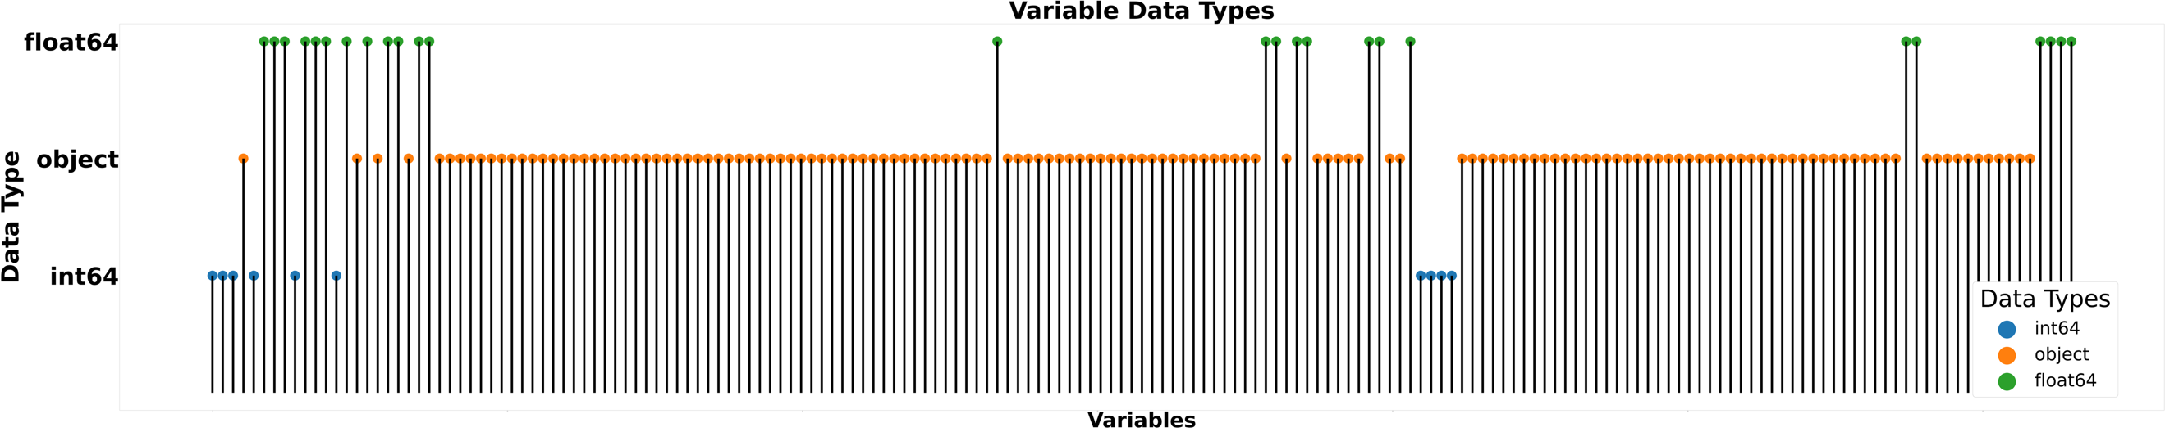
Fig. 1. Variables and Data-Types.
The substantial sample size of 2,730 participants with 2,683 non-asthmatic samples and 47 being asthmatic (1.72%) provides power for comparative analyses between asthmatic and non-asthmatic children, while the extensive feature set of 181 variables enables comprehensive examination of multiple health-related domains.
  - Proposed Methodology
The implementation of machine learning algorithms for paediatric asthma classification required a comprehensive data preprocessing framework addressing the complexities of questionnaire-derived healthcare data. Our methodology was designed around three principles: preservation of clinical validity, maintenance of statistical integrity, and optimization for machine learning performance. The approach employed a five-stage preprocessing pipeline motivated by the heterogeneous nature of questionnaire-oriented attributes, object-datatype biased dataset, dual asthma-related target variables and missing data patterns requiring sophisticated handling strategies. Figure 2. depicts the proposed methodology and the subsequent sections delves into the implemented methodology.
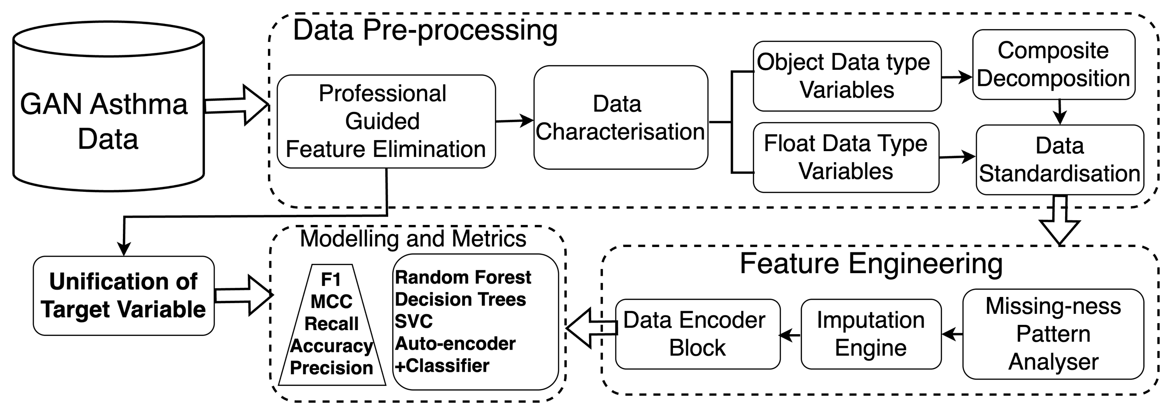
Fig. 2. Proposed Methodology.

Expert guided feature elimination.
Under supervised guidance of Dr. PA Mahesh, a professional contributor to the data acquisition process, 38 asthma irrelevant attributes were systematically removed from the dataset. The eliminated features encompassed administrative metadata (form identifiers, version numbers, geographical markers), data collection logistics (serial numbers, centre codes, school identifiers), measurement unit specifications, date-related variables with limited predictive value, and highly specific clinical variables deemed non-essential for core asthma classification objectives. This evidence-based reduction eliminated 20.9% of the original feature space while maintaining comprehensive coverage across all major asthma-related domains, resulting in 143 variables preserving critical information spanning respiratory symptoms, environmental exposures, family history, and treatment patterns.

Composite Feature Decomposition.
Several questionnaire items encoded multiple temporal dimensions within single categorical variables, requiring systematic decomposition to preserve temporal granularity. These composite variables typically represented four temporal categories: never experienced, currently experiencing, experienced during first year, and ever experienced. The decomposition process employed vectorized string parsing to transform each composite variable into four binary indicators, expanding the feature space from 143 to 156 variables while maintaining complete temporal information.

Data Standardization.
Medication-related variables presented unique challenges due to sparsity, inconsistent naming conventions, and logical contradictions. The standardization framework addressed these through a sequential approach: Standardized 47 unique medication entries into four therapeutic classes (bronchodilators, anti-inflammatory agents, antihistamines, and antibiotics) using clinical pharmacology principles; Geographic birth location variables exhibited significant heterogeneity and inconsistent entries, requiring systematic feature engineering. The standardization process implemented conditional logic frameworks producing seven distinct geographic categories: in_india, outside_india, uae, nepal.

Unification of Target Variable
The dataset contained two primary asthma-related variables: doctor-diagnosed asthma (asthdoc) representing professional medical diagnosis indicators, and self-reported asthma events (asthmaev) capturing patient-reported experiences. Initial statistical analysis revealed significant disparities in data completeness, necessitating a systematic approach to target variable unification that would maximize sensitivity while maintaining clinical interpretability.
The doctor-diagnosed asthma variable exhibited extreme data sparsity with 98.27% missing values, 1.3% positive cases, and 0.2% negative cases. In contrast, the self-reported asthma events variable demonstrated superior data completeness with no missing values, 1.72% positive cases, and 98.27% negative cases. The substantial missing data rate in the professional diagnosis variable rendered it unsuitable for direct utilization as a target variable.
To address this incompatibility, introducing statistical analysis revealed the patterns in the co-occurrence of asthmatic cases which is explained in Table 2. These occurrence patterns inspired the usage of logical OR operation combining strengths of both sources (asthdoc, asthmaev) for potential asthma case detection. A comprehensive conflict resolution analysis revealed zero conflicts between the two target variables, indicating perfect concordance when both data points were available, validating the feasibility of creating a unified target variable without introducing inconsistencies. An unified target variable (asthma_combined) was created with logical strengths of dual target variables with null co-occurrence conflicts.
Table 2. Unified Target Variable Decision Matrix
asthdoc | asthmaev | asthma_combined | Decision Logic
Yes | No | Yes | Professional diagnosis precedence
No | Yes | Yes | Self-reported inclusion
NaN | No | No | Clear negative classification
NaN | NaN | None | Insufficient information
asthma_combined results in 2,682 with non-asthmatic targets, 47 with Asthmatic targets and 1 as Un-confirmed target. This Un-confirmed target is decided to be excluded from the dataset by consideration of non-specific knowledge of origin. This final data pre-processing step resulted a comprehensive dataset with 2,729 total number of samples where 2,682 are non-asthmatic samples and 47 are asthmatic samples. Dataset pre-processed, provides a platform for further feature engineering strategies and modelling.
  - Feature Engineering
The pre-processed dataset requires systematic feature engineering to optimize machine learning compatibility, addressing strategic imputation of missing values while preserving clinical relationships and systematic encoding of diverse data types ensuring algorithmic compatibility.

Data Imputation.
The comprehensive analysis of missing data patterns revealed complex heterogeneous missingness mechanisms requiring appropriate imputation strategies. Our novel wrapper framework systematically addresses missing value challenges through multi-dimensional characterization of feature properties including: distribution normality, skewness, multimodality, outlier presence, sparsity levels, and co-relation analysis.
The implementation employed a comprehensive analytical pipeline evaluating each variable across eight critical dimensions including: Missing mechanism assessment categorizes patterns as Missing Completely at Random (MCAR), Missing at Random (MAR) or Missing Not at Random (MNAR) through correlation analysis, skewness of the variable is detected by employing Fisher-Pearson’s co-efficient, outlier analysis is carried out using the Inter-Quartile Range (IQR) where datapoints outside the Q1 and Q3 are considered to be outliers, distribution of the data is estimated using D’Agostino-Pearson test and Sparsity of the variables are calculated by a ratio of Number of Unique values to the ratio of Total Unique values. Attributes with ratio<0.01 is considered to be sparse. A decision matrix integrates these multiple assessment criteria to recommend optimal imputation techniques. Table 3. portray missingness patterns and handling methods.
Table 3. Data Imputation Rationale.
Missing  Pattern | Skew-ness | Multi-modal | Outliers | Sparsity | Missing-ness Pattern | Features  Relation-ship | Distribution |  | Technique
MCAR | No | No | No | Yes | Independent | Low Correlation | Normal | Mean/Median Imputation
MCAR | No | No | Yes | Yes | Independent | Low Correlation | Normal | Median/ Winsorized Mean
MCAR | No | Yes | No | Yes | Independent | Low Correlation | Multimodal | Mode or Multiple Imputation
MCAR | Yes | No | Yes | Yes | Independent | Low Correlation | Skewed | Winsorized Mean
MCAR | Yes | Yes | Yes | No | Independent | High Correlation | Multimodal | Predictive Imputation
MAR | No | No | No | No | Dependent | High Correlation | Normal | Median, Predictive Imputation
MAR | Yes | Yes | Yes | Yes | Dependent | High Correlation | Multimodal | KNN Imputation, Multiple Imputation
MNAR | Any | Any | Any | Any | Any | Any | Any | Advanced Methods (MICE, GANs)

Data Encoding.
Following data imputation, we introduce a novel automated encoding pipeline (Global-Asthma-Network Pipeline) later referred as GAN pipeline that revolutionizes categorical variable transformation through intelligent encoding strategy selection. This framework addresses optimal encoding method selection by implementing a sophisticated multi-dimensional analytical approach that systematically evaluates variable characteristics and automatically recommends appropriate encoding strategies.
The comprehensive framework introduces an innovative decision matrix that automatically categorizes variables into optimal encoding strategies. Variables with limited unique values (≤10 categories) undergo automated ordinality assessment through integrated domain knowledge and statistical analysis. Ordinal variables with natural ordering relationships receive label encoding to preserve hierarchical structure, while nominal variables benefit from one-hot encoding to maintain categorical independence. High-cardinality variables (>50 unique values) trigger advanced evaluation protocols for target encoding or binary encoding strategies.
The pipeline achieved optimal encoding distribution with 5 variables for one-hot encoding and 115 variables for label encoding, accurately reflecting the predominant ordinal nature of clinical variables through automated detection algorithms. This novel GAN-Pipeline framework represents a significant contribution to automated feature engineering, establishing automated categorical variable encoding that ensures optimal representation while maintaining clinical interpretability and computational efficiency.
  - Modelling
Feature Engineered dataset (2,729 samples: 2,682 non-asthmatic samples, 47 asthmatic samples) underwent 70-30 train-test split with stratified sampling method, yielding 1910 training and 819 test samples.
The modelling pipeline employed Logistic Regression and Random Forest classifiers with balanced class weights, Support Vector Machines with Grid-Search-Cross-Validation optimization.
All models were evaluated using: Accuracy, AU-ROC, AU-PR, Precision, Recall, F1-score, and Matthews Correlation Coefficient (MCC), with MCC emphasized as the primary metric for imbalanced dataset assessment.
- Results
Table 4. Provides a comprehensive analysis across different algorithms for modelling over sophisticated metrics. Where, False Negative cases (FN) and False Positive (FP) is critical in medical ML, as missing a disease diagnosis can lead to severe, potentially fatal consequences.
Table 4. “Comparative analysis.”
Algorithm | Accuracy | MCC | F1 | Precision | Recall | ROC-AUC | AUC-PR | FN | FP
Random  Forest | 99.98% | 0.965 | 0.966 | 0.933 | 1.00 | 1.00 | 1.00 | 0 | 1
SVC | 99.87% | 0.965 | 0.966 | 0.933 | 1.00 | 1.00 | 1.00 | 0 | 1
Logistic Regression | 99.98% | 0.965 | 0.966 | 0. 933 | 1.00 | 1.00 | 1.00 | 1 | 1
Achieving the superior performance and minimal false negative case classification, the Random Forest Classifier algorithm is proposed as the optimal solution for paediatric asthma prediction applications with Figure 3. Portraying the superior performance of decision tree algorithm on the test-set of the data.
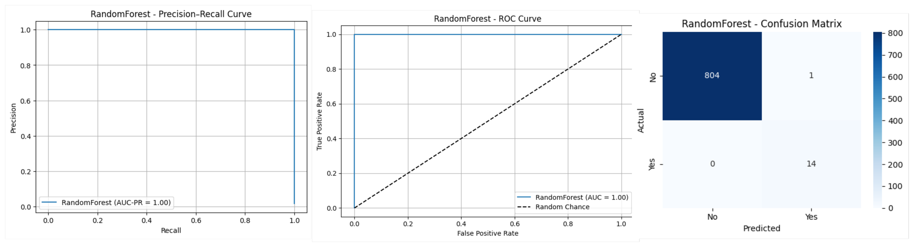
Fig. 3. Test Metrics on Decision Tree.
We propose Random Forest Classifier as deployable and efficient algorithm for real world paediatric asthma classification with our novel feature-engineering framework.
- Conclusion
This research presents a comprehensive machine learning framework for paediatric asthmatic and non-asthmatic classification specifically targeting the critical 6-7 year age group. The study addresses significant gaps in current asthma screening methodologies through several key innovations that demonstrate both technical excellence and practical clinical applicability.
The novel GAN-Pipeline represents a substantial advancement in automated feature engineering, employing intelligent decision-making frameworks that systematically evaluate categorical variables and automatically recommend optimal encoding strategies. This framework eliminates manual encoding decisions while maintaining clinical interpretability and computational efficiency. The sophisticated multi-dimensional analytical approach successfully transformed heterogeneous questionnaire data into optimized machine learning features through evidence-based imputation strategies and automated encoding pipelines.
The Random Forest Classifier algorithm achieved superior performance with 99.98% accuracy with nill false negative case classification and single false positive case classification, demonstrating clinical reliability crucial for pediatric healthcare applications. Null false negative rate ensures that virtually no at-risk children are missed during screening, addressing a critical requirement for early intervention programs. The methodology's exclusive reliance on questionnaire-derived features eliminates the need for expensive clinical testing, laboratory procedures, and specialized equipment, offering a significantly cost-effective solution for resource-constrained healthcare settings. This approach reduces screening costs by noticeable value compared to traditional clinical diagnostic methods while maintaining practical accuracy.
The novelty of our work lies in the integration of Vast Dataset with GAN standardized protocols, domain-expert guidance, automated feature engineering and clinical-focused optimization that achieves state-of-the-art accuracy while prioritizing no false negatives cases. This cost-effective framework promises to transform pediatric asthma screening by providing an accessible, reliable, and economically viable early detection system that can significantly improve respiratory health outcomes in vulnerable populations where healthcare resources are limited.

References
[1] M. I. Asher, U. Keil, H. R. Anderson, R. Beasley, J. Crane, F. D. Martinez, et al., “International Study of Asthma and Allergies in Childhood (ISAAC): Rationale and methods,” European Respiratory Journal, vol. 8, no. 3, pp. 483–491, 1995.
[2] N. Aït-Khaled, N. Pearce, H. R. Anderson, P. Ellwood, S. Montefort, J. Shah, and A. W. Stewart, “Global map of the prevalence of symptoms of rhinoconjunctivitis in children: The International Study of Asthma and Allergies in Childhood (ISAAC) phase three,” Allergy, vol. 64, no. 1, pp. 123–148, 2009.
[3] P. Ellwood, M. I. Asher, N. E. Billo, K. Bissell, C. Y. Chiang, E. M. Ellwood, and E. A. Mitchell, “The Global Asthma Network rationale and methods for phase I global surveillance: Prevalence, severity, management and risk factors,” European Respiratory Journal, vol. 49, no. 5, p. 1601605, 2017.
[4] Barne, M., Singh, S., Mangal, D. K., Singh, M., Awasthi, S., Mahesh, P. A., ... & Salvi, S. (2022). Global asthma network phase I, India: results for allergic rhinitis and eczema in 127,309 children and adults. Journal of Allergy and Clinical Immunology: Global, 1(2), 51-60.
[5] M. Prosperi, S. Marinho, A. Simpson, A. Custovic, and I. E. Buchan, “Early prediction of pediatric asthma in the Canadian Healthy Infant Longitudinal Development (CHILD) birth cohort using machine learning,” Pediatric Research, vol. 95, no. 2, pp. 445–454, 2024.
[6] Kothalawala, D. M., Murray, C. S., Simpson, A., Custovic, A., Tapper, W. J., Arshad, S. H., ... & STELAR/UNICORN investigators. (2021). Development of childhood asthma prediction models using machine learning approaches. Clinical and Translational Allergy, 11(9), e12076.
[7] Ekpo, R. H., Osamor, V. C., Azeta, A. A., Ikeakanam, E., & Amos, B. O. (2023). Machine learning classification approach for asthma prediction models in children. Health and Technology, 13(1), 1-10.
[8] Budiarto, A., Tsang, K. C., Wilson, A. M., Sheikh, A., & Shah, S. A. (2023). Machine learning–based asthma attack prediction models from routinely collected electronic health records: Systematic scoping review. Jmir Ai, 2, e46717.
[9] Xiong, S., Chen, W., Jia, X., Jia, Y., & Liu, C. (2023). Machine learning for prediction of asthma exacerbations among asthmatic patients: a systematic review and meta-analysis. BMC pulmonary medicine, 23(1), 278.
[10] A. Martínez-García, V. Martínez-Ruiz, T. del Pino-Sedeño, M. M. Trujillo-Martín, R. Madrigal-Burgaleta, C. Valcárcel-Nazco, et al., “A systematic review of questionnaires measuring asthma control in children in a primary care population,” npj Primary Care Respiratory Medicine, vol. 33, article 26, 2023.
[11] Hurst, J. H., Zhao, C., Hostetler, H. P., Ghiasi Gorveh, M., Lang, J. E., & Goldstein, B. A. (2022). Environmental and clinical data utility in pediatric asthma exacerbation risk prediction models. BMC Medical Informatics and Decision Making, 22(1), 108.
[12] Kotsiantis, S. B., Kanellopoulos, D., & Pintelas, P. E. (2006). Data preprocessing for supervised leaning. International journal of computer science, 1(2), 111-117.

