Making each lending cycle strengthen the business: an Underwrite for Collection application for 4G Capital
Nevil Maloba | Updated 18 October 2026

Start with what happens after the stock arrives
A merchant receives stock, makes sales and repays a working-capital loan. The next question is whether the business can replenish its shelves, meet its commitments and enter another trading cycle with sufficient cash. That question brings together the practical concerns behind my whitepaper, Underwrite for Collection: product design, evidence, underwriting, servicing, intervention, recovery and funding [1]. A recorded repayment is one event within that larger operating story. Understanding how it was produced helps the lender assess the next facility, recognise pressure earlier and identify useful support. For 4G Capital, this suggests a research partnership organised around the quality of successive business and lending cycles.
4G Capital’s published UPIA product combines unsecured, thirty-day working-capital finance with training, personal support and loyalty-based pricing [2]. KUZA describes twenty-one-day stock finance through distributor relationships, with disbursement directly to the distributor and pricing linked to business margins [3]. The company’s wider “touch-tech” approach combines digital access with personal engagement [4]. These features create a specific setting for the research: short cash-conversion cycles, repeat lending, observable purchase relationships and business support delivered alongside credit. The proposal here connects those activities into a testable framework. Its application would begin with agreed data, product definitions and operational priorities shared by the participating teams.

Three questions for a practical research programme
Research question one: How can merchant receipts, stock movements, margins and essential commitments establish whether each loan supports a sustainable operating cycle?
Research question two: Which combination of support, timing and authorised credit adjustment improves business cash, repayment and customer experience over successive cycles?
Research question three: How can the IFC risk-sharing partnership translate into additional, sustainable lending while its underwriting, claims, liquidity and retained-risk consequences remain measurable? The first question establishes the economic evidence. The second evaluates decisions. The third connects borrower outcomes to an institutional funding and protection arrangement. Their answers would support a coherent product and portfolio strategy.

Connect financed inventory to the next cash cycle
For a KUZA-style application, distributor payment provides an identifiable starting event. The proposed evidence chain connects the order, delivery confirmation, quantities received, expected selling period, actual sales, customer receipts and loan settlement. It also records returns, damaged stock, supplier credits and unsold inventory. The merchant’s previous relationship with a distributor can provide useful context for interpreting these events. Product assessment then asks whether the financed order fits the store’s sales capacity and stock mix. A higher purchase amount can increase the range available to customers, while its economic value depends on margins, turnover, payment timing and the remaining cash needed to keep trading.
The key liquidity calculation follows the same dates as the loan. For a defined payment window, a simple planning identity is:
Cash available for repayment = opening unrestricted cash + settled operating receipts − essential operating payments − household commitments − other obligations
All quantities use the same currency and time window. Stock purchases already included among operating payments are counted once. The merchant’s margin calculation separately records sales less the cost of goods sold; remaining inventory carries its own value and uncertainty. This distinction connects profitability to cash availability and gives an officer a way to discuss a payment date using the business’s actual operating calendar.
The reproducible companion now follows twelve synthetic merchants through 180 operating days, up to six lending opportunities and a runoff to day 300. Six merchants have stable trading assumptions, three experience delayed sales under stress and three experience weaker conversion. One merchant has an explicitly ineligible guarantee record. Every loan begins with distributor payment and an equal inventory receipt. The merchant's cash ledger records subsequent settled sales, operating expenses, household withdrawals, repayment and negotiated recovery. This makes the lender's advance, the merchant's goods and the eventual customer cash separately traceable. All commercial amounts, fees, stress responses and claim-processing assumptions belong to this teaching case.
The first baseline cycle starts with KES 20,000 cash and KES 100,000 of stock financed directly to the distributor. A 25% markup on cost produces KES 125,000 of sales, settled by day twenty. Daily operating needs of KES 200 and household needs of KES 150 total KES 4,200 and KES 3,150 over twenty-one days. The assumed contractual fee is KES 5,000. After paying principal and that fee, closing cash is:
C₂₁ = 20,000 + 125,000 − 4,200 − 3,150 − 100,000 − 5,000 = KES 32,650
The principal finances stock directly and appears once in the repayment calculation. Sales revenue and cost of goods sold produce the merchant's trading margin; principal repayment settles financing. The daily ledger also carries inventory and sales receivables, allowing a reader to distinguish a sale, its settlement and the liquidity needed until settlement. Accrued operating expenses and unpaid balances remain visible when cash becomes tight. Household consumption shortfalls have their own measure. At a workout, available cash first meets accrued operating payables; recovery then uses the amount remaining above the minimum operating cash floor. These distinctions matter because a comfortable cash balance can coexist with outstanding obligations or goods whose value still depends on sale.
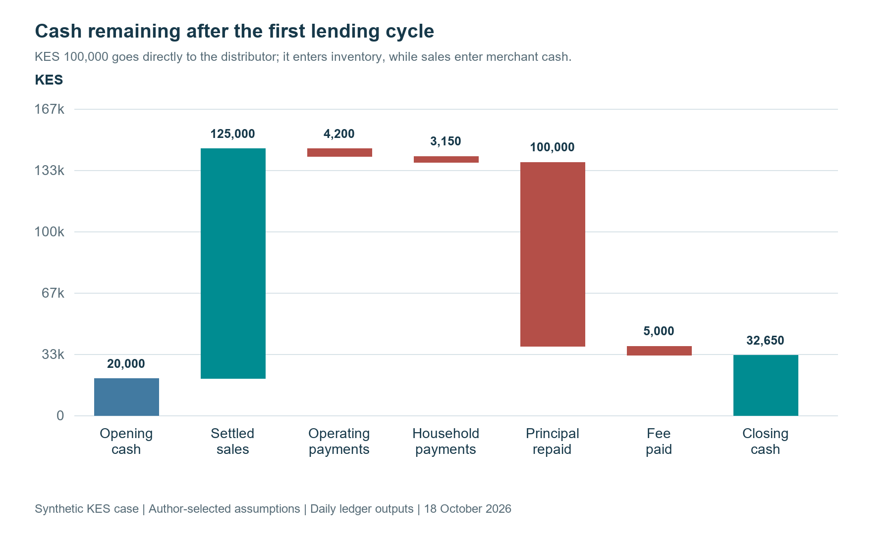
Figure 1. The first cycle reconciles distributor-financed inventory, settled sales, household needs and repayment.

Repeat borrowing follows observed cash conversion
A repeat opportunity opens after the previous loan settles, the relevant sales receipts arrive and the cooling period ends. The case projects repayment-window cash using the previous completed cycle's observed selling margin, inventory conversion and settlement timing. It approves a limit only when projected cash after expenses and debt service retains the KES 10,000 operating floor. A timely borrower with sufficient surplus can receive an increment, subject to the KES 120,000 teaching cap. A weaker forecast reduces the proposed amount or defers the next loan. This executable gate uses transparent cash arithmetic; the Bayesian extension described below adds a validated distribution around the quantities being forecast.
The baseline generates 72 loans, including 60 repeat loans, and ends with KES 1,140,000 aggregate merchant cash. The sales-and-settlement shock begins in cycle three and produces 60 loans and 3 defaults. Support combined with a fourteen-day extension produces 66 loans and 0 defaults under its assumed improvement in stock conversion. The simulation specifies that improvement as an input. A prospective study would estimate whether the offered support actually changes sales, cash and repayment, at what cost, and for which merchants. Extension alone has its own scenario so the cost of waiting can be compared with a change in the trading process.
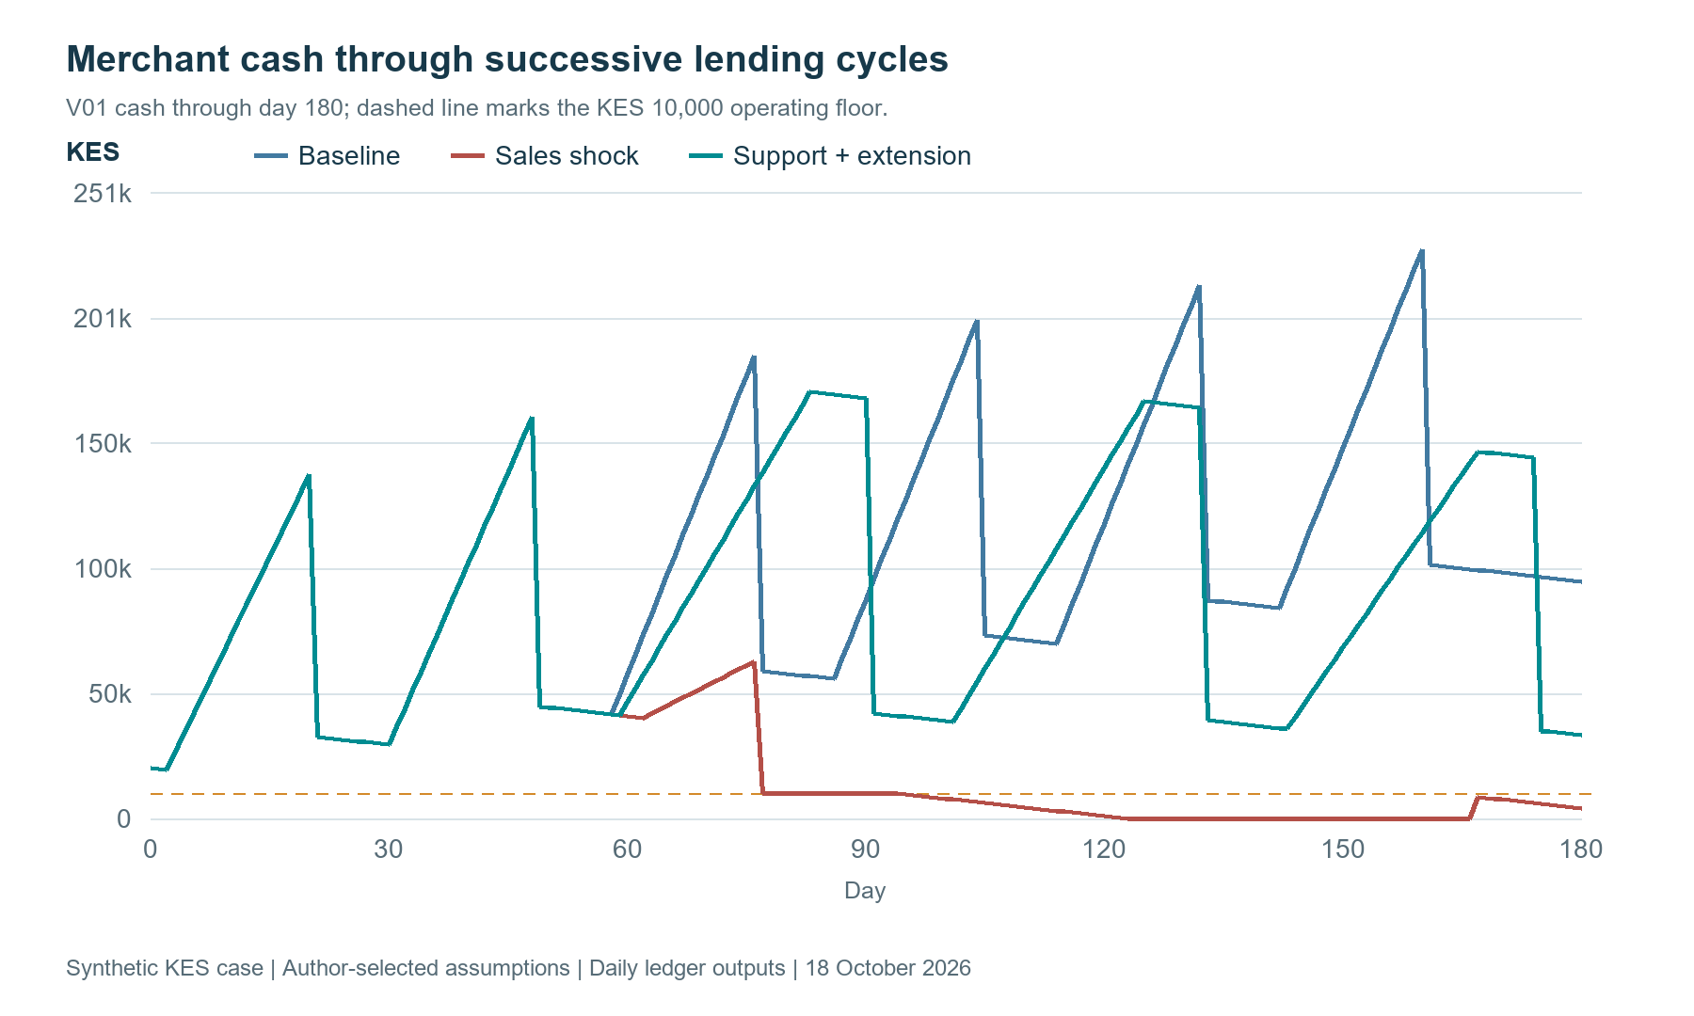
Figure 2. Merchant V01 illustrates how the same starting business develops through baseline, stressed and supported repeat cycles.
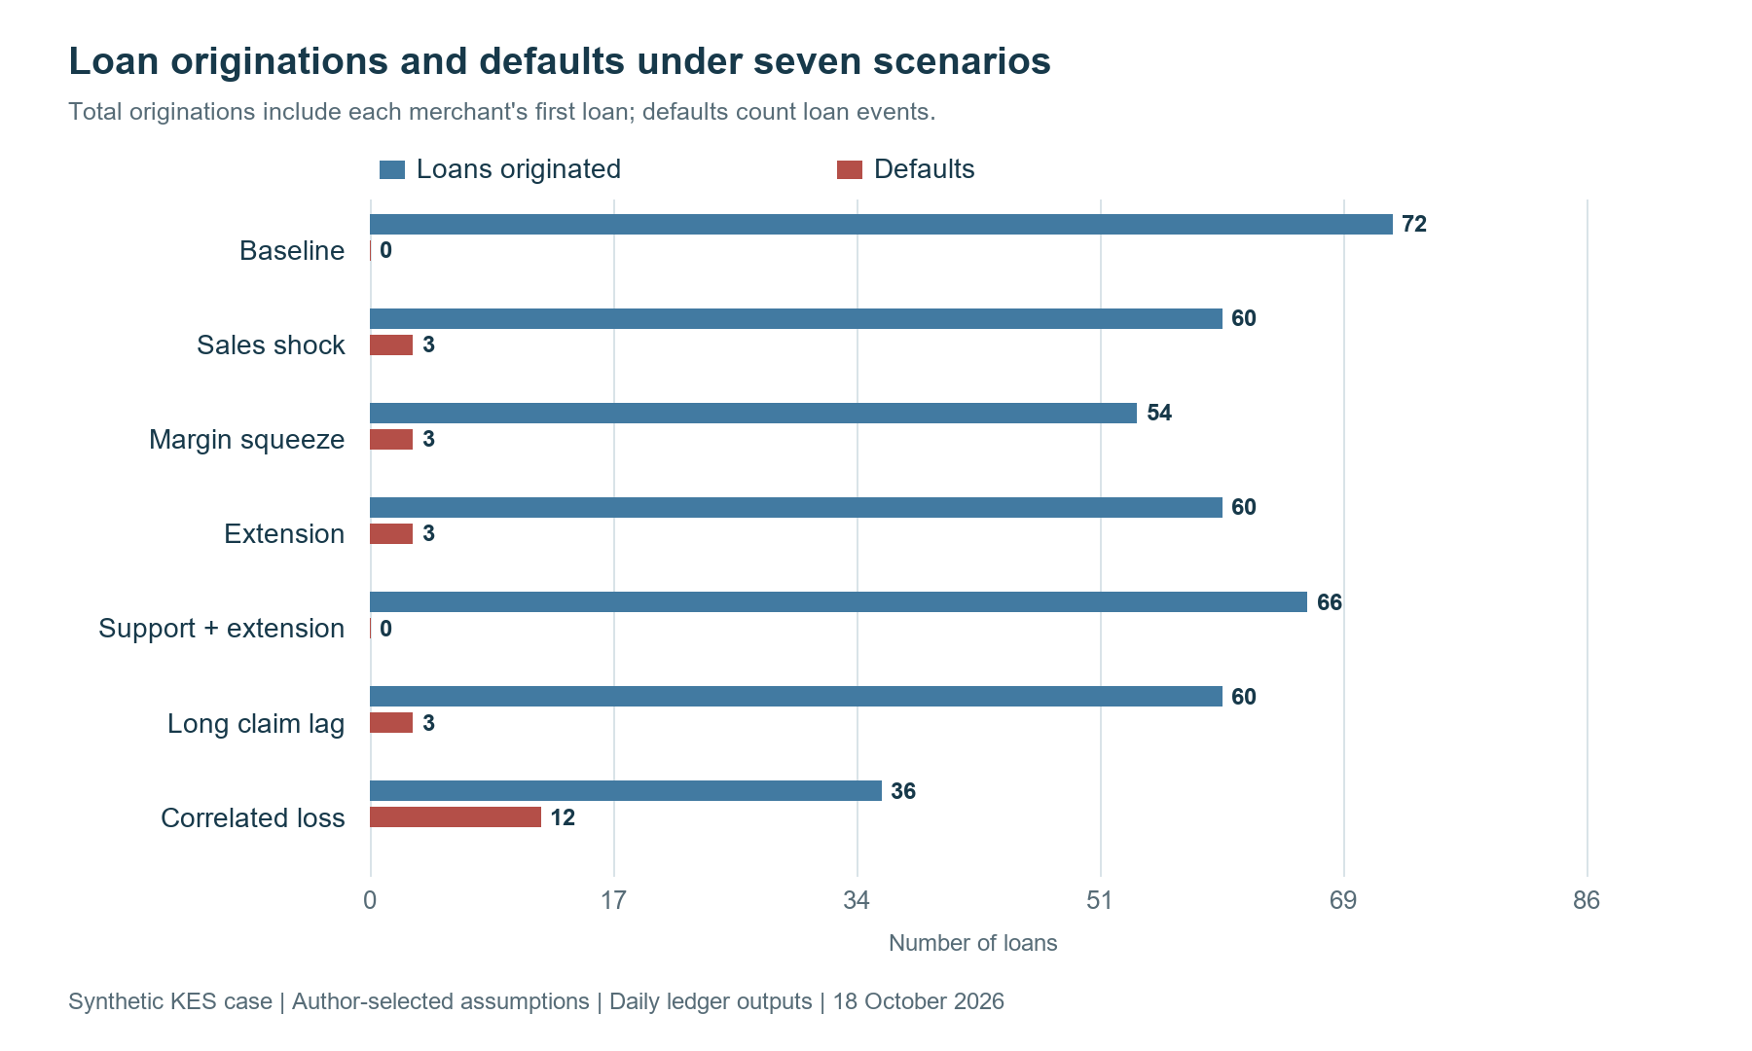
Figure 3. Repeat lending and default outcomes vary with sales, margins, support and the timing of the next facility.

Establish whose cash the evidence describes
An enterprise may use cash, several mobile-money wallets, a till and bank accounts belonging to its proprietor. Transfers among them need an economic interpretation. Underwrite for Collection develops an entity and transaction graph linking authorised accounts, businesses, facilities, orders and settlements. Each relationship records its source, effective date, verification and confidence. Customer receipts, owner contributions, borrowing, refunds and internal transfers retain distinct meanings. This lets an analyst consolidate the business while tracing an amount through several payment systems. A genuine sale to a related party can remain operating income when supported; an owner injection can strengthen liquidity with its financing character visible.
That distinction matters particularly when repeat repayment becomes a key underwriting signal. The proposed review would connect each repayment with the business activity and available liquidity that supported it. It would assess sales conversion, household withdrawals, supplier obligations and the working capital remaining afterwards. A merchant completing several cycles may have earned a higher limit, better terms or additional product options. The next decision can use that accumulated experience alongside changing stock requirements and other obligations. This produces a more informative record of progression: how the business performed, how the facility fitted its cycle and which evidence supports another lending decision.

Use time and uncertainty to improve judgement
Short contractual tenors make timing especially important. A twenty-one-day facility might encounter slower stock sales, a payment-system delay or an unexpected household expense. Each event can move the borrower through different states: performing, temporarily late, restructured, cured, defaulted or recovered. Survival models estimate the timing of defined outcomes; competing-risk models separate events such as full settlement and default; multi-state models describe subsequent transitions. An active, immature loan retains its observed history and follow-up window. Models can therefore compare equivalent periods, account for censoring and test whether apparent cure persists across later cycles. This connects branch observations with a consistent portfolio history.
Hierarchical Bayesian modelling supplies another practical advantage: learning from businesses with different amounts of experience. Underwrite for Collection combines enterprise evidence with partially pooled sector, location, product and time effects. Mwendo Pamoja provides complementary work on liquidity features, posterior uncertainty and governed decision thresholds [5]. A new trading segment can borrow information from relevant groups while retaining differences supported by its own outcomes. The hierarchy includes the individual likelihood, group distributions and priors governing between-group variation. Reviewers receive a credible interval around the estimated risk and a predictive range for future cash. Both outputs help explain how much the evidence supports a particular limit.
A proposed limit decision can include the quantity:
q = Pr(p > pₘₐₓ ∣ D)
Here p is the defined-horizon default probability under the specified model, pₘₐₓ is an approved policy threshold, D is the evidence available at the decision, and q is the posterior probability of exceeding that threshold. The decision also considers affordability, uncertainty, customer needs and the cost of the available actions. An officer could retain the existing limit, authorise a measured increase, request targeted evidence or offer an appropriate alternative. The output supports a reasoned choice whose assumptions, authority and subsequent outcome remain available for review.
Model development also records which applicants produced observable outcomes. Historical approvals, customer acceptance and repeat borrowing determine the population represented in a repayment dataset. A proposed expansion can test its relevance through shadow scoring, permitted external evidence and carefully designed prospective learning. Reject inference would document the assumptions connecting observed borrowers to the wider applicant population, with sensitivity analysis and uncertainty carried into decisions. Validation would keep related businesses together and hold out later lending cycles. This makes the performance claim useful: management can see the customers, conditions and policy under which an estimate has been tested, and which additional evidence would support broader use.

Evaluate business support as an intervention
4G Capital’s combination of lending and training creates an opportunity to study how support contributes to business performance. Relevant options might include stock planning, simple margin records, cash budgeting or the timing of a follow-up visit. Peer-reviewed experimental work by Campos and colleagues in Togo compared forms of business training and found that programme design materially affected enterprise outcomes [6]. That study motivates careful local evaluation of content and delivery. A proposed Kenyan programme would define its own customers, needs and outcomes, then estimate effects within that setting. The research question becomes specific enough to improve a service that teams actually deliver.
A controlled study could compare approved additional support options while maintaining the standard customer service. Eligibility, assignment, delivery and follow-up would be recorded before assessing results. Outcomes would include stock turnover, gross margin, cash after essential commitments, durable repayment, customer experience and incremental servicing cost. Baseline business conditions and lending history help explain heterogeneity. Where branches or distributors share practices, the design would consider clustering and spillovers. Observational evaluation requires explicit treatment-selection assumptions and appropriate handling of time-varying confounding [7]. This gives the institution evidence about which support improves outcomes, for whom and at what resource cost.
As evidence develops, a contextual bandit could help select among approved support options using current business circumstances. Its audit record would preserve action probabilities, decision context, outcomes and policy versions. Sequential methods become relevant when one intervention changes the next trading cycle, available credit or later need for support. Human approval would govern material contractual actions within the agreed policy. The immediate practical objective is a reliable feedback loop from delivered support to business and collection outcomes. Model complexity can then follow demonstrated value, operational readiness and the precision needed for the decision, making each stage useful to branch staff and management.

Why the IFC partnership sharpens the proposition
On 4 August 2026, IFC announced Catalytic First Loss Guarantee transactions involving 4G Capital, Equity Bank Kenya and KCB Bank Kenya. The announcement places the initiative within IFC’s MSME Platform and blended-finance support [8]. For 4G Capital, the relevant analysis begins with its individual project disclosure and executed agreement. Project 53511 describes an unfunded risk-sharing facility for a new Kenyan-shilling-equivalent MSME portfolio, including microenterprises and women-owned businesses. It also identifies advisory support for onboarding, underwriting methodology and distributor finance [9]. This creates a particularly close connection to the proposed research across product design, evidence, lending decisions, monitoring and financial protection.
The disclosure’s narrative describes a portfolio of approximately US$44.4 million equivalent and maximum IFC risk of US$6.2 million, comprising first-loss and second-loss participation. Its indicative Board table lists US$8.2 million. Implementation would reconcile those disclosure fields with the dated, executed agreement [9]. The working model would then load the confirmed eligible portfolio, attachment, sharing rules, caps, fees, dates and reporting duties. That process turns a public financing announcement into an operational specification. The project team can identify the exact exposures covered and reproduce the amount, timing and ownership of every potential claim from the agreement’s terms.

Model protection through its entire cash process
A useful protection ledger begins when an eligible loan enters the covered population. It follows outstanding principal, arrears, recoveries and any event establishing a claim. Subsequent states include notification, document completion, acceptance, recognised receivable and settled cash. Each state has an amount, date, evidence owner and destination account. The lender can therefore assess both ultimate risk sharing and the liquidity required while a claim progresses. Short merchant loans can still produce a longer protection and recovery cycle. Portfolio management benefits from seeing those clocks together, particularly when repeated lending continues while earlier claims await settlement.
The companion contains an explicit two-layer teaching schedule. A KES 4,440,000 cumulative inclusion budget is divided into a first KES 220,000 loss layer with KES 200,000 maximum protection and a further KES 4,220,000 layer with KES 420,000 maximum protection. These KES values preserve disclosed layer proportions for demonstration; they are a separate scale illustration. The assumed within-layer sharing percentages are 200/220 and 420/4,220. Eligibility, origination cutoffs, processing delays, fees and recovery allocation are independently configurable. Loading the executed agreement would replace those teaching conventions with its specific definitions, beneficiary rights and cash processes.
For cumulative eligible gross loss L, the teaching allocation is:
G(L) = (200/220) × min(L, 220,000) + (420/4,220) × min(max(L − 220,000, 0), 4,220,000)
A new loss receives the increment G(L after the loss) − G(L before the loss). The ledger allocates simultaneous losses in a stated order and records each loan's covered fraction. The inclusion budget counts covered originations cumulatively, so repeat loans consume additional capacity. Recovery reduces the beneficiary's net protection through pre-settlement adjustment or later remittance. The model elects no reinstatement of capacity after recovery. Its parameter file, claim rows and tests expose these choices so another researcher can reproduce the result or change one contractual convention without changing the merchant model.
In the delayed-sales case, loan V01-C03 defaults on day 107 with KES 37,900 unpaid principal. Its teaching allocation is KES 34,455. Submission occurs on day 112, acceptance on day 122 and cash settlement on day 152. The workout on day 167 produces no borrower recovery after operating payables and the cash floor are respected. The accepted receivable, settled cash and recovery remittance have different dated entries. The model funds the lender throughout that interval rather than treating acceptance as immediate cash.
Across the delayed-sales portfolio, gross written-off principal is KES 113,700, subsequent borrower recovery is KES 0, guarantee cash is KES 68,909 and recovery remittance is KES 0. Retained credit loss therefore equals KES 44,791. The long-claim scenario holds the merchant outcomes fixed and increases settlement delay from thirty to ninety days after acceptance. The ultimate protection amount is the same because this merchant path produces zero workout recovery; the later cash receipt changes the funding cost. The separate correlated-loss scenario reaches the second layer and produces KES 62,400 of borrower recoveries. For loan D01-C03, KES 4,727 is remitted to the guarantor on day 167 after an earlier KES 67,727 claim settlement. Total recovery remittances are KES 18,124. This case makes the recovery-sharing convention and residual lender exposure visible.
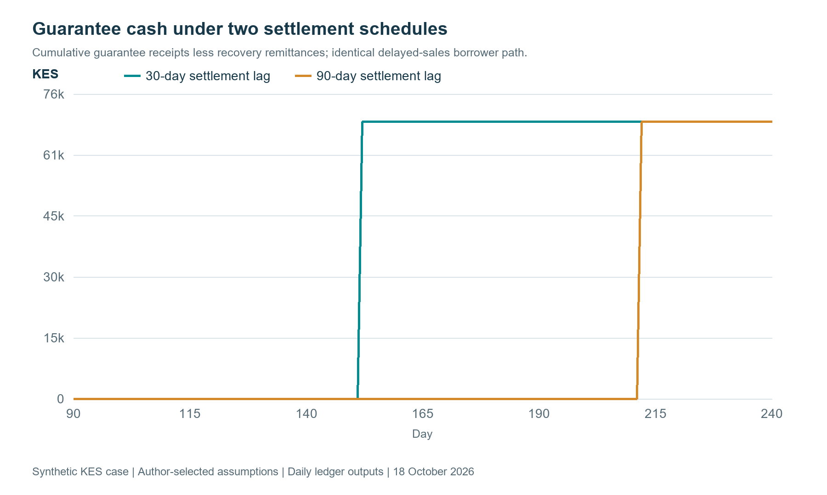
Figure 4. Claim settlement changes the date protection becomes available cash. The model also records recovery adjustments and remittances when recoveries occur.

Measure additionality alongside portfolio economics
The programme creates an important evaluation question: which viable businesses receive finance, suitable limits or improved terms because risk sharing and advisory support are available? International guarantee principles emphasise clear eligibility, sound governance, efficient claims and systematic evaluation [10]. For this application, a comparison design would examine similar eligible businesses and distinguish changes in credit access from changes in business outcomes. Measurements could include first access, approval, limits, total cost, product fit, stock investment, profits and resilience through subsequent cycles. The design would record programme entry and policy changes so that observed improvements can be connected to specific decisions and mechanisms.
The same analysis should report the lender’s retained economics. Customer receipts fund servicing, expected losses, funding costs and a return on the capital supporting the exposure. Protection can change retained loss and its uncertainty, while advisory improvements can change the underlying portfolio. Their contributions should be measured separately. Gross performance remains visible alongside covered performance, allowing management to assess underwriting quality, guarantee utilisation and commercial sustainability. The funding forecast then distinguishes borrower cash, recoveries, accepted claims and settled guarantee payments. Finance would apply the relevant accounting and prudential recognition requirements to the actual entity and instrument, alongside the model’s management analysis.

Reconcile profitability and the funding requirement
The lender model separates principal movement from income. Fees collected contribute revenue. Origination, daily servicing, support, collections, guarantee fees and interest on opening borrowing contribute costs. Written-off principal and later recoveries form the realised credit-loss bridge. Guarantee settlement and recovery remittance then determine the protection contribution. The reported result is a synthetic realised contribution before tax, central overhead allocation and a capital hurdle. Accrued unpaid fees, unresolved default balances, performing principal and accepted unsettled claims appear separately. A reader can therefore reconcile the contribution to cash and remaining assets instead of treating every incoming shilling as profit.
Π = collected fees − operating costs − funding cost − guarantee fees − written-off principal + borrower recoveries + guarantee cash − recovery remittances
Under baseline assumptions, protected contribution is KES 320,096, compared with KES 322,671 without protection. Both use the same merchant paths; the difference reflects protection costs when losses are absent. Under the delayed-sales shock, contribution is KES 190,858 with protection and KES 124,471 without it. The supported scenario produces KES 256,838 after KES 21,600 of support costs. The correlated-loss scenario produces KES -568,864 with protection. This comparison gives management a concrete way to examine the interaction of product margin, customer support, risk sharing and concentrated stress.
Liquidity has its own daily calculation. The case begins with zero lender cash and draws borrowing to meet disbursements and costs, applying a 12% annual teaching funding rate on opening debt. Incoming cash first reduces that borrowing, then accumulates as cash when the balance becomes positive. In the delayed-sales case, peak protected borrowing is KES 1,361,759. The long claim lag changes contribution by KES 204 through the funding path. A funding mandate could add commitment limits, liquidity reserves and the required return on committed equity. The current outputs show exactly where those decisions would enter.
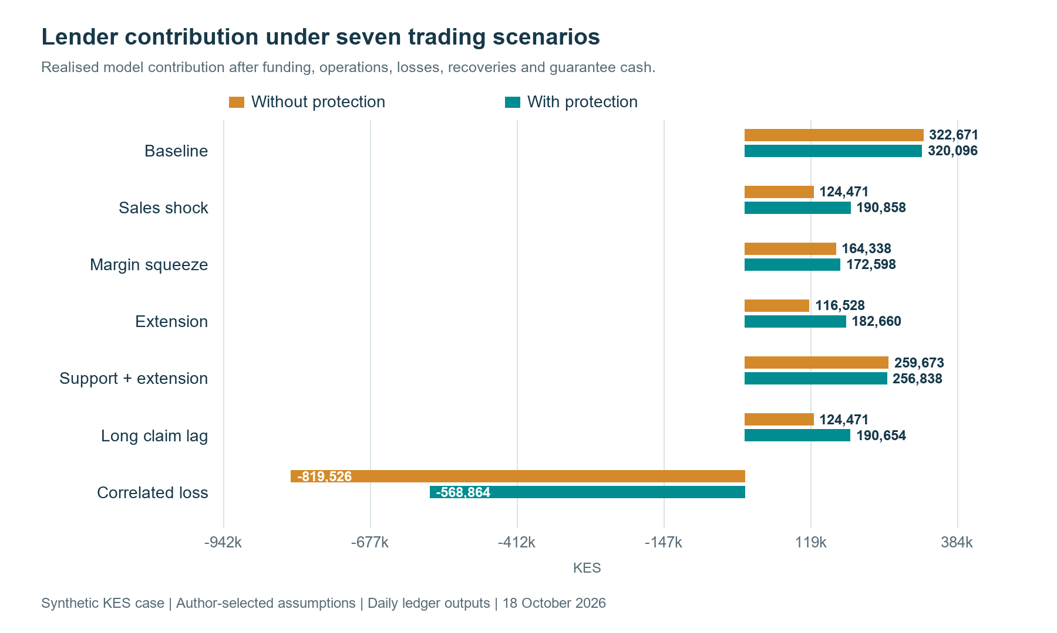
Figure 5. Lender contribution compares identical merchant outcomes with and without the teaching guarantee, including concentrated stress.
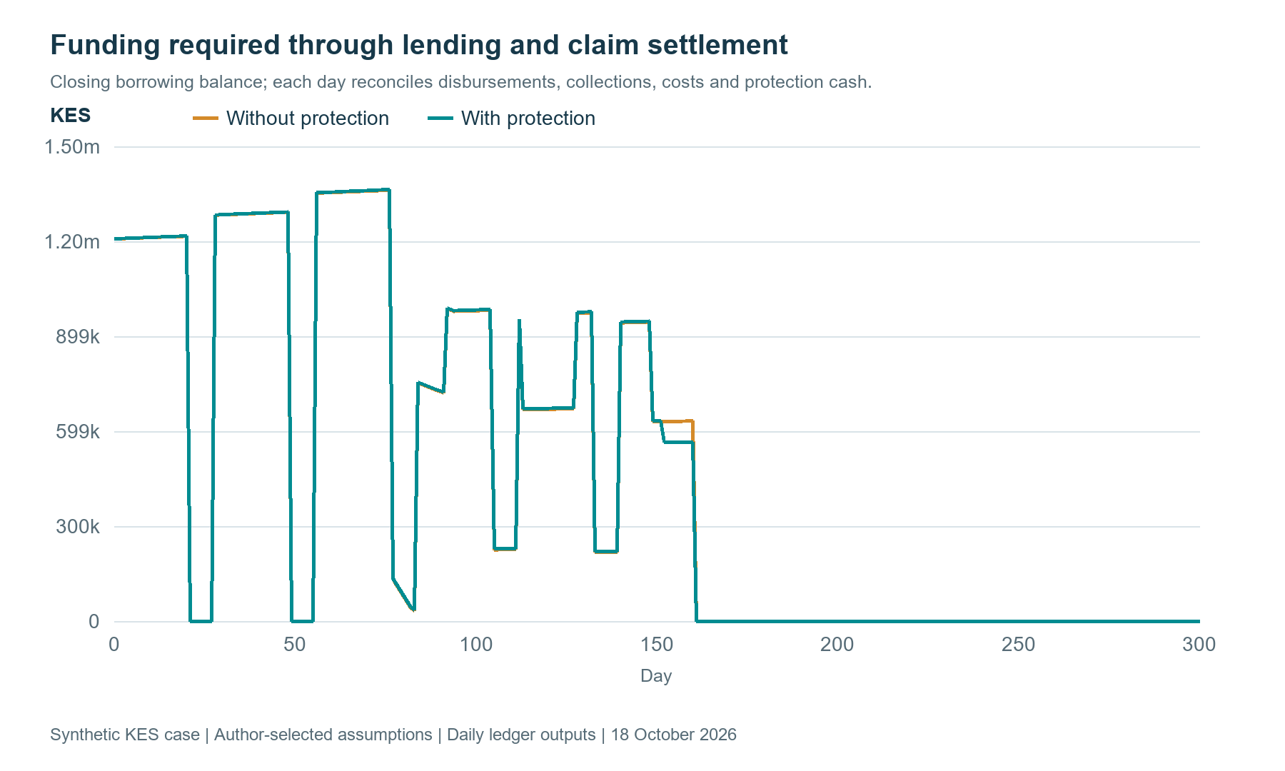
Figure 6. Daily borrowing reflects disbursements, repayments, protection costs and the arrival of guarantee cash.

Make the advisory connection operational
The IFC disclosure’s underwriting and distributor-finance advisory priorities suggest a practical set of deliverables [9]. A shared data dictionary would define borrower, facility, order, delivery, sale, receipt and intervention. A distributor integration specification would document payment and delivery reconciliation. An underwriting review would test product horizons, repeat-loan policies and evidence quality. An experiment protocol would evaluate approved support. The project’s environmental and social management requirements would connect eligibility, relevant screening, staff responsibilities and reporting [9]. These deliverables fit a single operating programme because the merchant, product and subsequent cash appear consistently across each workstream.
Customer protection and institutional integrity also enter that programme. Borrower identification, proportionate due diligence, transaction controls and escalation support the applicable anti-money-laundering requirements. Environmental and social records should follow the project’s agreed management system and reporting scope. Complaint and grievance routes need an identifiable owner, response history and evidence of resolution. Research can examine whether customers understand terms, receive useful support and can challenge an error. Those measures give customer teams and management an additional view of product quality. They also make it possible to analyse whether a commercially promising intervention produces outcomes that remain acceptable across different customer groups.

Keep privacy and decision responsibility explicit
For Kenyan customer data, the Data Protection Act supplies requirements covering processing principles, lawful purposes, information rights, impact assessment, security and automated decisions [11]. The General Regulations develop the operational treatment of automated individual decision-making and related safeguards [12]. An implementation would document permitted purposes, retention, role-based access, processing agreements and transfer arrangements. Identifiable merchant records would remain in the lender’s approved environment, with pseudonymised research extracts where appropriate. Customer communications would explain the relevant evidence and review routes. The legal applicability register would use the lender’s current authorisation, product and jurisdiction when translating these duties into operating controls.
Each recommendation would carry a versioned evidence packet: the business and facility identifiers, decision date, source freshness, feature definitions, posterior outputs, available actions and responsible reviewer. A correlation identifier connects the workflow, while individual event identifiers and timestamps preserve what actually happened. Maker–checker approvals govern specified changes, and execution receipts confirm the resulting action. CRM records communication and complaints; product subledgers record obligations and allocation; the general ledger receives reconciled postings. This gives an independent reviewer a reproducible route from an observed business condition to a decision, its approval, the customer’s response and the eventual financial outcome.

Distinguish merchant finance from receivables funding
Financing a merchant’s business assesses how inventory, sales, expenses and obligations generate repayment. A separate funding arrangement may identify eligible lender receivables and dedicate their collections to investors. That second proposition requires documented rights, transferability, concentration limits, servicing continuity and account control. An SPV is one possible implementation of ring-fenced receivables financing. Its own model would follow purchases, reserves, expenses, debt service and residual distributions. Any guarantee benefit entering that structure would follow its actual beneficiary and transfer terms. The same merchant evidence can inform both analyses while each financing relationship retains its own rights and cash ledger.

Begin with a connected pilot
A focused first project would select one product, a defined branch or distributor cohort and one repeat-lending or support decision. The team would reconcile historical orders, receipts, loan records and field observations, then establish baseline cash and lifecycle measures. Shadow recommendations would test explanations and operational fit. A controlled intervention stage would measure customer and lender outcomes with agreed precision and follow-up. In parallel, a protection module would reproduce the executed guarantee terms and stress settlement delays, recoveries and concentration. The final evidence pack would connect product performance, advisory improvements, guarantee additionality and retained economics, giving management a clear basis for its next investment.
The proposition for 4G Capital is therefore a practical one: examine whether each lending cycle leaves the merchant better able to operate and repay, identify the support that improves that outcome, and connect the evidence to institutional risk sharing and funding. Underwrite for Collection provides the main research architecture. Mwendo Pamoja contributes complementary methods for uncertainty, decision thresholds and financial reconciliation. Together, they offer a structured way to turn a short loan into a longer learning relationship with the business. A partnership can begin with one decision and expand as the evidence demonstrates value for merchants, frontline teams, the lender and its funding partners.

Reproduce the evidence before a pilot
The companion publishes its assumptions, daily merchant ledgers, loan records, protection events and paired lender cash flows [13]. Its tests reconcile merchant cash, inventory, receivables, principal and lender contribution, and exercise guarantee caps, eligibility, recovery timing and unsettled claims. The article and deck use those outputs directly. A partner can first run the synthetic example, inspect a loan and alter a timing assumption, then map an approved historical extract into the same definitions. The proposed agentic workflow prepares evidence and routes exceptions; validated calculation services generate results, authorised staff approve material decisions, and execution receipts preserve the action taken.

References
[1] N. Maloba, Underwrite for Collection: MSME Credit Lifecycle Whitepaper, 2026, doi: 10.5281/zenodo.23343888. [Online]. Available: https://doi.org/10.5281/zenodo.23343888 . Reproducible cases: https://github.com/TheAlchemistNerd/underwrite-for-collection/tree/main/research_lab
[2] 4G Capital, “UPIA: 30-Day Working Capital Business Loans.” Accessed: Oct. 13, 2026. [Online]. Available: https://www.4g-capital.com/upia
[3] 4G Capital, “KUZA: Embedded Retail Credit for Distributors.” Accessed: Oct. 13, 2026. [Online]. Available: https://www.4g-capital.com/kuza
[4] 4G Capital, “Financial Services for MSMEs in Kenya & Uganda.” Accessed: Oct. 13, 2026. [Online]. Available: https://www.4g-capital.com/
[5] N. Maloba, Mwendo Pamoja: Continuous Underwriting, research manuscripts, 2026. [Online]. Available: https://github.com/TheAlchemistNerd/mwendo-pamoja-continuous-underwriting
[6] F. Campos, M. Frese, M. Goldstein, L. Iacovone, H. Johnson, D. McKenzie, and M. Mensmann, “Teaching personal initiative beats traditional training in boosting small business in West Africa,” Science, vol. 357, no. 6357, pp. 1287–1290, 2017, doi: 10.1126/science.aan5329. [Online]. Available: https://documents1.worldbank.org/curated/en/865931506094667006/pdf/119938-REVISED-Teaching-personal-initiative-beats-traditional-training-in-boosting-small-business-in-West-Africa-Working-Paper.pdf
[7] M. A. Hernán and J. M. Robins, Causal Inference: What If. Boca Raton, FL, USA: Chapman & Hall/CRC, 2020, updated online edition. [Online]. Available: https://miguelhernan.org/whatifbook
[8] International Finance Corporation, “IFC Supports Expansion of Financing for Kenya’s Small Businesses through the First Catalytic First Loss Guarantee Transactions in Africa,” Aug. 4, 2026. [Online]. Available: https://www.ifc.org/en/pressroom/2026/ifc-supports-expansion-of-financing-for-kenya-s-small-businesses-through-the-first
[9] International Finance Corporation, “MFP-CFLG-4G CAP,” Summary of Investment Information, project 53511, disclosed May 24, 2026, updated Jul. 4, 2026. Accessed: Oct. 13, 2026. [Online]. Available: https://disclosures.ifc.org/project-detail/SII/53511/mfp-cflg-4g-cap
[10] World Bank and FIRST Initiative, Principles for Public Credit Guarantee Schemes for SMEs. Washington, DC, USA: World Bank, 2015. [Online]. Available: https://www.worldbank.org/en/topic/financialsector/publication/principles-for-public-credit-guarantee-schemes-cgss-for-smes
[11] Republic of Kenya, Data Protection Act, No. 24 of 2019, especially ss. 25, 26, 29–31, 35, 41–43 and 48–49. [Online]. Available: https://new.kenyalaw.org/akn/ke/act/2019/24/eng%402019-11-15/source
[12] Republic of Kenya, Data Protection (General) Regulations, Legal Notice No. 263 of 2021, especially reg. 22. [Online]. Available: https://www.odpc.go.ke/wp-content/uploads/2024/03/THE-DATA-PROTECTION-GENERAL-REGULATIONS-2021-1.pdf
[13] N. Maloba, "4G-inspired merchant cycle and risk-sharing reproducible case," 2026. [Online]. Available: https://github.com/TheAlchemistNerd/mwendo-pamoja-continuous-underwriting/tree/main/research_lab/four_g_merchant_finance_case

Publication record
Main article word count: 4,125 words. Updated with the reproducible merchant, lending and guarantee case. Count includes headings and captions, excluding image-link markup and references.
Licence: Creative Commons Attribution-NonCommercial-ShareAlike 4.0 International, https://creativecommons.org/licenses/by-nc-sa/4.0/.

