# AGRISHARE

# ABSTRACT

Despite the fact that agriculture accounts for as much as a quarter of the Indian economy and employs an estimated 60 percent of the labor force, it is considered highly inefficient, wasteful, and incapable of solving the hunger and malnutrition problems. Despite progress in this area, these problems have continued to frustrate India for decades. It is estimated that as much as one-fifth of the total agricultural output is lost due to inefficiencies in harvesting, transport, and storage of government-subsidized crops. Solving these issues will play a significant role in the socio-economic condition of this country. And the past year was all about the motion of decentralization and giving the right of consumers data in their own hand and privacy and bridging the concept of how blockchain will change the world for good. So we bring a simple proof of concept where we demonstrate how the concept of a community and decentralization can help farmers grow economically & socially. Investments in agriculture sounds pretty inept for a normal consumer, we break this idea and now we introduce the concept of general investment and shareholding in the agriculture ecosystem. Using Blockchain our concept guarantees a 100 percent transparent system in an end to end model, which means the farmer will be assured that what is paid for in the market for his produce is at par with the maximum profit possible because we remove the involvement of a lot of middle men between the farmer and the market leading to a higher profit to both retailer and the farmer. Having a structured community helps the idea of shared growth and learning which leverage the involvement of very poor farmers directly in the market directly, the two major benefits we project here is the overall risk in agriculture space is reduced because of the community support every farmer receives from the other fellow in that respective community and the overall production reach to the market will increase as the production will be from the whole community and from individual farmers. We now introduce the idea of task and reputation. Unorganised sector, also known as own account enterprises, refers to all unlicensed, self-employed or unregistered economic activity such as owner manned general stores, handicrafts and handloom workers, rural traders, farmers, etc. The idea of task is derived from the fact that it will allow every daily wage worker to participate in the community work in a structured way allowing them correct wage and the opportunity bringing them to the formal sector in this country. Reputations are another part of this concept of community is the about giving back and someway helping the community grow though your involvement in it which in return can be used for several purposes like buying seed etc.

# PROJECT WIREFRAME

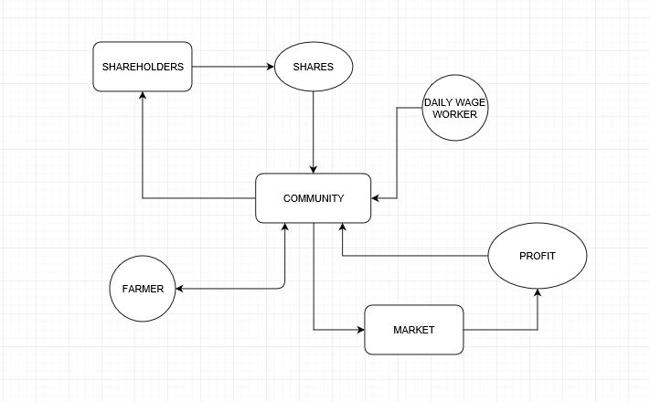

This is the wireframe of our platform where we try to bring in everyone starting right from the investor which can be you to the farmer to the shareholder and even the panchayat and the people who are selling it to retail or the wholesale.

**So how does it work?**

Using this platform is very simple.

1. Shareholder/ Investor - sure, you want to invest in the agricultural ecosystem and looking for a return.The strategy is simple you invest in any of the given community with a percentage of stake you want to buy and keep it just like normal investment in any company. With the growth in agricultural yield and community development the price of the stock increase and then it’ your choice to hold it or sell it.
2. Farmer - you have some land (be a part of a community). What it takes you may ask? You have to have your identification card and your asset details of your land and some proprietary details of what you grow and that's all about it.
3. Daily wager - see what jobs are around you. Take up the job you like.

This idea will always keep the cash flow in the agriculture industry and farmers can now take out money from the community for the resources they need with/without load from the bank.

# TECHNOLOGY AND DESIGN

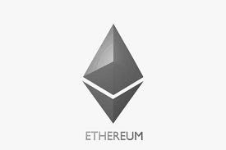

Ethereum is a decentralized platform that runs smart contracts: applications that run exactly as programmed without any possibility of downtime, censorship, fraud or third-party interference.These apps run on a custom built blockchain, an enormously powerful shared global infrastructure that can move value around and represent the ownership of property.This enables developers to create markets, store registries of debts or promises, move funds in accordance with instructions given long in the past (like a will or a futures contract) and many other things that have not been invented yet, all without a middleman or counterparty risk.

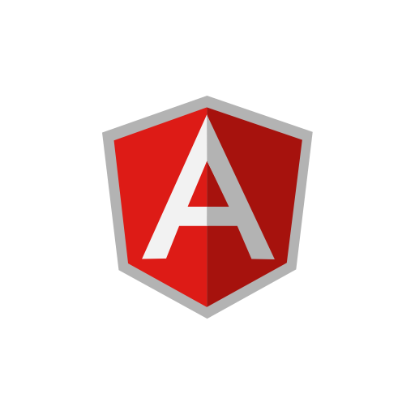

AngularJS is a JavaScript-based open-source front-end web application framework mainly maintained by Google and by a community of individuals and corporations to address many of the challenges encountered in developing single-page applications. HTML is great for declaring static documents, but it falters when we try to use it for declaring dynamic views in web-applications. AngularJS lets you extend HTML vocabulary for your application. The resulting environment is extraordinarily expressive, readable, and quick to develop.