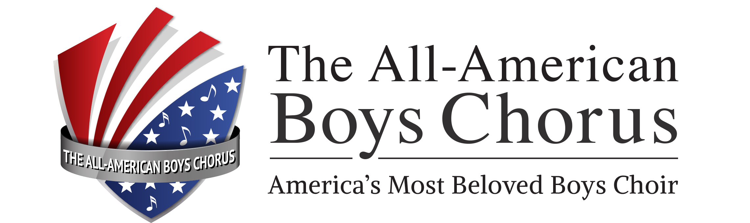

V I S I O N

To make a positive difference in our community, our nation and the world through the power and artistry of the voices and leadership and example of our choristers and alumni.

M I S S I O N

To provide a world-acclaimed music and performing arts curriculum that educates, motivates and builds character in boys through unparalleled opportunities for performance, leadership, travel and community service.

CORE VALUES

High Moral Standards and Values of Personal Responsibility
The Pursuit of Excellence through a philosophy of “Happy, Motivated Self-Discipline”
Leadership by Example
Love of Country
Seek and Trust Divine Guidance

STRATEGIC GOALS

Become the preeminent program of choral music for boys in the United States of America.

Preserve America’s musical heritage.

Create collaborations and community outreach that harness the power
and teach the joy of music.

Curriculum linking the concentration, the pursuit of excellence, and the commitment
and leadership necessary to be a world-class performance ensemble to other facets of a boy’s life, in particular to his academic studies.

Build self-esteem and self-confidence in each boy, enabling him to realize and achieve his highest potential, by teaching and emphasizing the value of each individual.

Promote camaraderie and convey a sense of pride and tradition to choristers that will result in life-long friendships with fellow choristers and a deep connection with the Chorus.

