     QUOTES
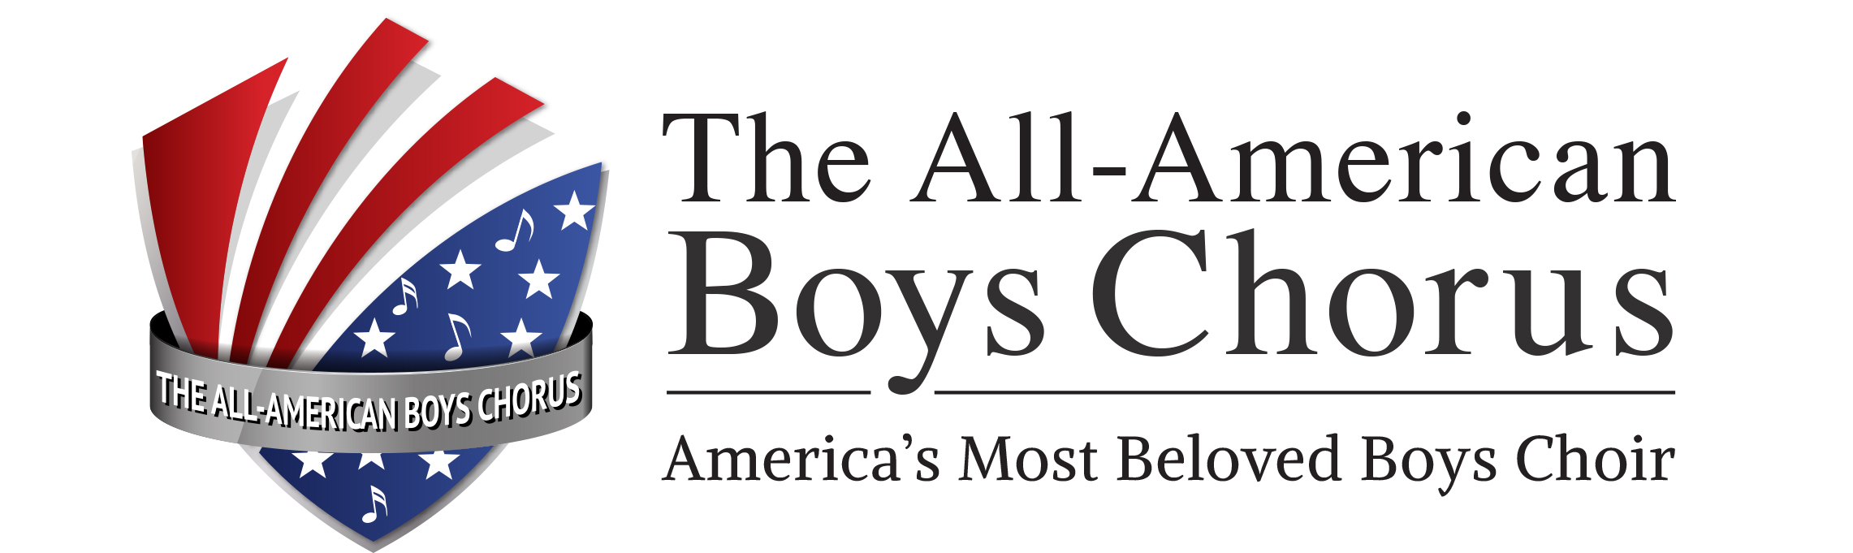

“They are, quite simply, wonderful!”
—The OC Register

“Perfect voices.”
—Long Beach Press-Telegram

“Congratulations on the terrific performance of
The All-American Boys Chorus on the opening night of the
75th Anniversary Season of the Hollywood Bowl.”
—Ernest Fleischmann, managing director

Los Angeles Philharmonic Orchestra

“Your spectacular performance MADE the evening!
You have the whole town talking!”
—Virginia McMonagle, University Relations
University of San Diego

“Wow! The All-American Boys Chorus was outstanding.
The response from the audience during and after the AABC’s performance spoke clearly to that point.”
—Michael A. Goldware, Concert for Heroes

“The boys were just marvelous and our client [IBM] couldn't be happier!
Your staff and the boys were so professional
that you made our jobs very easy.”
—Patricia Iannucci, The Carabiner Group

“You ‘wowed them’ with another fantastic performance!
Thanks again for making me look good.”
—Russ Kembel, National Life Insurance Company

