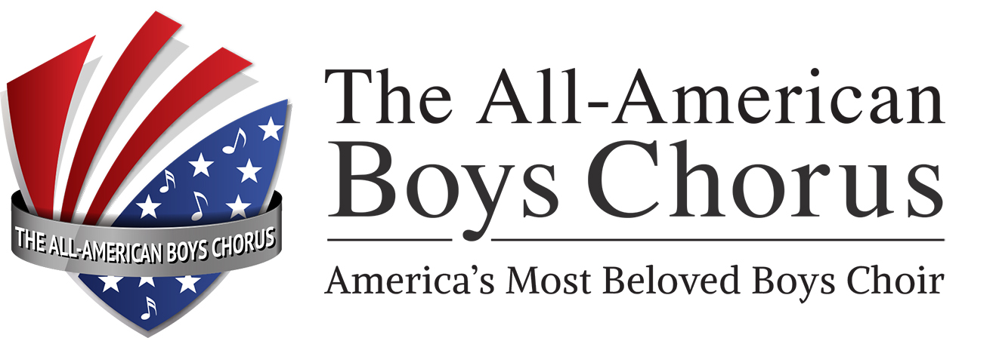

Media Release

The All-American Boys Chorus | Public Relations Office
1055 Arlington Drive, Costa Mesa, CA 92626 | Voice: (714) 708-1670 Fax: (714) 557-5447
FOR IMMEDIATE RELEASE: (Date) | Contact: TONY MANRIQUE (714) 708-1670x11  E-mail: a.manrique@taabc.org
 | Website: www.taabc.org

All-American Boys Chorus to Perform in (city)

Choristers will present “An American Musical Journey!”

City, State Where Released—The internationally acclaimed ALL-AMERICAN BOYS CHORUS will bring its troupe of young singers to (name of theater) on (day and date) for a concert titled, “An American Musical Journey! For tickets and information, call (area code and phone number).
The 32-voice ensemble, whose members range from 9 to 14 years old, will present audience favorites from America’s musical history. Best of Broadway tunes include selections such as “Tonight” from West Side Story, and “The Circle of Life” from Beauty and the Beast. There will also be medleys featuring the California sounds of The Beach Boys and the Mamas and the Papas, pop tunes from Michael Jackson and Chicago, swinging songs from the Big Band era, dynamic Dixieland melodies and jazz classics. A patriotic tribute spotlighting the music of Lee Greenwood and John Philip Sousa will also include a stirring salute to past and present members of the USA’s Armed Forces.
“The Chorus has been described as outstanding, pure energy and simply wonderful,” says Artistic Director Wesley Martin. “We’ve also developed a strong reputation for ‘theatricality’—for doing more than just standing there and singing.”
Executive Director Anthony S. Manrique notes that “throughout our 44-year history, The All-American Boys Chorus has provided boys—more than 1,000 of them to date—with the training, motivation and opportunity to develop and exercise leadership qualities within an exceptional program of choral music.”
(more)
Page 2-2-2 The All-American Boys Chorus
Manrique adds that the group has completed 55 concert tours in North America, Europe, Japan and Asia. “In 2013 and 2014,” he says, “we experienced absolutely wonderful trips during which we performed in New Zealand, Australia the USA Pacific Northwest and western Canada!”
The Chorus has appeared on the Disney Channel, on ABC with Josh Groban, in the Pasadena Tournament of Roses Parade, at the Calgary Stampede and Edmonton Klondike Days in Canada, and in TV and radio commercials for KFC, Mazda and Cartoon Network. The group also received enthusiastic reviews for its participation in various productions at the Segerstrom Center for the Performing Arts Center including appearances with the Pacific Symphony and Pacific Chorale, and with the Los Angeles Philharmonic Orchestra at the Hollywood Bowl.
The Chorus has produced five full-length albums, available on CD: the first is titled A Little Christmas Magic; the second, On the Sunny Side of the Street; the third, another holiday album named The Best Gift of All; the fourth, featuring audience favorites, called By Request!; and the latest, On Tour! For more information, visit the group’s Website at www.taabc.org Numerous color images and a media center are among its features.
# # #
Interviews with the Artistic Director and choristers may be arranged.
Contact Tony Manrique at (714) 708-1670 x11 or a.manrique@taabc.org

