 SHORT DESCRIPTION
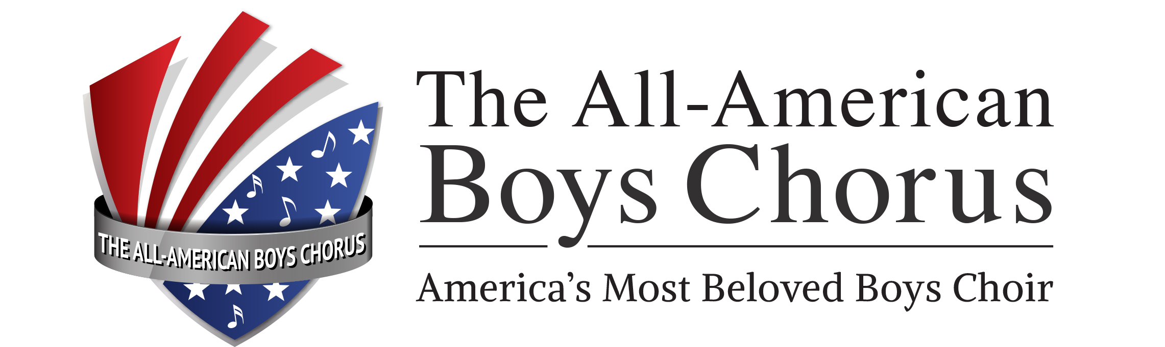

The All-American Boys Chorus, America’s Most Beloved Boys Choir, has delighted audiences worldwide for over forty years. Based in Costa Mesa, California, the Chorus is comprised of over 100 boys ages 8 to 14 drawn from throughout Southern California.

With a versatile repertoire ranging from classical and sacred works to jazz, Americana and contemporary selections, the Chorus is equally comfortable performing in concert halls or on the sets of films, television productions, and commercials, and was honored as an Orange County Outstanding Arts Organization.

Under the leadership of Artistic Director Wesley Martin, a graduate of Hungary's renowned Kodály Institute, the AABC provides boys with comprehensive musical training and unsurpassed performance and touring opportunities.

For bookings or interviews contact: Tony Manrique, Executive Director, at 714.708.1670 ext 11, email a.manrique@taabc.org or visit www.taabc.org

(ADDITIONAL COPY)

The AABC’s most recent concert tours saw them perform in New Zealand and Australia in 2013 and in the USA Pacific Northwest and western Canada in 2014. In 2015 the Chorus will tour the USA Eastern seaboard and in the nation of Japan.

Among the Chorus’s TV credits are commercials for Cartoon Network, Mazda, Toshiba and KFC. The AABC has appeared with artists such as Josh Groban, Tony Bennett, Taylor Hicks, David Benoit, Paul Anka, Bob Hope, Victor Borge, Della Reese and Melissa Manchester. It also has shared the stage with noted statesmen and U.S. presidents George Bush, Ronald Reagan, Gerald Ford, Jimmy Carter and Richard Nixon.

Boys are admitted after completing an eight-week audition process. They then train for an additional 6 to 12 months and learn the basic concert repertoire of 40 songs before acceptance into the Concert Chorus. Touring Choruses are selected from among Concert Chorus members and number 30 to 36 boys. Candidates must attend the AABC week-long music training camp, exhibit a high level of self-discipline and personal organization, and demonstrate a strong ability to interact positively with other Chorus members.

The Chorus has produced five full-length albums: the first is titled A Little Christmas Magic; the second, On the Sunny Side of the Street; the third, another holiday album named The Best Gift of All; the fourth, a compilation of audience favorites, called By Request!; and the latest, On Tour!

