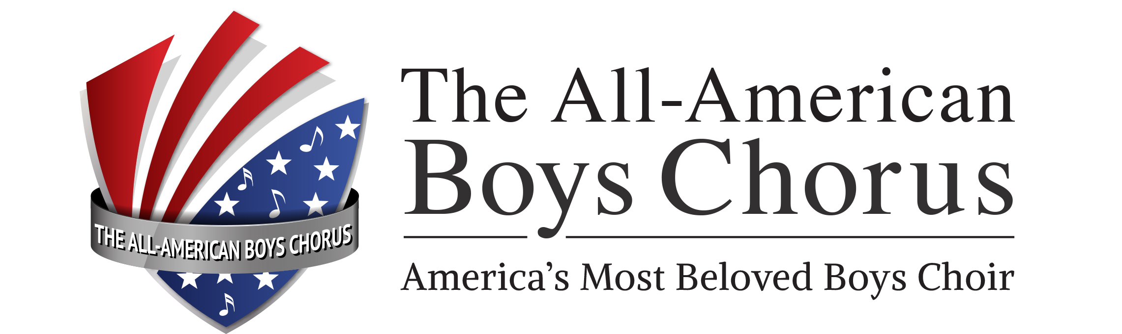
  WESLEY MARTIN
Artistic Director/Conductor
Wes Martin, conductor, arranger, educator. Born and raised in Australia, Wes has been living in Southern California since 2002 where he serves as Artistic Director for the All-American Boys Chorus.

After graduating from the Sydney Conservatorium of Music, Wes was awarded the prized Hungarian State Scholarship and went on to study at the esteemed Kodály Interzet, Hungary. This unique experience impressed upon him the beauty and joy of choral singing and its potential to transform the lives of both performer and audience. Classically trained as a singer and music educator, Wes’ diverse musical interests cover many different styles and genres, his principal interest being popular music styles. With expertise in building choral tone and a special interest in developing choral ensemble with the child’s voice and over twenty years’ experience with many different choral ensembles, Wes believes in the life enriching experiences that can be had through music and especially choral singing.

Under Wes’ musical direction the All-American Boys Chorus has been delighting audiences with its engaging, fun performances and has emerged as a favorite of event organizers and concert presenters regionally and nationally, as well as becoming one of America’s premier boys’ choirs. Under his leadership, the All-American Boys Chorus received the coveted Outstanding Arts Organization Award for 2011.

In 2010 the All-American Boys Chorus celebrated its fortieth anniversary, commemorating forty years as one of the region’s leading arts organizations. Together with Alumni and present membership, Wes led the unforgettable celebrations at the iconic Crystal Cathedral, Garden Grove.

Over the years, along with the AABC, Wes’ collaborations have included; John Williams, Josh Groban, The Vienna Boys Choir, The Disney Company, Jerry Lewis, Cartoon Network, The Pacific Symphony Orchestra, Opera Pacific, The Canadian Brass, The Philadelphia Boys Choir, The Masters of Harmony and the Tournament of Roses. He has led the AABC in numerous TV appearances including; CHRISTMAS IN L.A., CARTOON NETWORK, JERRY’S KID’S and SCRUBS, as well as being recognized for his work with GOOD NEWS FOR KID’S, one of the region’s major charitable events. Wes has led numerous acclaimed international tours and performances in world-class venues such as St Paul’s Cathedral, Westminster Abbey, London; Carnegie Hall, New York and The Sydney Opera House.

Wes particularly enjoys crafting arrangements especially suited for the AABC, or a specific event. His arrangements have featured in many AABC performances.

As an educator with more than twenty years’ experience Wes has developed a specialized Kodály-based curriculum focusing on both music literacy and ear training, all the while believing that it’s never too late to apply this leading method of music education. As a clinician, Wes’ style is relaxed, fun and engaging as he builds skills, ability and confidence in his students. His highly acclaimed education outreach performances, presented as part of his regular touring schedule with the All-American Boys Chorus, have reached thousands of students, further enhancing the reputation of the AABC and making it highly sought after as a touring ensemble bringing music education to many regions across the United States.

Wes’ wife, and best friend, Sue, does her best to keep him grounded while their two sons, Harry & Thomas, keep him in the ‘here and now’ and daily make him a better teacher.

