* make sure to enable calendar sharing

[https://docs.microsoft.com/en-us/microsoft-365/admin/manage/share-calendars-with-external-users](https://docs.microsoft.com/en-us/microsoft-365/admin/manage/share-calendars-with-external-users?view=o365-worldwide)

* **Outbound**

**Subscribe externally via OWA Calendar sharing invitation link**

<https://support.microsoft.com/en-us/office/import-or-subscribe-to-a-calendar-in-outlook-on-the-web-503ffaf6-7b86-44fe-8dd6-8099d95f38df>

* **Inbound**

**See your Google Calendar in Outlook**

<https://support.microsoft.com/en-us/office/see-your-google-calendar-in-outlook-c1dab514-0ad4-4811-824a-7d02c5e77126>

**Sync your iCloud calendar with Outlook for Mac**

<https://support.microsoft.com/en-us/office/sync-your-icloud-calendar-with-outlook-for-mac-c9c67e41-274f-4527-ae5e-ea1003d89fc5>

**Disclaimer**: below links are just for reference to research further alternatives  
 **Sync Google Calendar   
* Disclaimer, Microsoft doesn't guarantee the correctness of information for external 3rd party links**

1. **Option**[ [**External Link**](https://www.ablebits.com/office-addins-blog/2013/11/20/sync-google-calendar-with-outlook/)] " sync google calendar with outlook"
2. **Option**[[**External Link**](https://www.makeuseof.com/tag/how-to-sync-microsoft-outlook-with-google-calendar/)] "7 Tools to Sync Outlook With Google Calendar"
3. **Option**[ [**External Link**](https://phw198.github.io/OutlookGoogleCalendarSync/) ] "Outlook Google Calendar Sync"

**Reference:**

* **Inbound / OWA**  
  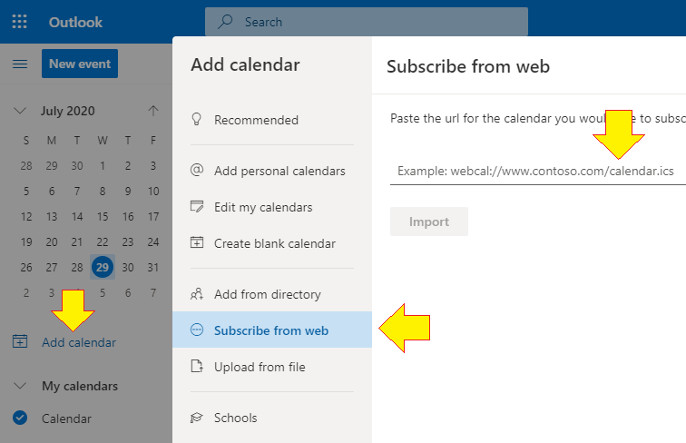
* **outbound OWA**

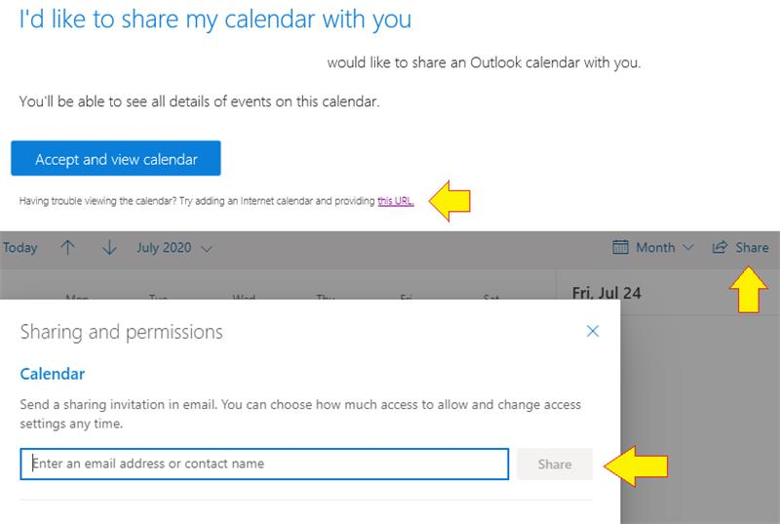

<https://outlook.office.com/calendar/options/calendar/SharedCalendars>

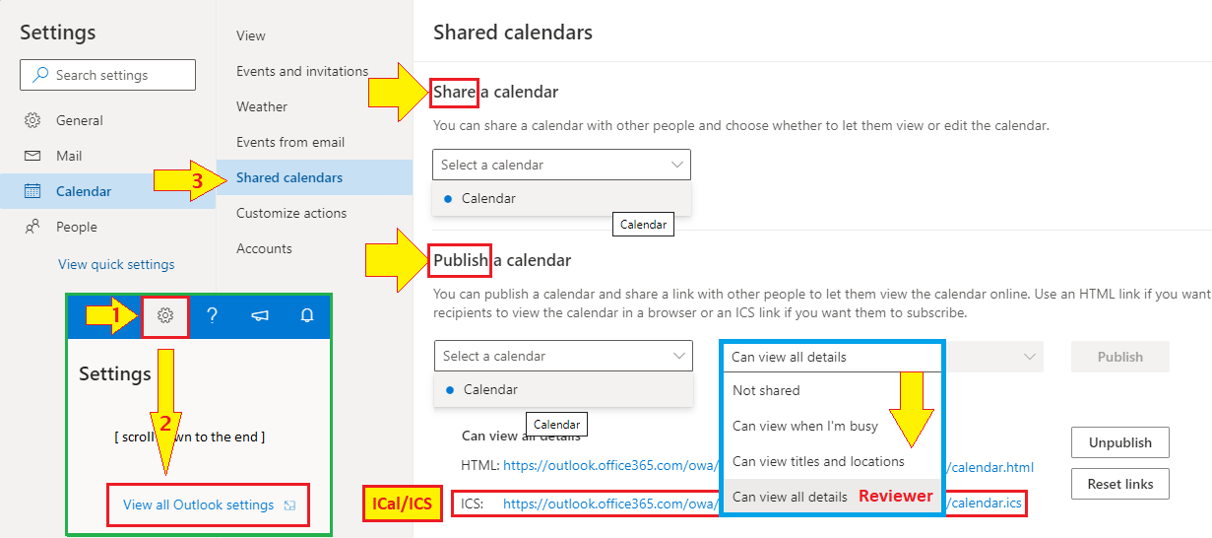

* **Microsoft Flow  
  Sync Office 365 Outlook Calendar with Google Calendar and Excel (Business)**

[**https://us.flow.microsoft.com/en-us/galleries/public/templates/7cf04fa1ca524da88c16d4099be8fd65/sync-office-365-outlook-calendar-with-google-calendar-and-excel-business/**](https://us.flow.microsoft.com/en-us/galleries/public/templates/7cf04fa1ca524da88c16d4099be8fd65/sync-office-365-outlook-calendar-with-google-calendar-and-excel-business/)

* enable ICal Invitations

<https://docs.microsoft.com/en-us/archive/blogs/timmcmic/office365-pop-and-imap-clients-receive-owa-links-for-calendar-invitations>