**Officially supported migration solutions:**  
<https://docs.microsoft.com/en-us/exchange/mailbox-migration/migrate-mailboxes-across-tenants>

[Office 365 email migration performance and best practices](https://docs.microsoft.com/en-us/exchange/mailbox-migration/office-365-migration-best-practices#office-365-throttling)  
  
**IMAP-migration** *\*only for your information*  
 **\*\*Disclaimer**: *not officially supported*  
  
**Background:** known **Limitations** for IMAP-migration:

* **2 years emails max.**
* **all mails go to the main folders: (inbox, sent , draft etc)** *(Mailboxes lose folder structure)*
* **no calendar**
* **no contacts**
* if you re-run failed batch manually, it ***might*** not give duplicates *\*not guaranteed*  
  - however, we **do not support IMAP migration and cannot guarantee it would succeed**
* **Log** into the **target tenant:**
* **Admin center > Setup > Other Mail Sources  
  UPDATE:** [**https://admin.microsoft.com/AdminPortal/Home#/EmailMigration/Source**](https://admin.microsoft.com/AdminPortal/Home#/EmailMigration/Source)

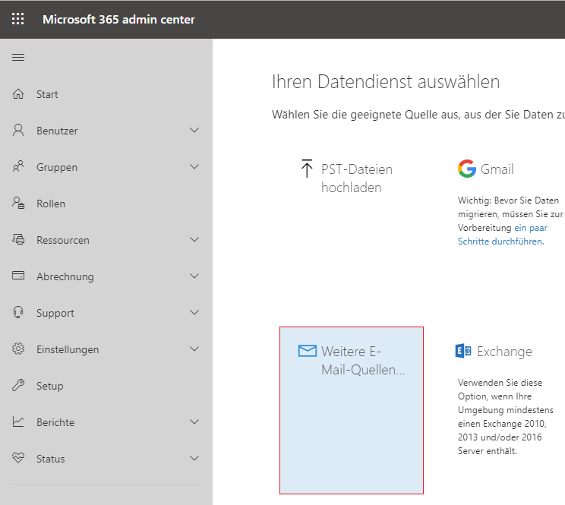

Initiate the **Migration** **endpoint**

IMAP-Servername: **outlook.office365.com**

Port: **993**

Protocol: **SSL**

Put any **email@source-domain.com**

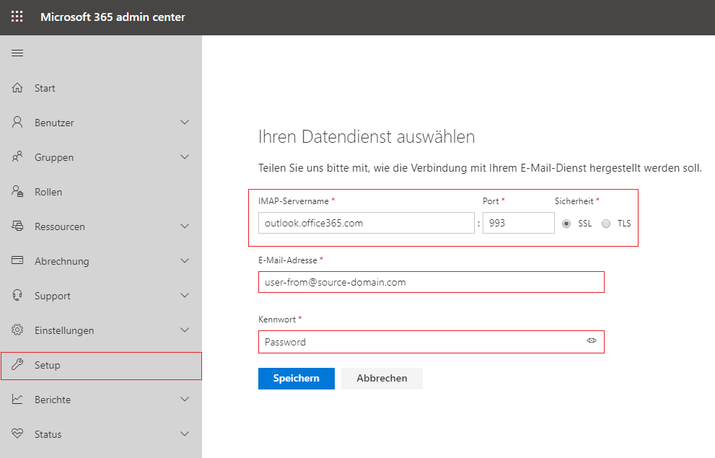

Select **target mailbox** on the left + source **username** + **password** on the correct **source-domain.com**

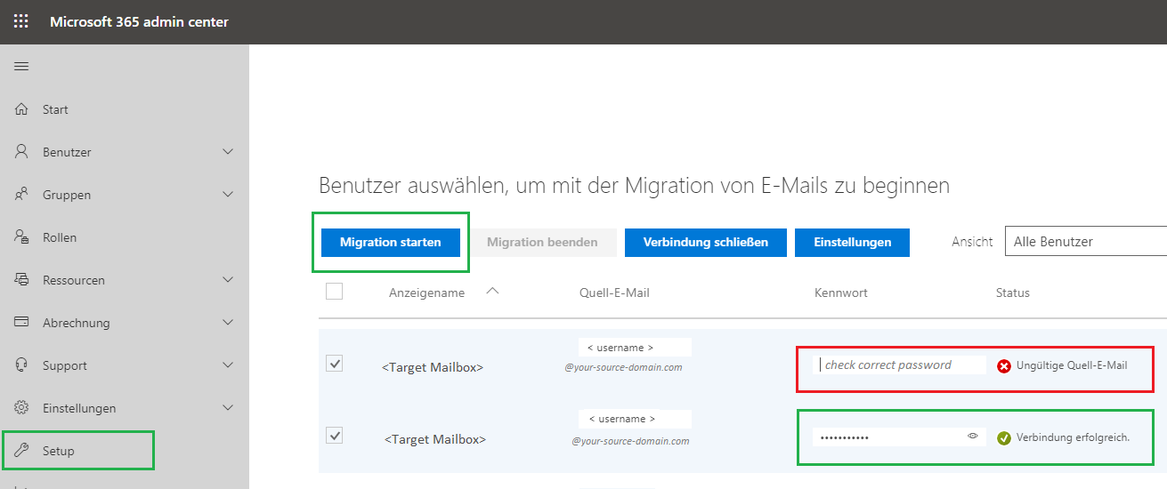

You can track the migration status in **Exchange Admin center > recipients > migration**

<https://outlook.office365.com/ecp/>

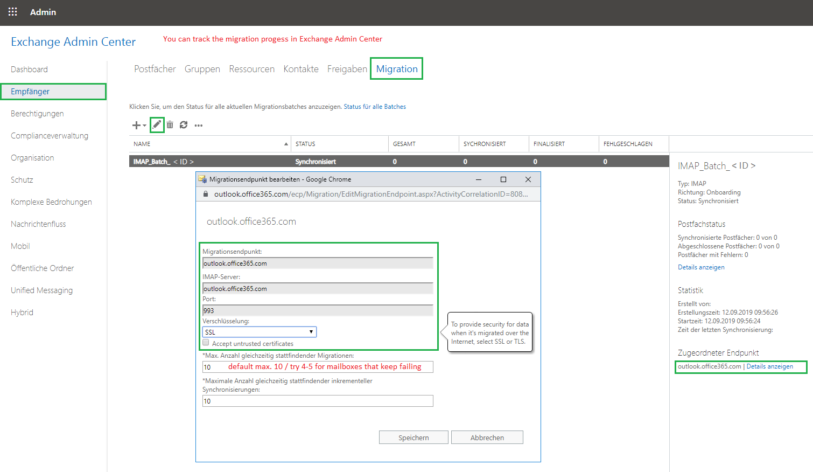

* For failing mailboxes the max concurrent connections is 10 [(source)](https://docs.microsoft.com/en-us/exchange/mailbox-migration/office-365-migration-best-practices#office-365-throttling)
* [**Tips for optimizing IMAP migrations**](https://docs.microsoft.com/en-us/exchange/mailbox-migration/migrating-imap-mailboxes/optimizing-imap-migrations)

**Officially supported migration solutions:**  
<https://docs.microsoft.com/en-us/exchange/mailbox-migration/migrate-mailboxes-across-tenants>

[Office 365 email migration performance and best practices](https://docs.microsoft.com/en-us/exchange/mailbox-migration/office-365-migration-best-practices#office-365-throttling)  
  
**IMAP-migration** *\*only for your information*  
**Disclaimer**: not officially supported  
  
**Background:** known **Limitations** for IMAP-migration:

* **2 years emails max. or 500.000 items**
* **all mails go to the main folders: (inbox, sent , draft etc)** *(Mailboxes lose folder structure)*
* **no calendar**
* **no contacts**

**Common sources:  
  
Germany:  
  
imap.ionos.de  
imap.strato.de 993**