How to connect with Powershell (Exchange/MSOL)

Download 64 Bit Version [PowerShell-6.2.2-win-x64.msi](https://github.com/PowerShell/PowerShell/releases/download/v6.2.2/PowerShell-6.2.2-win-x64.msi)  
  
iex "& { $(irm https://aka.ms/install-powershell.ps1) } -UseMSI"  
 **Get**-Host | Select-Object **Version**

* 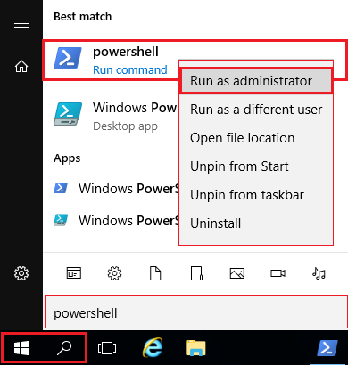[*Official Documentation: Connect to Powershell*](https://docs.microsoft.com/en-us/powershell/exchange/exchange-online/connect-to-exchange-online-powershell/connect-to-exchange-online-powershell)  
    
  *Below not official – provided “as is”*
* All-in-One
* First time only
* Step by step

All-in-One

|  |  |  |
| --- | --- | --- |
|  |  |  |
|  | Set-ExecutionPolicy RemoteSigned –Force |  |
|  |  |  |
|  | Get-Credential "*YOUR_ADMIN@DOMAIN.COM*" | Export-Clixml $ENV:UserProfile\Documents\MyCredential.xml |  |
|  | *\*Stores encrypted password under* ***%userprofile%\Documents\MyCredential.xml*** |  |

* copy below directly
* Alternative save as .TXT and rename .PS1
* Then type .\log.PS1 to connect to EXO / MSOL

|  |  |  |
| --- | --- | --- |
|  |  |  |
|  | $cred = Import-Clixml $ENV:UserProfile\Documents\MyCredential.xml |  |
|  |  |  |
|  | Connect-MsolService -Credential $cred |  |
|  |  |  |
|  | $Session = New-PSSession -ConfigurationName Microsoft.Exchange -ConnectionUri <https://outlook.office365.com/powershell-liveid/> -Credential $cred -Authentication Basic -AllowRedirection |  |
|  |  |  |
|  | Import-PSSession $Session –DisableNameChecking |  |
|  |  |  |



* Type ”**Powershell**” near Start Menu
* search will open
* **right-click** the appearing Powershell icon
* choose "Run as **Administrator**"
* It should look like this

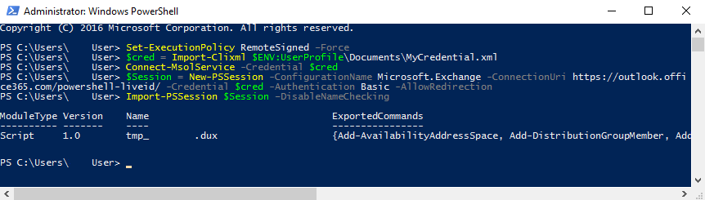

*If not successful, make sure that you are logged in with:*

* Admin
* correct password
* MFA disabled
* outdated Powershell Version *see above
* First time only

Powershell Download 64 Bit [PowerShell-6.2.2-win-x64.msi](https://github.com/PowerShell/PowerShell/releases/download/v6.2.2/PowerShell-6.2.2-win-x64.msi)

Check the installed Powershell version:

**Get**-Host | Select-Object **Version**iex "& { $(irm https://aka.ms/install-powershell.ps1) } -UseMSI"

Below is not supported, only provided “as is” for your convenience

[Official Documentation to connect to Powershell for reference](https://docs.microsoft.com/en-us/powershell/exchange/exchange-online/connect-to-exchange-online-powershell/connect-to-exchange-online-powershell)

* *Allow signed scripts – the* **-Force** *parameter will skip Y/N confirmation*

### **Alternative**: Allow ***unsigned*** scripts with: *Set-ExecutionPolicy* **Bypass** *–Force*

|  |  |  |
| --- | --- | --- |
|  |  |  |
|  | Set-ExecutionPolicy RemoteSigned –Force |  |
|  |  |  |

#### modify below to your **ADMIN login** ##########################

#### only enter your credentials once and stored encrypted #####

#### located under **%userprofile%\Documents\MyCredential.xml** ####

|  |  |  |
| --- | --- | --- |
|  |  |  |
|  | Get-Credential "*YOUR_ADMIN@DOMAIN.COM*" | Export-Clixml $ENV:UserProfile\Documents\MyCredential.xml |  |
|  |  |  |

* Step by step

**you can save the below in a TXT file and change it to log.PS1**

**then put the File in current dir and run as .\log.PS1**

* read out credentials from **%userprofile%\Documents\MyCredential.xml**

|  |  |  |
| --- | --- | --- |
|  |  |  |
|  | $cred = Import-Clixml $ENV:UserProfile\Documents\MyCredential.xml |  |
|  |  |  |

connect to Microsoft Online (user creation, tenant settings …)

|  |  |  |
| --- | --- | --- |
|  |  |  |
|  | Connect-MsolService -Credential $cred |  |
|  |  |  |

If above is not successful, install MSOL Module

|  |  |  |
| --- | --- | --- |
|  |  |  |
|  | Install-Module MSOnline -Force |  |
|  |  |  |

* Connect to Exchange

|  |  |  |
| --- | --- | --- |
|  |  |  |
|  | $Session = New-PSSession -ConfigurationName Microsoft.Exchange -ConnectionUri <https://outlook.office365.com/powershell-liveid/> -Credential $cred -Authentication Basic -AllowRedirection |  |
|  |  |  |
|  | Import-PSSession $Session –DisableNameChecking |  |
|  |  |  |

* Alternative to MSOL:  
    
  **AzureAD** *\*sometimes refered to as “MSOL 2.0* **Note: *different commands*** *+ only used in specific scripts*

|  |  |  |
| --- | --- | --- |
|  |  |  |
|  | Install-Module AzureAD -Force |  |
|  |  |  |

|  |  |  |
| --- | --- | --- |
|  |  |  |
|  | Connect-AzureAD -Credential $cred |  |
|  |  |  |

* Close the session with

|  |  |  |
| --- | --- | --- |
|  |  |  |
|  | Remove-PSSession $Session |  |
|  |  |  |