CHURN ANALYSIS REPORT
Emerging Markets Analysis
Quantitative Analysis & Qualitative Research Integration

Telco Customer Churn Dataset (IBM)
n = 7,043 customers

Portfolio Project for Product Researcher Role
Cashea Fintech Application By Angel Nerozzi

March 13, 2026

Table of Contents
Executive Summary 1
Key Metrics Overview 1
Data Quality Assessment 1
Data Cleaning Procedures 1
Churn Distribution Analysis 1
Contract Type Analysis 1
Contract Risk Analysis 1
Tenure and Survival Analysis 1
Tenure Group Analysis 1
Charges and Value Perception 1
Correlation Analysis 1
Qualitative Research Findings 1
Emergent Themes 1
Abandonment Timeline 1
Quantitative-Qualitative Triangulation 1
The Cumulative Distrust Model 1
Strategic Recommendations 1
1. Proactive Intervention (Months 3-6) - HIGH PRIORITY 1
2. Radical Transparency - HIGH PRIORITY 1
3. Anticipatory Communication - MEDIUM PRIORITY 1
4. Human Support Accessibility - HIGH PRIORITY 1
5. Commitment Incentives - MEDIUM PRIORITY 1
Limitations and Future Research 1
Recommended Next Steps 1
Conclusion 1

Note: Right-click the Table of Contents and select 'Update Field' to refresh page numbers.

Executive Summary
This comprehensive analysis investigates customer churn patterns in emerging markets by combining quantitative data from the Telco Customer Churn dataset (IBM) with qualitative insights from five in-depth interviews with Venezuelan merchants. The triangulation methodology reveals that churn in emerging markets is fundamentally different from developed markets: it is driven not by price or features alone, but by institutional distrust and opacity in processes.
The central finding challenges conventional wisdom: customers who churn actually pay 21.5% more on average than those who stay. This indicates that the problem is one of perceived value, not price sensitivity. The predictive model identifies the critical window for intervention (months 3-6), while qualitative interviews explain the underlying mechanism: an accumulation of opaque incidents that erode the 'pool of good will' until a tipping point is reached.

Key Metrics Overview
Metric | Value
Total Customers Analyzed | 7,043
Overall Churn Rate | 26.5%
Churn in First 12 Months | 47.4%
Monthly Contract Churn Rate | 42.7%
Two-Year Contract Churn Rate | 2.8%
Churners Monthly Charges | $74.44 (+21.5%)

Data Quality Assessment
The Telco Customer Churn dataset from IBM contains 7,043 customer records with 21 variables capturing demographic information, service subscriptions, contract details, and billing information. Data quality assessment revealed several issues that required preprocessing before analysis.

Data Cleaning Procedures
- TotalCharges Conversion: 11 records contained blank values converted to numeric format, representing new customers with tenure = 0
- Missing Value Imputation: TotalCharges calculated as MonthlyCharges × tenure for records with zero tenure
- Feature Engineering: Created tenure_group categorical variable with four bins (0-12m, 12-24m, 24-48m, 48m+)
- No duplicate customer IDs detected; all records represent unique customers

Churn Distribution Analysis
The overall churn rate of 26.5% represents a significant business challenge, with 1,869 customers abandoning the service out of 7,043 total. This rate is notably higher than typical telecommunications industry benchmarks of 15-20%, suggesting systemic issues in customer retention strategies.
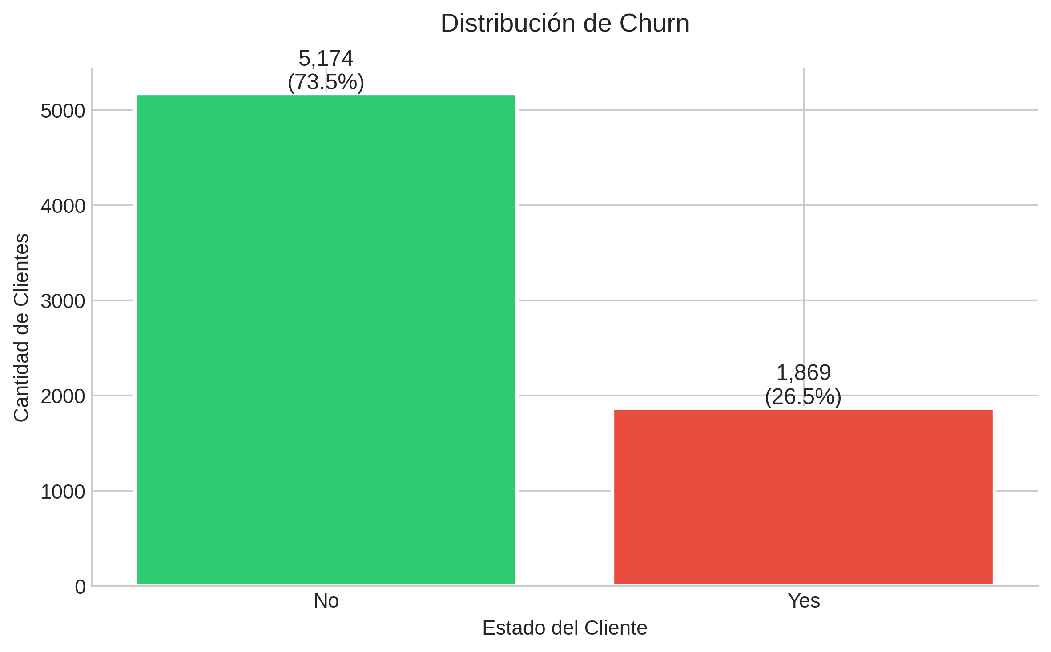
Figure 1: Distribution of Customer Churn Status

Contract Type Analysis
Contract type emerges as the most significant predictor of churn, with month-to-month contracts showing dramatically higher abandonment rates. The analysis reveals a 15-fold difference in churn risk between monthly and two-year contracts, indicating that commitment mechanisms play a crucial role in customer retention.
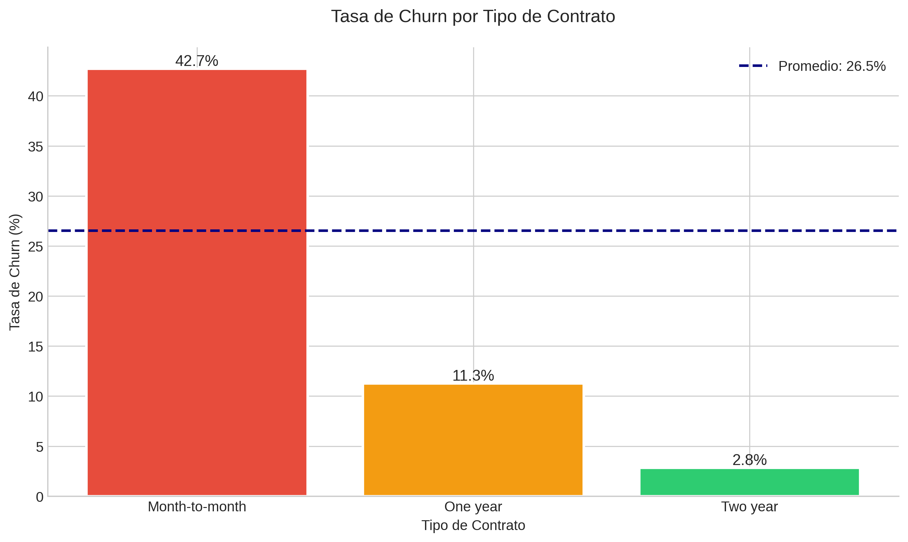
Figure 2: Churn Rate by Contract Type

Contract Risk Analysis
Contract Type | Churn Rate | Customers | Relative Risk
Month-to-month | 42.7% | 3,875 | 15.3x
One year | 11.3% | 1,473 | 4.0x
Two year | 2.8% | 1,695 | 1.0x (baseline)

Tenure and Survival Analysis
The tenure analysis reveals a critical insight: nearly half (47.4%) of customers in their first year abandon the service. This finding is particularly significant for product design, as it identifies a clear window for proactive intervention. The Kaplan-Meier survival analysis indicates that the median survival time for month-to-month contracts is approximately 10 months, after which more than half of these customers have churned.
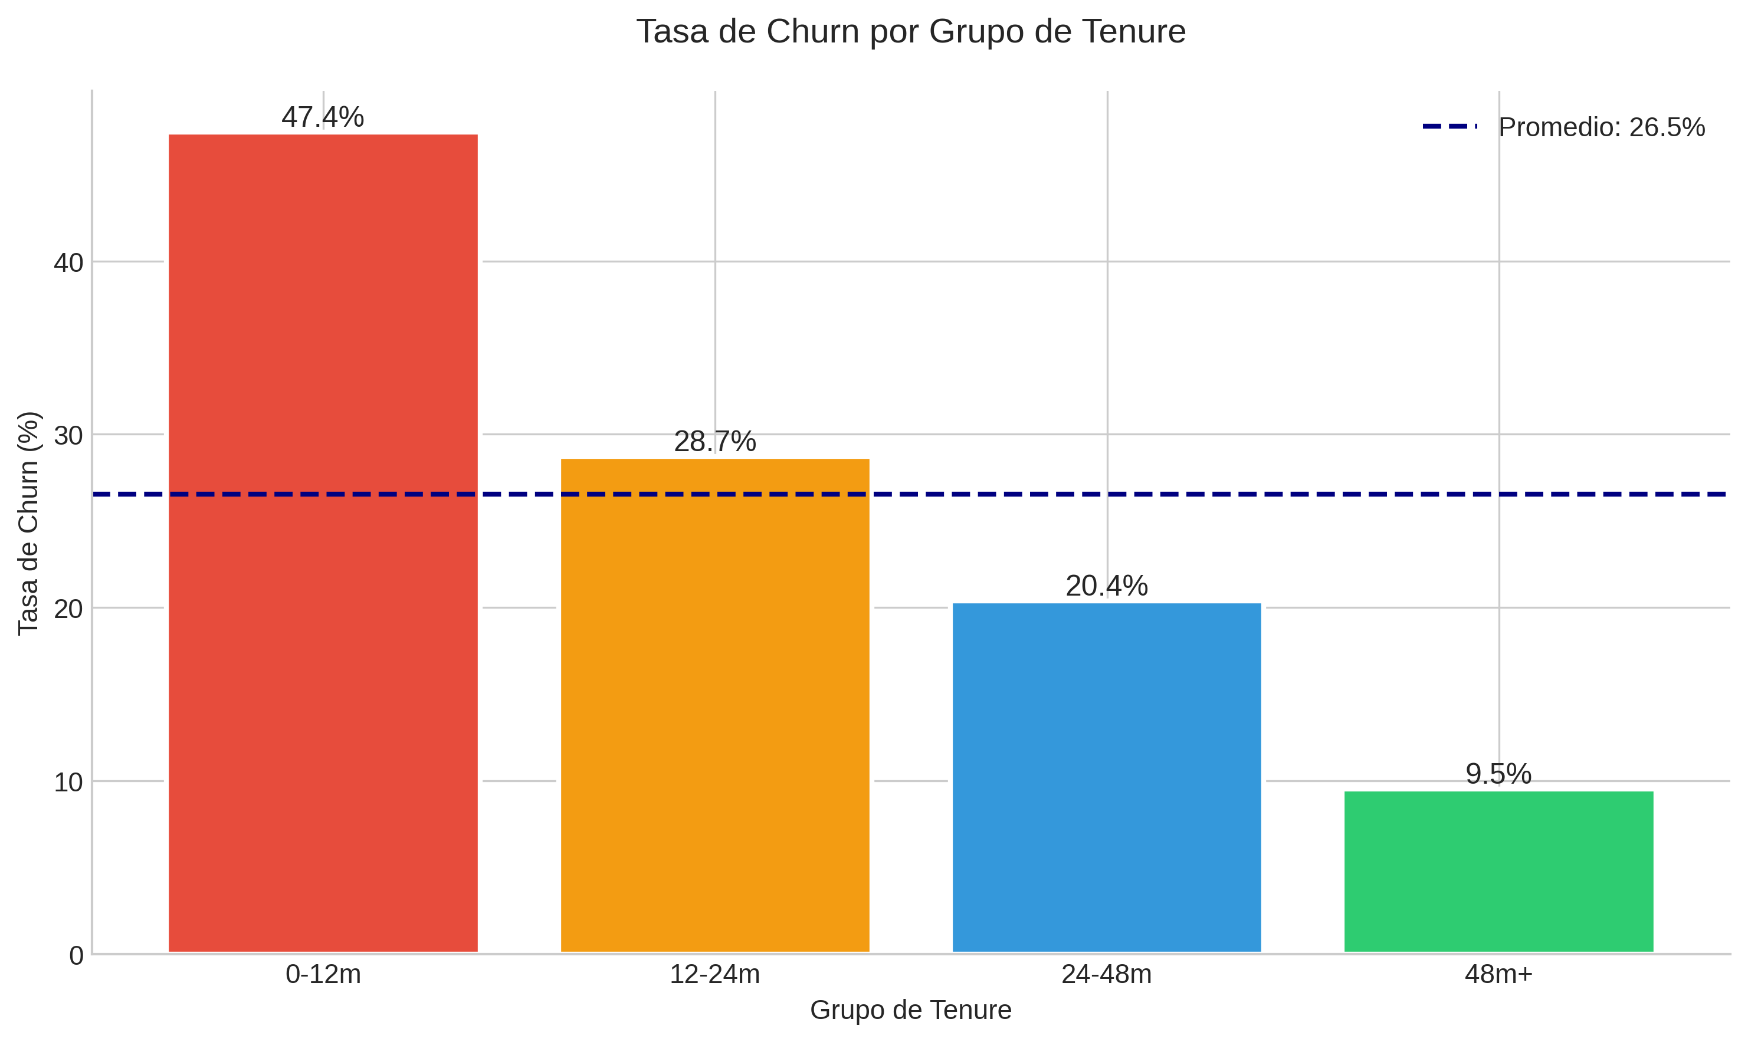
Figure 3: Churn Rate by Tenure Group

Tenure Group Analysis
Tenure Group | Churn Rate | Customers | Risk Level
0-12 months | 47.4% | 2,186 | CRITICAL
12-24 months | 28.7% | 1,024 | HIGH
24-48 months | 20.4% | 1,482 | MODERATE
48+ months | 9.5% | 2,351 | LOW

Charges and Value Perception
One of the most counterintuitive findings of this analysis is that customers who churn actually pay more on average than those who stay. Churners have an average monthly charge of $74.44 compared to $61.27 for non-churners—a difference of 21.5%. This directly contradicts the assumption that price sensitivity drives churn and suggests instead that the problem is one of perceived value.
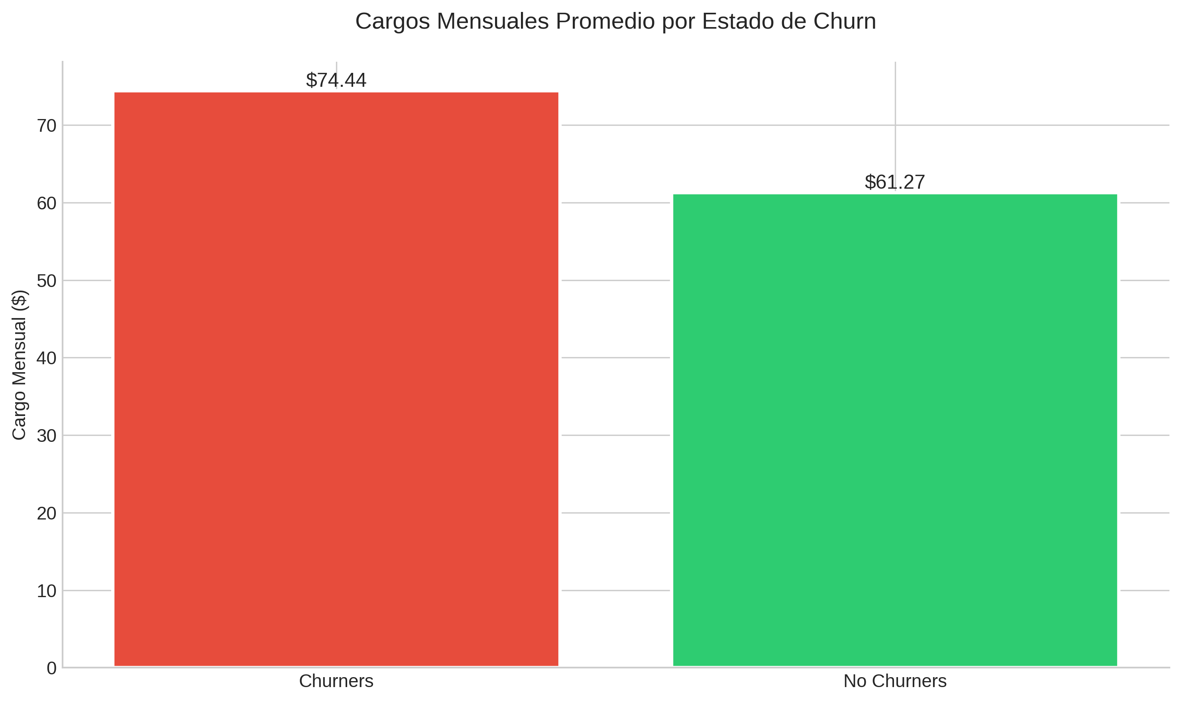
Figure 4: Monthly Charges Comparison by Churn Status
This finding has profound implications for retention strategy. Rather than focusing on discounts or price reductions, interventions should emphasize value communication, transparency in billing, and demonstrating ROI of the service. Customers paying premium prices have higher expectations for service quality and transparency—when these expectations are not met, they are more likely to churn.

Correlation Analysis
The correlation matrix reveals several important relationships. Tenure shows the strongest negative correlation with churn (-0.35), confirming that longer-tenured customers are significantly less likely to leave. Monthly charges show a positive correlation with churn (0.19), aligning with the finding that higher-paying customers are more churn-prone. Senior citizens show a slight positive correlation with churn, suggesting this demographic may require targeted retention strategies.
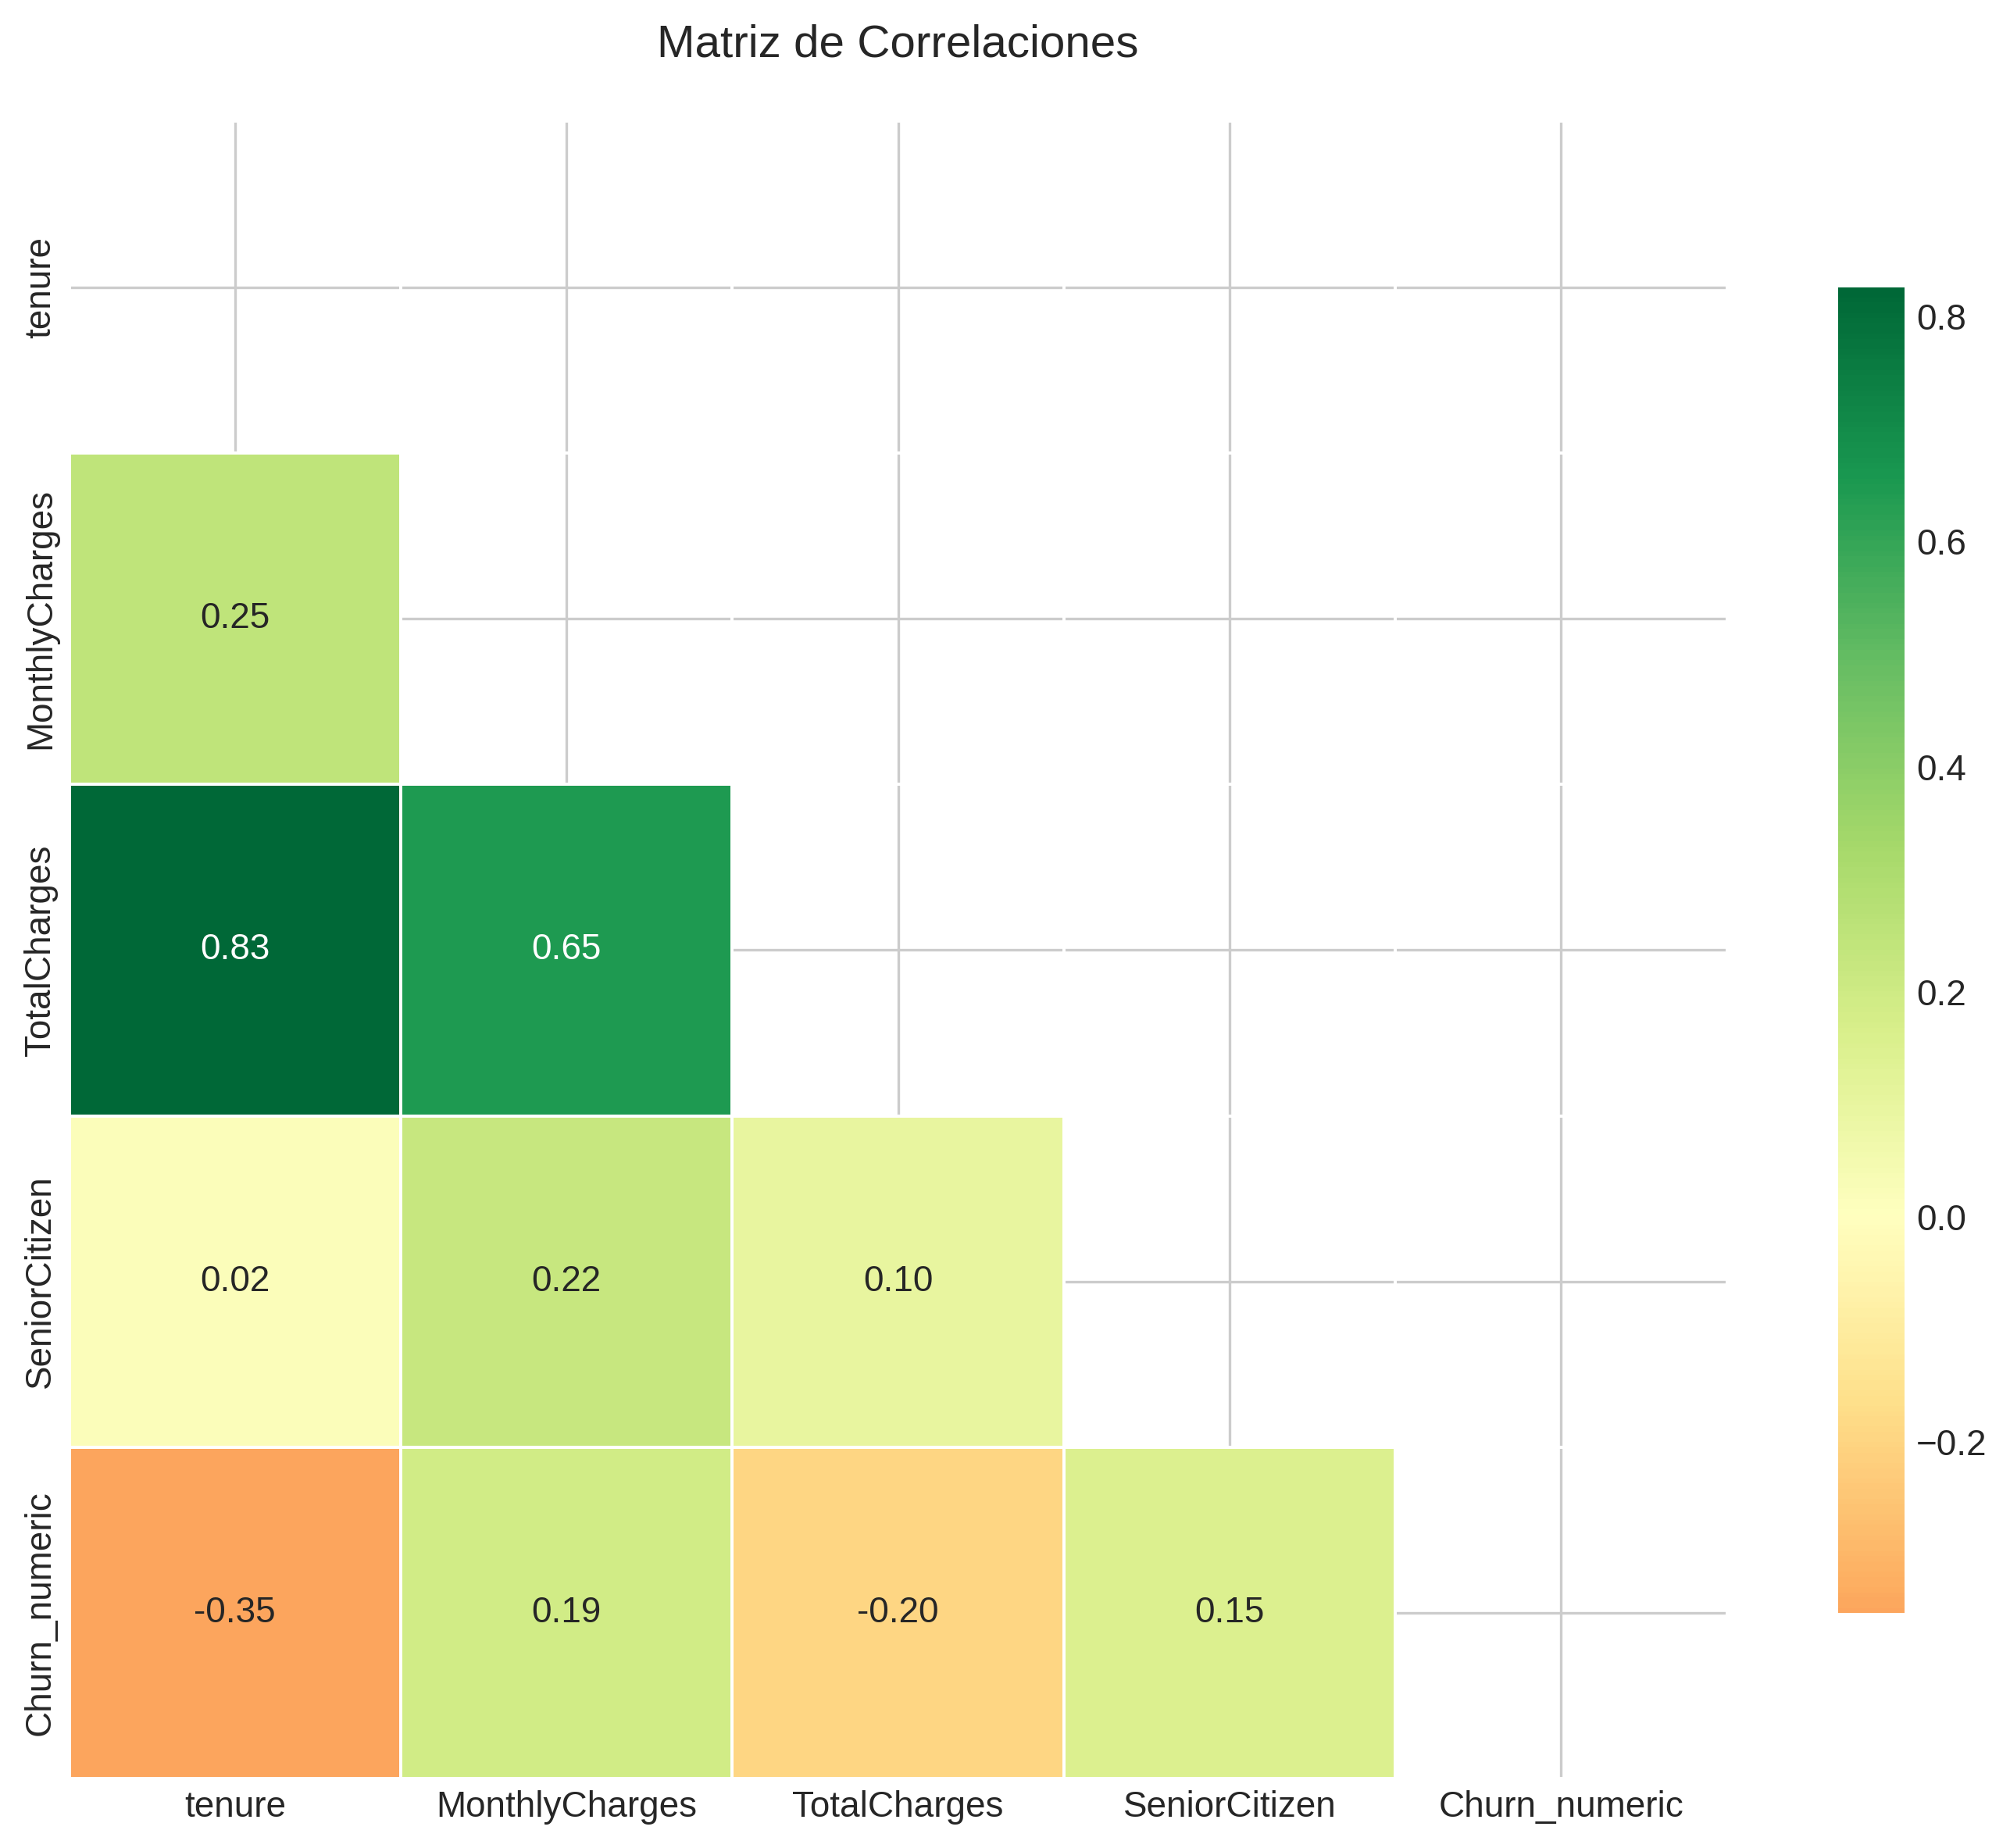
Figure 5: Correlation Heatmap of Key Variables

Qualitative Research Findings
Five semi-structured interviews were conducted with Venezuelan merchants who had abandoned digital tools. Each interview lasted 30-45 minutes and explored the complete journey from adoption to abandonment, focusing on the emotional and rational factors influencing the decision to leave.

Emergent Themes
Analysis of the interview transcripts revealed five dominant themes that consistently appeared across all participants:
- Opacity in Processes (5/5 participants): All interviewees described situations where they did not understand what was happening with their accounts, transactions, or issues. The lack of visibility into processes created anxiety and eroded trust.
- Non-Proactive Communication (4/5 participants): Most participants reported learning about problems from customers or through their own investigation, rather than from the company. This reactive communication style was perceived as neglectful.
- Unannounced Changes (3/5 participants): Changes to interfaces, pricing, or terms without adequate notice caused significant friction. One participant described feeling 'blind-sided' when a new interface removed familiar functionality.
- Insufficient Support (4/5 participants): When problems arose, participants struggled to get meaningful help. Generic responses and the absence of human support channels were frequently mentioned as frustrating.
- Promise-Reality Gap (4/5 participants): The gap between what was promised during acquisition and what was delivered created disappointment. This discrepancy was particularly damaging when combined with opaque processes.

Abandonment Timeline
The qualitative data reveals that 60% of interviewees abandoned the digital tool within the first six months. This aligns closely with the quantitative finding that 47.4% of customers churn within their first year. The median time to abandonment was 6 months, with a range from 4 to 14 months. Each participant described a 'tipping point' incident that triggered the final decision, but all noted that this incident was the culmination of multiple smaller frustrations.

Quantitative-Qualitative Triangulation
The triangulation of quantitative and qualitative findings produces a coherent narrative that explains not just when customers leave, but why they leave. The model identifies the critical timing (months 3-6 for intervention), while the interviews reveal the underlying mechanism (accumulation of opaque incidents eroding trust).
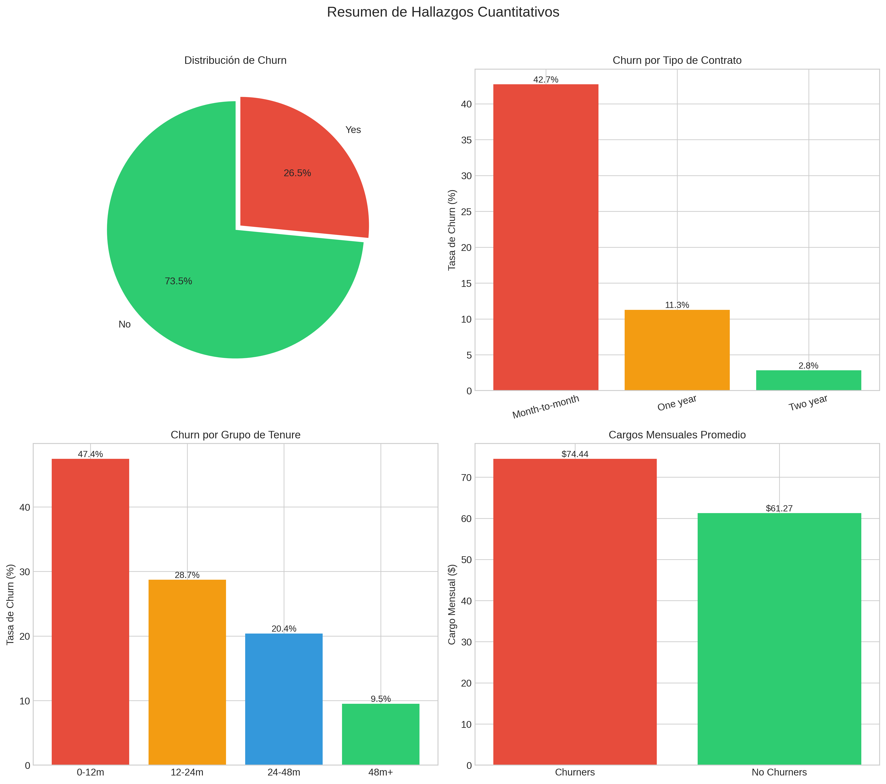
Figure 6: Summary of Quantitative Findings

The Cumulative Distrust Model
Based on the triangulated findings, we propose a Cumulative Distrust Model to explain churn in emerging markets. In contexts of high institutional distrust, customers approach new services with an already-reduced 'pool of good will.' Each incident that is handled opaquely—whether a billing issue, a service outage, or an unexplained change—draws from this pool. The pool depletes incrementally until a final 'tipping point' incident triggers abandonment.
This model has four key characteristics: (1) It is non-linear—the decision appears sudden but builds gradually; (2) It is emotional—feelings of being 'deceived' matter more than economic losses; (3) It is reversible until the tipping point—intervention before the final incident can preserve the relationship; and (4) It is cultural—the initial pool of good will is smaller in high-distrust markets.

Strategic Recommendations
Based on the triangulated analysis, we propose five strategic recommendations prioritized by impact and feasibility:

1. Proactive Intervention (Months 3-6) - HIGH PRIORITY
Implement automated check-ins at months 2, 4, and 6 to detect friction points early. These touchpoints should not be sales-driven but focused on problem detection and resolution. Expected impact: 15-25% reduction in early-stage churn.

2. Radical Transparency - HIGH PRIORITY
Deploy real-time status dashboards showing customers exactly where their requests, transactions, and issues stand. Complete transaction history should be accessible at all times. Expected impact: Increased customer confidence and LTV.

3. Anticipatory Communication - MEDIUM PRIORITY
Establish proactive notification systems for any changes to terms, pricing, or interfaces. Minimum 30-day notice with clear explanations should be standard. Expected impact: Reduced 'surprise' incidents that trigger distrust.

4. Human Support Accessibility - HIGH PRIORITY
Create a direct channel to human support for critical issues. The absence of human contact was cited by 4/5 interviewees as a major frustration. Expected impact: Resolution of issues before tipping point is reached.

5. Commitment Incentives - MEDIUM PRIORITY
Develop clear benefits for annual commitment with transparent terms. The 15x difference in churn risk between monthly and annual contracts suggests commitment mechanisms are highly effective. Expected impact: Conversion of high-risk monthly customers to stable annual relationships.

Limitations and Future Research
This analysis has several important limitations that should be considered when interpreting findings:
- Synthetic Dataset: The Telco Churn dataset is an academic sample, not real fintech data. Patterns may differ in actual financial services contexts.
- Small Qualitative Sample: Five interviews provide exploratory insights but are not statistically representative. Findings should be validated with larger samples.
- Specific Context: Venezuela has unique characteristics of institutional distrust. Generalization to other emerging markets requires validation.
- Memory Bias: Interviews relied on participant recall of past events, which may be subject to selective or biased remembering.
- Absence of Behavioral Validation: Insights have not been validated with actual behavior data from Cashea or similar fintech platforms.

Recommended Next Steps
- Quantitative Validation: Collect churn data from Cashea to validate identified patterns in actual fintech context.
- Longitudinal Study: Track new users from onboarding through 12 months to observe the churn journey in real-time.
- A/B Testing: Test proactive communication interventions against control groups to measure impact.
- Trust Measurement: Develop survey instruments to measure the 'pool of good will' construct.

Conclusion
This analysis demonstrates that churn in emerging markets is fundamentally a trust problem, not a price problem. Customers who pay more are more likely to leave—not because they cannot afford the service, but because their expectations for transparency and value delivery are higher. The quantitative model identifies when intervention is most critical (months 3-6), while qualitative research explains why (accumulation of opaque incidents).
For Cashea and similar fintech companies operating in emerging markets, the central lesson is clear: churn prevention requires proactive trust-building, not reactive discounting. The most effective interventions will focus on transparency, communication, and human support—investments that preserve the customer relationship before it reaches the tipping point of abandonment.

