**Practical No. 6**

**Aim**: To implement K Means Clustering Algorithmand use Visualization tab in WEKA to visualize the clusters created

**Prerequisite:**

* Working of K Means Clustering algorithm
* Understanding of fundamental programming constructs in C/C++/Java
* Basic features of WEKA tool

**Outcome:** After successful completion of this experiment students will be able to

* Understand the working of K Means Clustering algorithm through implementation and the various measures used for checking its performance
* Use Cluster tab in WEKA , apply K Means clustering algorithm and analyze the model created.
* Use the Visualization tab in WEKA and visualize the clusters created

**Theory:**

k-means is  one of  the simplest unsupervised  learning  algorithms  that  solve  the well-known clustering problem. The procedure follows a simple and easy way  to classify a given data set  through a certain number of  clusters (assume k clusters) fixed apriori. The main idea  is to define k centers, one for each cluster. These centers should  be placed in a cunning  way  because of  different  location  causes different  result. So, the better  choice  is  to place them  as  much as possible  far away from each other. The  next  step is to take each point belonging  to a  given data set and associate it to the nearest center. When no point  is  pending,  the first step is completed and an early group age  is done. At this point we need to re-calculate k new centroids as barycenter of  the clusters resulting from the previous step. After we have these k new centroids, a new binding has to be done  between  the same data set points  and  the nearest new center. A loop has been generated. As a result of  this loop we  may  notice that the k centers change their location step by step until no more changes  are done or  in  other words centers do not move any more. Finally, this  algorithm  aims at  minimizing  an objective function know as squared error function given by:

[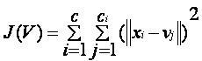](https://sites.google.com/site/dataclusteringalgorithms/k-means-clustering-algorithm/kmeans.JPG?attredirects=0)

where,  
                           *‘||xi- vj||’* is the Euclidean distance between *xi* and *vj.*

                       *‘ci’* is the number of data points in *ith* cluster

*‘c’* is the number of cluster centers.

**Algorithmic steps for k-means clustering**

Let  X = {x1,x2,x3,……..,xn} be the set of data points and V = {v1,v2,…….,vc} be the set of centers.

1) Randomly select *‘c’* cluster centers.

2) Calculate the distance between each data point and cluster centers.

3) Assign the data point to the cluster center whose distance from the cluster center is minimum of all the cluster centers.

4) Recalculate the new cluster center using:

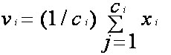

where,*‘ci’* represents the number of data points in *ith* cluster.

5) Recalculate the distance between each data point and new obtained cluster centers.

6) If no data point was reassigned then stop, otherwise repeat from step 3).

**Advantages**

1) Fast, robust and easier to understand.

2) Relatively efficient: O(tknd), where n is # objects, k is # clusters, d is # dimension of each object, and t  is # iterations. Normally, k, t, d << n.

3) Gives best result when data set are distinct or well separated from each other.

[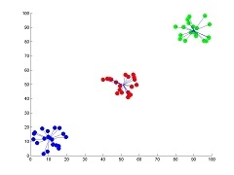](https://sites.google.com/site/dataclusteringalgorithms/k-means-clustering-algorithm/k-means.jpg?attredirects=0)  
**Fig I**: Showing the result of k-means for *'N'* = 60 and *'c'* = 3

**Disadvantages**

1. The learning algorithm requires apriori specification of the number of cluster centers.
2. The use of Exclusive Assignment - If  there are two highly overlapping data then k-means will not be able to resolve       that there are two clusters.
3. The learning algorithm is not invariant to non-linear transformationsi.e.,with different representation of data we get   different results (data represented in form of cartesian co-ordinates and polar co-ordinates will give different results).
4. Euclidean distance measures can unequally weight underlying factors.
5. The learning algorithm provides the local optima of the squared error function.
6. Randomly choosing of the cluster center cannot lead us to the fruitful result. Pl. refer [Fig](https://sites.google.com/site/dataclusteringalgorithms/k-means-clustering-algorithm/k-means_initial_cluster_selection).
7. Applicable only when mean is defined i.e. fails for categorical data.
8. Unable to handle noisy data and outliers*.*
9. Algorithm fails for non-linear data set.

[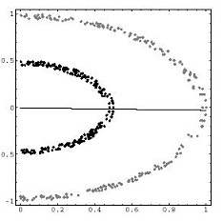](https://sites.google.com/site/dataclusteringalgorithms/k-means-clustering-algorithm/k-means_fail.jpg?attredirects=0)

**Fig II**: Showing the non-linear data set where k-means algorithm fails

**************************

(TO BE COMPLETED BY STUDENTS)

|  |  |
| --- | --- |
| Roll No. | Name: |
| Class: | Batch: |
| Date of Practical: | Date of Submission: |
| Grade: |  |

1. Implement a code to create clusters using K Means Clustering algorithm for the data set indicating the marks scored by 7 students in two subjects A and B. Create 2 clusters.

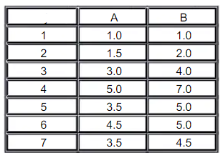

1. Using WEKA Tool – Create a K Means clustering model in WEKA for the Iris data set (iris.arff) and analyze the clusters with the Visualization tab.

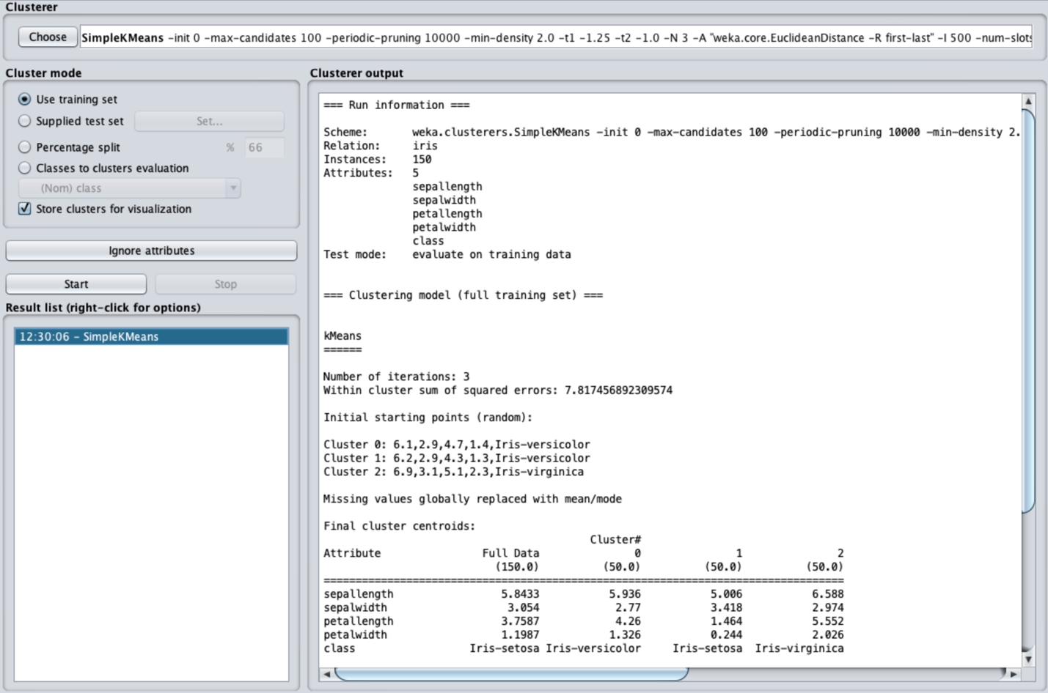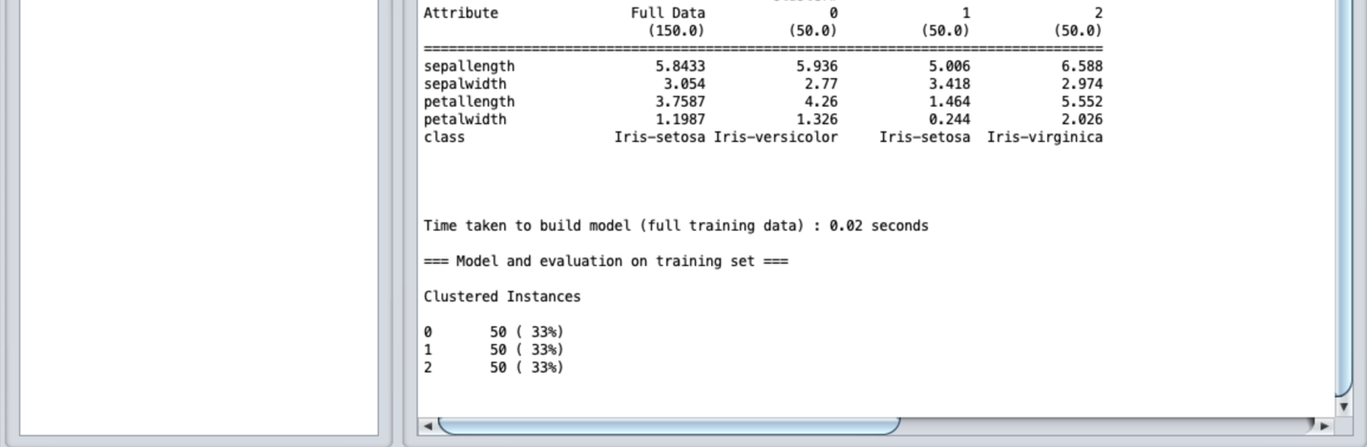

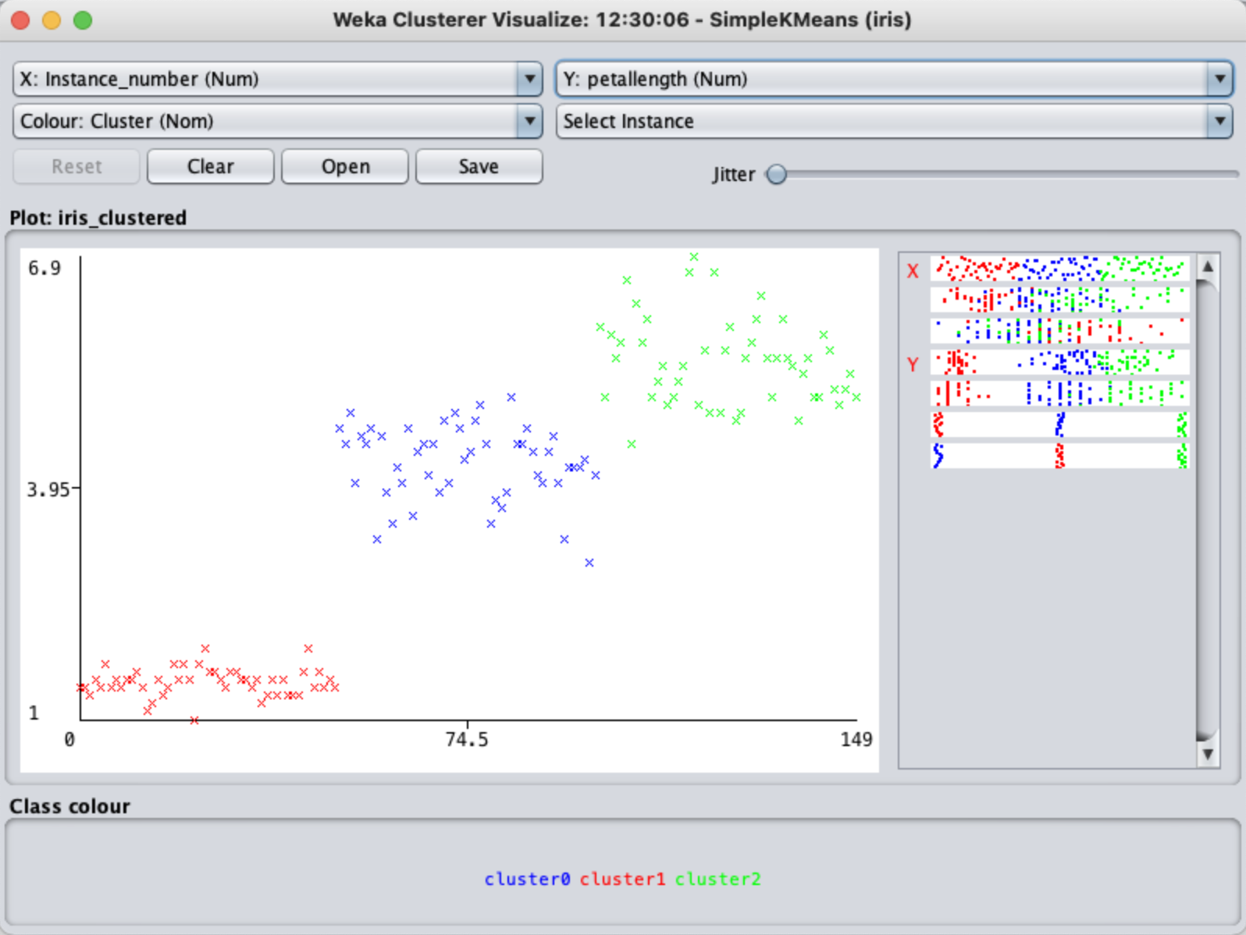

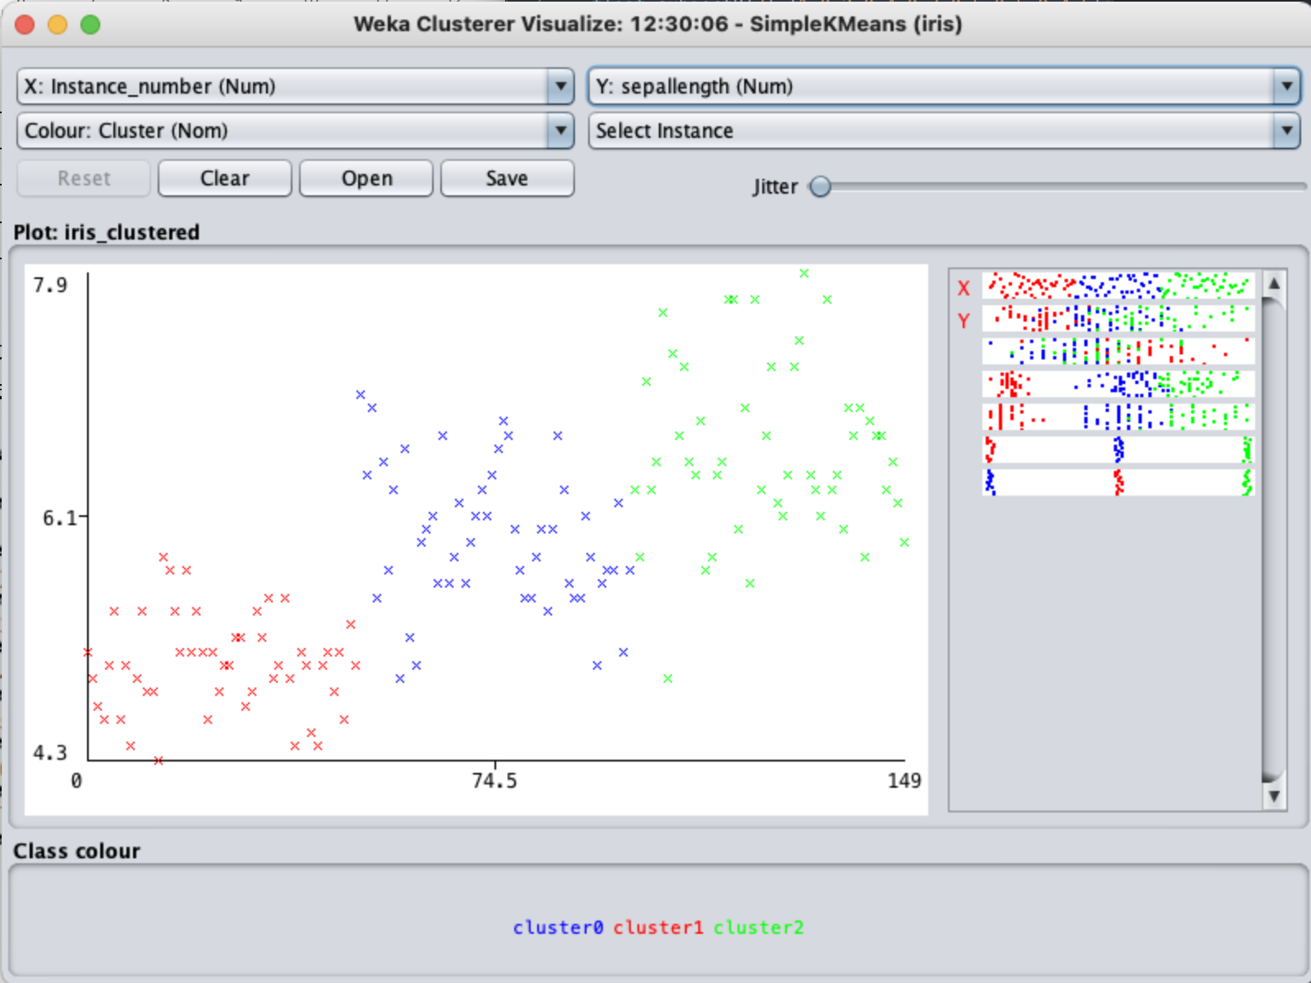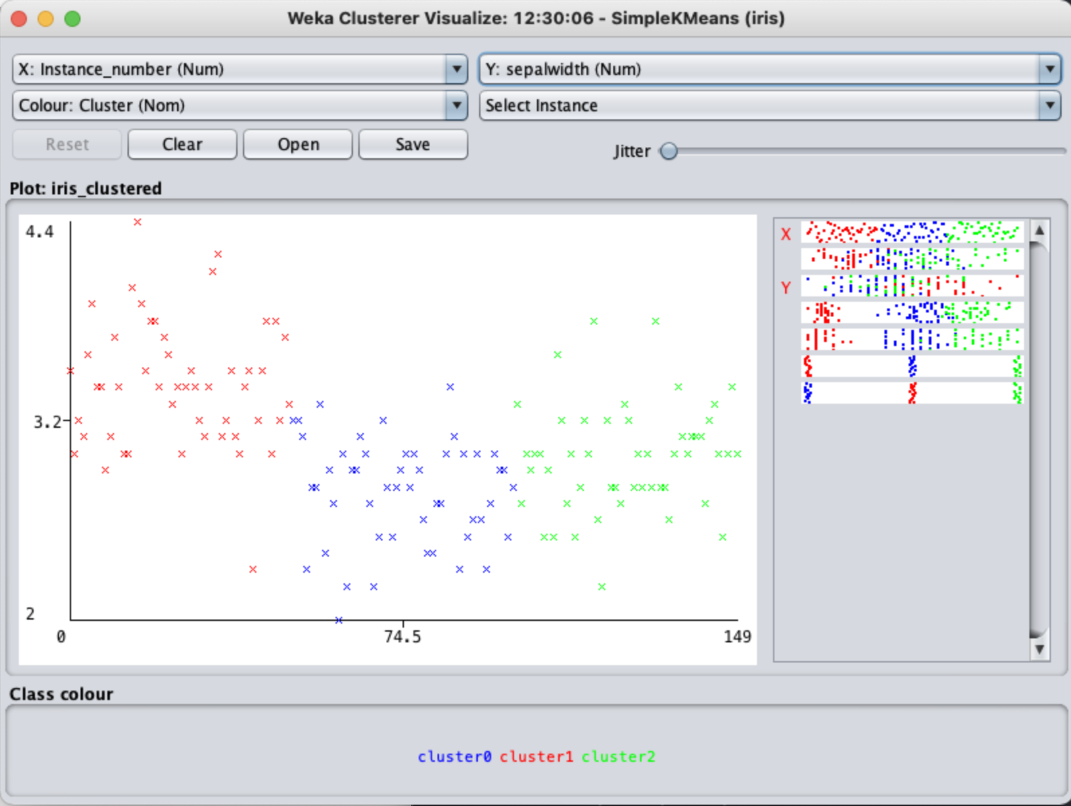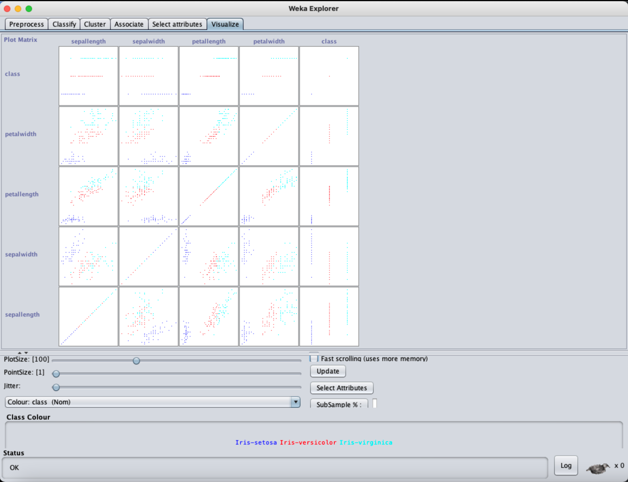

**Questions to be answered:**

1. What is the benefit of using a K Medoid approach than a K Means method of cluster creation?
2. Explain any one method of handling outliers in Clustering.

**\*\*\*\*\*\*\*\*\*\*\*\*\*\*\*\*\*\*\*\*\*\*\*\*\*\*\*\*\*\***