**Practical No. 7**

|  |  |
| --- | --- |
| Roll No.: K041 | Name: Anish Sudhan Nair |
| Class: B.Tech Cybersecurity | Batch: K2 |
| Date of Practical: 05/03/2022 | Date of Submission: 05/03/2022 |
| Grade: |  |

**Aim**: To study Experimenter feature in WEKA tool

**Prerequisite:**

* Understanding of the basic data mining tasks

**Outcome:** After successful completion of this experiment students will be able to

* Understand and use the Experimenter feature in WEKA Tool.

**Theory:**

The Weka Experiment Environment enables the user to create, run, modify, and analyse experiments in a more convenient manner than is possible when processing the schemes individually. For example, the user can create an experiment that runs several schemes against a series of datasets and then analyze the results to determine if one of the schemes is (statistically) better than the other schemes. The Experimenter comes in two flavours, either with a simple interface that provides most of the functionality one needs for experiments, or with an interface with full access to the Experimenter’s capabilities. You can choose between those two with the Experiment Configuration Mode radio buttons:

• Simple

• Advanced

Both setups allow you to setup standard experiments that are run locally on a single machine, or remote experiments, which are distributed between several hosts. The distribution of experiments cuts down the time the experiments will take until completion, but on the other hand the setup takes more time.

**************************

(TO BE COMPLETED BY STUDENTS)

|  |  |
| --- | --- |
| Roll No.: K041 | Name: Anish Sudhan Nair |
| Class: B.Tech Cybersecurity | Batch: K2 |
| Date of Practical: 05/03/2022 | Date of Submission: 05/03/2022 |
| Grade: |  |

Create and run an experiment environment in WEKA tool on the Iris data set. Analyze the results obtained.

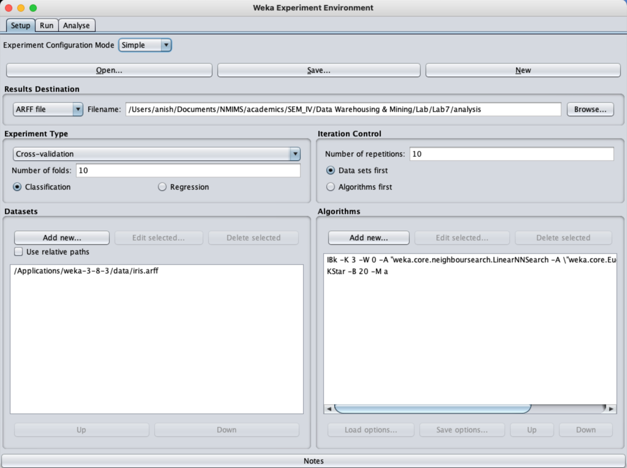

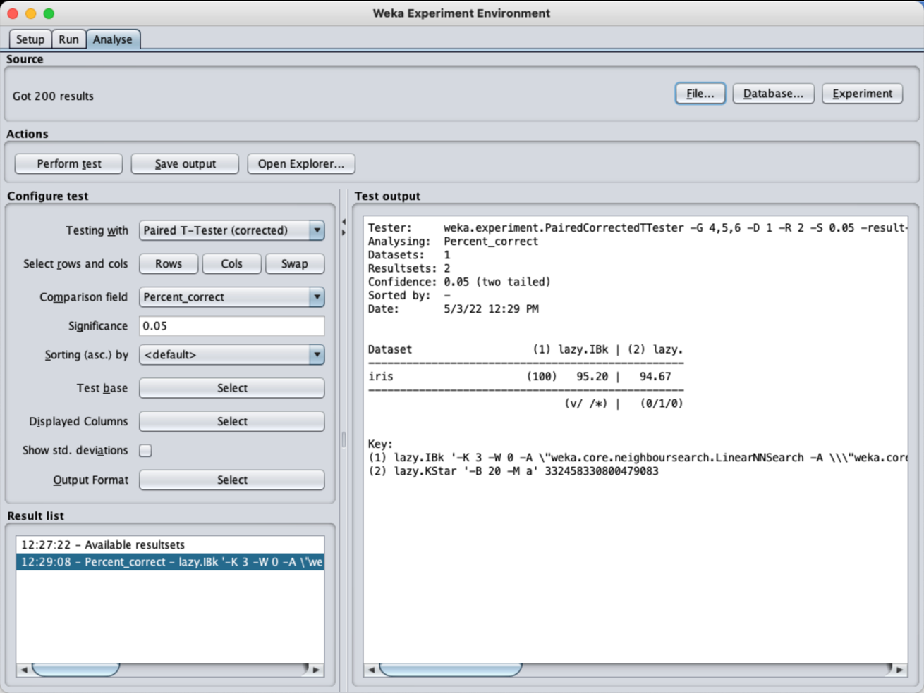

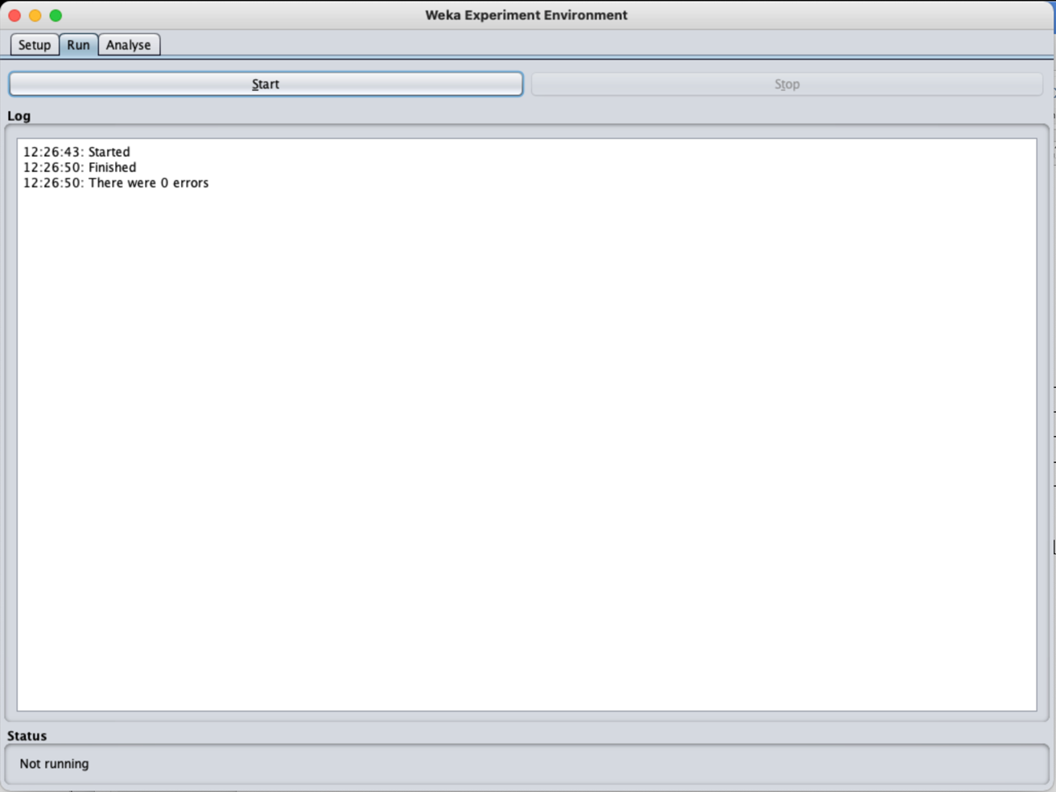

Analysis report created in the desired location



