**OPERATING SYSTEM LAB 1 – WEEK 1**

|  |  |
| --- | --- |
| Roll No.: K041 | Name: Anish Sudhan Nair |
| Batch No.: A2/K2 | Date: 08/12/2021 |

Aim: To be introduced to the MS-DOS Commands on windows command prompt and get familiar with the same.

Commands:

1. cd: To change directory or path



1. cls: To clear the window

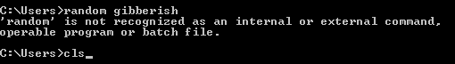

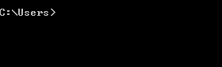

1. dir: To display contents of a directory

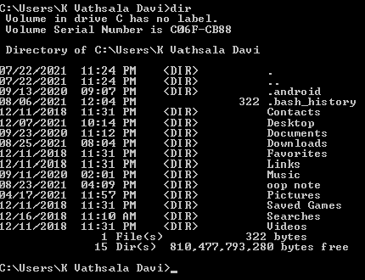

1. help: To display the list of commands

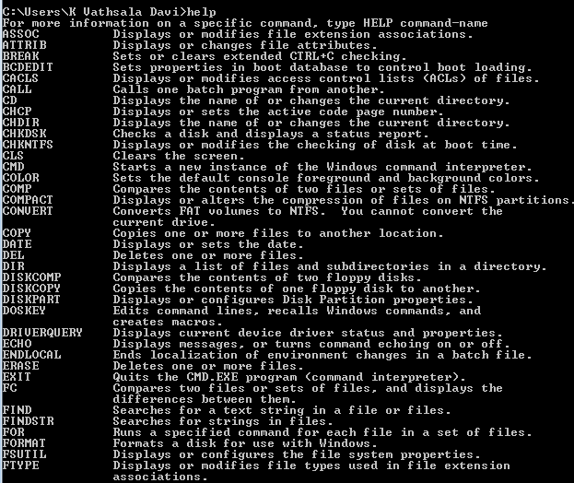

1. notepad: To run the Notepad text editor application

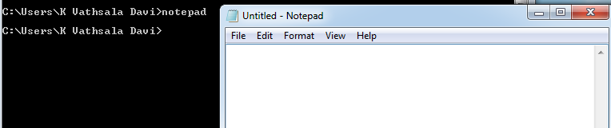

1. type: To display the contents of a text file

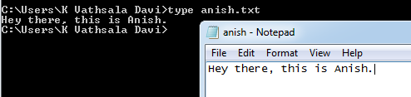

1. ipconfig: To display internet configuration

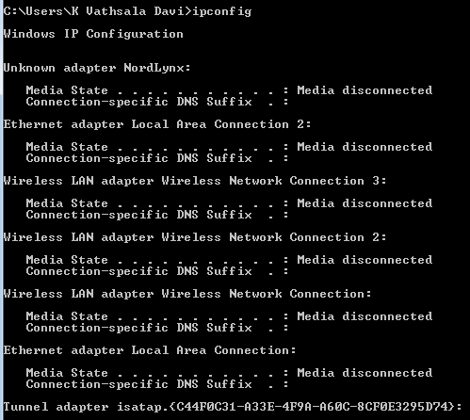

1. netsh: To display the network services shell

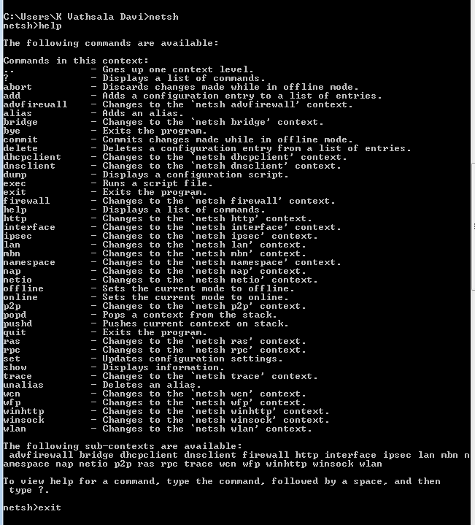

1. netstat: To display current TCP/IP network connections and statistics

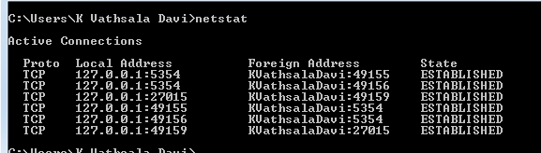

1. nslookup: To lookup IP addresses to/from domain name

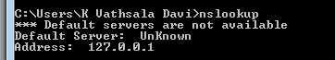

1. tree: To display the directory structure in a graphical manner

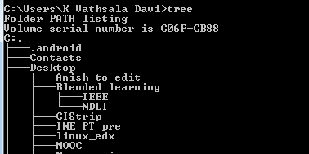

1. time: To display or set the time of the computer

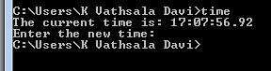

1. date: To display or set the date of the computer



1. mkdir: To create a new directory

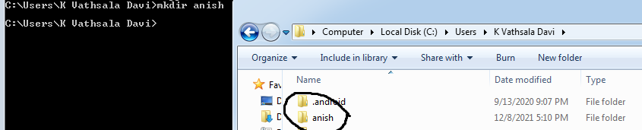

1. rd: To remove an existing directory

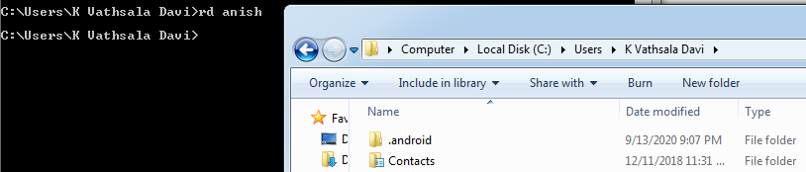

1. ren: To rename a file or files



1. start: To start a new window to run an application

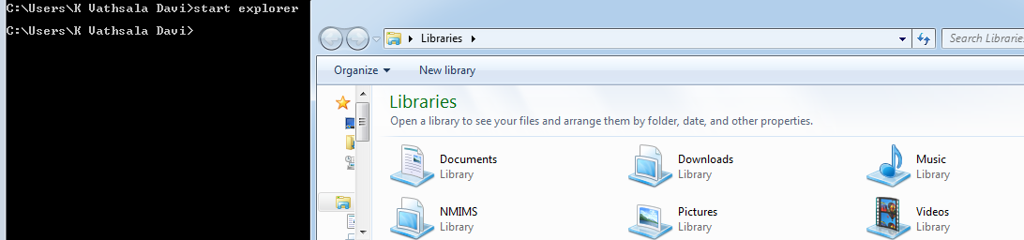

1. doskey: To display history or define macros

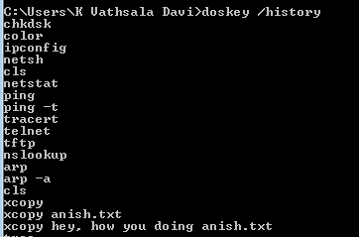

1. arp: To display ARP translation tables



1. del: To delete a file or files



CONCLUSION:

In this lab, we were introduced to the MS-DOs Commands and this is helpful in navigating the windows file structure through the terminal and only using a keyboard.