**OPERATING SYSTEM LAB 4a**

|  |  |
| --- | --- |
| Roll No.: K041 | Name: Anish Sudhan Nair |
| Batch No.: A2/K2 | Date: 10/01/2021 |

Aim: To familiarise and implement the shortest job first scheduling algorithm.

1. Example 1

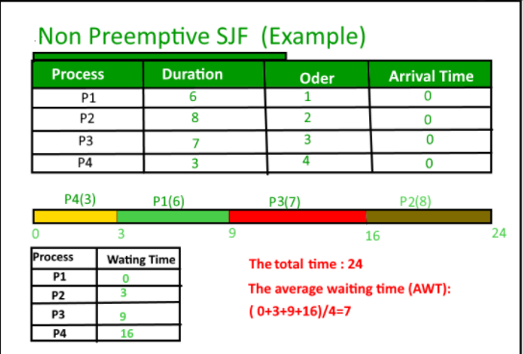

Output:

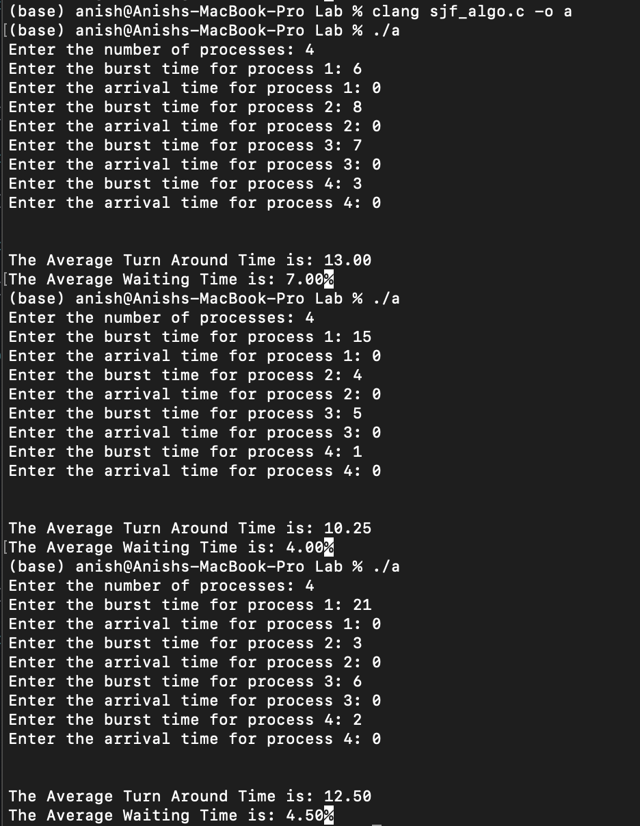

1. Example 2

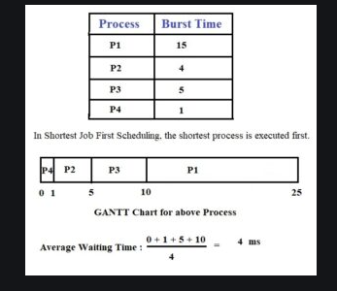

Output:



1. Example 3

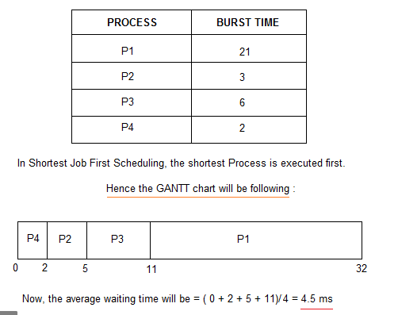

Output:



CODE:

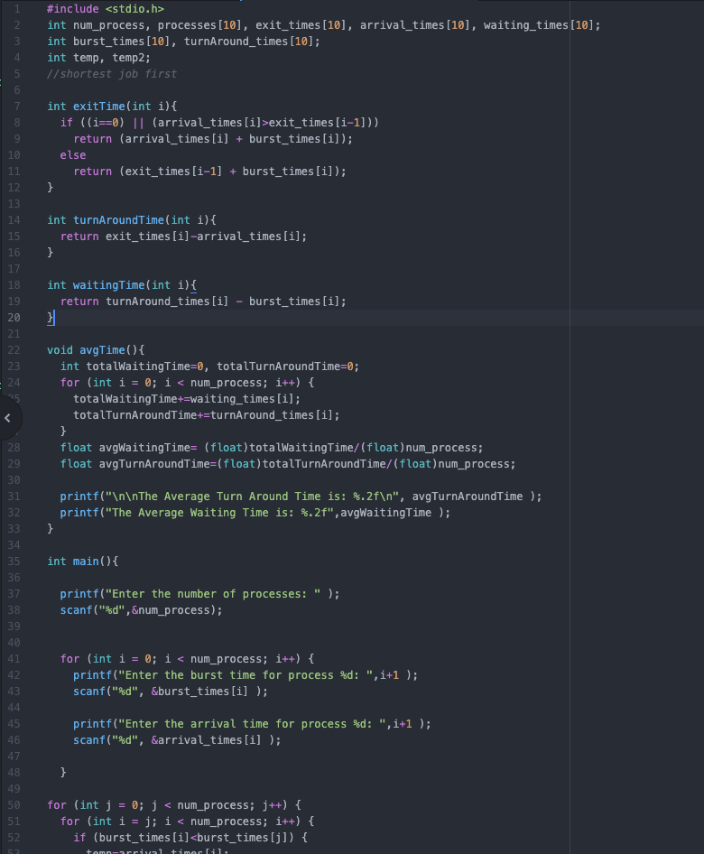

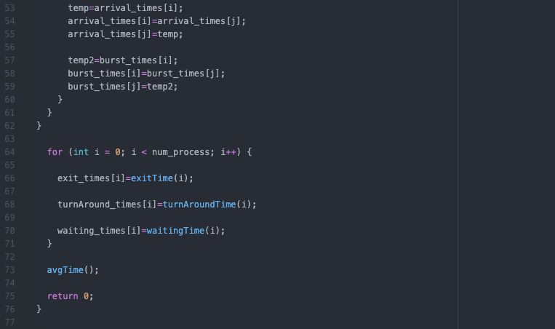

CONCLUSION:

In this lab, we were to implement and demonstrate the working of the shortest job first algorithm. By actually coding the algorithm, it helped to reinforce the working of this process and the manner in which it schedules the processes in a CPU.