**OPERATING SYSTEM LAB 4b**

|  |  |
| --- | --- |
| Roll No.: K041 | Name: Anish Sudhan Nair |
| Batch No.: A2/K2 | Date: 17/01/2021 |

Aim: To familiarise and implement the priority scheduling algorithm.

1. Example 1

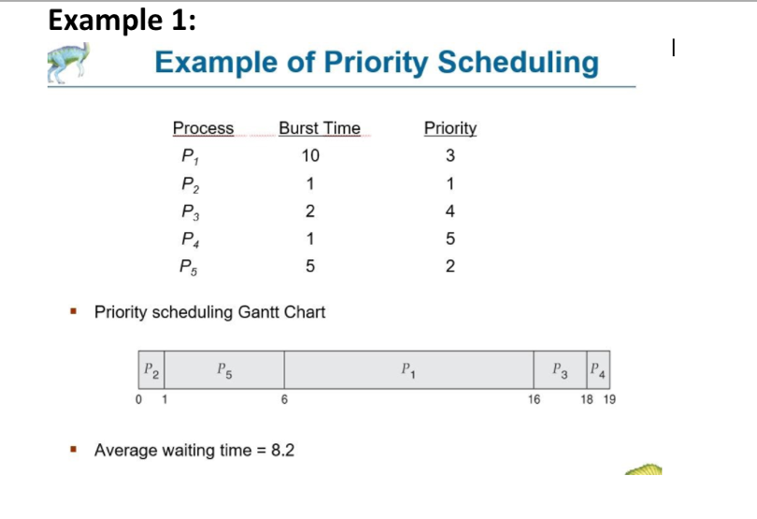

Output:

Pre-emptive

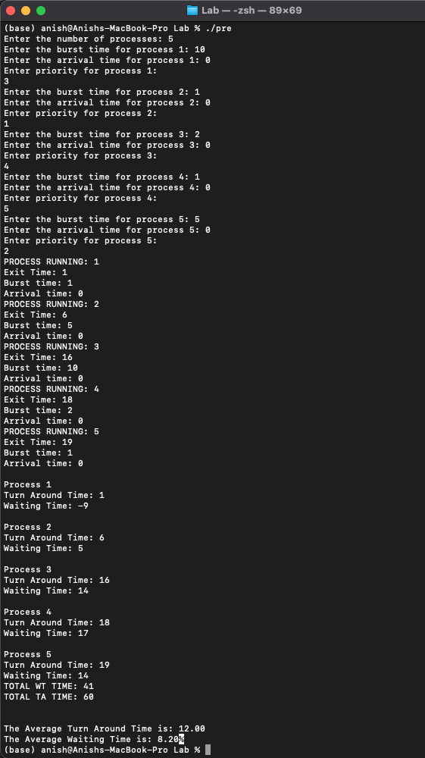



Non Pre-emptive

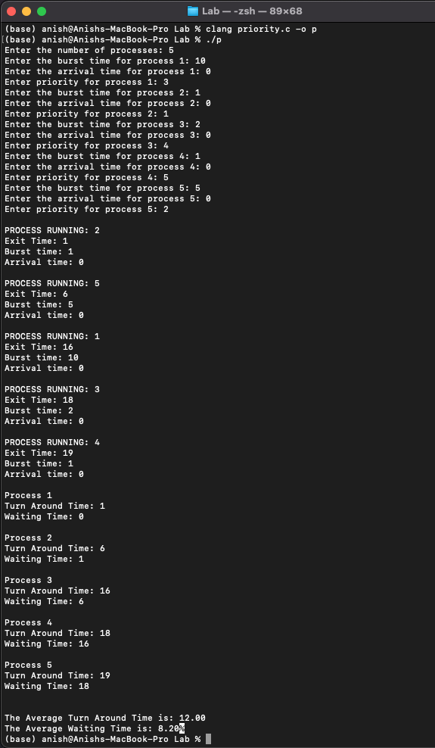

1. Example 2

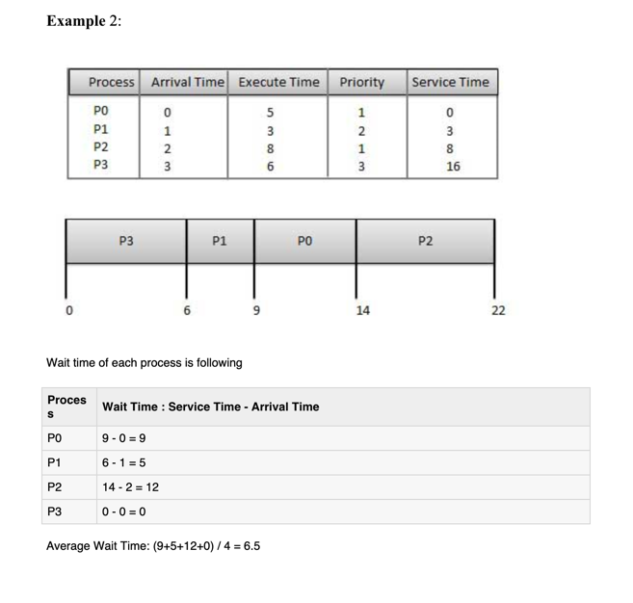

Formula Taught:

Turnaround Time: Exit Time(prev) + Arrival Time

Waiting Time: Turnaround Time – Burst Time

Output:

Pre-emptive

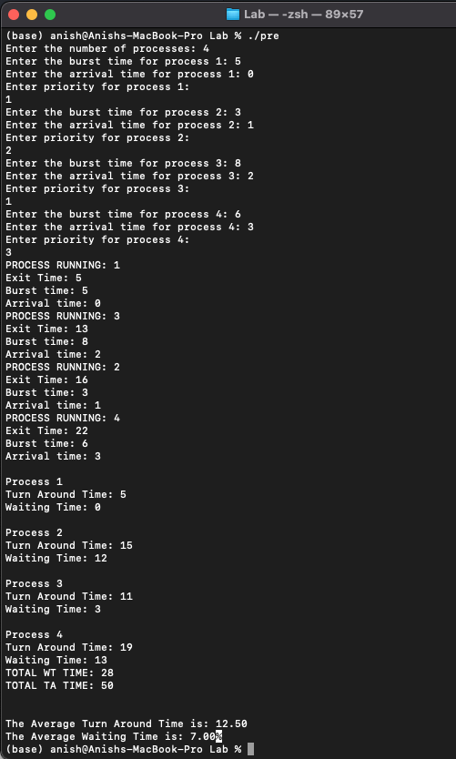

Non Pre-emptive

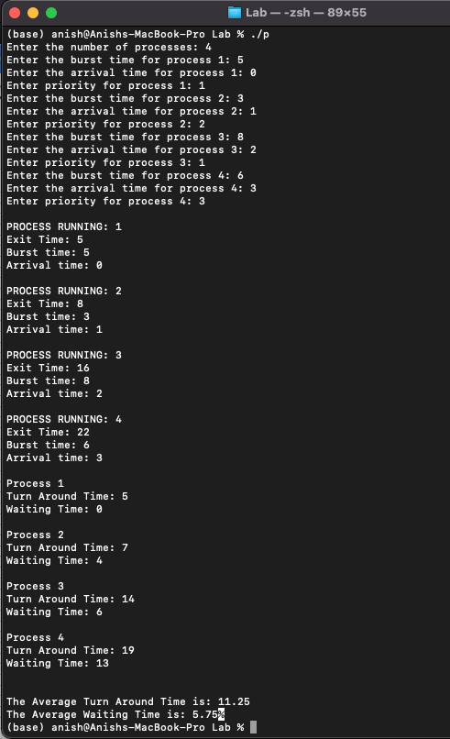

CODE:

Pre-emptive

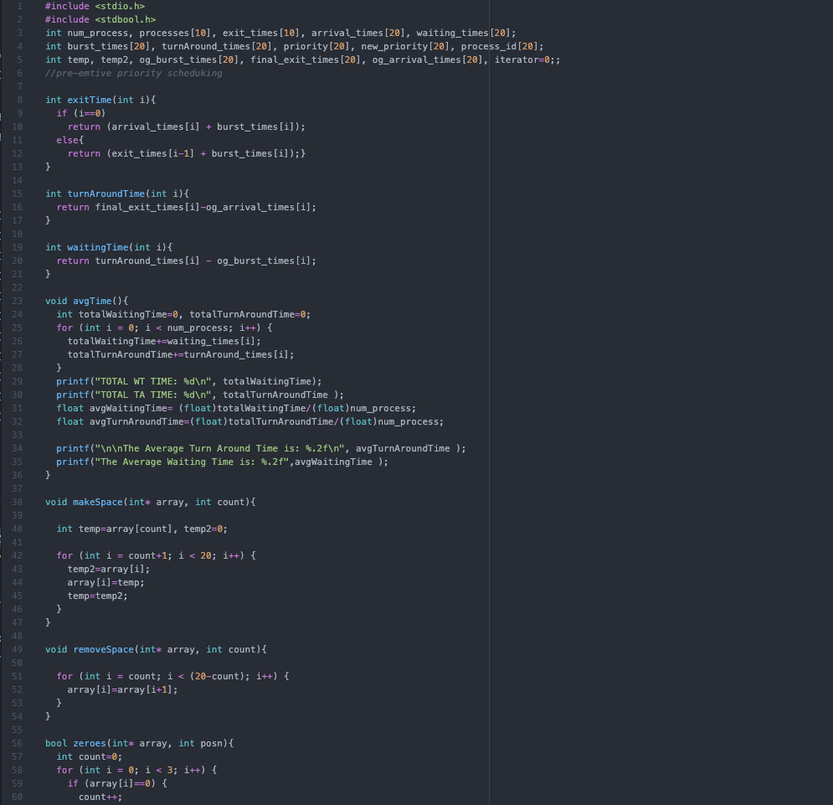

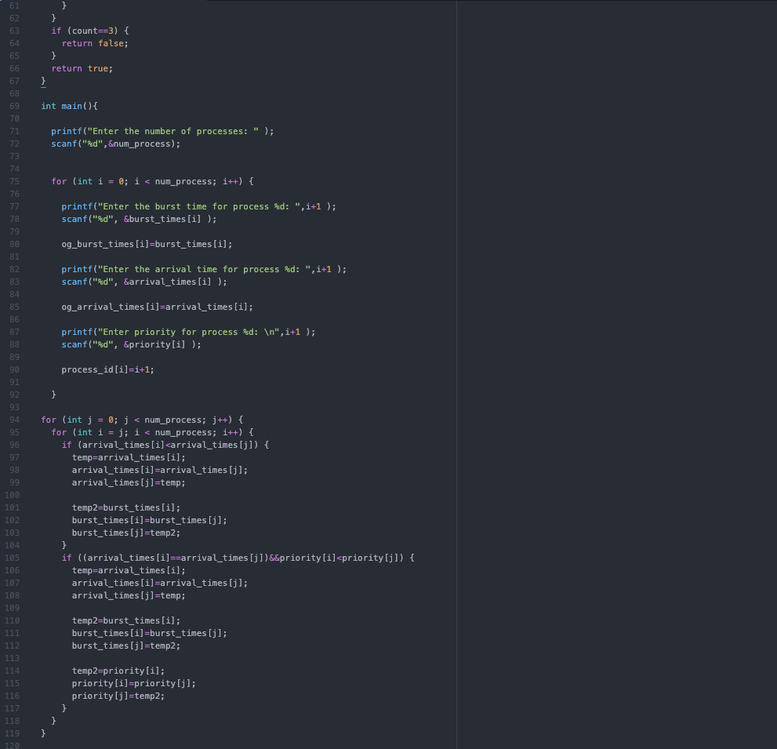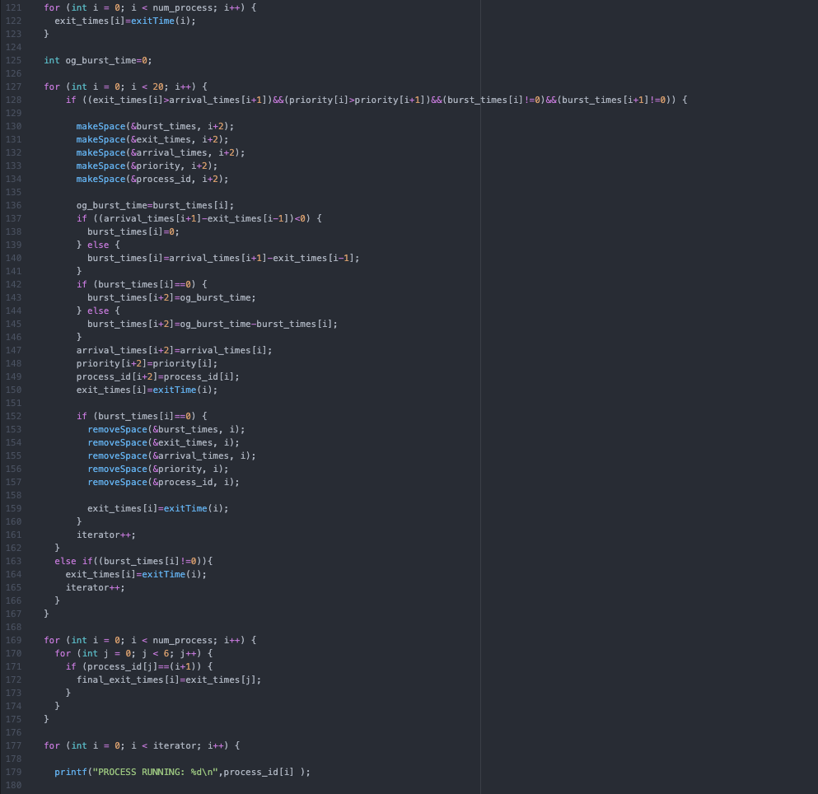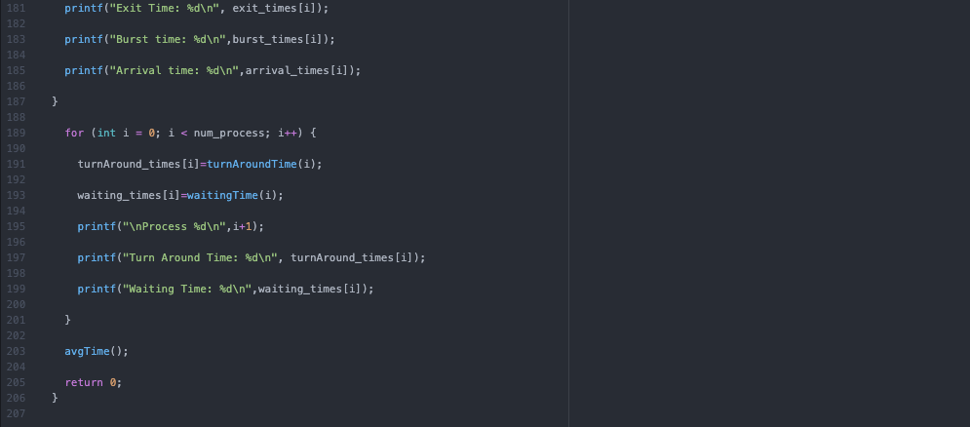

Non Pre-emptive

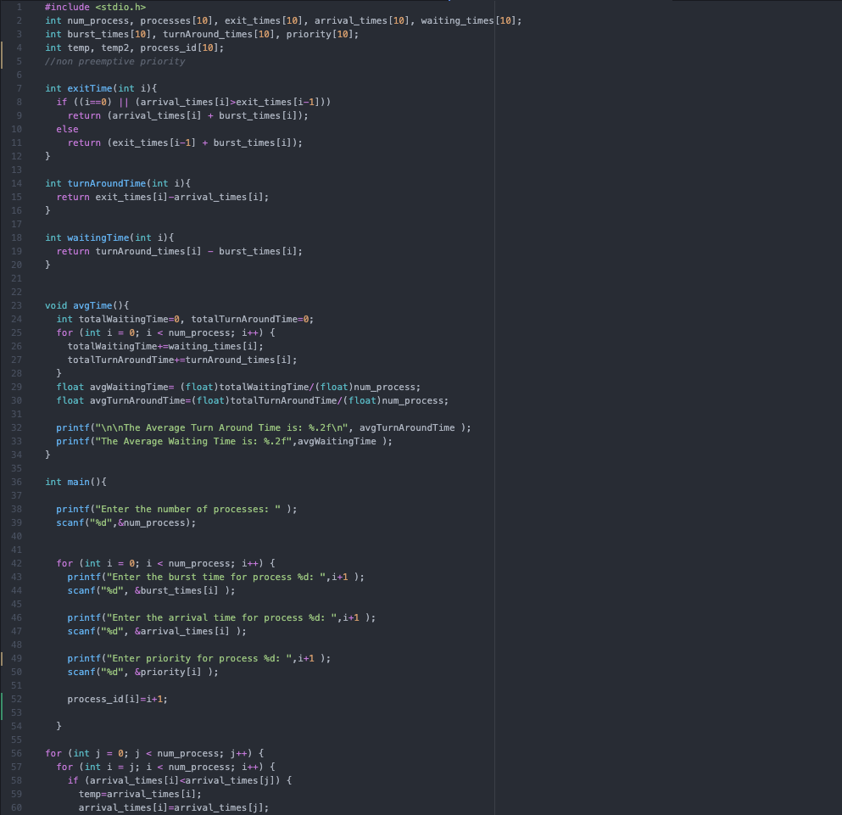

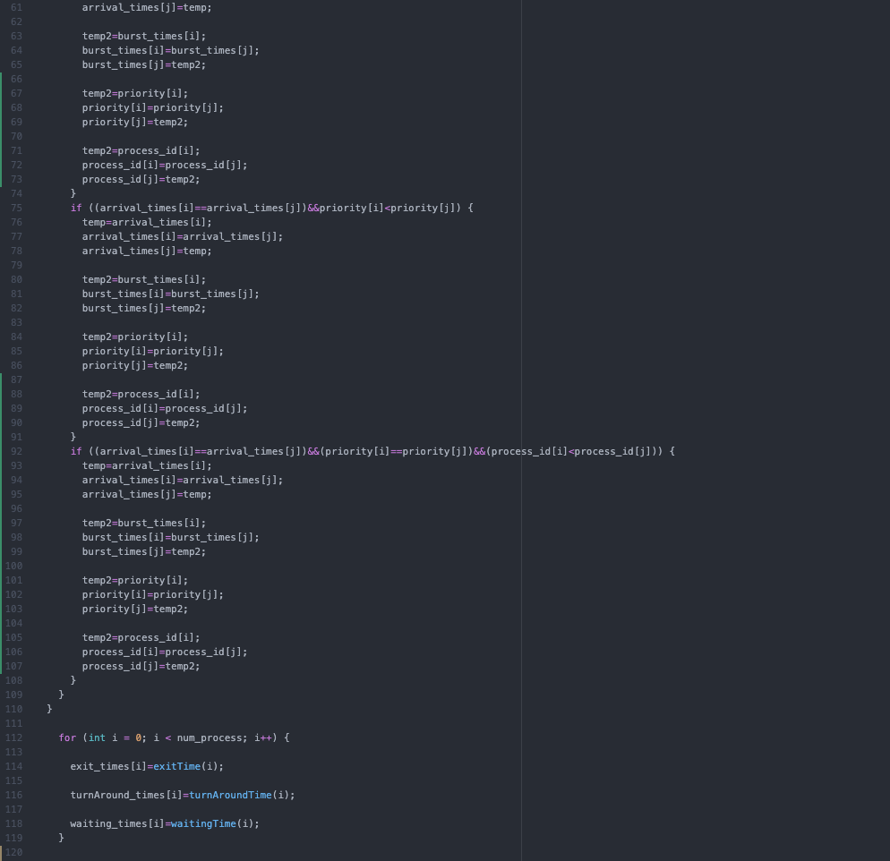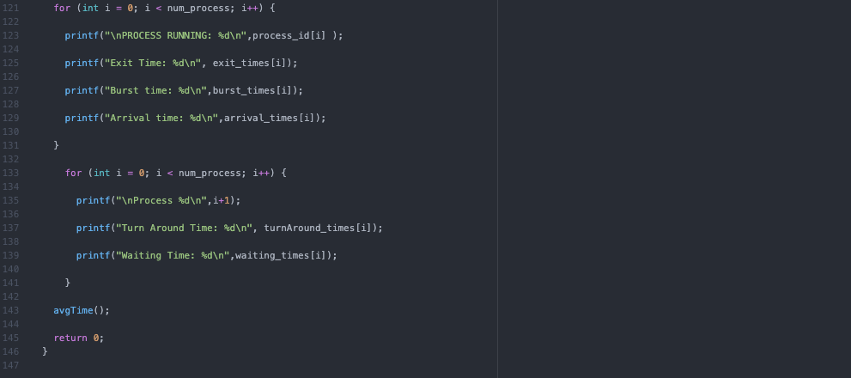

CONCLUSION:

In this lab, we were to implement and demonstrate the working of the priority scheduling algorithm (pre-emptive and non pre-emptive). By actually coding the algorithm, it helped to reinforce the working of this process and the manner in which it schedules the processes in a CPU.