**SVKM’S NMIMS**

**MUKESH PATEL SCHOOL OF TECHNOLOGY MANAGEMENT& ENGINEERING**

**(Campus Name)**

Academic Year: 2021-2022

# **Practical 4-Shortest Job first scheduling algorithm**

|  |  |  |
| --- | --- | --- |
| Name | Roll_No | SAP-ID |
|  |  |  |

Dear all,

Kindly complete the following task with your name in output file also attach the C program with the file.

Find the Turnaround time and Average Turnaround time.

Find the Waiting time and Average Waiting time.

### **Example 1:-**

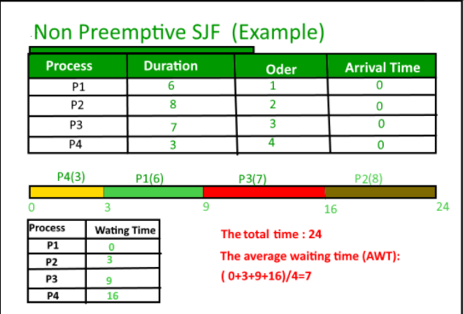

**Example 2:-**

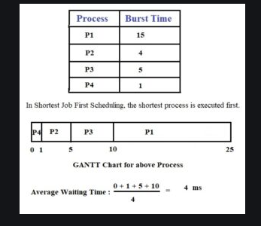

Example 3:-

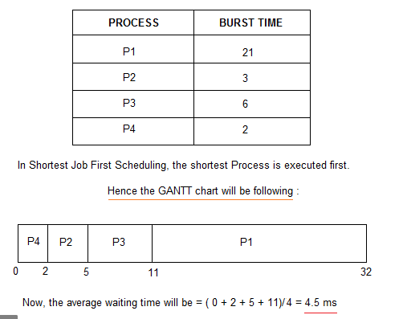

## **Conclusion: -**

Write your observation about Shortest Job algorithm. How it is better than First come first serve algorithm.