PROBABILITY & STATISTICS – LAB 1

B.Tech. Computer Science and Engineering (Cybersecurity)

|  |  |
| --- | --- |
| Name: Anish Sudhan Nair | Roll No.: K041 |
| Batch: K2/A2 | Date of performance: 23/12/2021 |

Aim: To be introduced to the R language and the basic syntax including data types, matrix operations and such.

Question 1: Write an R program to create three vectors – numeric, character and logical data types. Display the content of the vectors and their type.

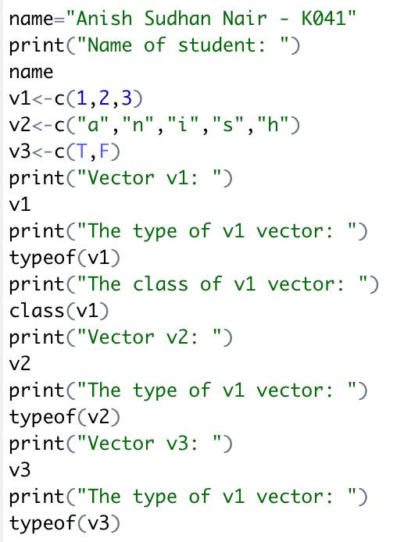 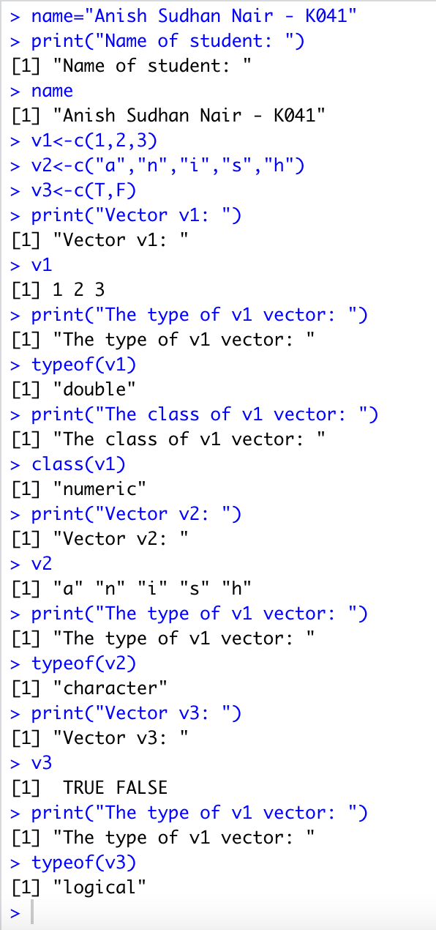

Question 2

Write an R program to create a 4x5 matrix and a 3x2 matrix with labels, and fill the matrix by rows alongside a 2x2 matrix with labels, filling the matrix by columns.

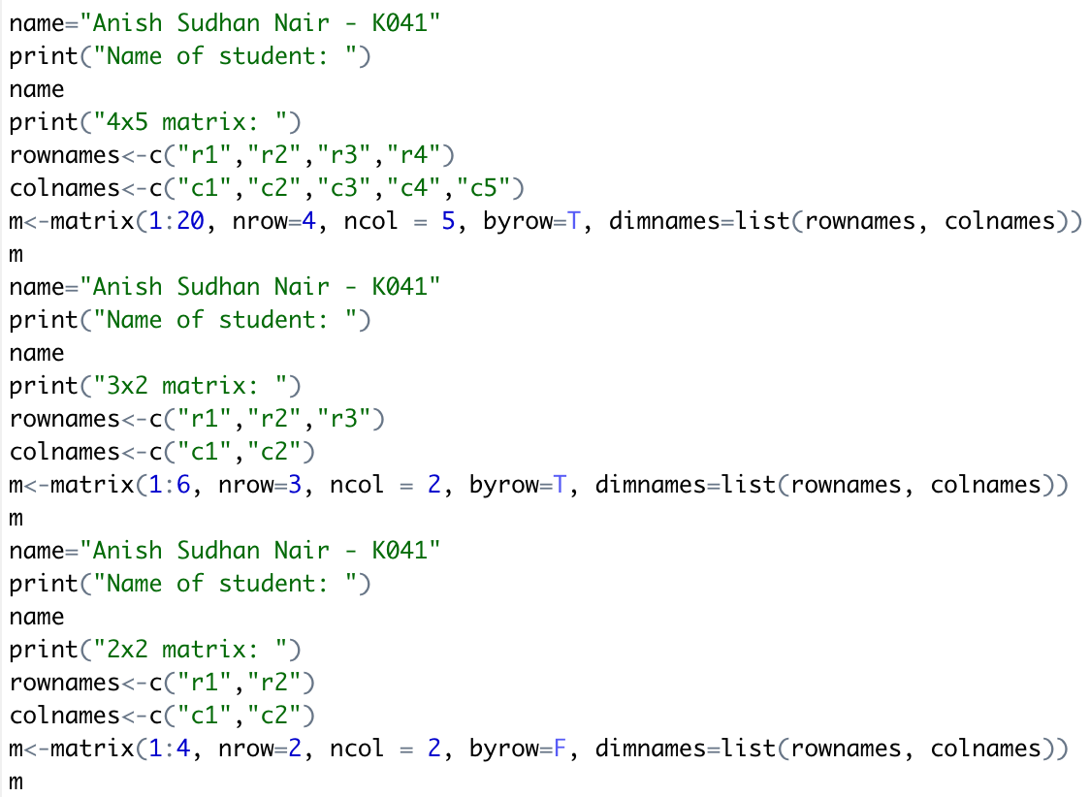

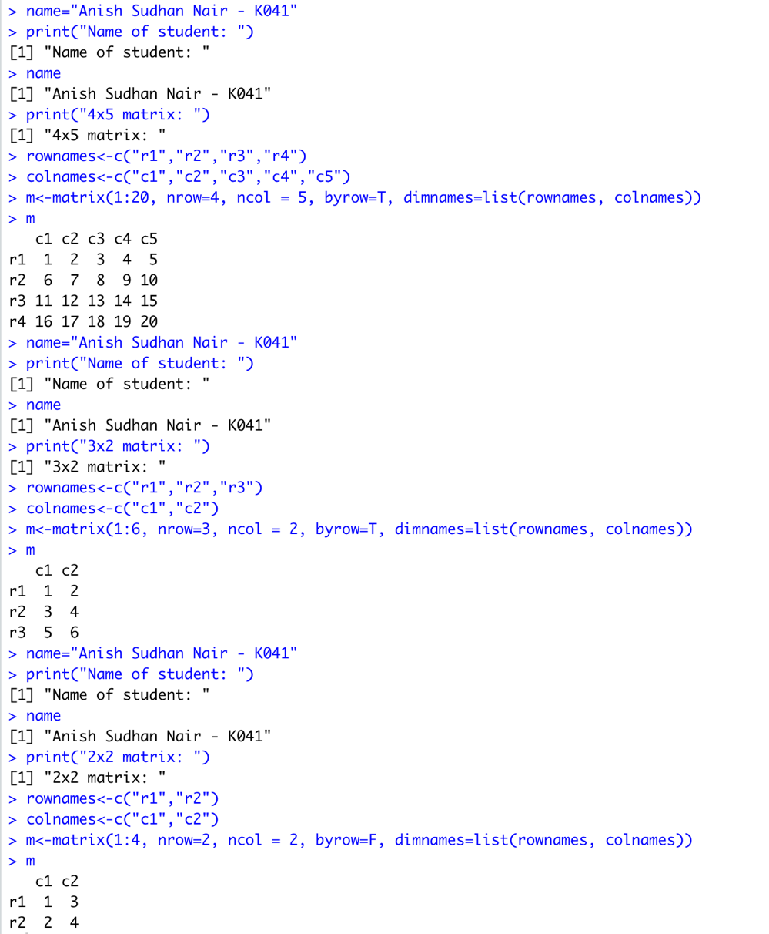

Question 3

Write an R program to compute the sum, the mean and the product of a given vector elements.

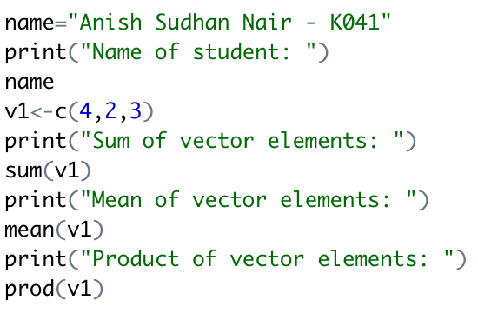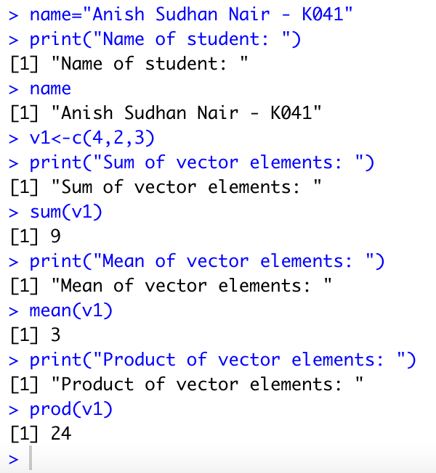

Question 4

Write an R program to compute addition and subtraction of two matrices of dimension nx(n+1).

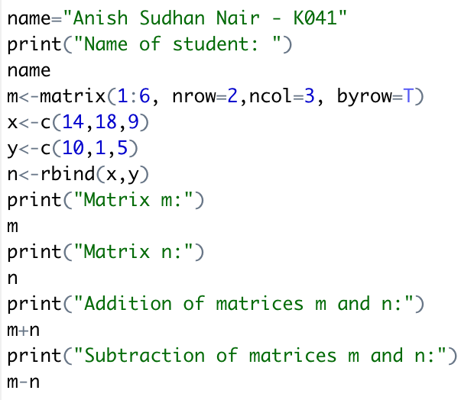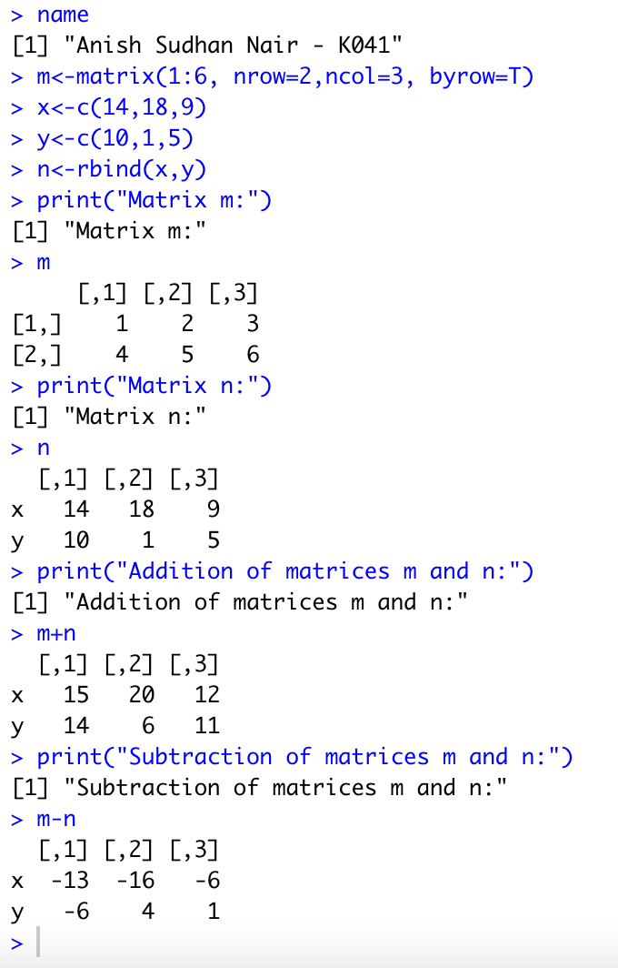

Question 5

Write an R program to create a list containing a vector, a matrix, and a list; and give names to the elements in the list. Access the second element of the list.

