PROBABILITY & STATISTICS – LAB 2

B.Tech. Computer Science and Engineering (Cybersecurity)

|  |  |
| --- | --- |
| Name: Anish Sudhan Nair | Roll No.: K041 |
| Batch: K2/A2 | Date of performance: 06/01/2021 |

Aim: To work with charts and datasets in R.

1.Draw a histogram of sepal width from dataset iris. In Which range does the highest frequency occur?

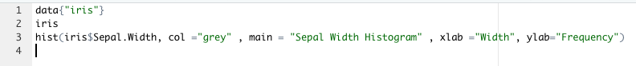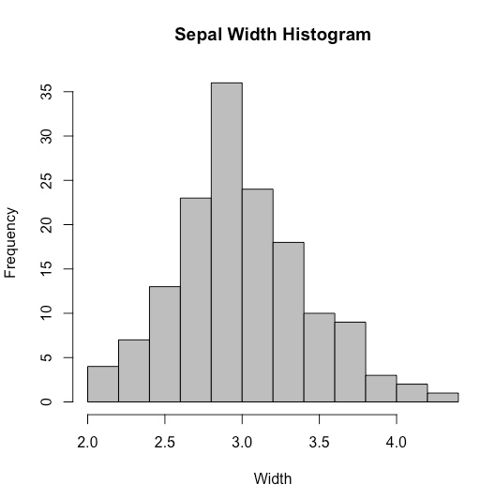

Range: 2.8-3.0 (Highest Frequency)

2. Create a csv file for the following data

Source Cu

Site1 19.700

Site2 10.643

Site3 33.792

Site4 5.353

Site5 19.890

Site6 26.966

Draw a boxplot to show atmospheric copper concentration by sites.

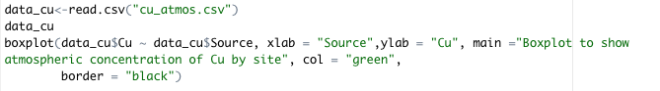

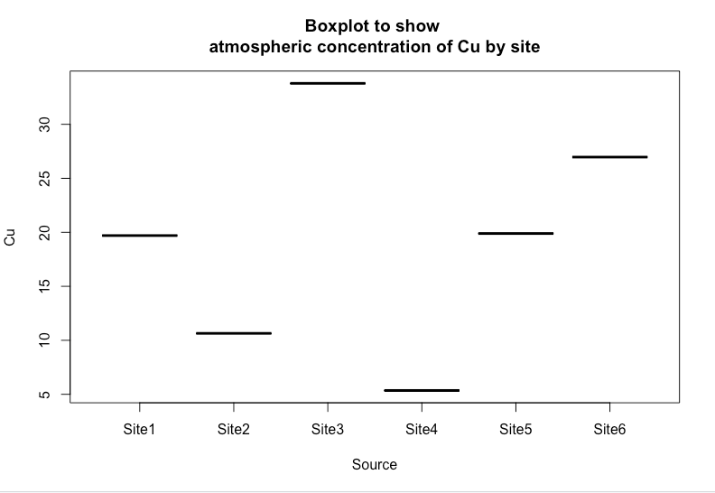

3. Create a csv file for the following data

## City ProductA ProductB ProductC

## 1 Seattle 23 11 12

## 2 London 89 6 56

## 3 Tokyo 24 7 13

## 4 Berlin 36 34 44

## 5 Mumbai 3 78 14

Draw a bar graph to show total sales across different cities

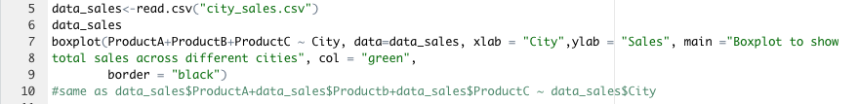

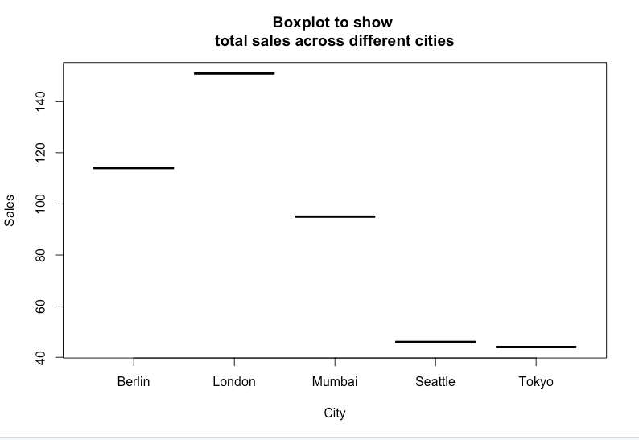

4. Write R program to change the first level of a factor with another level of a given factor

CODE:

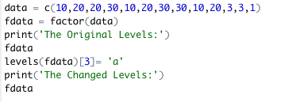

OUTPUT:

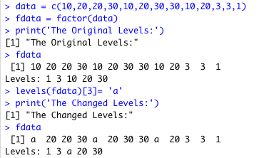

5. The dataset swiss contains a standardized fertility measure and various socio-economic indicators for each of 47 French-speaking provinces of Switzerland in about 1888. a. Draw a scatterplot of Fertility against %Catholic. Which kind of areas have the lowest fertility rates? b. Discuss the relationship between the variables Education and Agriculture.

a.

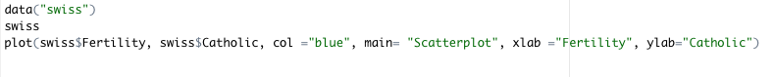

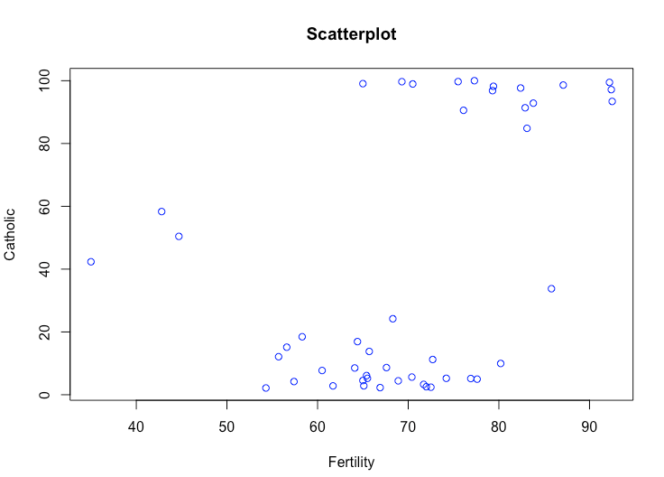

V. De Geneve has lowest fertility rate with 35.0%, having Catholic Population of about 42.34%.

The other regions with low fertility include Rive Gouche (42.8%) and Rive Droite (44.7%) having Catholic populations in percentages of 58.33% and 50.43% respectively.

The least fertility therefore lies in the 40-60% Catholic population range.

b.

Education and Agriculture variables have a direct yet negative correlation. The scatterplot below clearly indicates that persons with higher level of education are less likely to be involved in or with agriculture while those with lesser level of education are more likely to be involved with agriculture.

