PROBABILITY & STATISTICS – LAB 3-1

B.Tech. Computer Science and Engineering (Cybersecurity)

|  |  |
| --- | --- |
| Name: Anish Sudhan Nair | Roll No.: K041 |
| Batch: K2/A2 | Date of performance: 11/01/2021 |

Aim: To work with probability distribution functions

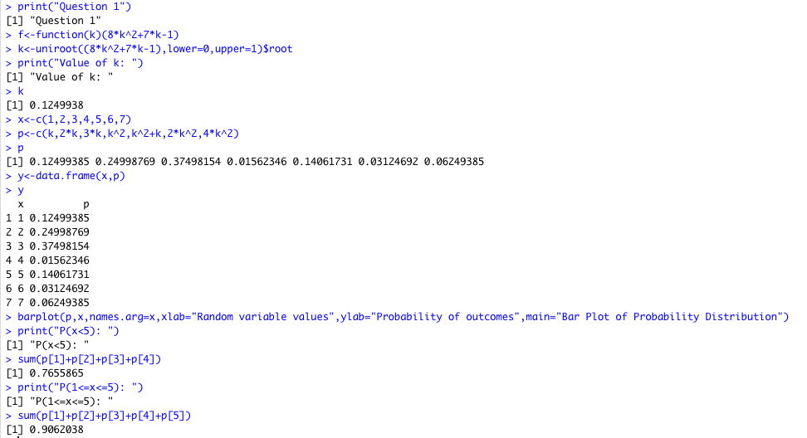

|  |  |  |  |  |  |  |  |  |  |  |  |  |  |  |  |  |  |  |  |  |  |  |  |  |  |  |  |  |  |  |  |  |  |  |  |  |  |  |  |  |  |  |  |  |  |  |  |  |  |  |  |  |  |  |  |  |
| --- | --- | --- | --- | --- | --- | --- | --- | --- | --- | --- | --- | --- | --- | --- | --- | --- | --- | --- | --- | --- | --- | --- | --- | --- | --- | --- | --- | --- | --- | --- | --- | --- | --- | --- | --- | --- | --- | --- | --- | --- | --- | --- | --- | --- | --- | --- | --- | --- | --- | --- | --- | --- | --- | --- | --- | --- |
| 1. PDF of random variable X is:  |  |  |  |  |  |  |  |  | | --- | --- | --- | --- | --- | --- | --- | --- | | X | 1 | 2 | 3 | 4 | 5 | 6 | 7 | | P(X) | k | 2k | 3k | k2 | k2+k | 2k2 | 4k2 |   Find  Write a R program for the above problem. Also write a R program to plot probability distribution  Code:    Output:     1. A random variable X has the following pdf  |  |  |  |  |  |  |  | | --- | --- | --- | --- | --- | --- | --- | | X | -2 | -1 | 0 | 1 | 2 | 3 | | P(X) | 0.1 | k | 0.2 | 2k | 0.3 | 3k |   Find k, p(X <2), c.d.f.  Write a R program for the above problem. Also write a R program to plot cumulative distribution function.  Code:      Output:       1. A RV X has the following probability distribution:  |  |  |  |  |  |  | | --- | --- | --- | --- | --- | --- | | X | -2 | -1 | 0 | 1 | 2 | | P(X=x) | 1/5 | 1/5 | 2/5 | 2/15 | 1/15 |   Find the probability distribution of .  Write a R program for the above problem.  Code:    Output:       1. Given the following distribution:  |  |  |  |  |  |  |  | | --- | --- | --- | --- | --- | --- | --- | | x | -3 | -2 | -1 | 0 | 1 | 2 | | P(X=x) | 0.05 | 0.1 | 0.2 | 0.3 | 0.2 | 0.15 |   Find Mean and Variance.  Write a R program for the above problem.  Code:    Output:     1. An urn contains 7 white and 3 red balls. Two balls are drawn together, at random from this urn. Compute the expected number of white balls drawn   Write a R program for above problem. Also write a program for to plot probability distribution and cumulative probability distribution.  Code:    Output: |
|  |

WRITTEN WORK ATTACHED AFTER THIS PAGE