PROBABILITY & STATISTICS – LAB 3-2

B.Tech. Computer Science and Engineering (Cybersecurity)

|  |  |
| --- | --- |
| Name: Anish Sudhan Nair | Roll No.: K041 |
| Batch: K2/A2 | Date of performance: 13/01/2021 |

Aim: To work with probability distribution functions

1. The probability of entering students in chartered accountant will graduate is 0.5. Determine the probability that out of 10 students

i. None

ii. One

iii. At least one will graduate

Write a R program for above problem.

Code:

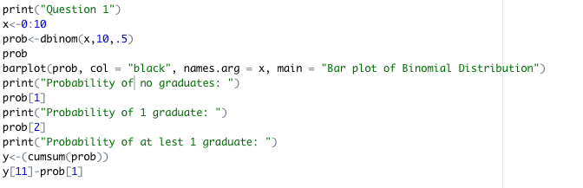

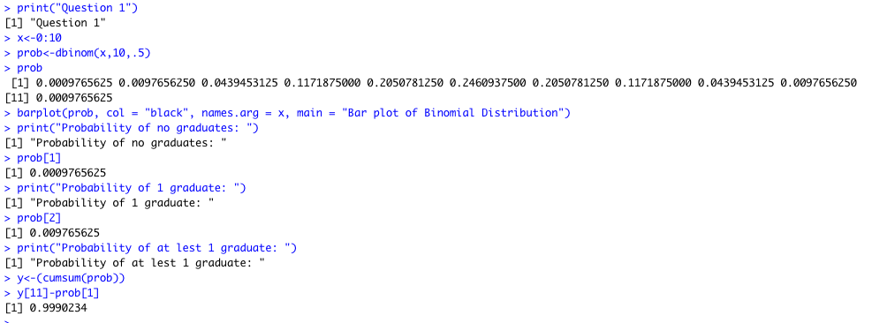Output:

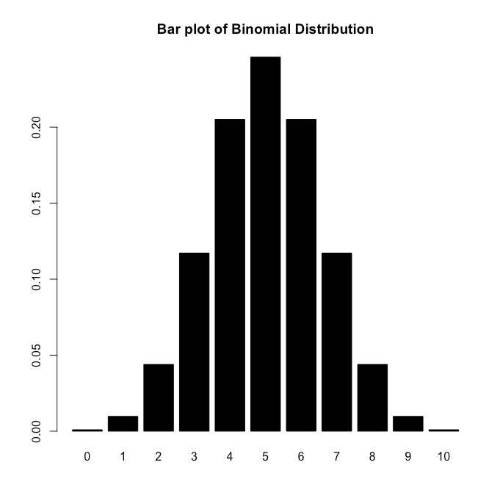

2. Find binomial distribution if the mean is 5 and variance is 10/3.

Write a R program for above problem. Also write a R program to plot probability distribution and cumulative probability distribution.

Code:

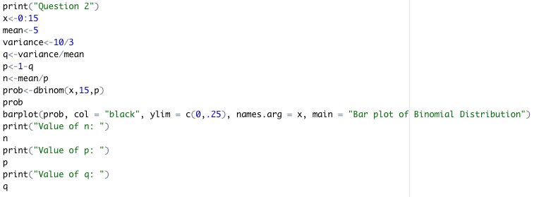

Output:

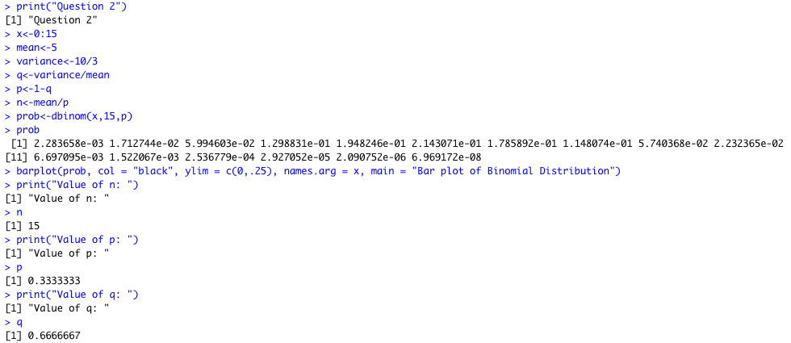

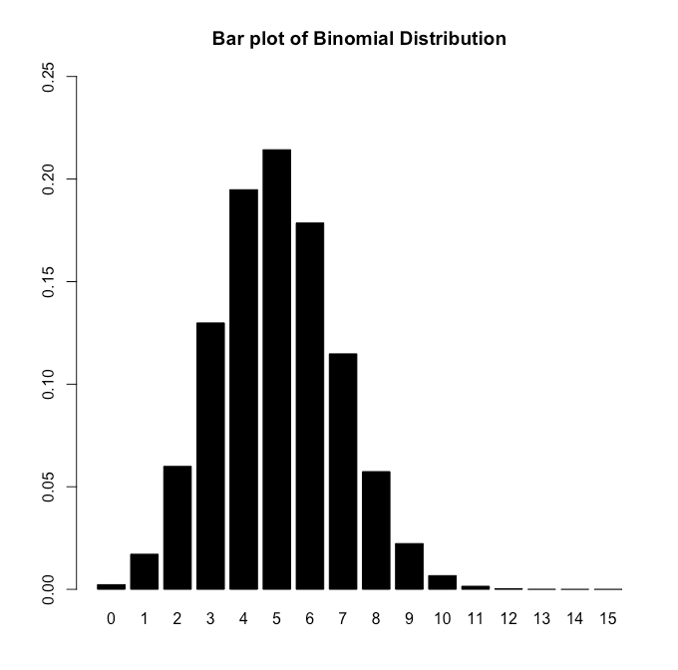

3. The number of traffic accidents that occur on a particular stretch of road during a month follows a Poisson distribution with a mean of 7.6. Find the probability that

i. less than three accidents will occur next month on this stretch of road.

ii. Exactly three accidents will occur next month on this stretch of road.

Write a R program for above problem.

Code:

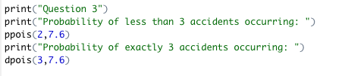

Output:

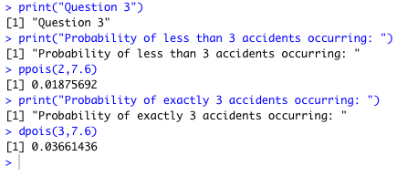

4. The items produced by a certain machine include only one defective in every 250 items. Ten bags of 10 items each are considered. Find the probability that in ten bags there is (i) no defective item, (ii) exactly one defective item, (iii) at least one defective item.

Code:

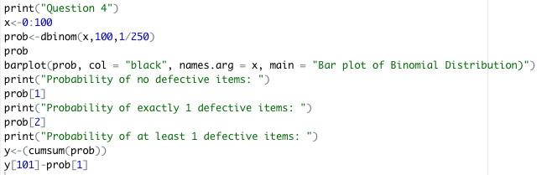

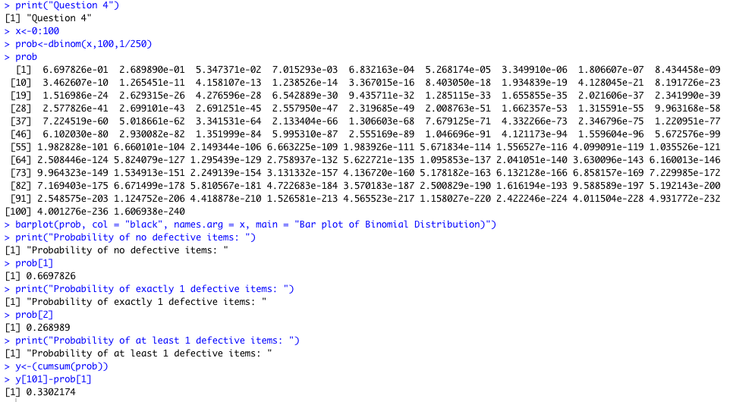Output:

