SVKM’s NMIMS University

Mukesh Patel School of Technology Management & Engineering

**PROGRAM: BTech IT/MBATECH SEMESTER IV**

**COURSE: Web Programming Practical Experiment: 3**

**Part A**

**Aim:**

1. Apply styling technique Using Inline CSS
2. Apply styling technique Using Internal CSS

**Prerequisites:-**

* Basic Tags of HTML.

**Theory:-**

**Cascading Style Sheets (CSS)**

**Syntax**

selector { property: value }

* A CSS rule-set consists of a selector and a declaration block:
* Declaration part is further divided into property and values.

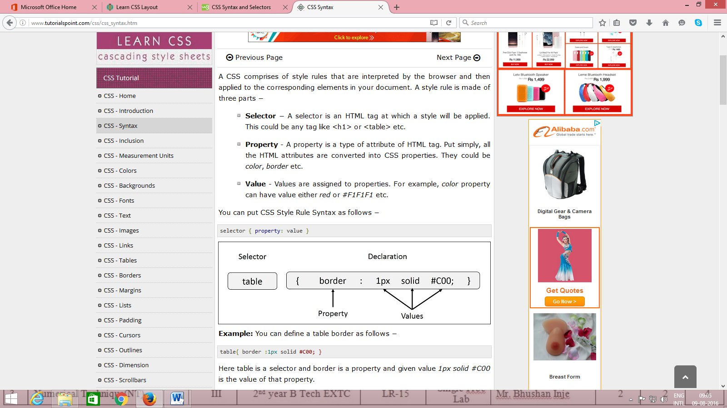

* **Selector** − A selector is an HTML tag at which a style will be applied. This could be any tag like <h1> or <table> etc.
* **Property** - A property is a type of attribute of HTML tag. Put simply, all the HTML attributes are converted into CSS properties. They could be *color*, *border* etc.
* **Value** - Values are assigned to properties. For example, *color* property can have value either *red* or any other color.

The selector points to the HTML element you want to style.

The declaration block contains one or more declarations separated by semicolons.

Each declaration includes a property name and a value, separated by a colon.

|  |  |
| --- | --- |
| **Properties** | **Values** |
| background-attachment | scroll, fixed |
| background-color | (color), transparent |
| background-image | none, (location) |
| background-position | (percent), (length), top, center, bottom, left, center, right |
| background-repeat | repeat, repeat-x, repeat-y, no-repeat |
| Background | Any of the above background values separated by spaces. |
| Color | (color) |

|  |  |
| --- | --- |
| **Properties** | **Values** |
| margin-bottom | (length), (percent), auto |
| margin-left | (length), (percent), auto |
| margin-right | (length), (percent), auto |
| margin-top | (length), (percent), auto |
| margin | Any of the above margin values in top, right, bottom, left order separated by spaces. |
| padding-bottom | (length), (percent) |
| padding-left | (length), (percent) |
| padding-right | (length), (percent) |
| padding-top | (length), (percent) |
| padding | Any of the above padding values in top, right, bottom, left order separated by spaces. |
| border-bottom-width | medium, thin, thick, (length) |
| border-bottom | Any of the border-top-bottom, border-color and border-style values. |
| border-color | (color) |
| border-left-width | medium, thin, thick, (length) |
| border-left | Any of the border-top-left, border-color and border-style values. |
| border-right-width | medium, thin, thick, (length) |
| border-right | Any of the border-right-width, border-color and border-style values. |
| border-style | none, dotted, dashed, solid, double, groove, ridge, inset, outset |
| border-top-width | medium, thin, thick, (length) |
| border-top | Any of the border-top-width, border-color and border-style values. |
| border | Any of the border values. Applies to all borders. |
| height | auto, (length), (percent) |
| width | auto, (length), (percent) |
| list-style-type | disc, circle, square, decimal, lower-roman, upper-roman, lower-alpha, upper-alpha, upper-latin, hebrew, armenian, georgian, cjk-ideographic, hiragana, katakana, hiragana-iroha, katakana-iroh, none |
| list-style-image | none, (url) |
| list-style-position | outside, inside |
| **Properties** | **Values** |
| list-style | Any of the above list-style values separated by spaces. |
| white-space | normal, pre, nowrap |
| border-collapse | collapse, separate, inherit |
| border-spacing | (length)(length), inherit |
| caption-side | top, bottom, left, right, inherit |
| empty-cells | show, hide, inherit |
| speak-header | once, always, inherit |
| table-layout | auto, fixed, inherit |

**Three Ways to Insert CSS**

There are three ways of inserting a style sheet:

* Internal style sheet
* Inline style
* External style sheet

**Internal Style Sheet**

An internal style sheet should be used when a single document has a unique style. You define internal styles in the head section of an HTML page, inside the <style> tag, like this:

<head>  
<style>  
hr{color:sienna;}

p{margin-left:20px;}

body{background-image:url("images/background.gif");}   
</style>  
</head>

**Inline Styles**

An inline style loses many of the advantages of a style sheet (by mixing content with presentation). Use this method sparingly!

To use inline styles, add the style attribute to the relevant tag. The style attribute can contain any CSS property. The example shows how to change the color and the left margin of a paragraph:

<p style="color:sienna;margin-left:20px;">This is a paragraph.</p>

**Instructions to Students:-**

1. Write html code in Note Pad & save with .html extension.
2. Execute using Web Browser.
3. Copy and Paste code as well as output (snapshot of output) in Part B

SVKM’s NMIMS University

Mukesh Patel School of Technology Management & Engineering

**PROGRAM: BTech IT/MBATECH SEMESTER IV**

**COURSE: Web Programming Practical Experiment: 3**

**PART B**

(Students must submit the soft copy as per the following segments. A soft copy containing Part A and Part B must be uploaded on the platform specified by the Practical Teacher. The filename should be **RollNo_Name_Exp1**)

|  |  |
| --- | --- |
| **Roll No.:**K041 | **Name:** Anish Sudhan Nair |
| **Prog/Yr/Sem:** B.Tech. Cybersecurity | **Batch:** K2/A2 |
| **Date of Experiment:** 24/12/2021 | **Date of Submission:** 25/12/2021 |

1. Design a web page using CSS which includes the following:

1) Use different font styles

2) Control the repetition of image with background-repeat and no-repeat property

3) Define style for links as a: link, a: active, a: hover, a: visited

**Note: You can reference the following page**

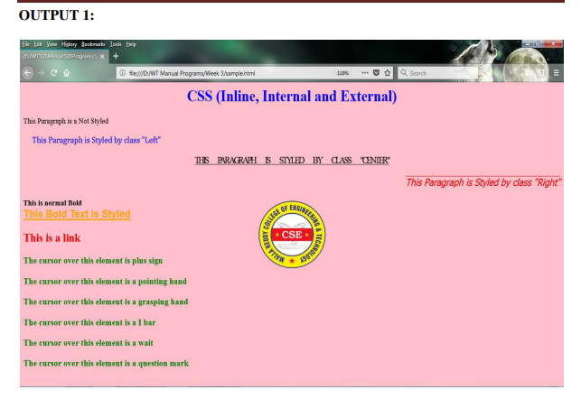

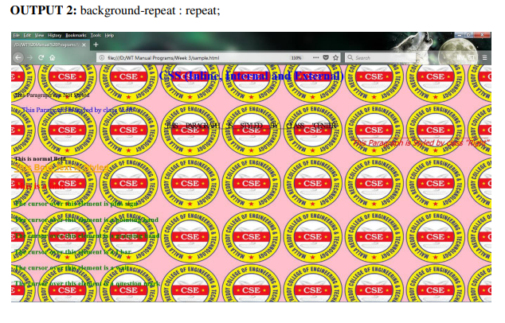

**Code:-**

**NO REPAT BG**

**HTML code**

<!DOCTYPE HTML5>

<html lang="en" dir="ltr">

<head>

<meta charset="utf-8">

<title>Assignment 3 - AnishSudhanNair</title>

<style>

h1{

font-size:40px;

color:blue;

font-family:;

}

body{

background-image:url("bg1.png");

background-size:cover;

background-repeat: no-repeat;

}

.Left{

color:blue;

font-weight: 600;

text-align:left;

}

</style>

<link rel="stylesheet" type="text/css" href="css_assignment3.css">

</head>

<body>

<h1>CSS (Inline, Internal and External)</h1>

<p >This is a normal parapgraph without any styling</p>

<p class="Left">This Parapgraph is Styled by Class "Left"</p>

<p class="Center">This paragraph is styled by class "center"</p>

<p class="Right">This Paragraph is Styled by class "Right"</p>

<b>This is normal bold</b> <br>

<b style="color:orange;text-decoration:underline;text-transform:capitalize;">This bold text is styled</b> <br>

<a id="link" href="https://www.w3schools.com" target="_blank">This is a link</a> <br>

<p class="cursor" style="cursor:crosshair">The cursor over this element is a plus sign</p>

<p class="cursor" style="cursor:pointer">The cursor over this element is a pointing sign</p>

<p class="cursor" style="cursor:grabbing">The cursor over this element is a grasping hand</p>

<p class="cursor" style="cursor:text">The cursor over this element is a I bar</p>

<p class="cursor" style="cursor:wait">The cursor over this element is a wait</p>

<p class="cursor" style="cursor:help">The cursor over this element is a question mark</p>

</body>

</html>

**CSS file**

.cursor{

color: green;

font-family: serif;

font-weight: bold;

}

#link{

/* color: red; */

font-weight:900;

text-decoration: none;

margin-top: 100px;

line-height: 400%

}

.Center{

text-transform: uppercase;

text-decoration: underline;

color: black;

font-weight:100;

font-family:"Lucida Bright", sans-serif;

text-align: center;

word-spacing: 10px;

letter-spacing: -3px;

}

.Right{

color: red;

text-decoration: overline;

text-align: right;

font-style: italic;

font-family: sans-serif;

}

a:link{

color: green;

}

a:visited{

color: red;

}

a:hover{

color: hotpink;

}

a:active{

color:blue;

}

**REPEAT BG**

**HTML file**

<!DOCTYPE HTML5>

<html lang="en" dir="ltr">

<head>

<meta charset="utf-8">

<title>Assignment 3 - AnishSudhanNair</title>

<style>

h1{

font-size:40px;

color:blue;

font-family:;

}

body{

background-image:url("bg1.png");

background-size:200px 100px;

background-repeat: repeat;

}

.Left{

color:blue;

font-weight: 600;

text-align:left;

}

</style>

<link rel="stylesheet" type="text/css" href="css_assignment3.css">

</head>

<body>

<h1>CSS (Inline, Internal and External)</h1>

<p >This is a normal parapgraph without any styling</p>

<p class="Left">This Parapgraph is Styled by Class "Left"</p>

<p class="Center">This paragraph is styled by class "center"</p>

<p class="Right">This Paragraph is Styled by class "Right"</p>

<b>This is normal bold</b> <br>

<b style="color:orange;text-decoration:underline;text-transform:capitalize;">This bold text is styled</b> <br>

<a id="link" href="https://www.w3schools.com" target="_blank">This is a link</a> <br>

<p class="cursor" style="cursor:crosshair">The cursor over this element is a plus sign</p>

<p class="cursor" style="cursor:pointer">The cursor over this element is a pointing sign</p>

<p class="cursor" style="cursor:grabbing">The cursor over this element is a grasping hand</p>

<p class="cursor" style="cursor:text">The cursor over this element is a I bar</p>

<p class="cursor" style="cursor:wait">The cursor over this element is a wait</p>

<p class="cursor" style="cursor:help">The cursor over this element is a question mark</p>

</body>

</html>

**CSS file**

.cursor{

color: green;

font-family: serif;

font-weight: bold;

}

#link{

/* color: red; */

font-weight:900;

text-decoration: none;

margin-top: 100px;

line-height: 400%

}

.Center{

text-transform: uppercase;

text-decoration: underline;

color: black;

font-weight:100;

font-family:"Lucida Bright", sans-serif;

text-align: center;

word-spacing: 10px;

letter-spacing: -3px;

}

.Right{

color: red;

text-decoration: overline;

text-align: right;

font-style: italic;

font-family: sans-serif;

}

a:link{

color: green;

}

a:visited{

color: red;

}

a:hover{

color: hotpink;

}

a:active{

color:blue;

}

**Input and Output:-**

**NO REPEAT BG**

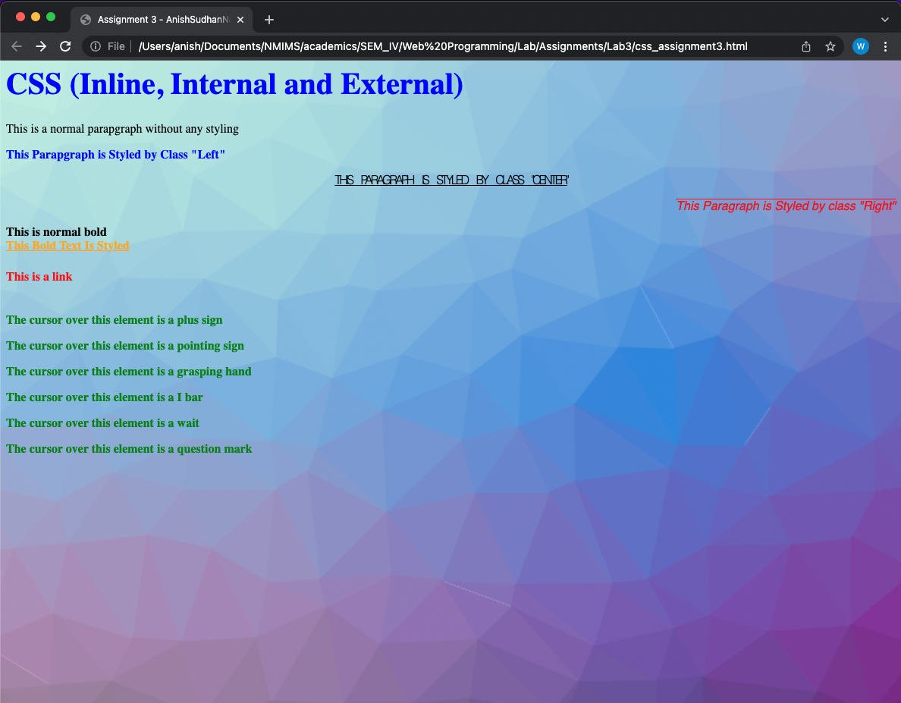

**REPEAT BG**

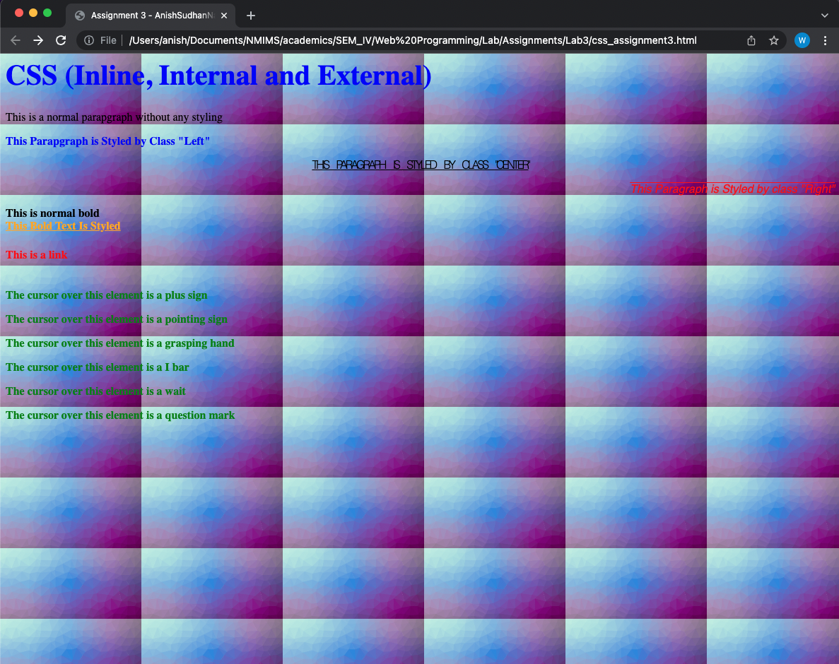

**Observation and Learning:-**

CSS greatly helps with designing and adding flair to any webpage. The multitude of attributes for all html tags and values for css properties enable great lengths of modification and customisation. This practical was conducive in introducing a number of useful css properties that can be applied on most html elements thus enabling a greater level of web page front end designing.

**Conclusion:-**

Through this practical we were introduced to CSS, its types – inline, internal and external, and learnt about the implementation of various css properties for the different html elements, the hierarchy and specificity levels of the css defined.

**Questions:-**

1. What is CSS?

* CSS or cascading style sheets is a rule-based language that is the decorative component of website building. It is used to define how the structural html elements must be presented to the end users.

1. What are advantages of CSS?

* CSS has several advantages apart from its basic objective of making webpages look prettier.
* It enables to maintain consistent design language across the page by having to declare a style set for an element only once
* In case of exception or particulars we can define style sets for the ids or classes
* Apart from consistency, its rule-based approach is time saving since the same styles need to be mentioned over and over for the same or even different elements
* CSS is very simple and there is no need for programmatic logic to learn or comprehend it
* It’s easier to align and place the text and elements

1. What are selector, property and value?

* A selector is the html element for which the style set is being applied. eg: h1 element
* A property is the css attribute or aspect that we are defining as a part of the designing the web page eg: color property
* Value is the exact kind of property being applied to the selector element eg: yellow value

1. What are various ways to embedded CSS in HTML?

* CSS can be embedded or implemented in HTML in three different ways:
* Inline: Using style attribute, the css properties and values are defined within the html element’s opening tag itself
* Internal: Using the style tag within the header tag, we can define the css rules in the html document itself
* External: We can define the css rules in a separate css document and then link it to the html file using the link tag within the header tag of the html file