|  |  |
| --- | --- |
| **Roll No.:**K041 | **Name:** Anish Sudhan Nair |
| **Prog/Yr/Sem:** B.Tech. Cybersecurity | **Batch:** K2/A2 |
| **Date of Experiment:** 07/01/2022 | **Date of Submission:** 07/02/2022 |

**Aim:**

1. Apply various styling techniques Using External CSS.
2. Frames & iFrame
3. Transform property

**Prerequisites:-**

* Basic Tags of HTML and CSS.

**Theory:-**

**External Style Sheet**

An external style sheet is ideal when the style is applied to many pages. With an external style sheet, you can change the look of an entire Web site by changing just one file.

Each page must include a link to the style sheet with the <link> tag. The <link> tag goes inside the head section:

<head>  
<link rel="stylesheet" type="text/css" href="mystyle.css">  
</head>

An external style sheet can be written in any text editor. The file should not contain any html tags. The style sheet file must be saved with a **.css** extension. An example of a style sheet file is shown below:

**"myStyle.css"**:

hr {color: red;}  
p {margin-left: 20px;}  
body {background-image: url("images/background.gif");}

When using CSS it is preferable to keep the CSS separate from your HTML. Placing CSS in a separate file allows the web designer to completely differentiate between content (HTML) and design (CSS). External CSS is a file that contains only CSS code and is saved with a ".css" file extension.

**Why use external css?**

* It keeps your website design and content separate.
* It's much easier to reuse your CSS code if you have it in a separate file. Instead of typing the same CSS code on every web page you have, simply have many pages refer to a single CSS file with the "link" tag.
* You can make drastic changes to your web pages with just a few changes in a single CSS file.

**Importing CSS**

**<style type= “text/css”>@import url (specify url here)**

**</style>**

**Frame & iFrame**

HTML Iframe is used to display a nested webpage (a webpage within a webpage). The HTML <iframe> tag defines an inline frame, hence it is also called as an Inline frame.

An HTML iframe embeds another document within the current HTML document in the rectangular region.

The webpage content and iframe contents can interact with each other using JavaScript.

Iframe Syntax

An HTML iframe is defined with the <iframe> tag:

1. <iframe src="URL"> </iframe>

Here, "src" attribute specifies the web address (URL) of the inline frame page.

Set Width and Height of iframe

You can set the width and height of iframe by using "width" and "height" attributes. By default, the attributes values are specified in pixels but you can also set them in percent. i.e. 50%, 60% etc.

Example: (Pixels)

<!DOCTYPE html>

<html>

<body>

<h2>HTML Iframes example</h2>

<p>Use the height and width attributes to specify the size of the iframe:</p>

<iframe src="https://www.yahoo.com/" height="300" width="400"></iframe>

</body>

</html>

You can also change the size, color, style of the iframe's border.

Example:

<!DOCTYPE html>

<html>

<body>

<h2>Custom Iframe Border</h2>

<iframe src="https://www.yahoo.com/" style="border:2px solid tomato;"></iframe>

</body>

</html>

Iframe Target for a link

You can set a target frame for a link by using iframe. Your specified target attribute of the link must refer to the name attribute of the iframe.

Example:

<!DOCTYPE html>

<html>

<body>

<h2>Iframe - Target **for** a Link</h2>

<iframe height="300px" width="100%" src="new.html" name="iframe_a"></iframe>

<p><a href="https://www.yahoo.com" target="iframe_a">Yahoo.com</a></p>

<p>The name of iframe and link target must have same value **else** link will not open as a frame. </p>

</body>

</html>

Following are some steps to add YouTube video on your webpage:

* Goto YouTube video which you want to embed.
* Click on SHARE ➦ under the video.
* Click on Embed <> option.
* Copy HTML code.
* Paste the code in your HTML file

Change height, width, and other properties (as per requirement).

**Transform property**

CSS transforms allow you to move, rotate, scale, and skew elements.

Mouse over the element below to see a 2D transformation:

With the CSS transform property you can use the following 2D transformation methods:

translate()

rotate()

scaleX()

scaleY()

scale()

skewX()

skewY()

skew()

**The translate ( ) Method**

The translate ( ) method moves an element from its current position (according to the parameters given for the X-axis and the Y-axis).

The following example moves the <div> element 50 pixels to the right, and 100 pixels down from its current position:

<html>

<head>

<style>

div {

width: 300px;

height: 100px;

background-color: yellow;

border: 1px solid black;

transform: translate(50px,100px);

}

</style>

</head>

<body>

<h1>The translate() Method</h1>

<p>The translate() method moves an element from its current position:</p>

<div>

This div element is moved 50 pixels to the right, and 100 pixels down from its current position.

</div>

</body>

</html>

**The rotate() Method**

Rotate

The rotate() method rotates an element clockwise or counter-clockwise according to a given degree.

The following example rotates the <div> element clockwise with 20 degrees:

<html>

<head>

<style>

div {

width: 300px;

height: 100px;

background-color: yellow;

border: 1px solid black;

}

div#myDiv {

transform: rotate(20deg);

}

</style>

</head>

<body>

<h1>The rotate() Method</h1>

<p>The rotate() method rotates an element clockwise or counter-clockwise.</p>

<div>

This a normal div element.

</div>

<div id="myDiv">

This div element is rotated clockwise 20 degrees.

</div>

</body>

</html>

**Instructions to Students:-**

1. Write html code in Note Pad & save with .html extension.
2. Execute using Web Browser.
3. Copy and Paste code as well as output (snapshot of output) in Part B

**PART-B**

|  |  |
| --- | --- |
| **Roll No.:**K041 | **Name:** Anish Sudhan Nair |
| **Prog/Yr/Sem:** B.Tech. Cybersecurity | **Batch:** K2/A2 |
| **Date of Experiment:** 07/01/2022 | **Date of Submission:** 07/02/2022 |

1. Apply styling technique Using External CSS

**Apply Styling For Following**

* Background Properties.
* Text Properties.
* Font Properties.
* Border Properties.
* Margin Properties.

**Also Use**

* Grouping of Selector.

1. Create a similar web page with external CSS

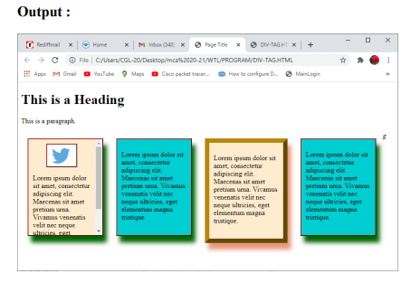

1. Display the images on the web page as-

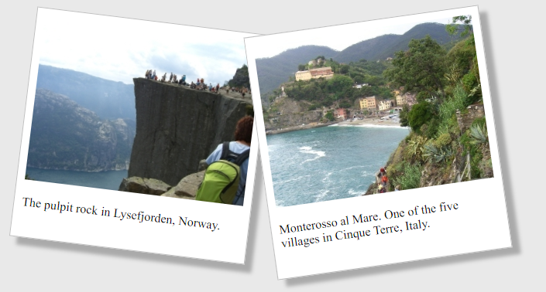

**Code:-**

Code 1:

HTML – lab4pt1.html

<!DOCTYPE HTML5>

<html lang="en" dir="ltr">

<head>

<meta charset="utf-8">

<title></title>

<link type="text/css" rel="stylesheet" href="pt1.css">

</head>

<body>

<h1>CSS (Inline, Internal and External)</h1>

<p >This is a normal parapgraph without any styling</p>

<p class="Left">This Parapgraph is Styled by Class "Left"</p>

<p class="Center">This paragraph is styled by class "center"</p>

<p class="Right">This Paragraph is Styled by class "Right"</p>

<b>This is normal bold</b> <br>

<b style="color:orange;text-decoration:underline;text-transform:capitalize;">This bold text is styled</b> <br>

<a id="link" href="https://www.w3schools.com" target="_blank">This is a link</a> <br>

<p class="cursor" style="cursor:crosshair">The cursor over this element is a plus sign</p>

<p class="cursor" style="cursor:pointer">The cursor over this element is a pointing sign</p>

<p class="cursor" style="cursor:grabbing">The cursor over this element is a grasping hand</p>

<p class="cursor" style="cursor:text">The cursor over this element is a I bar</p>

<p class="cursor" style="cursor:wait">The cursor over this element is a wait</p>

<p class="cursor" style="cursor:help">The cursor over this element is a question mark</p>

<div id="div1">

<img src="img1.jpeg" style="height:200px;width=200px" alt="Image">

</div>

</body>

</html>

CSS – pt1.css

h1{

font-size:40px;

color:blue;

font-family:sans-serif;

}

body{

background-image:url("image1.jpeg");

/* background-size:200px 100px; */

/* background-repeat: no-repeat; */

background-size: cover;

}

.Left, .Right, .Center{

color: white;

text-shadow: 0 3px 4px #00FF00;

/* Using group selector */

}

div {

width: 355px;

height: 200px;

border: 4px solid white;

margin-left: 50px;

}

.Left{

/* color:blue; */

font-weight: 600;

text-align:left;

}

.Center{

text-transform: uppercase;

text-decoration: underline;

/* color: black; */

font-weight:100;

font-family:"Lucida Bright", sans-serif;

text-align: center;

word-spacing: 10px;

letter-spacing: -3px;

}

.Right{

/* color: red; */

text-decoration: overline;

text-align: right;

font-style: italic;

font-family: sans-serif;

}

.cursor{

color: green;

font-family: serif;

font-weight: bold;

}

#link{

/* color: red; */

font-weight:900;

text-decoration: none;

margin-top: 100px;

line-height: 400%

}

a:link{

color: green;

}

a:visited{

color: red;

}

a:hover{

color: hotpink;

}

a:active{

color:blue;

}

Code 2:

HTML – lab4pt2.html

<!DOCTYPE html>

<html lang="en" dir="ltr">

<head>

<link type="text/css" rel="stylesheet" href="frame.css">

<meta charset="utf-8">

<title></title>

</head>

<body>

<h1>The iframe element</h1>

<center>

<iframe id="frame" src="iframe.html" title="Welcome Page"></iframe>

<iframe id="frame1" src="iframe.html" title="Welcome Page"></iframe>

<iframe id="frame2" src="iframe.html" title="Welcome Page"></iframe>

<iframe id="frame3" src="iframe.html" title="Welcome Page"></iframe>

</center>

</body>

</html>

CSS – frame.css

#frame{

border: 3px solid red;

width: 200px;

height: 200px;

background-color: red;

}

#frame1{

border: 3px dotted green;

width: 200px;

height: 200px;

background-color: green;

}

#frame2{

border: 3px dashed yellow;

width: 200px;

height: 200px;

background-color: yellow;

}

#frame3{

border: 3px double black;

width: 200px;

height: 200px;

background-color: orange;

}

Code 3:

HTML – lab4pt3.html

<!DOCTYPE html>

<html lang="en" dir="ltr">

<head>

<meta charset="utf-8">

<link type="text/css" rel="stylesheet" href="div.css">

<title>K041 - Lab4 pt2</title>

</head>

<body>

<center>

<div id="divBG">

<div id="div1">

<img src="img1.jpeg" style="height:100px;width=100px" alt="Image left">

Cool Background 1

</div>

<div id="div2">

<img src="img2.jpeg" style="height:100px;width=100px" alt="Image right">

Cool Background 2

</div>

</div>

</center>

</body>

</html>

CSS – div.css

#div1 {

width: 200px;

height: 160px;

border: 1px solid #a9a9a9;

transform: rotate(15deg);

display: inline-block;

}

#div2 {

width: 200px;

height: 160px;

border: 1px solid #a9a9a9;

transform: rotate(-15deg);

display: inline-block;

}

div {

background-color: white;

padding-top: 10px;

filter: drop-shadow(10px 10px 4px #a9a9a9);

}

body {

padding-top: 50px;

}

img {

padding-bottom: 10px;

}

#divBG {

width: 500px;

height: 300px;

background-color: #D3D3D3;

padding-top: 70px;

filter: none;

}

**Input and Output:-**

Output 1:

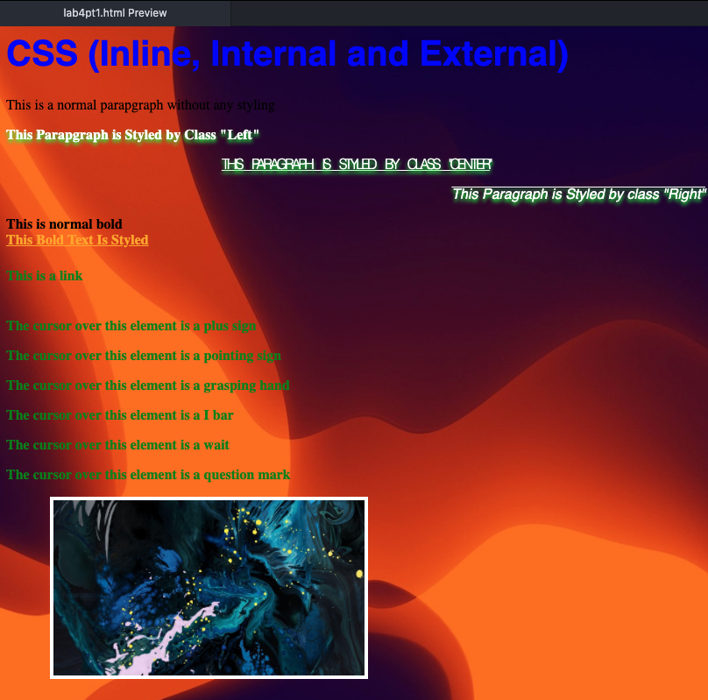

Output 2:

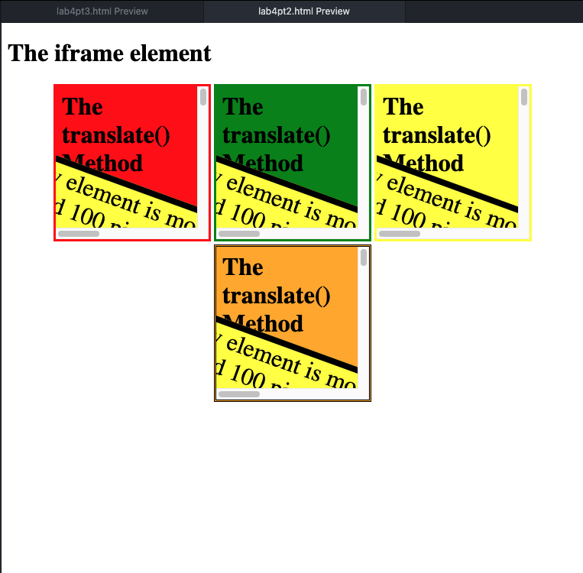

Output 3:

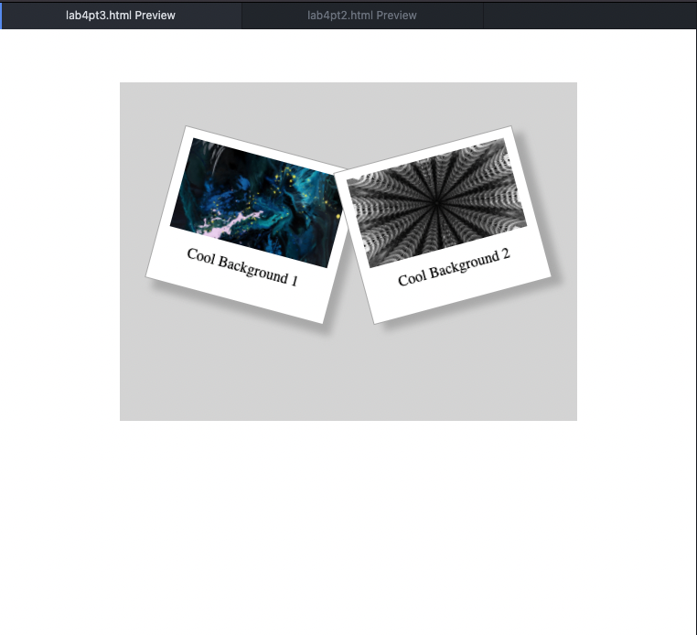

**observation and Learning:-**

We learnt about more CSS and HTML elements which help better with structuring webpages and also help to make more complicated designs on which CSS can be applied. The use of frames and div tags especially greatly aid in making better looking web pages while being able to embed media helps with functionality.

**Conclusion:-**

In this practical we learnt exhaustively and implemented HTML tags and CSS properties t make much more complicated and better looking webpages, while also learning about ways to increase functionality of the same.

**Questions:-**

1. What is grouping of Selector?

Grouping of selectors refers to applying the same set of properties and relevant values to a set of html selectors

1. What are values of ‘rel’ attribute.?

The ‘rel’ attribute of the link tag has several values to denote the relationship between the current document and the lined document.

alternate: links to an alternate version of the same document

author: links to author of the document

dns-prefetch: specifies the browser to do dns resolution for target resources’ origin

help: links to a supporting or help document

icon: links to an icon meant for document representation

license: links to copyright information

next: links next document in the series

pingback: provides address of server handling pingbacks to the document

preconnect: specifies browser to connect to target resources’ origin

preload: specifies browser to fetch and cache the target resource

prerender: specifies browser to pre-render the specified webpage in background

prev: references previous document in series

search: links to resource to be used for searching in current document and related pages

stylesheet: imports a style sheet

1. What is iFrame and how to use it on web page to open YouTube videos?

An iframe is an inline frame used for embedding another document within the current html document.

Using iframe we can embed youtube videos (considered as a document) by using the url of the video, allowing full screen and other media control options.

Eg: <iframe width="560" height="315" src="https://www.youtube.com/embed/2Z6APbAQCyE" title="YouTube video player" frameborder="0" allow="accelerometer; autoplay; clipboard-write; encrypted-media; gyroscope; picture-in-picture" allowfullscreen></iframe>