**PART-B**

|  |  |
| --- | --- |
| **Roll No.:**K041 | **Name:** Anish Sudhan Nair |
| **Prog/Yr/Sem:** B.Tech. Cybersecurity | **Batch:** K2/A2 |
| **Date of Experiment:** 28/01/2022 | **Date of Submission:** 06/02/2022 |

1. Find out the number ,whether it is palindrome or not.

Code:

<!DOCTYPE html>

<html>

<head>

<script type="text/javascript">

function palindrome() {

var rem, rev=0, no, temp;

no=Number(document.getElementById("abc").value);

temp=no;

while(no>0) {

rem=no%10;

rev=rev+rem;

rev=(rev*10);

no=parseInt(no/10);

}

rev=rev/10;

if (rev==temp) {

window.alert("This is a palindrome");

}

else {

window.alert('Not palindrome');

}

}

</script>

</head>

<body>

Enter the number: <input id="abc">

<button onclick="palindrome()">Check</button>

</body>

</html>

Output:

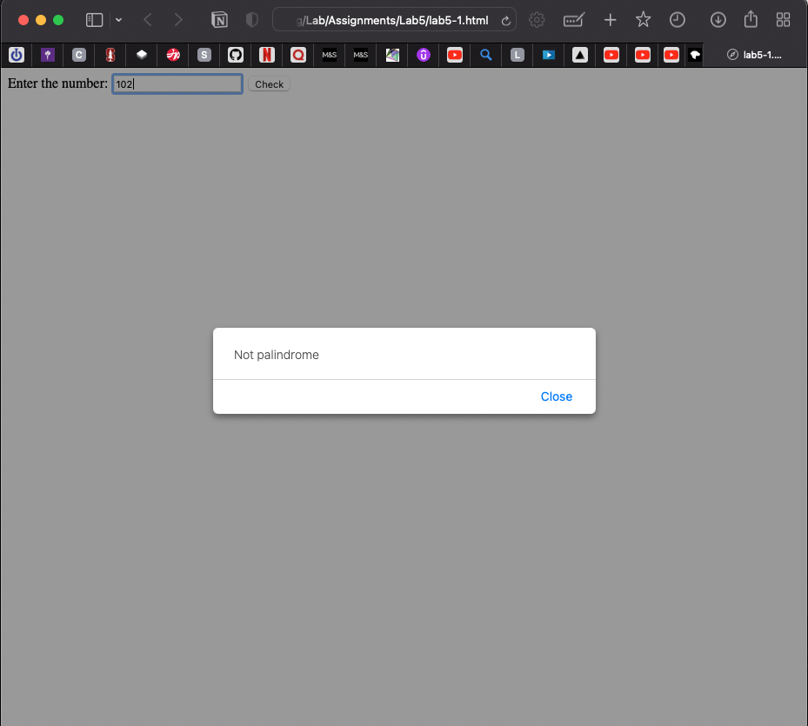

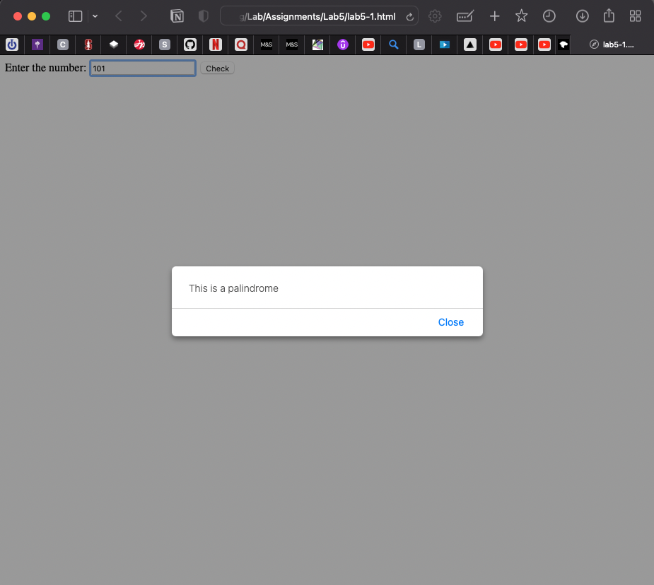

1. Reverse the digit of the given number.

Code:

<!DOCTYPE html>

<html>

<head>

<script type="text/javascript">

function reverse() {

var rem, rev=0, no, temp;

no=Number(document.getElementById("abc").value);

temp=no;

while(no>0) {

rem=no%10;

rev=rev+rem;

rev=(rev*10);

no=parseInt(no/10);

}

rev=rev/10;

alert(rev);

}

</script>

</head>

<body>

Enter the number: <input id="abc">

<button onclick="reverse()">Check</button>

</body>

</html>

Output:

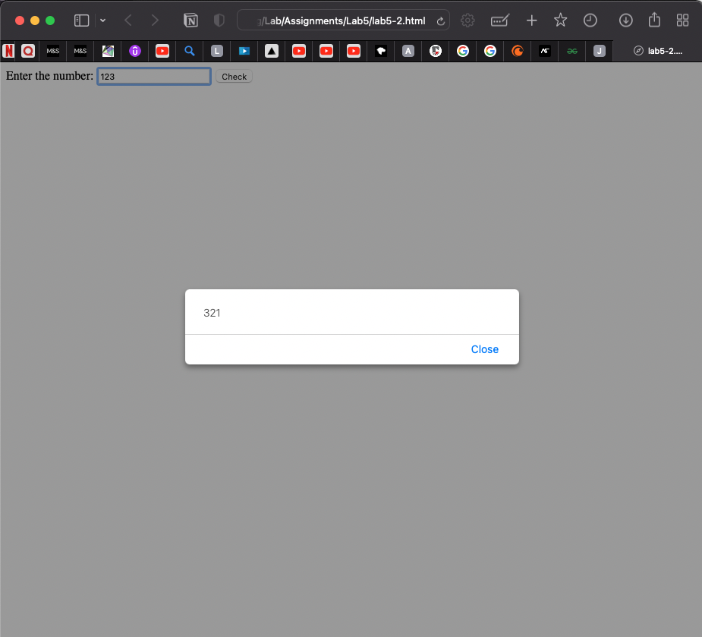

1. Write a Program in java to find the person is eligible to vote in below constraint.

- If above > 18 then can vote  
- If 18<above >=25 and Female then call them young Participants.

- If 18<above >=25 and Male then call them Youth Participants.  
- If 25<above >=40 then call them Mature Participants.  
- If 60<above then call them Senior citizen Participants

Code:

<!DOCTYPE html>

<html>

<head>

<script type="text/javascript">

function validate() {

var age=parseInt(prompt('Enter the age: '));

var gender=(prompt('Enter the gender: '));

var vote="Can't vote<br>";

var ans ="Person is ineligible";

if (age>18) {

vote="Can vote<br>";

}

if (age<=25 && age>18 && gender=="Male") {

ans="Youth participants";

}

if (age<=25 && age>18 && gender=="Female") {

ans="Young participants";

}

if (age<=45 && age>25) {

ans="Mature participants";

}

if (age<=65 && age>45) {

ans="Super Mature participants";

}

if (age>60) {

ans="Senior Citizens";

}

document.write(vote);

document.write(ans);

}

</script>

</head>

<body>

<script type="text/javascript">

validate();

</script>

</body>

</html>

Output:

For 1 test condition (24, Female)

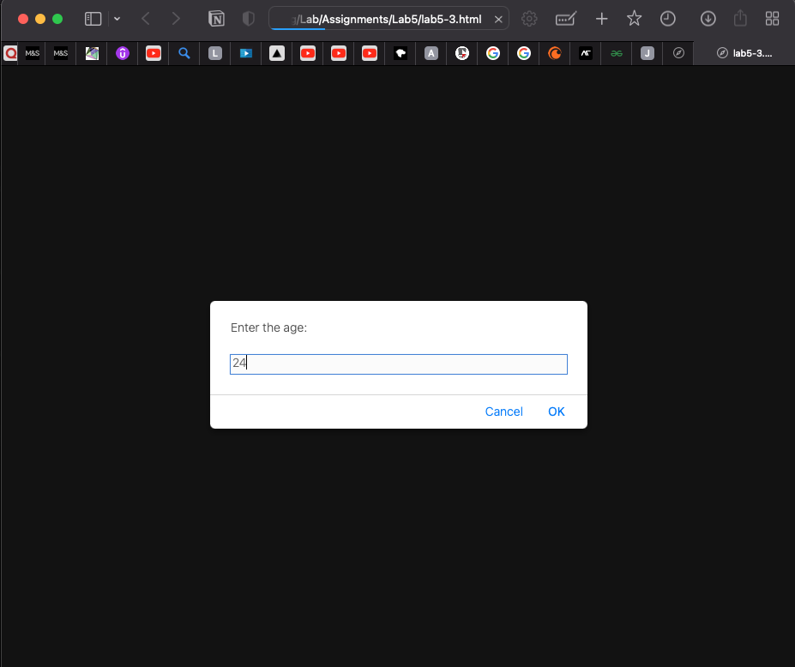

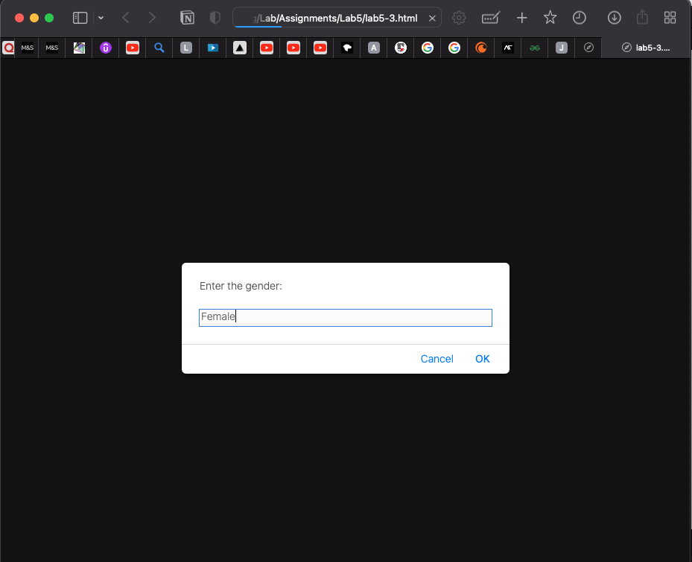

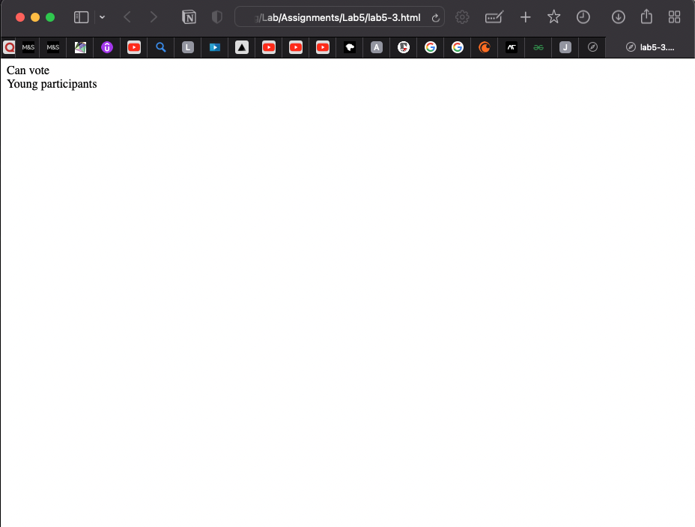

1. Find out the factorial of the number.

Code:

<!DOCTYPE html>

<html>

<head>

<script type="text/javascript">

function factorial() {

var number=parseInt(prompt('Enter the number: '));

var fact=1;

for (var i = 1; i <=number; i++) {

fact*=i;

}

document.write("Factorial of " +number + " is: "+fact);

}

</script>

</head>

<body>

<script type="text/javascript">

factorial();

</script>

</body>

</html>

Output:

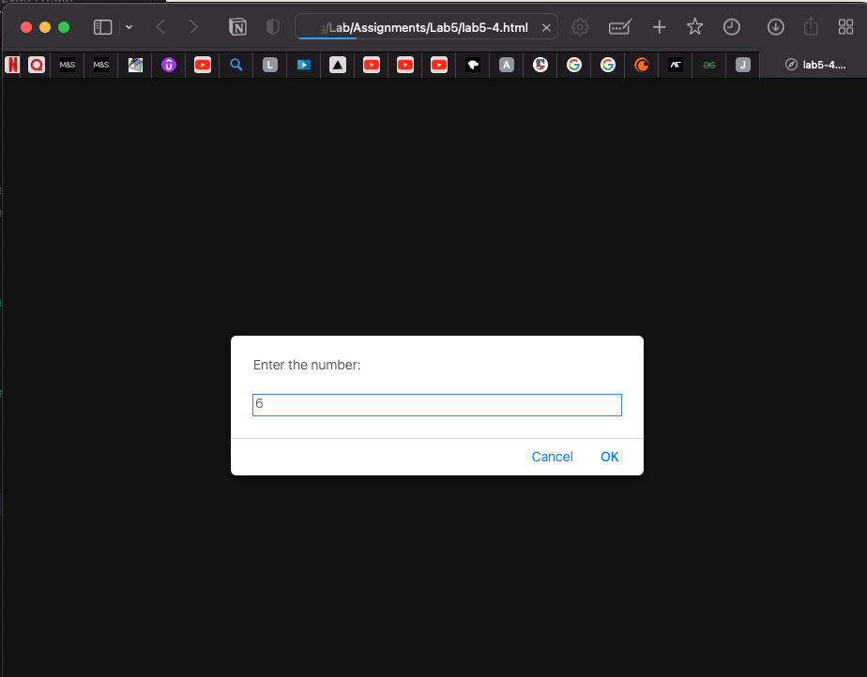

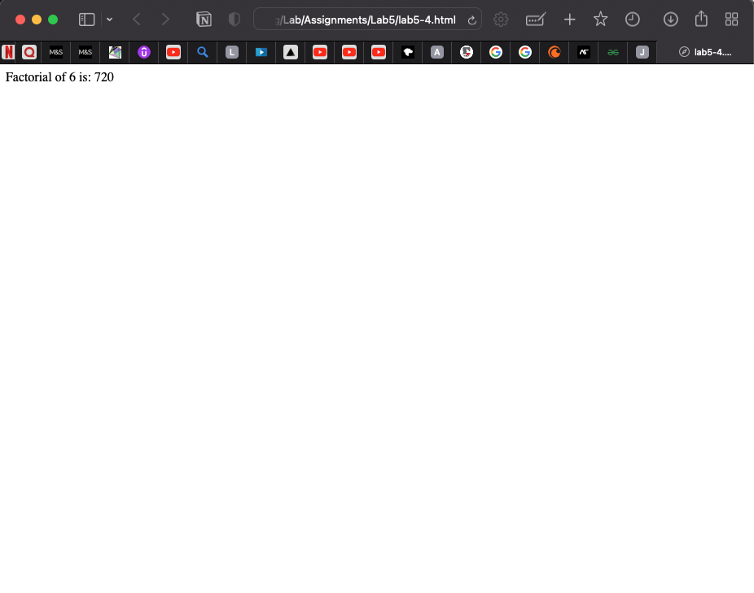

1. WAP to Find whether a given Number is divisible by 3 using an Array

[1,2,3,4,5,6,7,8,9,20].

Code:

<!DOCTYPE html>

<html>

<head>

</head>

<body>

<script type="text/javascript">

var marks=[1,2,3,4,5,6,7,8,9,20];

for (var i = 0; i < marks.length; i++) {

if (marks[i]%3==0) {

document.write(marks[i]+" is divisible by 3 <br />")

}

}

</script>

</body>

</html>

Output:

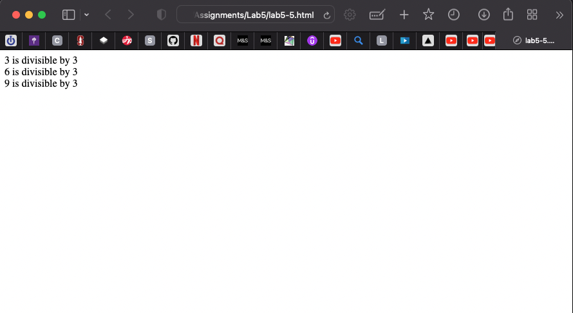

1. Write a Code using Java script as to print following details on HTML pages

- Name  
- College Name

- College Site

- Address

Code:

<!DOCTYPE html>

<html>

<head>

</head>

<body>

<script type="text/javascript">

document.write("<h4>Anish Sudhan Nair</h4>")

document.write("<h5>MPSTME</h5>" + "<h6>NMIMS</h6>")

document.write("<p>Bhakti Vedant, Sahar Rd, near Cooper Hospital, JVPD Scheme, Vile Parle West, Mumbai, Maharashtra 400056</p>")

document.write("<a href='https://engineering.nmims.edu'>College Website</a>")

// use different kind of quotes for the href's target url to differentiate it from the enclosing ones - single if double and vice versa

</script>

</body>

</html>

Output:

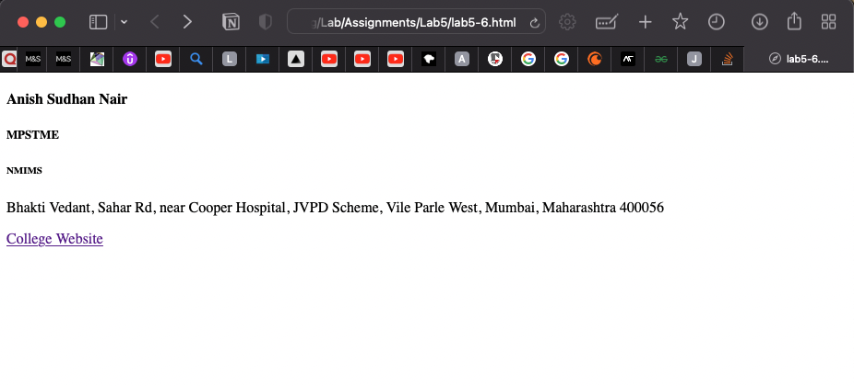

1. WAP to find average of marks of n subjects entered by user using “for loop” with java script.

Code:

<!DOCTYPE html>

<html>

<head>

</head>

<body>

<script type="text/javascript">

var sub1=parseInt(prompt('Enter the marks for subject 1: '));

var sub2=parseInt(prompt('Enter the marks for subject 2: '));

var sub3=parseInt(prompt('Enter the marks for subject 3: '));

var sub4=parseInt(prompt('Enter the marks for subject 4: '));

// var marks=[45,67,89,30];

var marks=[sub1, sub2, sub3, sub4]

var total=0;

for (var i = 0; i < marks.length; i++) {

total+=marks[i];

}

var avg=(total/marks.length);

document.write("The average of the marks is "+avg);

</script>

</body>

</html>

Output:

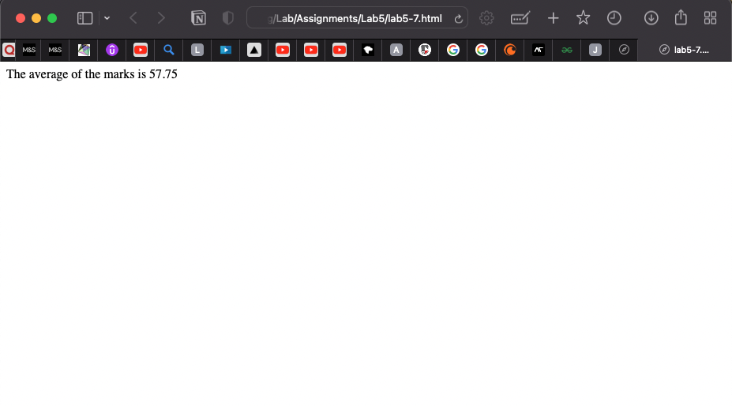

**observation and Learning:-**

We were introduced to JavaScript, its basic syntax and means of incorporating within the codes of existing web pages made of CSS and HTML. We further learnt to write text and answers derived from logical arithmetic on the web page by using basic operators, loops like for and conditional statements. We also learnt to work on arrays and also take input from users via prompts for various calculations. JavaScript helps to greatly increase the functionality of a web page.

**Conclusion:-**

In this practical we learnt about basic JavaScript and its simple implementation in web pages.

**Questions:-**

1. What is meaning of inner html?

innerHTML is used to interact with HTML elements from within JavaScript. It can be used to either return the content of an HTML element or set its content.

1. What is the meaning of DOM?

DOM which stands for Document Object Model is a tree structure of all the HTML elements in a web page that is created by the browser when the page is loaded. JavaScript therein uses the DOM to manipulate and interact with the HTML elements in that page.

1. What is JavaScript needed to be used in conjunction with HTML for building webpages?

The main advantage of using JavaScript in a webpage is the dynamic interaction that it allows for. It enables users to interact with the page without having to reload it every time and can update and data and manipulate the elements and front end in real time on interacting with the user. This, apart from increasing the functionality of the page, enables to make it look and feel better than a static HTML only web page.