Transition 3

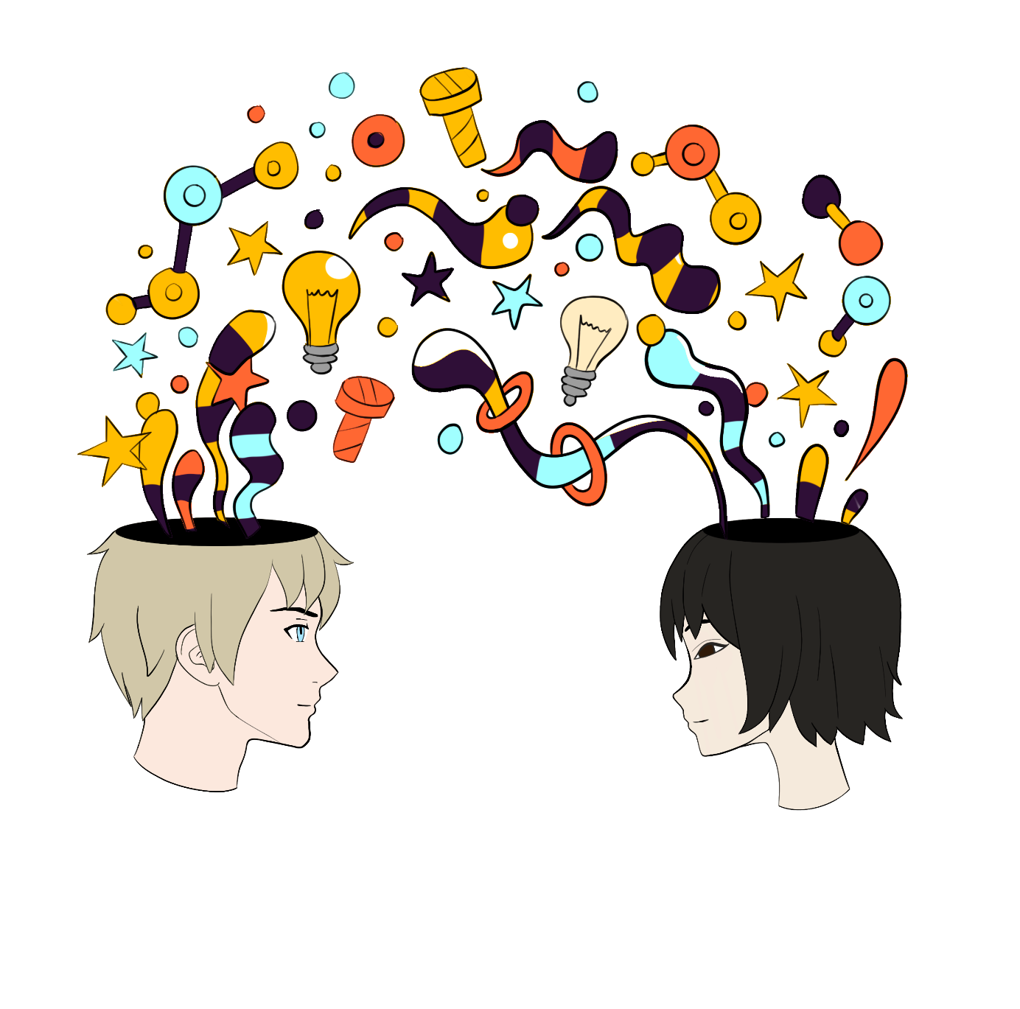

You are not meant to walk alone in this

Engage

Execute

Equip

Transition 2

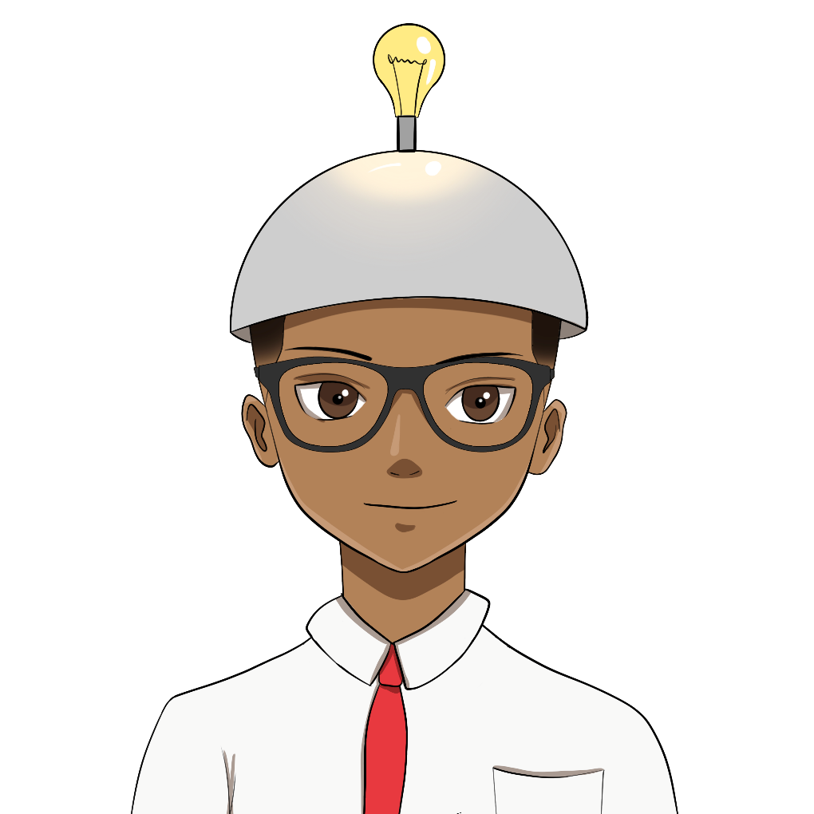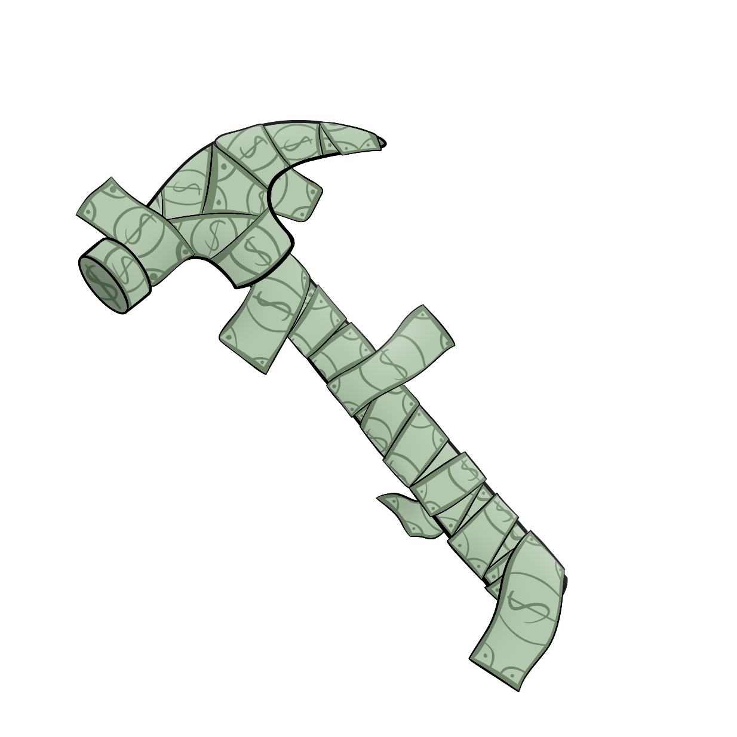Transition 1

You are born to have an impact on this Earth

Engage

Execute

Equip

Engage

Money is tool. Let’s first equip ourselves then together we will build something great.

Engage

Equip

Execute