**Liber Web Update**

Home Page

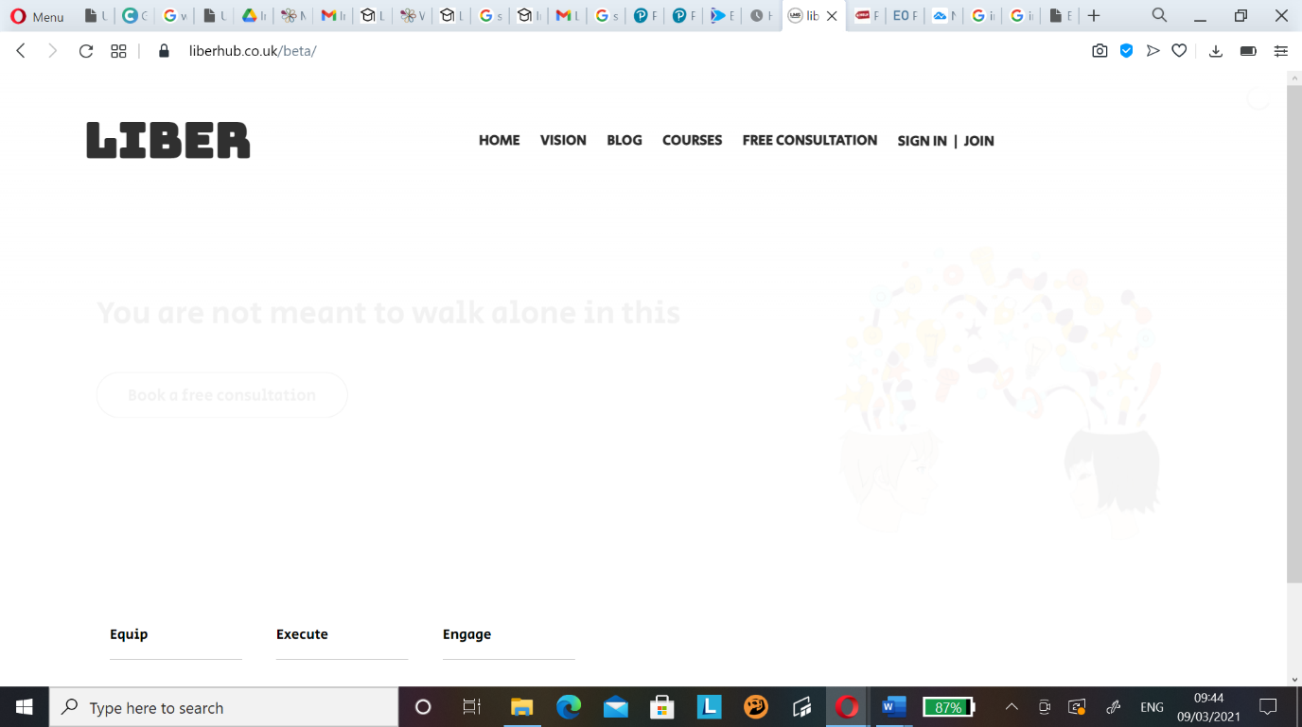

Will be putting a logo in this space so if we can shift the LIBER title to the right and the menu bar to the left away from the SIGN IN/JOIN with room for the Instagram and mail icon. If you could find some black and white icons for that if you have any that would be great and then link it to my email and insta page for the site.

_ _ _ _ _ _ _ _ _ _ _ _ _ _ _ _ _ _ _ _ _ _ _ _ _ _ _ _ __ _ __ _ __ _ _ __ _ _ __ _ __ _ __ _ __ _

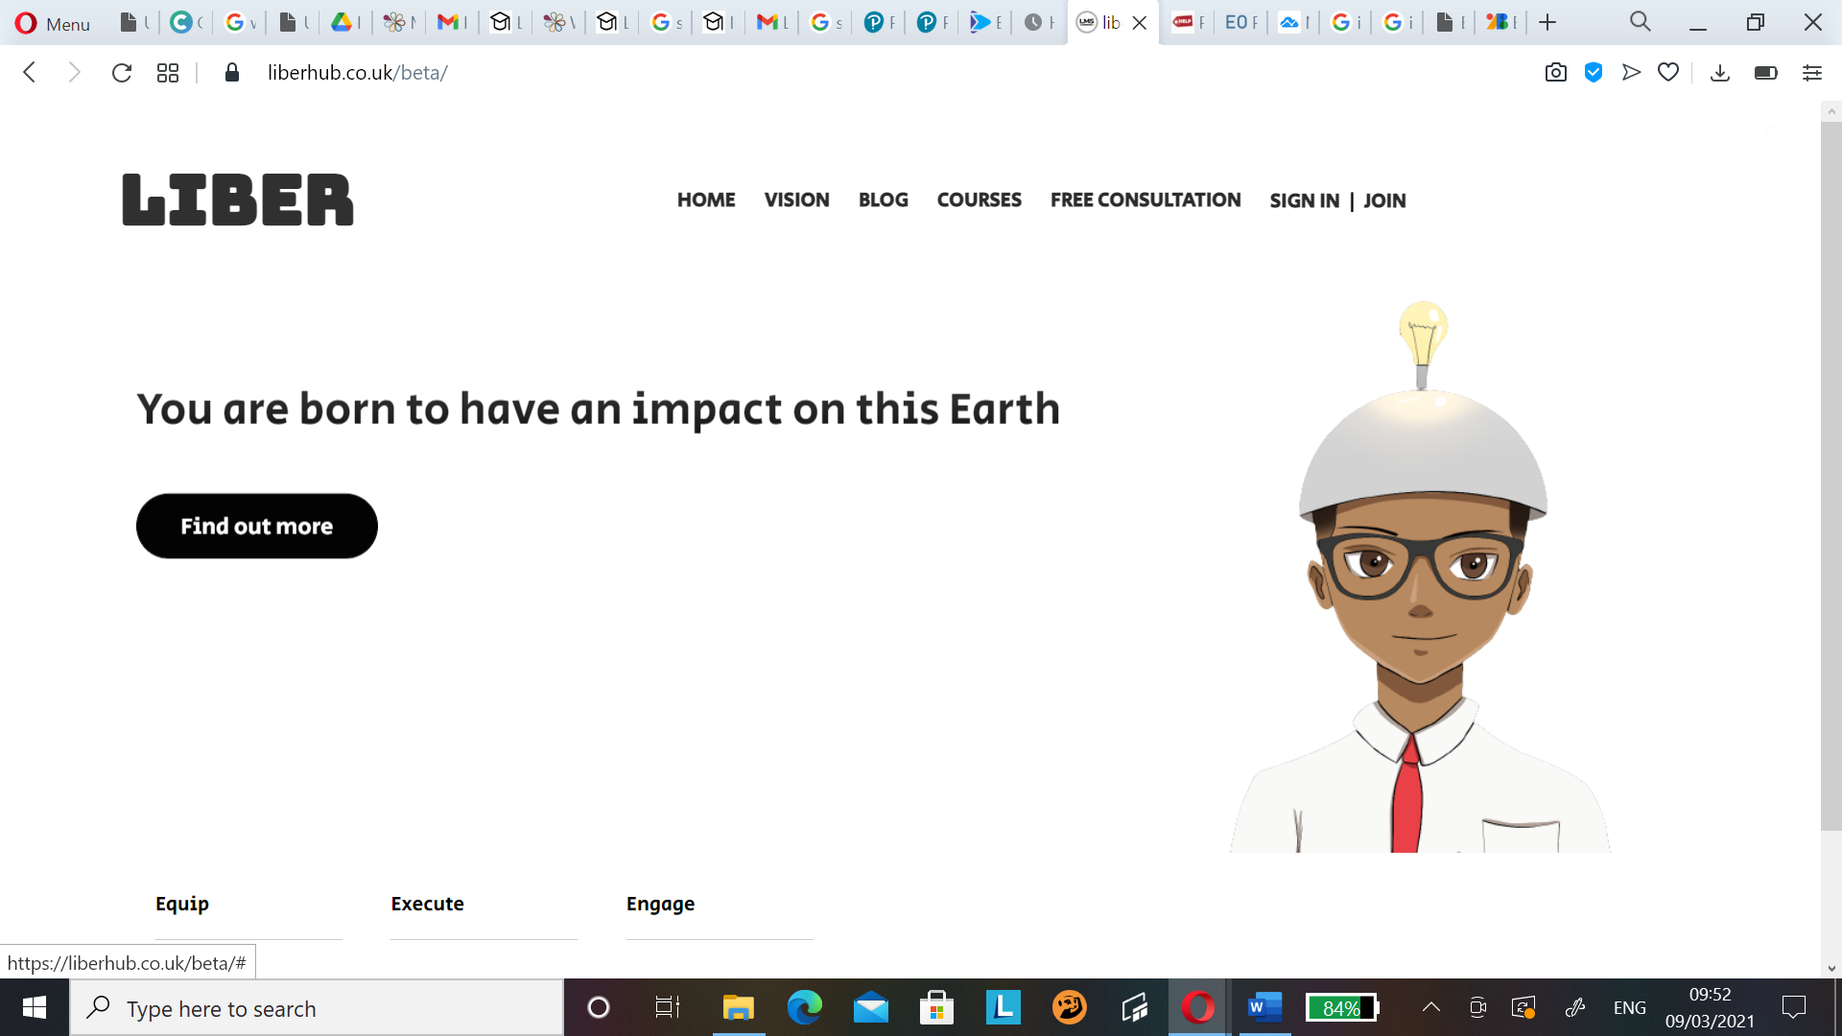

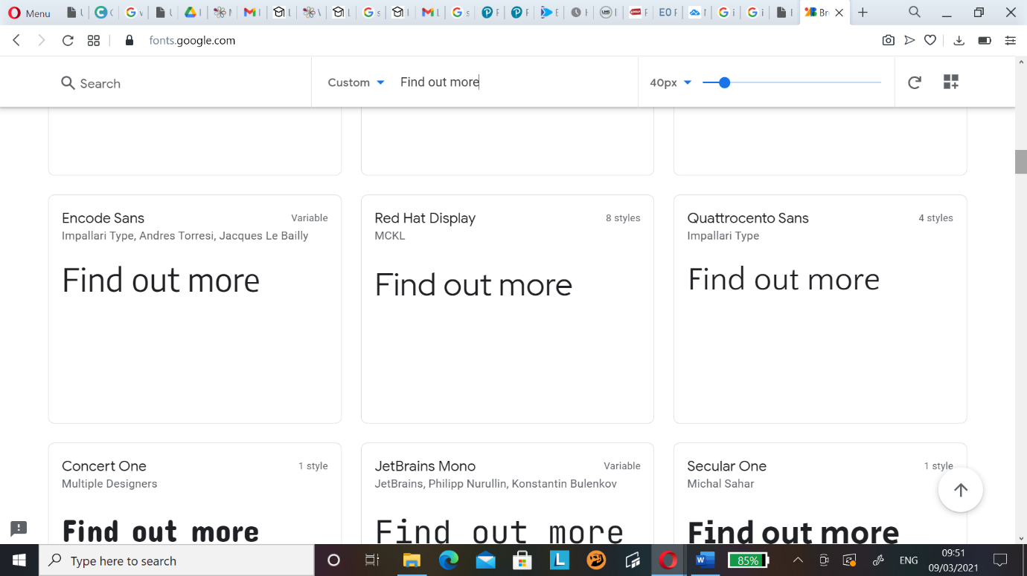 I would like a change of font for this section. Also, when could the writing be this effect instead:

This colour scheme instead. Loading bar strip should be this colour also.

_ _ _ _ _ _ _ _ _ _ _ _ _ _ _ _ _ _ _ _ _ _ _ _ _ _ _ _ __ _ __ _ __ _ _ __ _ _ __ _ __ _ __ _ __ _

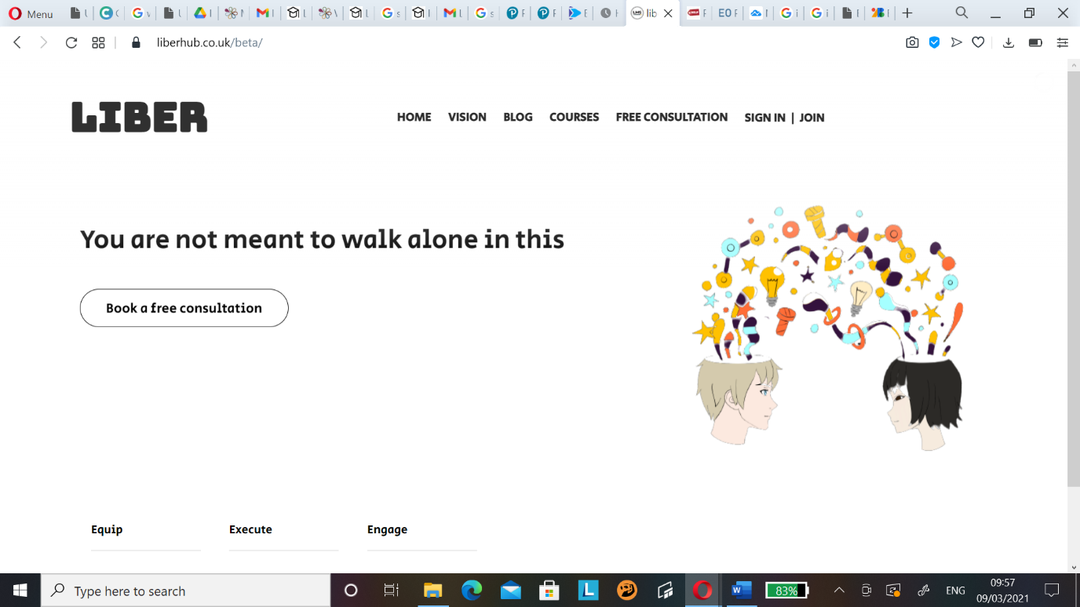Enlarge images to fill that space there

_ _ _ _ _ _ _ _ _ _ _ _ _ _ _ _ _ _ _ _ _ _ _ _ _ _ _ _ __ _ __ _ __ _ _ __ _ _ __ _ __ _ __ _ __ _

When you click a page on the menu bar the page your on should be underlined.

_ _ _ _ _ _ _ _ _ _ _ _ _ _ _ _ _ _ _ _ _ _ _ _ _ _ _ _ __ _ __ _ __ _ _ __ _ _ __ _ __ _ __ _ __ _



All the black strip sections with the name of the page on them should be removed and bring all the page content up into that prior occupied space. Search bar can be taken away also. It is like this on every other page so it can be removed on all of them.

_ _ _ _ _ _ _ _ _ _ _ _ _ _ _ _ _ _ _ _ _ _ _ _ _ _ _ _ __ _ __ _ __ _ _ __ _ _ __ _ __ _ __ _ __ _

Course page should have this set up:

Should be transitions of these images. Starts on the left.

Left: image to do with the course.

Once you hover over the image the right effect takes place.

Right: Title is the blue box and underneath brief summary of course.

If you are a member when you click it will take you into the course. If not then you will be taken to a hidden page where it has subscription options. We can decide what that will look like later.

_ _ _ _ _ _ _ _ _ _ _ _ _ _ _ _ _ _ _ _ _ _ _ _ _ _ _ _ __ _ __ _ __ _ _ __ _ _ __ _ __ _ __ _ __ _

Registering – should be taken to a page of subscription choices – for monthly payments there should be a mini form to fill as I am going to personally verify monthly subs – as for annual at once payments they can go ahead without authorisation. So they can be taken straight to Stripe integration page once selected.