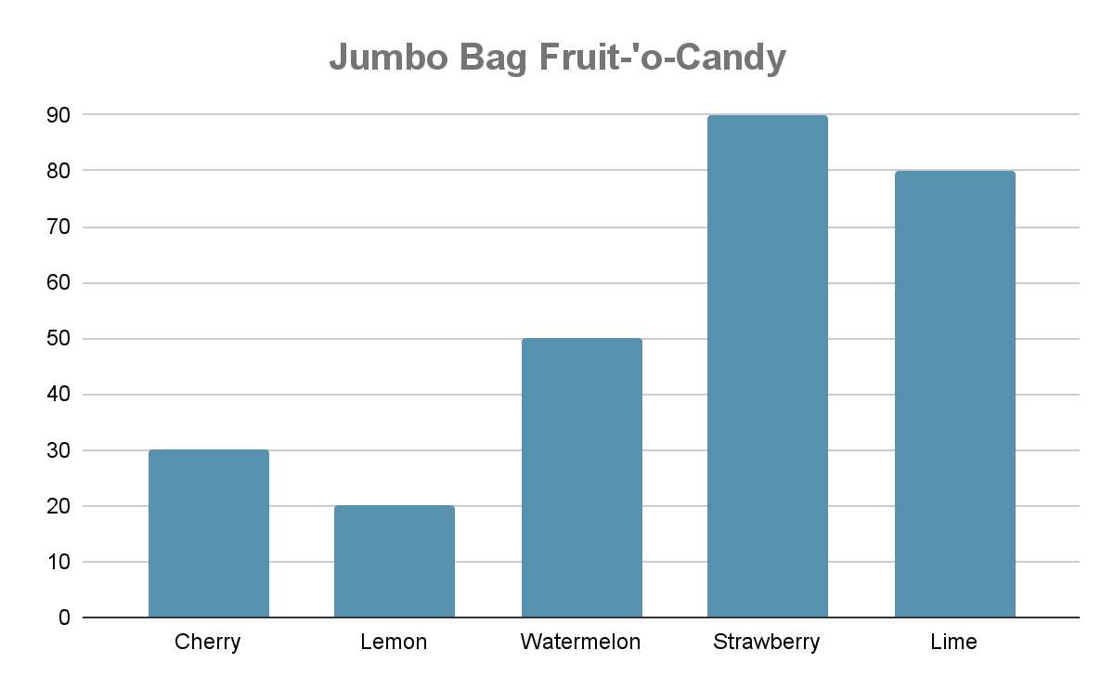

| **Add**     |  |  |  |  |  | | --- | --- | --- | --- | --- | |  | 2 | 2 | 0 | 8 | | + | 2 | 7 | 3 | 2 | |  |  |  |  |  | | **Subtract**   |  |  |  |  |  | | --- | --- | --- | --- | --- | |  | 4 | 2 | 2 | 3 | | **-** | 3 | 3 | 4 | 2 | |  |  |  |  |  | |
| --- | --- | --- | --- | --- | --- | --- | --- | --- | --- | --- | --- | --- | --- | --- | --- | --- | --- | --- | --- | --- | --- | --- | --- | --- | --- | --- | --- | --- | --- | --- | --- | --- | --- | --- | --- | --- | --- | --- | --- | --- | --- |
| **Multiply**  3 x 12 | **Divide**  32 ➗ 4 |
| **Fractions**  **Compare - which is bigger?**  10 ◯ 5  ^Fraction2.1 ◯ ^Fraction2.2  **Plot this fraction on the numberline**  ^Fraction3.1 | **Graphing (Picture)**  ^Insert graph (bar, line, pictograph with legend)  ^GraphQ1  ^GraphQ2  ^GraphQ3 |
| **Elapsed Time**  ^StoryQ1 |