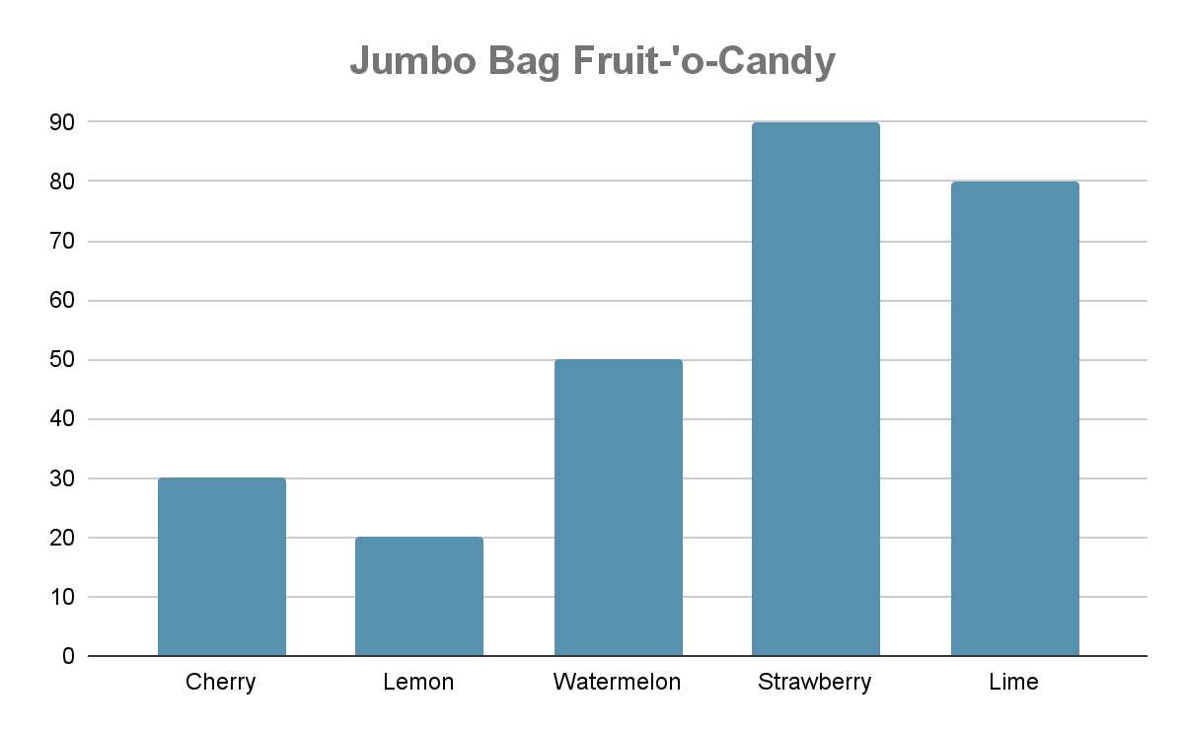

| **Add**     |  |  |  |  |  | | --- | --- | --- | --- | --- | |  | 4 | 2 | 9 | 6 | | + | 2 | 1 | 1 | 9 | |  |  |  |  |  | | **Subtract**   |  |  |  |  |  | | --- | --- | --- | --- | --- | |  | 0 | 7 | 2 | 9 | | **-** | 0 | 4 | 1 | 6 | |  |  |  |  |  | |
| --- | --- | --- | --- | --- | --- | --- | --- | --- | --- | --- | --- | --- | --- | --- | --- | --- | --- | --- | --- | --- | --- | --- | --- | --- | --- | --- | --- | --- | --- | --- | --- | --- | --- | --- | --- | --- | --- | --- | --- | --- | --- |
| **Multiply**  10 x 4 | **Divide**  14 ➗ 7 |
| **Fractions**  **Compare - which is bigger?**  2 ◯ 6  ^Fraction2.1 ◯ ^Fraction2.2  **Plot this fraction on the numberline**  ^Fraction3.1 | **Graphing (Picture)**  ^Insert graph (bar, line, pictograph with legend)  ^GraphQ1  ^GraphQ2  ^GraphQ3 |
| **Elapsed Time**  ^StoryQ1 |