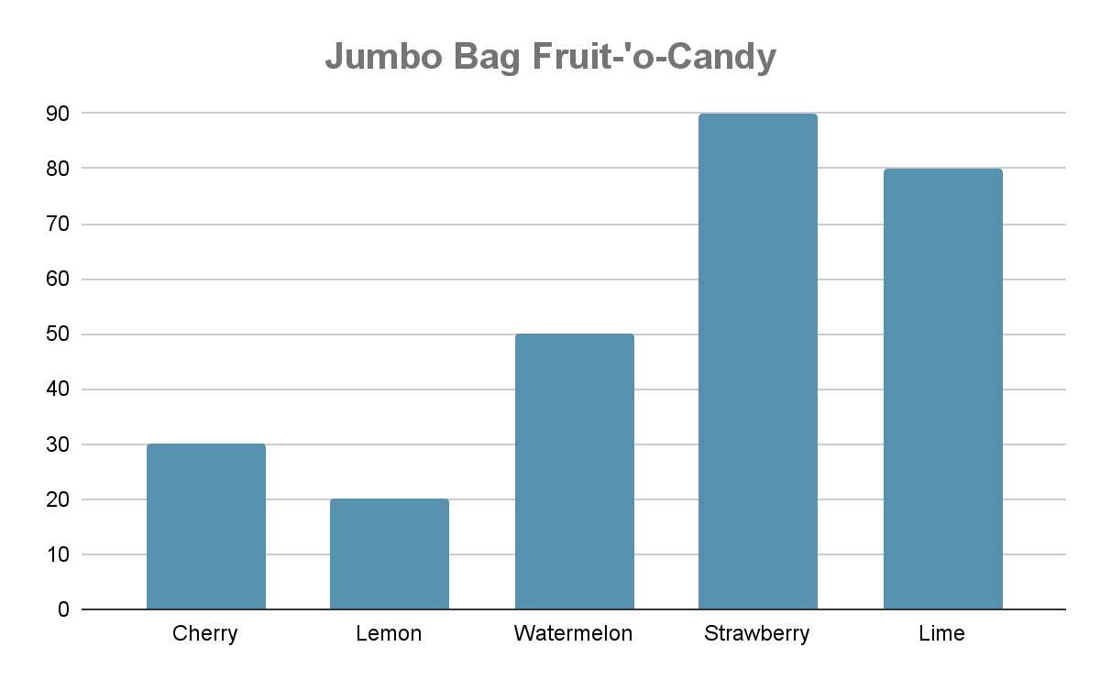

| **Add**     |  |  |  |  |  | | --- | --- | --- | --- | --- | |  | 3 | 7 | 0 | 2 | | + | 1 | 0 | 6 | 0 | |  |  |  |  |  | | **Subtract**   |  |  |  |  |  | | --- | --- | --- | --- | --- | |  | 3 | 1 | 3 | 1 | | **-** | 0 | 6 | 0 | 0 | |  |  |  |  |  | |
| --- | --- | --- | --- | --- | --- | --- | --- | --- | --- | --- | --- | --- | --- | --- | --- | --- | --- | --- | --- | --- | --- | --- | --- | --- | --- | --- | --- | --- | --- | --- | --- | --- | --- | --- | --- | --- | --- | --- | --- | --- | --- |
| **Multiply**  2 x 9 | **Divide**  18 ➗ 2 |
| **Fractions**  **Compare - which is bigger?**  3 ◯ 4  ^Fraction2.1 ◯ ^Fraction2.2  **Plot this fraction on the numberline**  ^Fraction3.1 | **Graphing (Picture)**  ^Insert graph (bar, line, pictograph with legend)  ^GraphQ1  ^GraphQ2  ^GraphQ3 |
| **Elapsed Time**  ^StoryQ1 |