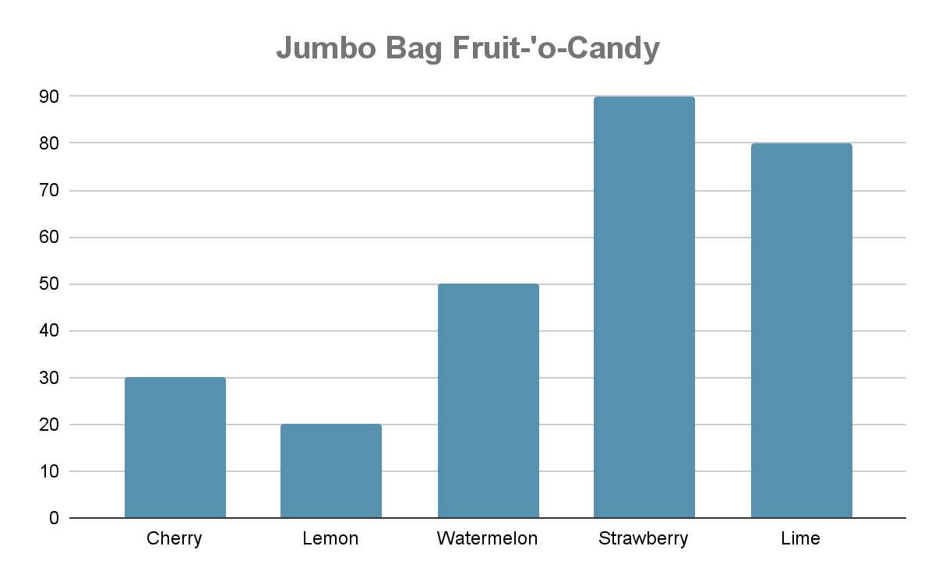

| **Add**     |  |  |  |  |  | | --- | --- | --- | --- | --- | |  | ^Add1.4 | ^Add1.3 | ^Add1.2 | ^Add1.1 | | + | ^Add2.4 | ^Add2.3 | ^Add2.2 | ^Add2.1 | |  |  |  |  |  | | **Subtract**   |  |  |  |  |  | | --- | --- | --- | --- | --- | |  | ^Sub1.4 | ^Sub1.3 | ^Sub1.2 | ^Sub1.1 | | **-** | ^Sub2.4 | ^Sub2.3 | ^Sub2.2 | ^Sub2.1 | |  |  |  |  |  | |
| --- | --- | --- | --- | --- | --- | --- | --- | --- | --- | --- | --- | --- | --- | --- | --- | --- | --- | --- | --- | --- | --- | --- | --- | --- | --- | --- | --- | --- | --- | --- | --- | --- | --- | --- | --- | --- | --- | --- | --- | --- | --- |
| **Multiply**  ^Multi1 x ^Multi2 | **Divide**  ^Div1 ➗ ^Div2 |
| **Fractions**  **Compare - which is bigger?**  ^Fraction1.1 ◯ ^Fraction1.2  ^Fraction2.1 ◯ ^Fraction2.2  **Plot this fraction on the numberline**  ^Fraction3.1 | **Graphing (Picture)**  ^Insert graph (bar, line, pictograph with legend)  ^GraphQ1  ^GraphQ2  ^GraphQ3 |
| **Elapsed Time**  ^StoryQ1 |