Building a New Project
- In Project Setup, set Targeted Project Type to Empty
- To disable FPU compilation
  - Right Clock on Project directory and click Properties
  - Under C/C++ Build, select Settings.
  - Clock the Tool Settings tab
  - Select MCU/MPU Settings
  - Set Floating-point unit to None
  - set Floating-point ABI to Software implementation
  - Apply. Apply and Close
- To Debug
  - Right click Project
  - Hover over Debug as and select STM32 Cortex-M C/C++ Application
  - Under Debugger, set Debug probe to ST-LINK (GDB server)
  - Enable Serial Wire Viewer

SWV Working Principle
- SWO (Serial Wire Output)
  - works over SWD (Serial Wire Debugger) interface
  - connected to ITM and SWD, and goes to ST link ckt (usb debugger)
- Cortex M4 and up MPUs have ITM unit
  - Instrumentation Trace Macrocell Unit
  - supports printf style debugging
  - has hardware fifo where printf data is written, and is connected to SWO pin
- MPU has SWD connector (Serial Wire Debugger)
  - 2 pins for debug, 1 for trace
    - Debug: SWDIO: bidirectional data line
    - Debug: SWCLK: clock driven by host
    - Trace: SWO (Serial Wire Output) used for printf functionality
  - alternative to JTAG debugging
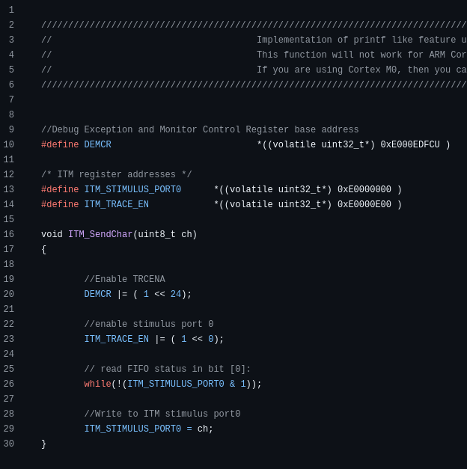
- The TRCENA register has to be enabled in order for the fifo to be read/written.
- The ITM_TRACE_EN has to be enabled to utilize port 0 of the ITM trace.
- Wait for the status to be true.
- Write character to port

Understanding Memory Map of MCU
- System Bus: 32 bits
- Processor can produce 2^32 of different addresses. 4Gb
  - 0x0000_0000 to 0xffff_ffff
- When the processor produces address 0x4002 0000 - 0x4002 03FF on the system bus, it is referring to GPIOA registers. This was given from section 2.3 Memory Map in the reference manual. Pg 65
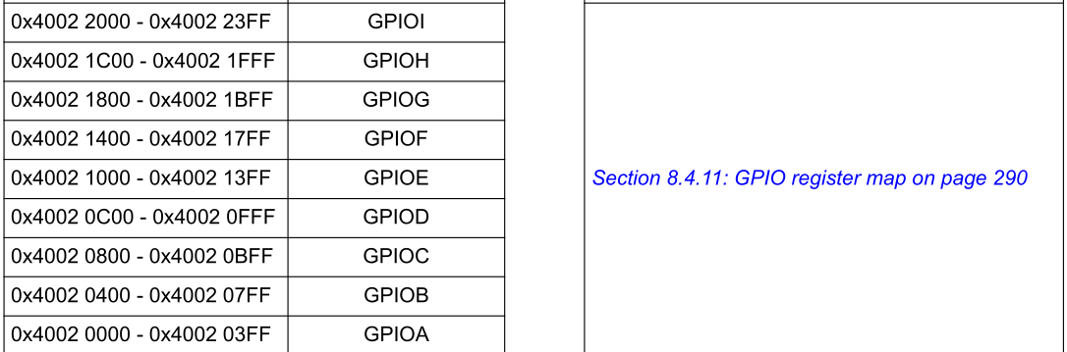

MCU Bus Interfaces
- Buses from the MPU (Arm Cortex M4)
  - I-Bus: Instruction
  - D-Bus: Data
  - S-Bus: System
- String literals and constant data values are stored in the ROM (Flash Memory)
  - Not constant data is stored in the SRAM
  - Flash stores instructions, constant data, and vector tables
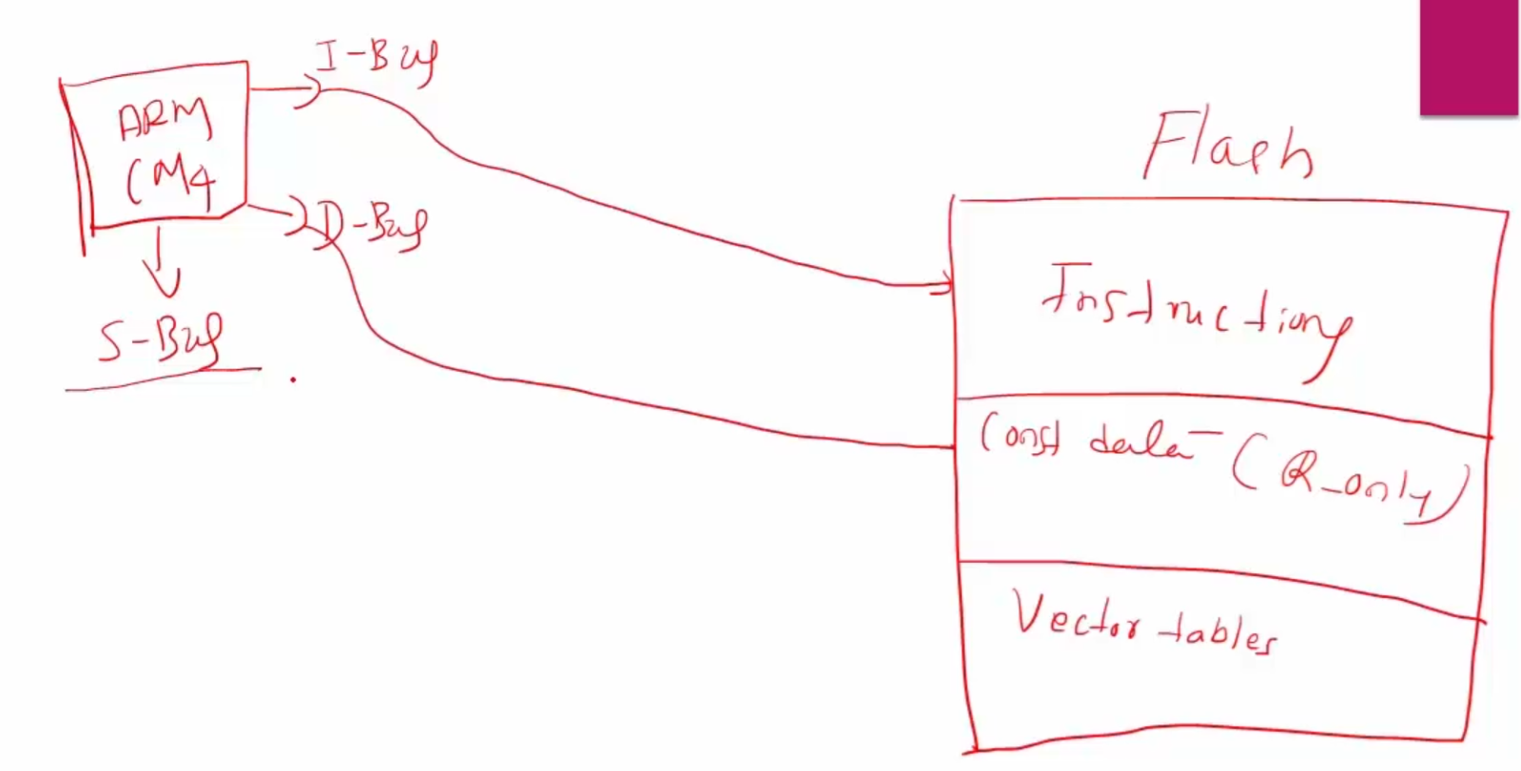

- I-bus connects to instructions in flash. D-bus connects to const data in flash.
- Use I-bus to fetch instructions between 0x0 and 0x1FFFFFFC and will use the system bus if outside this range.
- Use D-bus to fetch data between 0x0 and 0x1FFFFFFF and use System bus if outside this range
- AHB/APB bridges (Advanced High-performance Bus / Advanced Peripheral Bus) are for carrying data across the mcu between the MPU, SRAMs, GPIOs and other components.

Clocks
- Sources
  - Crystal Oscillator
    - external component to the mcu
    - HSE – High speed external
  - RC Oscillator
    - comes inside mcu (not external component)
    - HSI – High speed internal
  - PLL (Phase Locked Loop)
    - Generates high frequency from low frequency
    - Internal to MCU
    - Get high frequency clock in mcu
- RCC – Reset and Clock Control
- HCLK – AHB clock – derived from system clock
- Before using any peripheral, you must enable its peripheral clock
  - managed thru RCC registers
  - steps:
    - find which bus the peripheral uses (APB1 or APB2 or etc)
    - find RCC bus peripheral clock enable register (rcc base address + offset) and enable it

