MINI PROJECT REPORT ON

**ANALOG FUNCTION GENERATOR**



SUBMITTED FOR MINI PROJECT OF ANALOG FUNCTION GENERATOR

### By

**M. AASHRITH - 23EEB0B03**

**SD. ASLAM SHAREEF - 23EEB0B15**

**B. AJAY KUMAR – 23EEB0B24**

**DEPARTMENT OF ELECTRICAL AND ELECTRONICS ENGINEERING**

**NATIONAL INSTITUTE OF TECHNOLOGY, WARANGAL TELANGANA-506004**

# Analog Function Generator

## 1. Introduction

The function generator is an essential electronic device used to generate various waveforms such as square, triangular, sawtooth, and sine waves. It is widely used in testing and development of electronic circuits. This report focuses on the design and development of an analog function generator using operational amplifiers and transistors.

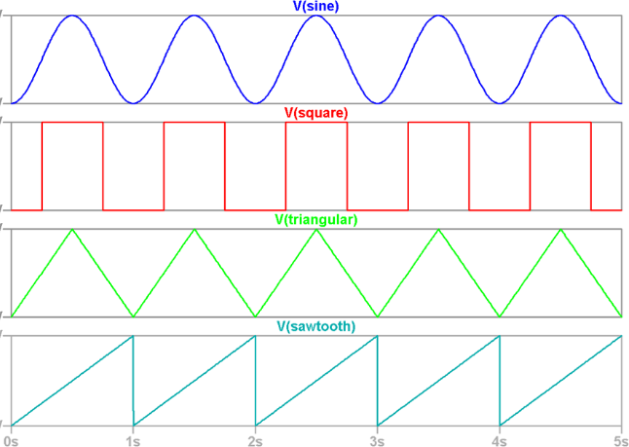

*Figure 1 - Different types of waveforms*

## 2. Objective

The objective of this project is to design and develop a low-cost analog function generator capable of producing multiple waveforms with adjustable amplitude and frequency. The function generator should provide a stable output while maintaining low distortion levels and high efficiency.

## 3. Components Used

- Operational Amplifiers (TL072, LM741)  
- Resistors and Capacitors  
- Diodes and Transistors  
- Rotary Switch  
- Step-down Transformer (15V)  
- Rectifier Bridge  
- Voltage Regulators (LM7812, LM7912)  
- Potentiometers  
- PCB Board

## 4. Working Principle

The function generator operates by utilizing different circuit configurations to generate various waveforms. An operational amplifier-based oscillator circuit is used to generate the basic waveforms. A feedback mechanism stabilizes the amplitude and ensures accurate frequency generation. Additional circuits, such as push-pull amplifiers, help modify and enhance the waveforms.

## 5. Circuit Operation

**Waveform Generation**

**1.Square Wave**

The square wave as well as the triangular waves are combined together, which means that the output of one circuit acts as input of the other. The square wave was just the result of the comparator property of the Op-Amp used. The triangular wave was sent through the inverting input and a threshold voltage was set with the help of a feedback resistor and an input resistor. To change the frequency of the wave we are going to use a potentiometer in the place of R3 with a fixed resistor.

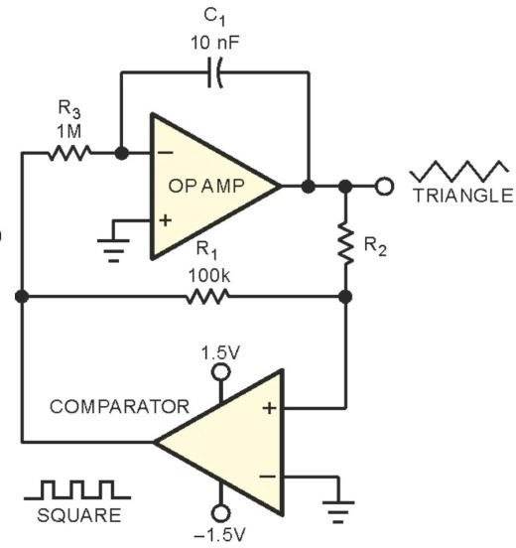

*Figure 2 - Square & triangular waveform generating circuit*

The solitary-comparator circuit uses a relaxation oscillator approach with the triangle approximation assuming an RC nature and by adding an integrator improves the triangle approximation. The circuit includes a hysteretic-feedback path as well as an RC or integrator feedback path comprising R3 and C1. The hysteretic-feedback path keeps changing the direction of the RC integrator and setting the new target voltage, and the RC integrator sets the rate of change toward the new target.

In the above circuit, we can calculate the frequency using the following equation.

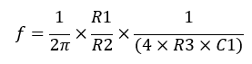

So, we are planning to change the frequency of the waveform using R3 resistor and C1 capacitor fixing the resistors R1 & R2.

**2.Triangular Wave**

As shown in the figure 2 the integral Op-Amp is used in generate triangular wave from square wave. The square wave output was input to the Op-Amp with a capacitance and an input resistor value which makes the Op- Amp to act as a desired integrator. The frequency of the wave can be changed in the same way by changing the frequency of the square wave.

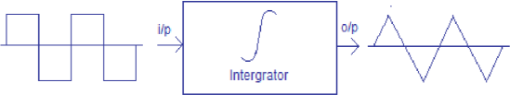

*Figure 3- integrator*

**3.Sawtooth Wave**

We plan to generate the sawtooth waveform from the same output pin where the triangular wave is generated. The only change made in the circuit is, if the non-inverting input of the Op-Amp is set to ground triangular wave is generated whereas if that is set to a potentiometer with a varying voltage a sawtooth waveform is generated. The modification is given below.

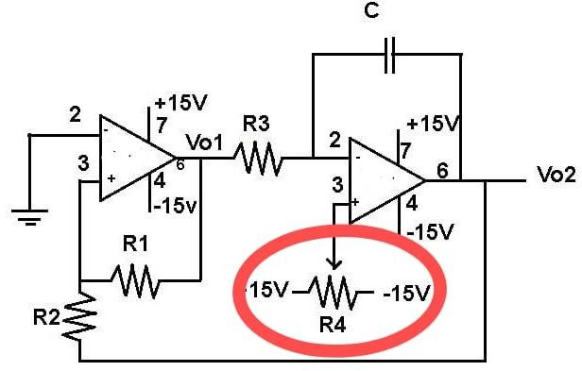

*Figure 4 - Sawtooth generation circuit*

**4.Sine Wave**

To obtain the sine waveform, we plan to use the Wein bridge oscillator circuit. The circuit is stabilized for controlling the gain. The Wein bridge oscillator has two capacitors, of which the values should be equal to each other. The frequency range is selected using these capacitors, while the variable resistor is used to obtain a specific frequency within the selected range.

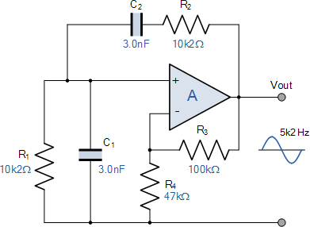

*Figure 5 - Wein Bridge Oscillator*

Hence, here is a frequency point where the maximum Vout can be occurred and it is known as oscillator resonance frequency(fr) At fr, Xc = R and phase difference between input and output is zero.

The circuit contains two RC pairs where in one R & C are in series and in the other the R & C are in parallel. Both the series and parallel RC combinations combined together to make a frequency dependent voltage divider. The output of the operational amplifier (op amp) is fed back to both the inputs of the op amp, through a feedback resistor to the inverting input and through the series RC combination to the non-inverting input. The whole combination generates a sine wave at the resonance frequency(fr), given by the equation,

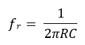

Fr -resonant frequency

R-Resistance

C- Capacitance

In this circuit, in series and parallel RC

combinations, two resistors and two capacitors have to be of the same value.

**5.Power Supply Circuit**

We have to create +15V and -15V DC power supply to perform our expected task. Since the function generator is a laboratory equipment and it is used for a long time, we planned to supply the voltage using an AC power supply. We are going to use a step down transformer of 18V, a rectifier bridge and LM7812 and LM7912 regulators for this purpose.

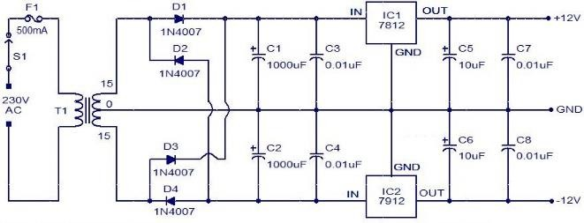

Figure 6 - Power Supply Circuit

**SIMULATIONS**

**1.Sine Wave**

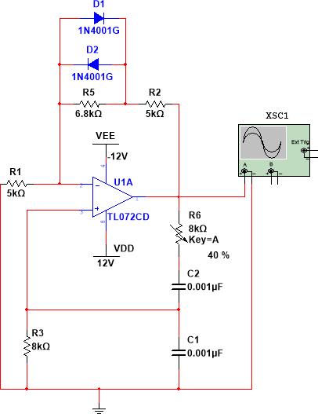

**-15V**

**15V**

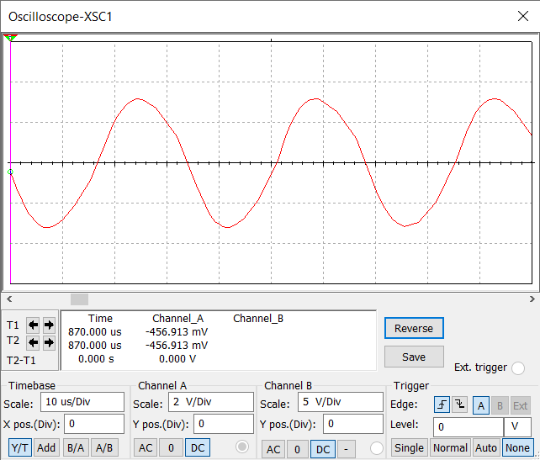

*Figure 7 - Sine Wave Simulation*

**2.Triangular, Square, Sawtooth, & PWM**

## 

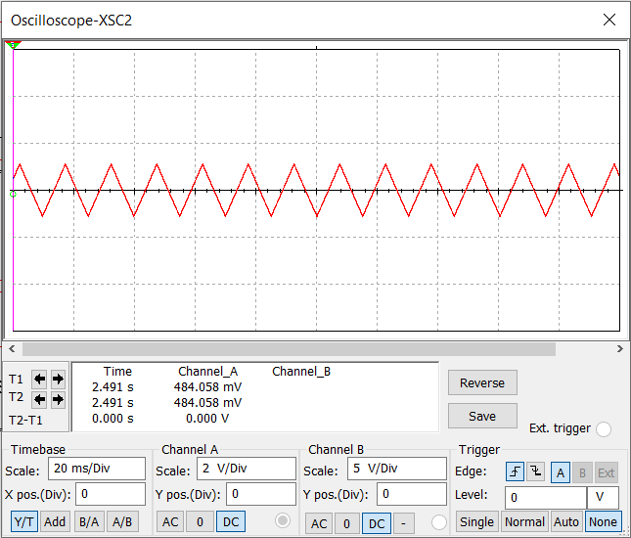

*Figure 8 - Triangular Wave Simulation*

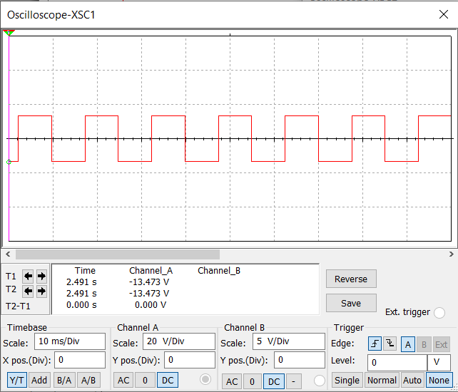

*Figure 9 - Square Wave Simulation*

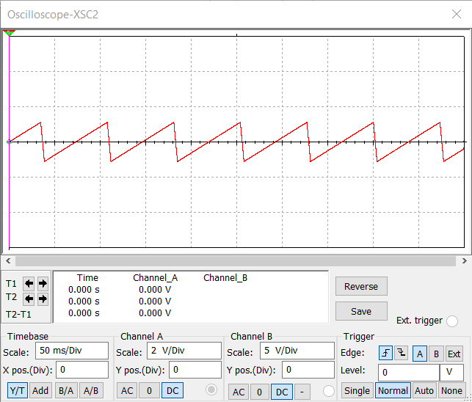

*Figure 10 - Sawtooth Wave Generation*

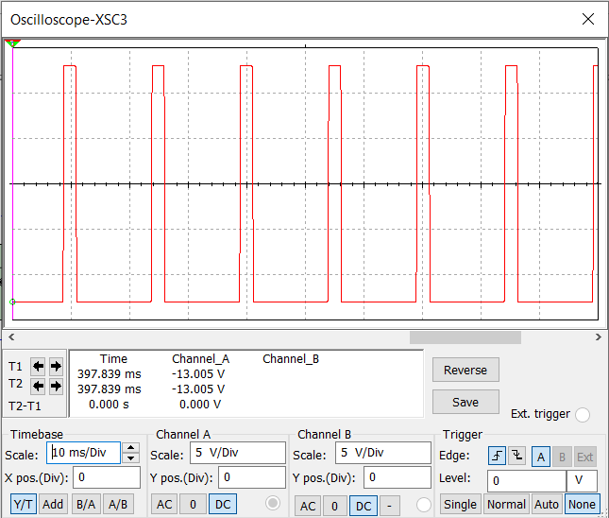

*Figure 11 - PWM Wave Generation*

**CALCULATIONS**

**1.Triangular, Sawtooth and Square Wave Calculation**

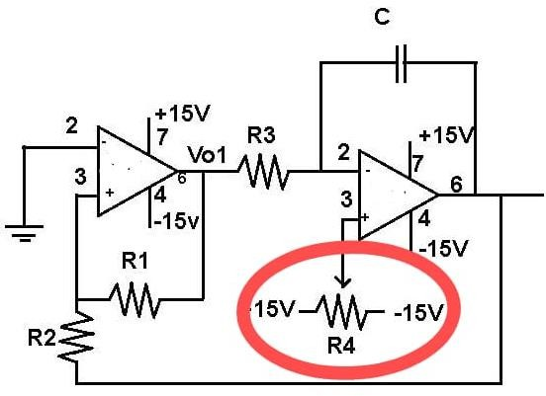

*Figure 11 -Wave Form Generation Circuit*

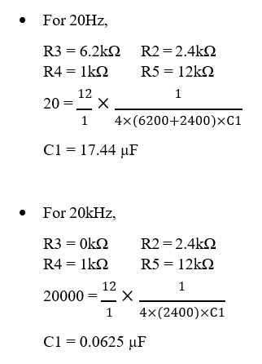

**2.Sine Wave Calculation**

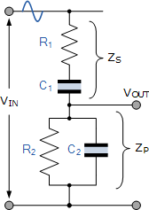

*Figure 12 -Sine Wave Generation Circuit*

For example, we can take R1=R2=12kΩ, C1=C2=3.9nF and the supply frequency f=3.4kHz.

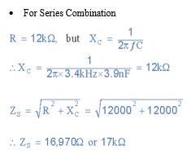

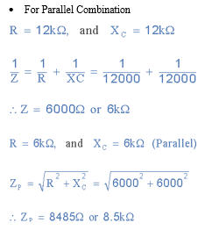

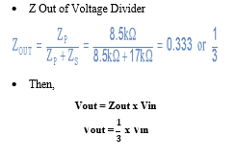

Above values are used to show how 1/3 comes and We will change the resistor values for the circuit while we will be testing the circuits according to the results.

**3.Wein Bridge Oscillator**

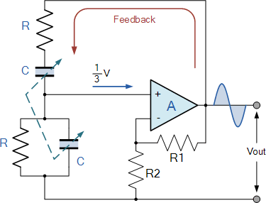

*Figure 13- Wein Bridge Oscillator*

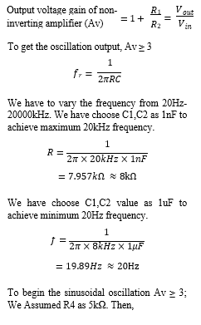

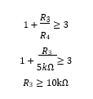

We need to use some methods to be stabilizing the amplitude of the oscillations. If the voltage gain of the amplifier is too small the desired oscillation will decay and stop. If it is too large the output will saturate to the value of the supply rails and distort. We have used feedback diodes to stabilization of amplitude.

## 6. Advantages

- Capable of generating multiple waveforms  
- Adjustable amplitude and frequency  
- Cost-effective compared to digital function generators  
- Provides stable and low-distortion signals  
- Can drive loads with minimal distortion

## 7. Challenges and Limitations

- Requires precise component selection to minimize distortion  
- Stability issues at high frequencies  
- Harmonic distortions in the sine wave generation  
- Noise sensitivity due to external interference  
- Limited frequency range compared to digital alternatives

## 8. Applications

- Testing and debugging of electronic circuits  
- Signal processing and communication systems  
- Research and development in electronics  
- Modulation and waveform analysis  
- Educational laboratory experiments

## 9. Future Enhancements

- Implementation of a microcontroller-based digital control for better accuracy  
- Expansion of frequency range up to higher limits  
- Integration of a display to monitor waveform parameters  
- Development of a fully digital version for enhanced functionality  
- Addition of more modulation options such as AM and FM  
- Implementation of PWM waveform generation for advanced signal processing  
- Addition of a DC shift feature to modify waveform bias levels

## 10. References

[https://www.instructables.com/id/Function-](https://www.instructables.com/id/Function-Generator/) [Generator/](https://www.instructables.com/id/Function-Generator/)

[https://www.watelectronics.com/square-](https://www.watelectronics.com/square-wave-generator-circuit-using-op-amp/) [wave-generator-circuit-using-op-amp/](https://www.watelectronics.com/square-wave-generator-circuit-using-op-amp/)

[https://www.radiolocman.com/shem/schema](https://www.radiolocman.com/shem/schematics.html?di=277157) [tics.html?di=277157](https://www.radiolocman.com/shem/schematics.html?di=277157)

[http://www.circuitsgallery.com/2012/04/tria](http://www.circuitsgallery.com/2012/04/triangul%20ar-wave-generator-using-op-amp.html) [ngul ar-wave-generator-using-op-amp.html](http://www.circuitsgallery.com/2012/04/triangul%20ar-wave-generator-using-op-amp.html)

[https://www.maximintegrated.com/en/desig](https://www.maximintegrated.com/en/design/technical-documents/app-notes/3/3846.html) [n/technical-documents/app-](https://www.maximintegrated.com/en/design/technical-documents/app-notes/3/3846.html) [notes/3/3846.html](https://www.maximintegrated.com/en/design/technical-documents/app-notes/3/3846.html)

## 11. Conclusion

The development of an analog function generator provides an effective solution for generating multiple waveforms for electronic applications. By carefully designing the circuit and selecting appropriate components, a stable and efficient function generator can be achieved. Future improvements can further enhance its capabilities, making it more versatile and user-friendly.