Avery Tan (altan) 1392212 CMPUT366A7

Part 2. Learning curve for Sarsa agent

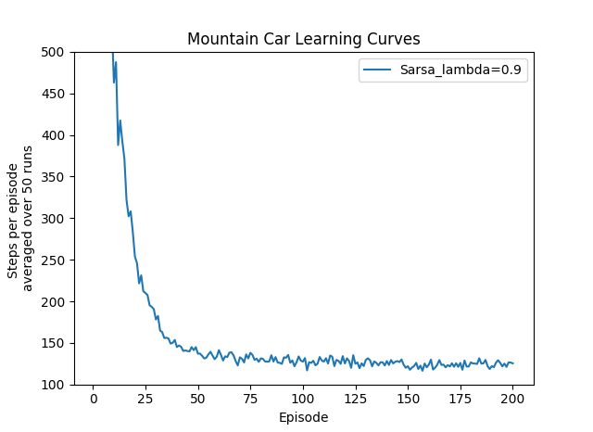

Fig 1. Learning Curve for Sarsa Agent

Part 3. 3D plot of cost-to-go function

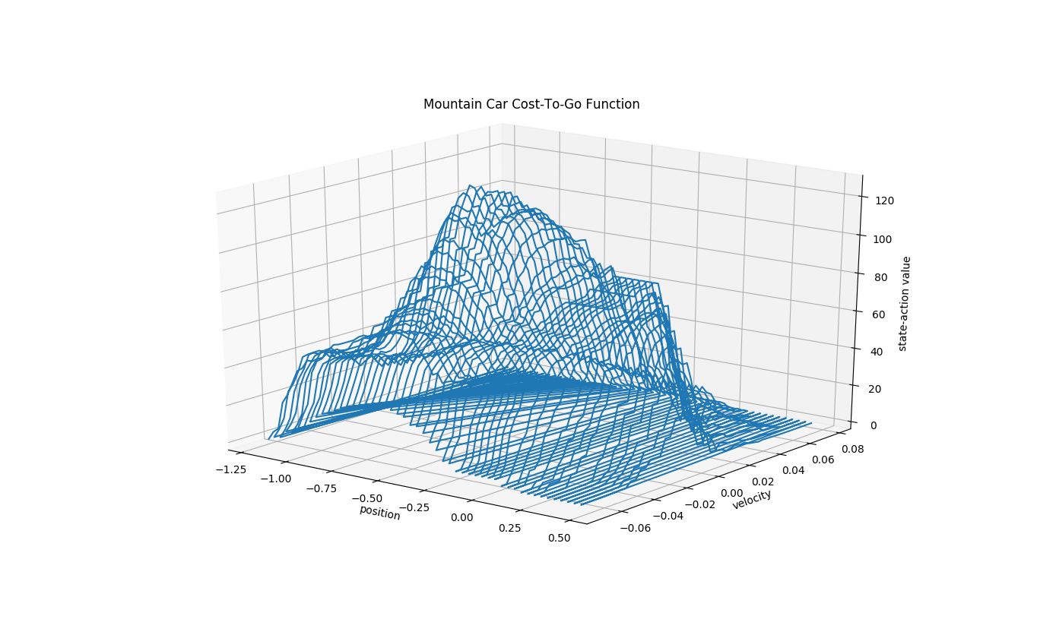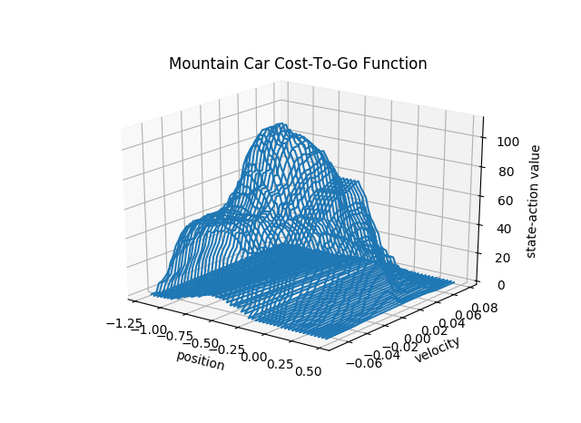

Fig 3. After 50 runs of 200 episodes

Fig 2. After 1 run of 1000 episodes