GHANA COMMUNICATION TECHNOLOGY UNIVERSITY.

Course: CIIS 332 Web Application Development Project



Name: Atila Kwadwo Francis
Index: 2526110028

AKWAABA TRAILS WEBSITE DEVELOPMENT REPORT
CIIS 332 Web Application Development
Individual Project

Table of Contents
Chapter 1 Introduction 3
1.1 Project Summary 3
1.2 Background and Objectives 4
1.3 Requirements and Intended Users 5
Chapter 2 Planning 6
2.1 Site Structure 6
2.2 Content Planning and Sources 7
Chapter 3 Interface Design 8
3.1 Visual Design 8
3.2 Responsive Design 9
3.3 Navigation and Page Layout 10
Chapter 4 Website Implementation 11
4.1 HTML Structure 11
4.2 CSS Implementation 12
4.3 JavaScript Interactions 13
4.4 Gallery and Contact Form 14
Chapter 5 Testing and Deployment 15
5.1 Testing Results 15
5.2 Deployment and Maintenance 16
Chapter 6 Conclusion and References 18

Chapter 1 Introduction

1.1 Project Summary
Akwaaba Trails is a six-page informational website about travel, heritage and visitor etiquette in Ghana. I built the project with HTML, CSS and JavaScript. I did not use a visual page builder or a front-end framework. The finished site contains a home page, an exploration page, a culture guide, an interactive trip planner, a filterable gallery, and a contact and sources page. Every page uses the same navigation and footer, so a visitor can move through the site without returning to the home page.
The subject was selected because a travel guide gives enough scope to demonstrate content planning, responsive layouts, image handling, navigation, forms and JavaScript interaction within one coherent website. I kept the information practical. Instead of treating the project as a list of tourist attractions, the pages explain how to approach heritage sites, markets, craft communities and local customs with care. The coastal section refers readers to Ghana's forts and castles, whose historical importance is documented by the UNESCO World Heritage Centre (n.d.).
The website uses original SVG illustrations stored inside the project. This decision avoids copyright problems and prevents broken images when the site is opened without internet access. The artwork also keeps a consistent visual style across the six pages. Each image has alternative text, and the pages use semantic headings, visible form labels and keyboard-friendly controls.

Project Outcome
The result meets the core project requirements: it contains more than five connected pages, uses relevant multimedia, includes useful content, and is ready to publish as a static site through GitHub Pages. The Word report records the process from the initial site map to browser testing and deployment instructions.

1.2 Background and Objectives
A useful travel website has to answer two different questions. First, it must help a visitor decide where to go. Second, it must explain the behaviour and preparation expected at the destination. Many destination pages focus heavily on photographs and short promotional descriptions. For this project, I used a quieter approach. The content is organised around routes, visitor preparation and cultural context.
Ghana was a suitable subject because the country has coastal heritage, forests, urban landmarks, traditional craft centres and northern wildlife areas. This variety made it possible to design pages with different content structures while keeping one subject. The coastal route includes Cape Coast and Elmina. UNESCO records that the forts and castles along Ghana's coast developed between 1482 and 1786 and later became closely connected to the history of the transatlantic slave trade (UNESCO World Heritage Centre, n.d.). That history required direct language and respectful presentation rather than exaggerated travel advertising.

Objectives
- Create at least five complete and interconnected web pages using code.
- Present original, relevant text and multimedia without offensive material.
- Apply responsive design so the site remains usable on phones, tablets and desktop screens.
- Use JavaScript for interactions that are visible and easy to demonstrate.
- Apply basic accessibility practices, including labels, alternative text and keyboard controls.
- Prepare the project for hosting in a GitHub repository and through GitHub Pages.
The objectives shaped the technical choices. Plain HTML was enough for the page structure. A shared CSS file created the layout and responsive behaviour. One JavaScript file handled the menu, trip planner, gallery and contact form. This separation keeps the work easy to explain during a defence and easy to maintain after submission.

1.3 Requirements and Intended Users
I translated the assignment brief into a checklist before writing code. The site needed five or more pages, suitable content on every page, working links between pages, relevant multimedia and code produced without a WYSIWYG authoring tool. The accompanying report needed a title page, table of contents, numbered figures, instructional material and a detailed explanation of the development process. The formatting of this report follows the specified Times New Roman typeface, 12-point body text, 14-point headings, 1.5 line spacing and the required margins.

Intended Users
The main user is a first-time visitor who wants a simple introduction to Ghana and does not yet know how to group destinations. The site is also suitable for a student or resident looking for a short summary of routes and respectful visitor behaviour. These users may access the site on a phone while travelling, so the design cannot depend on wide tables, hover effects or a permanent desktop navigation bar.

Functional Requirements
- The navigation must connect all six pages and show the current page.
- The trip planner must accept a route, duration, number of travellers and travel style, then display an itinerary and estimate.
- The gallery must filter images by category and open a larger view.
- The contact form must validate required fields and display clear feedback.
- The mobile menu must open and close without hiding the main page content from assistive technology.

Quality Requirements
The pages needed consistent typography, sufficient contrast, descriptive page titles, meaningful image alternatives, and layouts that reflow at smaller widths. W3C guidance recommends explicit labels for form controls because the association improves both usability and assistive technology support (W3C Web Accessibility Initiative, n.d.-a). I applied that guidance to every input and select control.

Chapter 2 Planning

2.1 Site Structure
I started with the site map shown in Figure 2.1. The home page acts as the entry point, but it is not a gate that users must pass through repeatedly. The same navigation appears on every page. The Sources section sits inside the Contact page because the references support the whole project and do not need a separate seventh page.
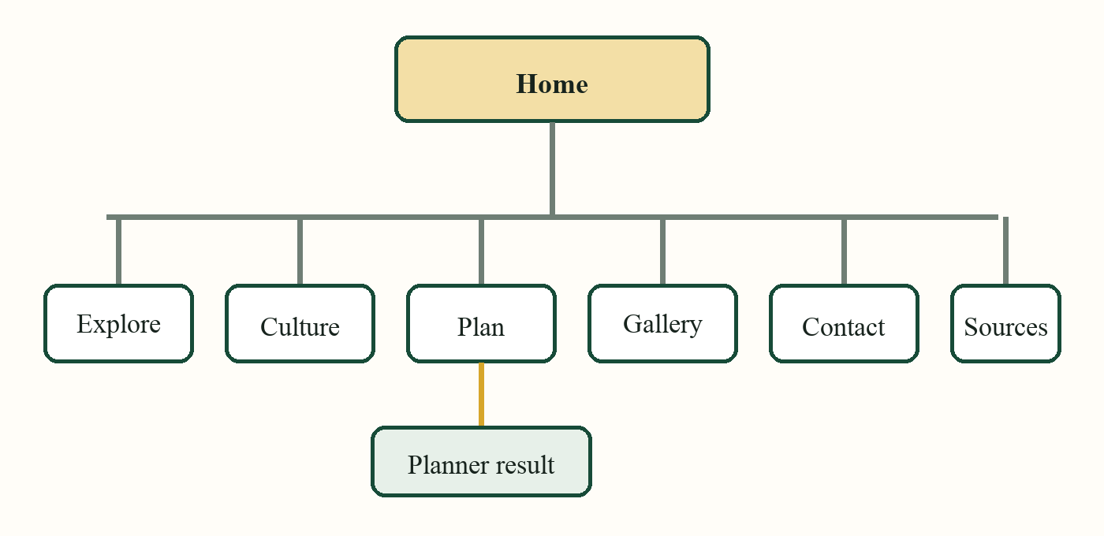
Figure 2.1. Site map for the Akwaaba Trails website
The structure is deliberately shallow. A visitor can reach any main page with one navigation action. The Explore page groups destinations by route, while the Culture page groups guidance by topic. The Plan page contains the site's main interactive feature. Gallery has its own page because images are useful for browsing but should not interrupt the longer explanations on the other pages.

File Structure
website/
index.html
explore.html
culture.html
planner.html
gallery.html
contact.html
assets/css/styles.css
assets/js/main.js
assets/images/*.svg

2.2 Content Planning and Sources
I wrote a short purpose statement for each page before preparing the interface. Home introduces the subject and directs visitors to the main routes. Explore gives enough detail to compare four route types. Culture explains greetings, photography, dress and craft. Plan turns a few choices into an itinerary. Gallery demonstrates image filtering, while Contact demonstrates form validation and records the information sources.
The page text avoids fixed entrance prices, opening hours and transport schedules because those details can become inaccurate quickly. The planner's cost is clearly labelled as an early planning estimate. The destination text tells users to confirm details directly before travelling. This is more responsible than presenting a student project as a booking service.

Source Selection
For heritage information, I used the UNESCO World Heritage Centre entry on Ghana's forts and castles. The website's sources page also points readers to the Ghana Tourism Authority, the Ghana Museums and Monuments Board and the Forestry Commission of Ghana. These organisations are more suitable for checking current visitor details than an anonymous travel blog. Technical decisions were checked against the W3C Web Accessibility Initiative and the Mozilla Developer Network.

Writing Approach
The copy was written in short, connected paragraphs. I removed promotional claims that could not be supported and avoided describing communities as attractions. Instructions use direct verbs, such as ask, confirm, carry and follow. The site uses Ghanaian place names consistently and explains why a visitor should take a particular action. For example, the Culture page does not only say that photographs require care; it asks visitors to seek permission before photographing people, workspaces, ceremonies or market stalls.
Each page was edited after it was placed in the browser. This exposed headings that were too long, repeated phrases and card descriptions that did not fit the available space. Content planning therefore continued during layout and testing rather than ending before coding began.

Chapter 3 Interface Design

3.1 Visual Design
The visual design uses a warm cream background, dark green headings, a gold accent and a muted clay colour. These colours relate to landscape and textile references without copying a national flag or a commercial tourism identity. Georgia is used for large website headings, while the body uses a clear sans-serif stack. The report itself follows the type requirements in the assignment brief.
As shown in Figure 3.1, the home page begins with a short heading, two clear actions and one large illustration. The main message appears before the artwork in the source order, which supports keyboard and small-screen reading. The curved image treatment makes the first view distinct without adding a heavy animation or video.
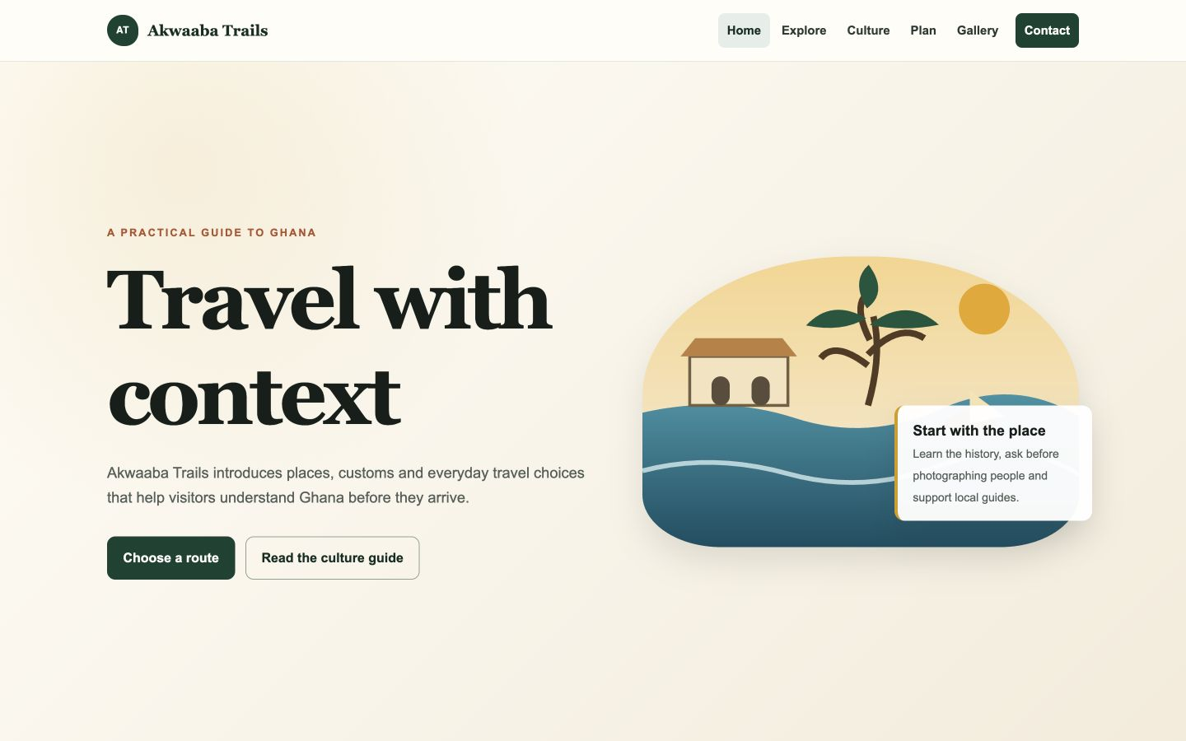
Figure 3.1. Desktop view of the Akwaaba Trails home page

Design System
Reusable CSS variables store the main colours, border radius, shadow and maximum content width. Buttons, cards, tags, panels and section headings use shared classes. This produces consistent spacing and reduces the chance that one page develops a different style. White cards are placed on either the paper or cream background, and borders remain visible even when shadows are not displayed.
The original SVG images share flat shapes and a limited colour palette. They remain sharp on high-resolution screens and are small enough for a static website. Each file also contains a title and description, while every HTML image element supplies an alternative text value that matches the image's function on that page.

3.2 Responsive Design
The interface was designed for a desktop width first, then adjusted at 900 pixels and 620 pixels. At the first breakpoint, two-column sections become one column, three-card layouts become two columns, and the desktop navigation changes to a menu button. At the second breakpoint, cards, gallery items, form rows and the footer become single-column layouts.
Figure 3.2 shows the mobile menu in its open state. The button updates its aria-expanded value when the menu opens, which provides a programmatic indication of the state. The menu is positioned below the sticky header and spans the available width with a border and shadow. Links remain large enough to select without precise pointer movement.
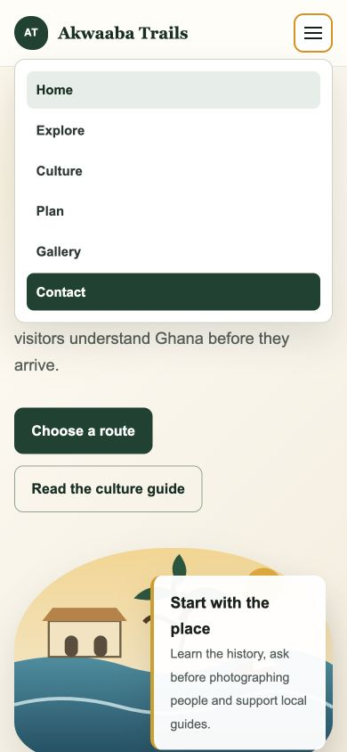
Figure 3.2. Mobile home page with the navigation menu open

Responsive Content Decisions
Responsive work involved more than shrinking widths. The destination pages remove alternating image order on small screens so every article follows the same image-then-text sequence. The trip planner places the form before the result. The contact page places project information before the enquiry form. These choices match the reading order in the HTML.
Font sizes use the CSS clamp function for major headings. This allows the size to change gradually within a controlled range. Images use aspect ratios and object-fit where needed, so card heights remain consistent. A reduced-motion media query removes long transitions for users who prefer less motion. The site contains no horizontal carousel, and no essential instruction appears only on hover.

3.3 Navigation and Page Layout
Every page uses the same header and footer. The current navigation link carries aria-current with the value page and receives a soft green background. A skip link is the first focusable item. It stays outside the visible area until a keyboard user focuses it, then moves into view and links directly to the main content.
The Explore page in Figure 3.3 demonstrates the main long-form card pattern. Each route has an image, estimated duration, title, location tags, a short explanation and practical notes. Alternating the desktop image position gives the page rhythm, but the content order remains consistent on phones.
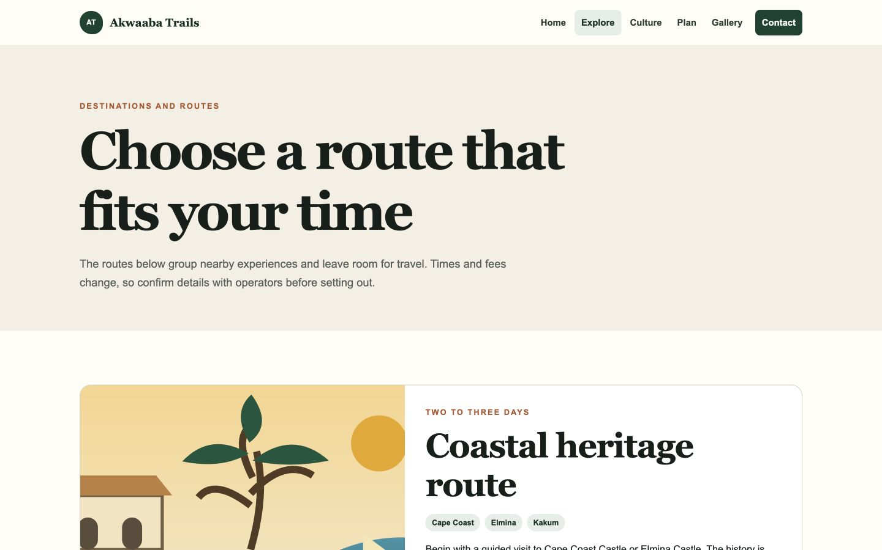
Figure 3.3. Explore page showing the route-based content layout

Page Hierarchy
Each page has one first-level heading. Major content sections use second-level headings, and card titles use third-level headings. Paragraphs follow the headings they explain. This structure helps a reader scan the page and gives assistive technology a useful outline. The W3C Web Accessibility Initiative (n.d.-b) identifies text alternatives, labels and meaningful structure as basic parts of perceivable and understandable content.
Footer links repeat the principal destinations and include a direct route to Sources. Repeating the links is useful at the end of long pages and avoids forcing a user to scroll back to the header. The footer also states that the work is an educational project, which separates it from an actual travel agency or booking platform.

Chapter 4 Website Implementation

4.1 HTML Structure
The pages use HTML5 landmarks, including header, nav, main, section, article, aside and footer. These elements make the document easier to understand than a page built entirely with generic containers. Navigation links are ordinary anchor elements, so they still work if JavaScript is unavailable. Forms use native input, select, textarea and button elements.
Figure 4.1 shows the Culture page. Its content combines a split section, three guidance cards and a simple timeline. The page remains meaningful without the style sheet because the headings and paragraphs are in a logical order.
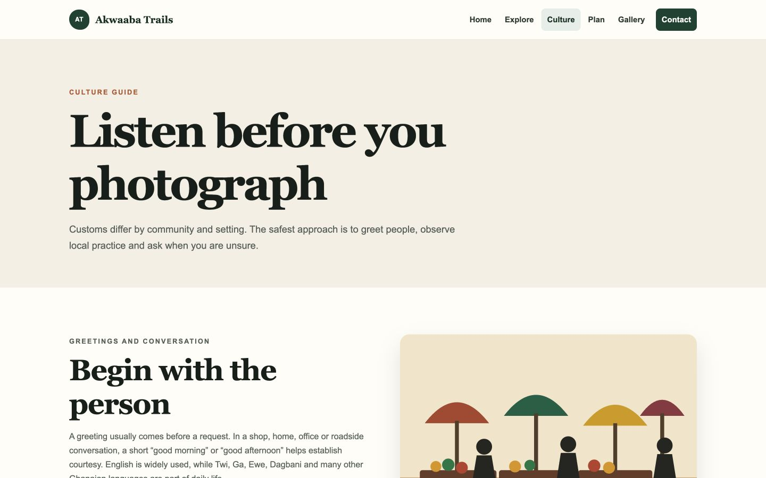
Figure 4.1. Culture page with guidance cards and original artwork

Example Page Pattern
<main id="main">
<section class="page-hero">
<h1>Listen before you photograph</h1>
</section>
<section class="section">
<article>...</article>
</section>
</main>
Metadata in the head gives every page a unique title and description. The viewport meta element enables the responsive layout on mobile devices. The stylesheet is loaded in the head, while the JavaScript file uses the defer attribute so the document can be parsed before the script runs.

4.2 CSS Implementation
The CSS begins with custom properties for colours, spacing, shadows and the maximum content width. A small reset applies border-box sizing and ensures images do not overflow their containers. The container class centres content and uses a calculated width that leaves space at the sides on narrow screens.

Layout Methods
CSS Grid controls the main two-column sections, destination articles, card groups, statistics, forms and footer. Flexbox is used for shorter one-dimensional arrangements such as the navigation, buttons, tags and section headings. Grid was useful where column relationships needed to remain consistent; Flexbox was simpler for elements that wrap naturally.
.hero-grid {
display: grid;
grid-template-columns: 1.05fr .95fr;
align-items: center;
gap: 4rem;
}
@media (max-width: 900px) {
.hero-grid { grid-template-columns: 1fr; }
}

States and Readability
Links and buttons have hover and visible keyboard-focus states. Form controls use a darker border and a gold focus outline. Body text uses a line height of 1.65 and a muted colour that remains readable against the paper background. The maximum line length is controlled by the page container and the width of lead paragraphs.
The style sheet includes only two media-query breakpoints plus a reduced-motion query. This is enough for the current layouts and keeps the code easy to explain. The breakpoints respond to the content: 900 pixels is where the navigation and paired columns begin to feel crowded, while 620 pixels is where cards and paired form fields work better as a single column.

4.3 JavaScript Interactions
The JavaScript file is divided into independent blocks. Each block first checks whether the required element exists. This allows one file to be shared by all six pages without errors on pages that do not contain the planner, gallery or form.
The trip planner reads the selected route, number of days, number of travellers and travel style. It selects activities for the route, calculates a planning estimate and writes the result into an aria-live region. Figure 4.2 shows the result produced during testing for three travellers on a four-day northern route.
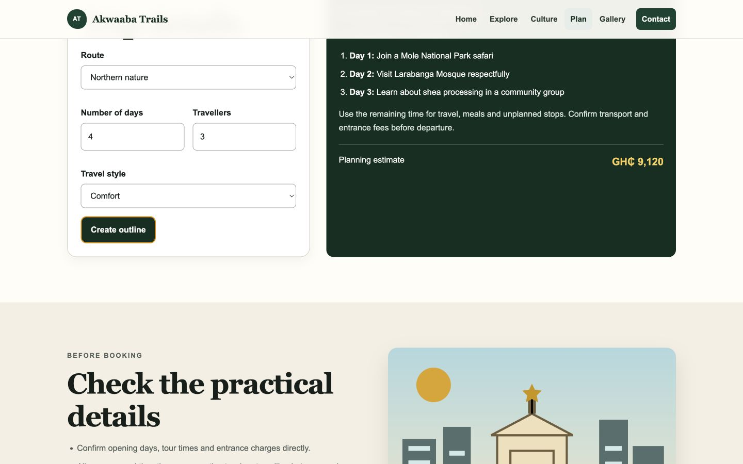
Figure 4.2. Trip planner result generated with JavaScript
const total = dailyRate * days * travellers;
plannerResult.innerHTML = `... GH₵ ${total.toLocaleString()}`;
localStorage.setItem('akwaaba-plan', JSON.stringify(plan));
The planner stores the last selections in localStorage. When the page is opened again on the same device, the form restores those values. The stored information contains only route preferences and does not contain a person's name, email address or payment details.

Navigation Script
On small screens, the menu button toggles an open class on the navigation and updates aria-expanded. Selecting a link closes the menu. The current year in the footer is also inserted by JavaScript so it does not need manual annual editing.

4.4 Gallery and Contact Form
The gallery uses data-category attributes on each image button. When a filter is selected, JavaScript compares the chosen category with each item's category and applies the hidden property when they do not match. Selecting an image opens a full-screen lightbox, copies the selected source and alternative text, and moves focus to the close button. The Escape key also closes the lightbox.
Figure 4.3 shows the Gallery page before a filter is applied. The six illustrations cover coast, forest, textile, savannah, market and city subjects. The files are stored locally, so the gallery works on the development server and after GitHub Pages deployment.
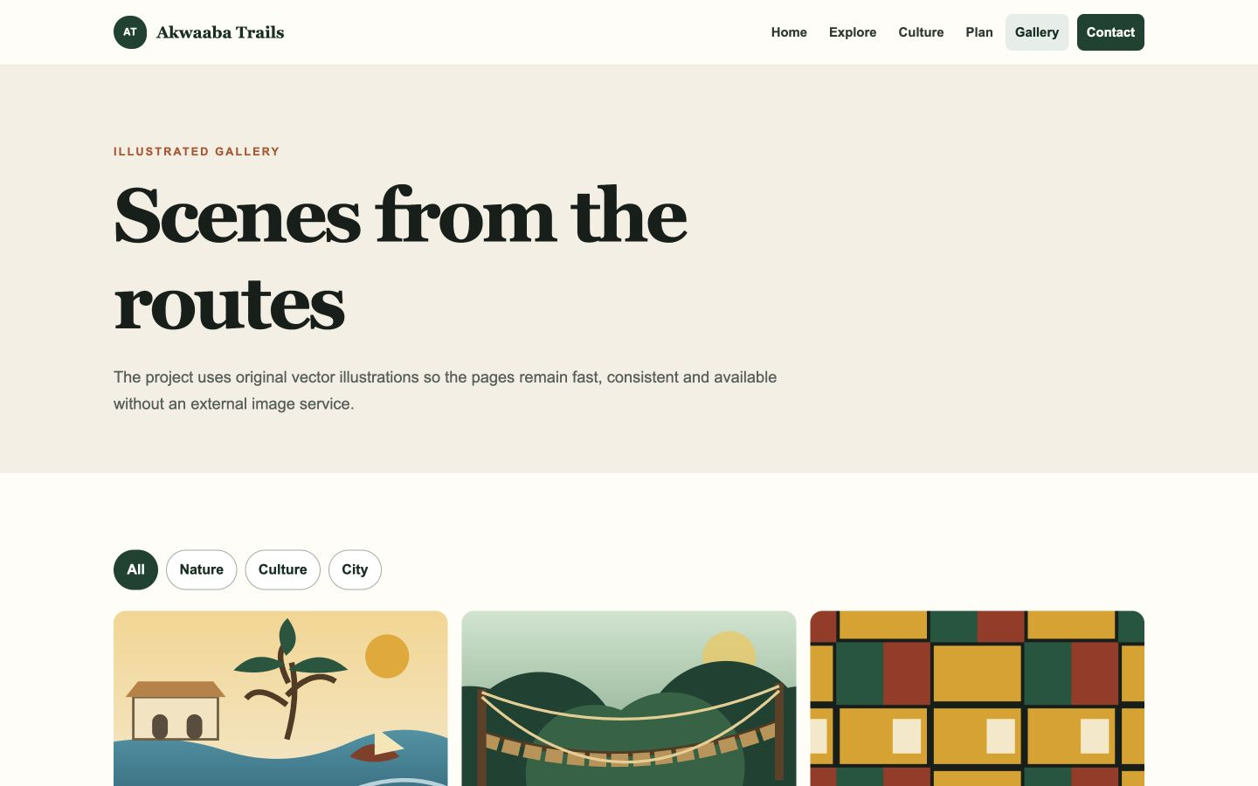
Figure 4.3. Filterable gallery page with six local SVG illustrations

Form Validation
The contact form uses required fields, an email input type and a minimum message length. JavaScript checks the native validity result and displays a message in an aria-live status paragraph. The form is a demonstration and does not send data to a server. That limitation is stated above the form and repeated in the confirmation message.
Visible labels sit directly above the controls. Their for attributes match the corresponding input IDs. W3C form guidance recommends this explicit association because it gives the control an accessible name and enlarges the clickable label area (W3C Web Accessibility Initiative, n.d.-a). Error feedback does not rely on colour alone; it also states what the user needs to correct.

Chapter 5 Testing and Deployment

5.1 Testing Results
Testing covered file structure, navigation, images, interaction and responsive behaviour. I used an automated local validator to examine all six HTML files. It checked local links, fragment links, image paths, page titles and image alternative text. The final run checked 99 links and 19 image uses without a missing target.
I also opened the site through a local HTTP server and tested the planner, gallery and mobile menu in a browser. The planner produced the expected GH₵9,120 estimate for four days, three travellers and the comfort rate of GH₵760 per traveller per day. The Culture gallery filter displayed two matching items. The lightbox opened and closed correctly. At a 390 by 844 pixel viewport, the navigation button opened the mobile menu and changed aria-expanded to true.
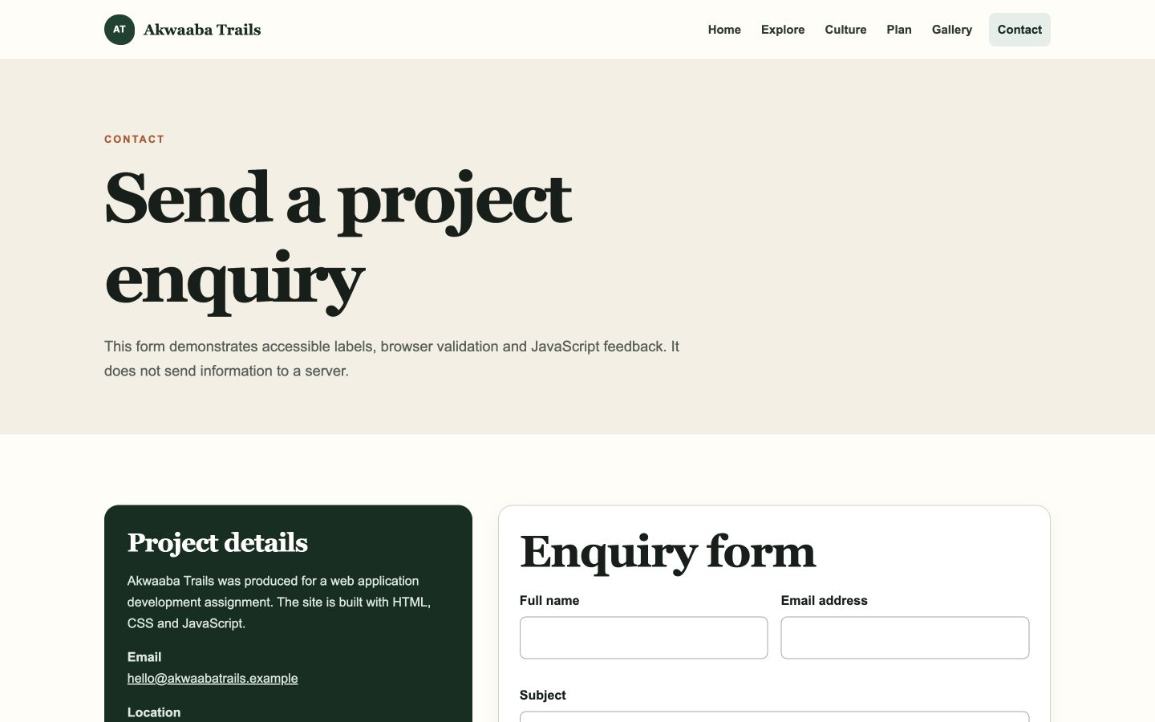
Figure 5.1. Contact page used to verify labels and form layout

Issues Corrected
The first static validation found an empty alternative text value on the lightbox's fallback image. Although JavaScript replaces the text when a user opens an image, the empty initial value made the source less clear. I replaced it with a short fallback description and repeated the validation. I also verified that the home page was captured from localhost rather than an old service-worker route associated with the numeric loopback address.
No console error appeared during the tested interactions. Links and forms remained readable at desktop and mobile widths, and the report figures were captured from the tested build rather than from design mock-ups.

5.2 Deployment and Maintenance

GitHub Pages Deployment
The website is ready for static hosting because it does not require a database, server-side language or build process. To publish it, I would create a GitHub repository, copy the contents of the website folder into the repository root, commit the files and push the main branch. In the repository settings, Pages can be configured to deploy from the main branch and root folder.
- Create a new public repository and give it a clear project name.
- Add the six HTML files and the assets folder without changing their relative structure.
- Commit with a message that describes the complete first release.
- Open Settings, select Pages, and choose the main branch and root folder as the source.
- Open the published address and repeat the navigation and interaction checks.

Maintenance Plan
The main maintenance risk is outdated destination information. Current charges, opening times, road conditions and access rules should be checked before they are added. The Sources section should continue to point to the responsible Ghanaian institutions and recognised heritage bodies. Broken-link checks should be repeated after any file is renamed.
New pages should reuse the existing header, footer, container and section classes. A new image needs both a meaningful filename and alternative text. A new form control needs a visible label. JavaScript additions should check for their target element before registering event listeners so pages without that feature remain error-free.

Backup and Version Control
Git commits provide a record of changes and allow a faulty version to be compared with a working one. Major updates should be made in a separate branch, reviewed in the browser, and merged only after the validator and manual tests pass.

Chapter 6 Instructional Materials

6.1 Running the Website
The project can be opened directly by selecting index.html, but a local server provides behaviour closer to a hosted website. From the assignment folder, run the command below and open the address in a browser.
python3 -m http.server 8000 --directory website
http://localhost:8000

6.2 Using the Main Features
- Use the header links to move among Home, Explore, Culture, Plan, Gallery and Contact.
- On a narrow screen, select the menu button to reveal the navigation links.
- On the Plan page, choose a route, enter days and travellers, select a travel style, then select Create outline.
- On the Gallery page, select a category to reduce the visible images. Select an image to open it and use the close button or Escape key to return.
- On the Contact page, complete all required fields. The browser checks the email format and message length before the demonstration confirmation appears.

6.3 Updating Content
Text changes are made inside the appropriate HTML file. Shared colours and spacing are stored near the top of assets/css/styles.css. The navigation and interactive features are in assets/js/main.js. Illustrations are stored in assets/images. When a page name changes, its link must be updated in every header and footer.

Chapter 6 Conclusion and References

6.1 Conclusion
Akwaaba Trails meets the assignment requirements through six connected pages, original multimedia and three clear JavaScript interactions. The project demonstrates semantic HTML, reusable CSS, responsive layouts, local storage, form validation and browser testing. The design remains consistent because shared rules control navigation, containers, cards, buttons and form fields.
The strongest part of the project is the connection between subject and implementation. The planner compares routes, the gallery supports visual browsing, and the form demonstrates clear input feedback. Skip navigation, alternative text, explicit labels and responsive reading order are part of the initial structure.
Further development could add a small content management system, verified live opening information, a real form service and route maps. Those features would require stronger data maintenance and privacy decisions. For the present course scope, the static implementation is easier to host, inspect and defend.

6.2 References
Duckett, J. (2011). HTML and CSS: Design and build websites. John Wiley & Sons.
Forestry Commission of Ghana. (n.d.). Forestry Commission Ghana. https://fcghana.org/
Ghana Museums and Monuments Board. (n.d.). Ghana Museums and Monuments Board. https://gmmb.gov.gh/
Ghana Tourism Authority. (n.d.). Visit Ghana. https://visitghana.com/
Mozilla Developer Network. (n.d.). MDN Web Docs. https://developer.mozilla.org/
UNESCO World Heritage Centre. (n.d.). Forts and castles, Volta, Greater Accra, Central and Western Regions. https://whc.unesco.org/en/list/34/
W3C Web Accessibility Initiative. (n.d.-a). Labeling controls. https://www.w3.org/WAI/tutorials/forms/labels/
W3C Web Accessibility Initiative. (n.d.-b). Accessibility principles. https://www.w3.org/WAI/fundamentals/accessibility-principles/

