Music for Pleasure

You can spot the vinyl addicts because after a while they get fed up with the rack they are flicking through, march over to a completely different section of the shop, pull a sleeve out from the middle somewhere, and come over to the counter; this is because they have been making a list of possible purchases in their head ("If I don't find anything in the next five minutes, that blues compilation I saw half an hour ago will have to do"), and suddenly sicken themselves with the amount of time they have wasted looking for something they don't really want.

There is no doubt in my mind. I am addicted to vinyl, buying, listening to, coveting – the groaning shelves of our house speak for themselves. This addiction has some unintended consequences. I cannot pass a charity shop, it must be explored and, even if there are no records on show, it is always worth checking with someone. “Are there any records in the back?”. Don’t ask. Don’t get. When records are 50p or a quid it is easy to justify the acquisition of the Big Big Sounds of Chaquito. And Top TV Themes. And so on. And on.

This is how I ended up becoming, not obsessed, but not not obsessed with the EMI sub-label Music for Pleasure (MFP). It was Geoff Love who started it. There are tonnes of Geoff Love records out there, ten different movie theme records alone, and you see them in charity shops all the time. Most people, you’d imagine, look at them and think ‘not for me, I’ll move on’. But I am an addict, and why collect records if you’re not going to collect records? How do you know that there is no treasure sealed in the grooves of Big Hollywood Movie Themes? And then it snowballs. Suddenly you stumble upon a curious Beach Boys record or Curried Jazz. There’s a French instantiation of the label? And a South African one? Pink Floyd, Motown compilations, weird children’s records? What the hell is going on? What were the guys at EMI doing?

The ones that sell

In 1965 Joseph Lockwood went to America and saw first hand a new technique for mass marketing recorded music. This was the birth of Music for Pleasure.

Joseph Lockwood, by account, was not a record man. At one point when asked for his favourite records, he just said: ‘The ones that sell.’ He had been an industrial designer of flour mills, this was his initial area of expertise where he literally wrote the book, Flour Milling (1945), on the subject. During the mid 1950s. When EMI were in a slump he was encouraged to take over as chairman of their board. He was said to be of “inspiring, single-minded, decisive, fiery character” and he significantly streamlined operations at EMI during the years 1954 to 1979. Any loss making operation was canned. Manufacture of television, record players and radios stopped. The focus was on the rapid expansion of the money making business of recorded music.

While UK figures from the early 1960s are rarely published, it is difficult to imagine that EMI did not possess or at least intuit data pointing to a substantial population of record-player owners who were not regular record buyers when MFP was first conceived. By 1970, this demographic logic was being articulated explicitly in EMI’s French MFP operation: a Billboard report notes that millions of households owned record players but purchased very few records, making clear that MFP understood its task as converting hi-fi ownership into music consumption.

There were huge changes in a number of areas of retail in the 1960s. The article A distribution revolution: Changes in music distribution in the UK 1950-75 (Kevin D. Tennent) goes into significant detail about the specifics of these changes in the music industry and is well worth a read. Even just to get a historic outlook on arguments that continue to happen today around the introduction of any new distribution technology to the music industry.

One of the big changes in the 1960s, and the change that Joseph Lockwood had noticed first hand on his trip the US was that of rack jobbing. Rack jobbing is the practice of the supplier stocking and managing a shop’s shelves for them, taking a cut of sales while the retailer just provides the space. Rack jobbing placed records into everyday retail environments, increasing their visibility and making them available as impulse purchases to consumers who had rarely been directly addressed by the record industry. As Chris Ellis put it, “MFP, not kids – it’s mums in the supermarket thinking that they used to like this.” A test promotion of vintage material confirmed that such a market existed, even if MFP’s high turnover and sales thresholds ultimately made it inhospitable to anything that could not move in six-figure volumes.

In 1949 Paul Hamlyn started Books for Pleasure. Booksellers were protected by an austere organisation, the Booksellers Association of Great Britain and Ireland. It was designed by publishers with the intention of enhancing the role of the book as a cultural medium (Jarvis Thompson 54). The understanding of the association was, any surplus books would be pulped to reduce any over-stocking. However, the cost of production has already been realised, why not reduce the price and generate some sales? This then was an entrance for Paul Hamlyn a low cost low risk entry into publishing, into which he flourished. As an aside, an example of his brilliance was his deal over the right to publish the English language Larousse Gastronomique for £1,000 – this he would turn into millions.

Both of these astute businessmen then were well placed with the right skills to create Music for Pleasure. Lockwood brought EMI’s catalogue, its pressing capacity, and its distribution network. Hamlyn contributed his expertise in budget retailing and his access to Italian printers, whose low-cost but high-quality sleeve production far undercut EMI’s usual costs.

A man who knows the price of everything and the value of nothing

This section is all about the price of records that I have done some analysis on and can be brief.

The records themselves. MFP is not a genre label, there is no coherency in the releases at all. It is best described as bircolage the label operates through an eclectic, piecemeal, grab-what’s-at-hand aesthetic. This unpredictability is part of the appeal: at first glance you rarely know what you’re actually getting. A title like Tijuana Brass, appearing so often in the charity racks is quickly understood to not be a banger, but something called Curried Jazz or Stereo Discotheque could contain anything—from genuine experimentation to absolute drivel. The fundamental is that collecting these records is often joyous because you get a lot of "what is that?" moments; both good and bad. I'm going to take a quick look at some of my favourite LPs.

The Beach Boys (MFP 1382)

EMI acquired Capitol in 1955, their focus was primarily on popular music and their roster was incredibly strong, Nat King Cole, Frank Sinatra and latterly the Beach Boys. Now, this is not a best of or a greatest hits, and to be fair it is not marketed as such - simply The Beach Boys. The scattergun tracklist is entirely in keeping with MFP’s wider methodology.

One criticism that I have met online about the label is that the records were poorly pressed. If there is anything to take away from this essay it is this. MFP records are generally very well pressed. These records may well have been mistreated, even trashed, but the UK records were generally pressed at the Hayes plant in Middlesex and, I believe, would have gone through better quality control than would be the case today.

This Beach Boys album is a great example this and the sort of record I think we would like to see being repressed today - a well known band, a good mix of tunes, well packaged and cheap.

Rupert and The Firebird (MFP 50084)

One of the surprising things about the period that MFP operated in was the amount of organisation and strategy that was coming into the industry. The MFP children's records were some of the first records to get market tested before going into full production. In fairness this was done with singles rather than albums, but the point is still there that even in the madness there was some kind of plan. The children's market segment was big business for MFP accounting for around 10% of the label’s sales in 1969.

Although this record is a little bit of a one track wonder - I Can Fly could well appear on Paul Hillery's compiled Folk Funk & Trippy Troubadours series on RE:WARM.

Curried Jazz (MFP 1307)

"Curried Jazz" sits squarely within Music For Pleasure’s most interesting territory, where the budget label is moving into the creation of new, more experimental recordings away from reissues and recompilations. The album documents a unique attempt to bring together Indian classical music and jazz, two improvisational traditions that are structurally quite different. As bandleader Ken Burgess noted[1], Indian classical improvisation unfolds against a drone and uses fluid timing, which is opposite to jazz's reliance on fixed chord sequences and counted bars. The challenge was more about structure than style.

The solution was pragmatic. Arranger Victor Graham was brought in to create written parts that made the Indian drone patterns look like familiar chord charts for the jazz musicians, while leaving enough freedom for the Indian players. The result was a coexistence, not a forced blend. Often, the jazz section would play a theme and then drop out entirely, letting the Indian musicians take over.

The group was assembled informally, sitarist Dev Kumar, for example, was found through a chain of phone calls. The line-up was modest. In total just seven jazz and four Indian musicians were involved in the music on the project. This was not a major label's engineered fusion trend; more like a documented experiment that happened to get a national release. Even though a 1969 Melody Maker column recommended "Curried Jazz" alongside albums by Charlie Parker and Ella Fitzgerald, framing it as serious listening, it still would have been a kind of novelty record. One contemporary review, having listed the personnel, retreated into a culinary aside: “It’s strictly korma rather than vindaloo, but like good Indian food, it’s cheap!”

Ken Burgess reported that it sold 15,000 copies in its first month, even though MFP thought it wouldn't sell. That hesitation is understandable: Curried Jazz does not sit comfortably within the MFP catalogue, pairing atypical repertoire with otherwise conventional manufacture.

Curried Jazz challenges the idea of MFP as a simple catalogue-clearing operation. Not a best-of or a nostalgia piece, it shows how price and distribution could extend the reach of an otherwise unlikely Indo-British jazz experiment.

L'Oeil Ecoute - Les Instruments De Percussions (MFP 2M 046 – 13.266)

This is a very odd record indeed, when I started looking more deeply in the MFP catalogue this record struck out. Obviously this is an educational record, a one off for them as far as I am aware. One side is just drum hits, my assumption is that some school teacher would sullenly play this out for the class to note how to differentiate percussion instruments? Who knows. Whatever, for the right person this record would be sample heaven.

Big Terror Movie Themes (MFP 50248)
Even the look of this album today feels super kitsch. Hand painted dioramas from various horror and scary films of the 1970s and at the centre – the great white shark from Jaws. At the top of the cover, Geoff Love and His Orchestra.
Geoff Love grew up in Todmorden, Yorkshire. He learned the trombone as a schoolboy, eventually becoming a professional touring musician and eventually a band leader and arranger. He never forgot his origins and would go back to Todmorden and work with the local colliery band.
He was so prolific that there are multiple pseudonyms under which he worked, including Mandingo, Chaquito and Manuel and the Music of the Mountains. Honestly it is going to be a question of taste as to how much you’re going to get out of the Geoff Love oeuvre. But this terror themes record is definitely worth a listen.
Geoff Love says himself the musicianship of the players who made these records was second to none. Most of the recordings would have been made in one or two takes, with players who were supremely confident in not just reading music but interpreting dynamics and understanding quickly musical direction.
The recordings are really high quality as well, that lush 70s sound with lots of microphone bleed between horns and strings. The drums have such a distinctive timbre from that era. When you take the record in totality it is something that just could not, for the money, be made today but the music industry at the time was geared to produce these records in bulk. Inexpensive access to sizeable studio spaces, large-scale vinyl manufacturing, and broad distribution through high-street retailers made these kind of projects possible.
That is not to say that these kind of albums are overlooked masterpieces. Often the orchestral arrangements can be a little conservative. At the same time they should not be completely ignored either.

Stereo Discotheque (2 M 046-94687)
Credited to the unusually named Chicken Curry And His Pop Percussion Orchestra this album is banger after banger from start to finish. If you are interested in groovy music from the 70s this record is a must have. Written by premium Belgian jazzers and library music composers John Sluszny and Ralph Benatar (amongst others) this record is a perfect example of MFP doing the business the right way. Funky guitars, lovely woodwind, big fat drums. Yes. Please.
It is also an example of MFP moving operations outside of the UK. This release was put out in France and Italy. EMI, already operating in international markets, during 1970 launched MFP in France. Perhaps unsurprisingly the French were opposed to the introduction of this budget approach to selling records. Jacques Le Calve, president of the French Syndicat des Disquaires, stated at the time “if the public becomes accustomed to paying this price for a good quality album, how can we continue to sell normal product at more than twice that price?"
The objection was not to rack jobbing but the sale price and a semi boycott was launched garnering support from around 400 retailers. But despite this resistance in July the label was up in running in France with 60 titles in the catalogue.
Mussorgsky & Debussy (MFP 22116)
Music for Pleasure was latterly split into several sub-labels. One of these was Classics for Pleasure (CFP) and there are a lot of very enjoyable cheap classical records available on that label. Initially MFP dealt with everything, easy listening, light jazz pop and classical. Classical was considered with particular importance; classical record buyers were very much repeat customers. If they could get classical customers they would have a more reliable income stream than from easy listening or jazz, and with a reputation it might reduce the need for marketing or specialised releases.
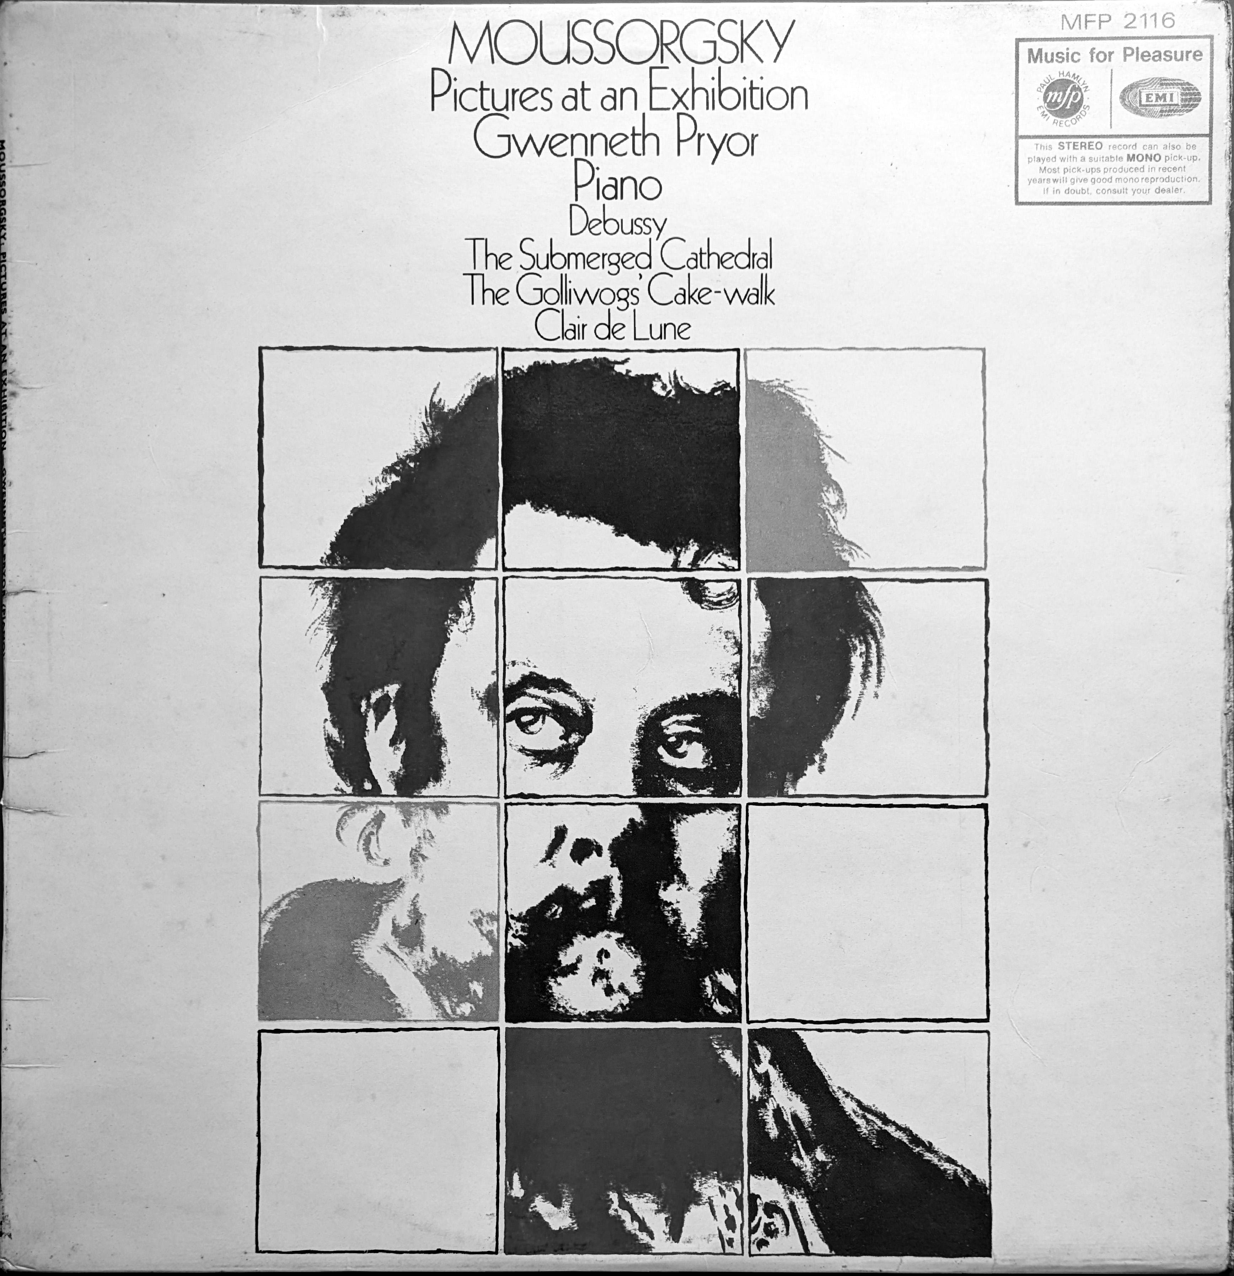
This particular release is worth attention for a number of different reasons. Firstly, the music of Moussorgsky and Debussy is profoundly beautiful. The solo piano of
Gwenneth Pryor is enchanting. Her performance on this album stands as a testament to her skill, and a reminder of the importance of labels like MFP in providing an avenue for talented artists who might otherwise have slipped through the cracks of the classical music mainstream. In spite of a promising start she did not have the opportunity to record extensively throughout her career.

Finally sleeve design, Keith Davis did a lot of work for MFP and other labels as well, Roots by Ian Carr’s Nucleus remains a favourite of his sleeves. This album cover though employs a captivating 60s pop-art-style; bold, vibrant use of colour. The design features a grid of brightly hued screen-print inspired squares forming a portrait of Mussorgsky. The result creates a dynamic visual effect, and would have looked great in the racks in 1969.

The story of budget labels like Music for Pleasure is inseparable from the shifting landscape of music consumption over the last fifty years. Their rise relied on a system where scarcity and carefully calibrated pricing created distinct tiers of taste, guiding audiences through pop, jazz, and classical in ways that reinforced both accessibility and cultural hierarchy. The arrival of the CD disrupted this system: suddenly, entire catalogues became available on a single format, eroding the distinctions that had defined listening habits. The internet accelerated the trend, and streaming has largely completed it, creating an environment where the symbolic value of music is less about genre and more about how it is consumed — the equipment, the context, the curation, and the stance of the listener.
This collapse of stratification is a key factor behind the resurgence of vinyl in recent years. Collectors now prize records not merely for their sound but for the ritual, the tangibility, and the scarcity they represent — markers of taste and engagement in a world where almost anything is instantly accessible. Meanwhile, countless records from the budget era still circulate for next to nothing, a quiet reminder of the enormous reach these labels once had, and the way they nurtured both artists and audiences outside the mainstream.
Ultimately, the history of budget labels is a testament to how technology reshapes cultural value. What once defined status — access, rarity, or hierarchy of genre — has shifted to process, knowledge, and participation. In this light, the vinyl revival is more than nostalgia: it is a new form of cultural stratification, one that owes its resonance to the very collapse of the old system that budget labels helped to create.

There are there was conflict between other areas of EMI's business for use of previously recorded material -

PARIS July 1970
MFP is targeting the 17 million French citizens with access to record players who seldom purchase records. Luzéna highlighted that while the American music industry sells three records per person annually and the U.K. sells 2.4, France lags behind with only 1.1 records per person each year.

Bibliography
1: Ken Barnes, , 2007,

