Assagai – Afrorock (SPR 90054)

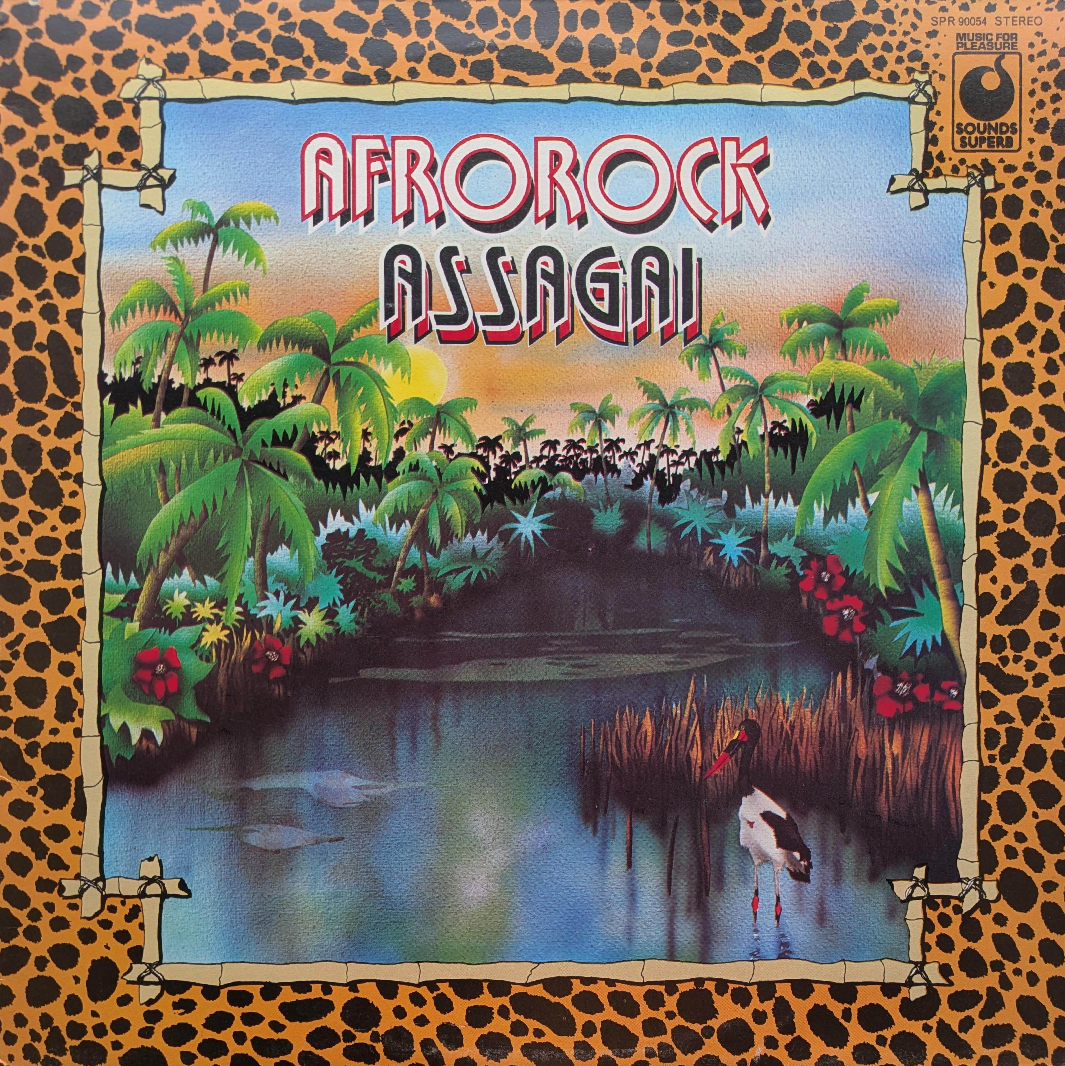
Assagai were a group of South African and Nigerian musicians working in London. Their line up included drummer Louis Moholo, trumpeter Mongezi Feza, alto saxophonist Dudu Pukwana, tenor saxophonist Bizo Mngqikana, and guitarist Fred Coker.

Assagai mixed African musical traditions with jazz and rock. The result was a distinctive, percussion-heavy sound shaped by the band's shared heritage, with congas, driving rhythms and vocals influenced by African folk styles. This record was originally released in 1971 with completely different title, Zimbabwe, and artwork.

One of the key income streams that Music for Pleasure mined was the reissue. They would have had plenty of master tapes, and the rights to reissue them, sitting in the vaults. It often feels as though the selection process was something of a gamble, yet in 1974 they chose to reissue this album as Afrorock, priced at the budget rate of just 49p. Although the music was unchanged they felt the need to alter the artwork. In place of the original psych-style sleeve was 70s kitschy packaging. The design choices would have been made with the intention of driving sales from the budget racks.

The reissue's title and artwork reflect the marketing assumptions of the mid-1970s, repackaging the same music in a form thought more commercially appealing. Today, based on Discogs statistics, roughly four times as many people own the MFP pressing as the original. Whether MFP's reissue broadened the audience for Assagai's music or simply reframed it for easier consumption is difficult to separate. Probably both.

