Music for Pleasure

Peruse a charity shop or check out a car boot sale and you might find a bunch of records. Nestled in them will likely be an LP or two from the Music for Pleasure (MFP) record label.

It feels that somehow we need to strive for pleasure. Is enjoyment heightened through additional effort? The vinyl community is paradigmatic of this kind of indulgence. Where the presence of records, turntables and hi-fi equipment maintains “friction” that modern technologies remove. Enduring some pain of turntable and needle drop in order to add some intangible audio shimmer and outshine the streaming services. This is then packaged and sold as a lifestyle.

But this was not always the way because this technology, the micro-groove album, was once seen as the embodiment of ease. No more winding gramophones and changing needles. Where an album had literally been an album of discs now the record was a simple single item. And this was the state of play when MFP operated.

MFP ran in parallel to the golden era of the album. Launched in 1965, its name, Music for Pleasure, is partially true. It wasn’t really about pleasure, or at least that was tangential. It was about selling records which they did in their millions; literally. In 1972 alone they sold over 9 million records. The aim for EMI, who jointly owned the venture with Hamlyn, was to sell records to people who did not usually buy records.

The modus operandi was high volume, low price and sell in locations not usually associated with music or records. Boots Chemist, WH Smith, Woolworths etc. For me the reputation of the label has, over the years, been skewed negatively. Likely because I see the same not great records in charity shops all the time. However, their catalogue is vast and even a broken clock is right twice a day. This vastness of the MFP catalogue, generally providing good quality records with satisfactory music, occasionally produced good stuff and even some genuinely extraordinary records.

So that is what this is - a little fanzine looking at, for the most part, the outliers of the MFP catalogue. Additionally some very brief notes on two of the key founders in the organisation.

Assagai – Afrorock (SPR 90054)

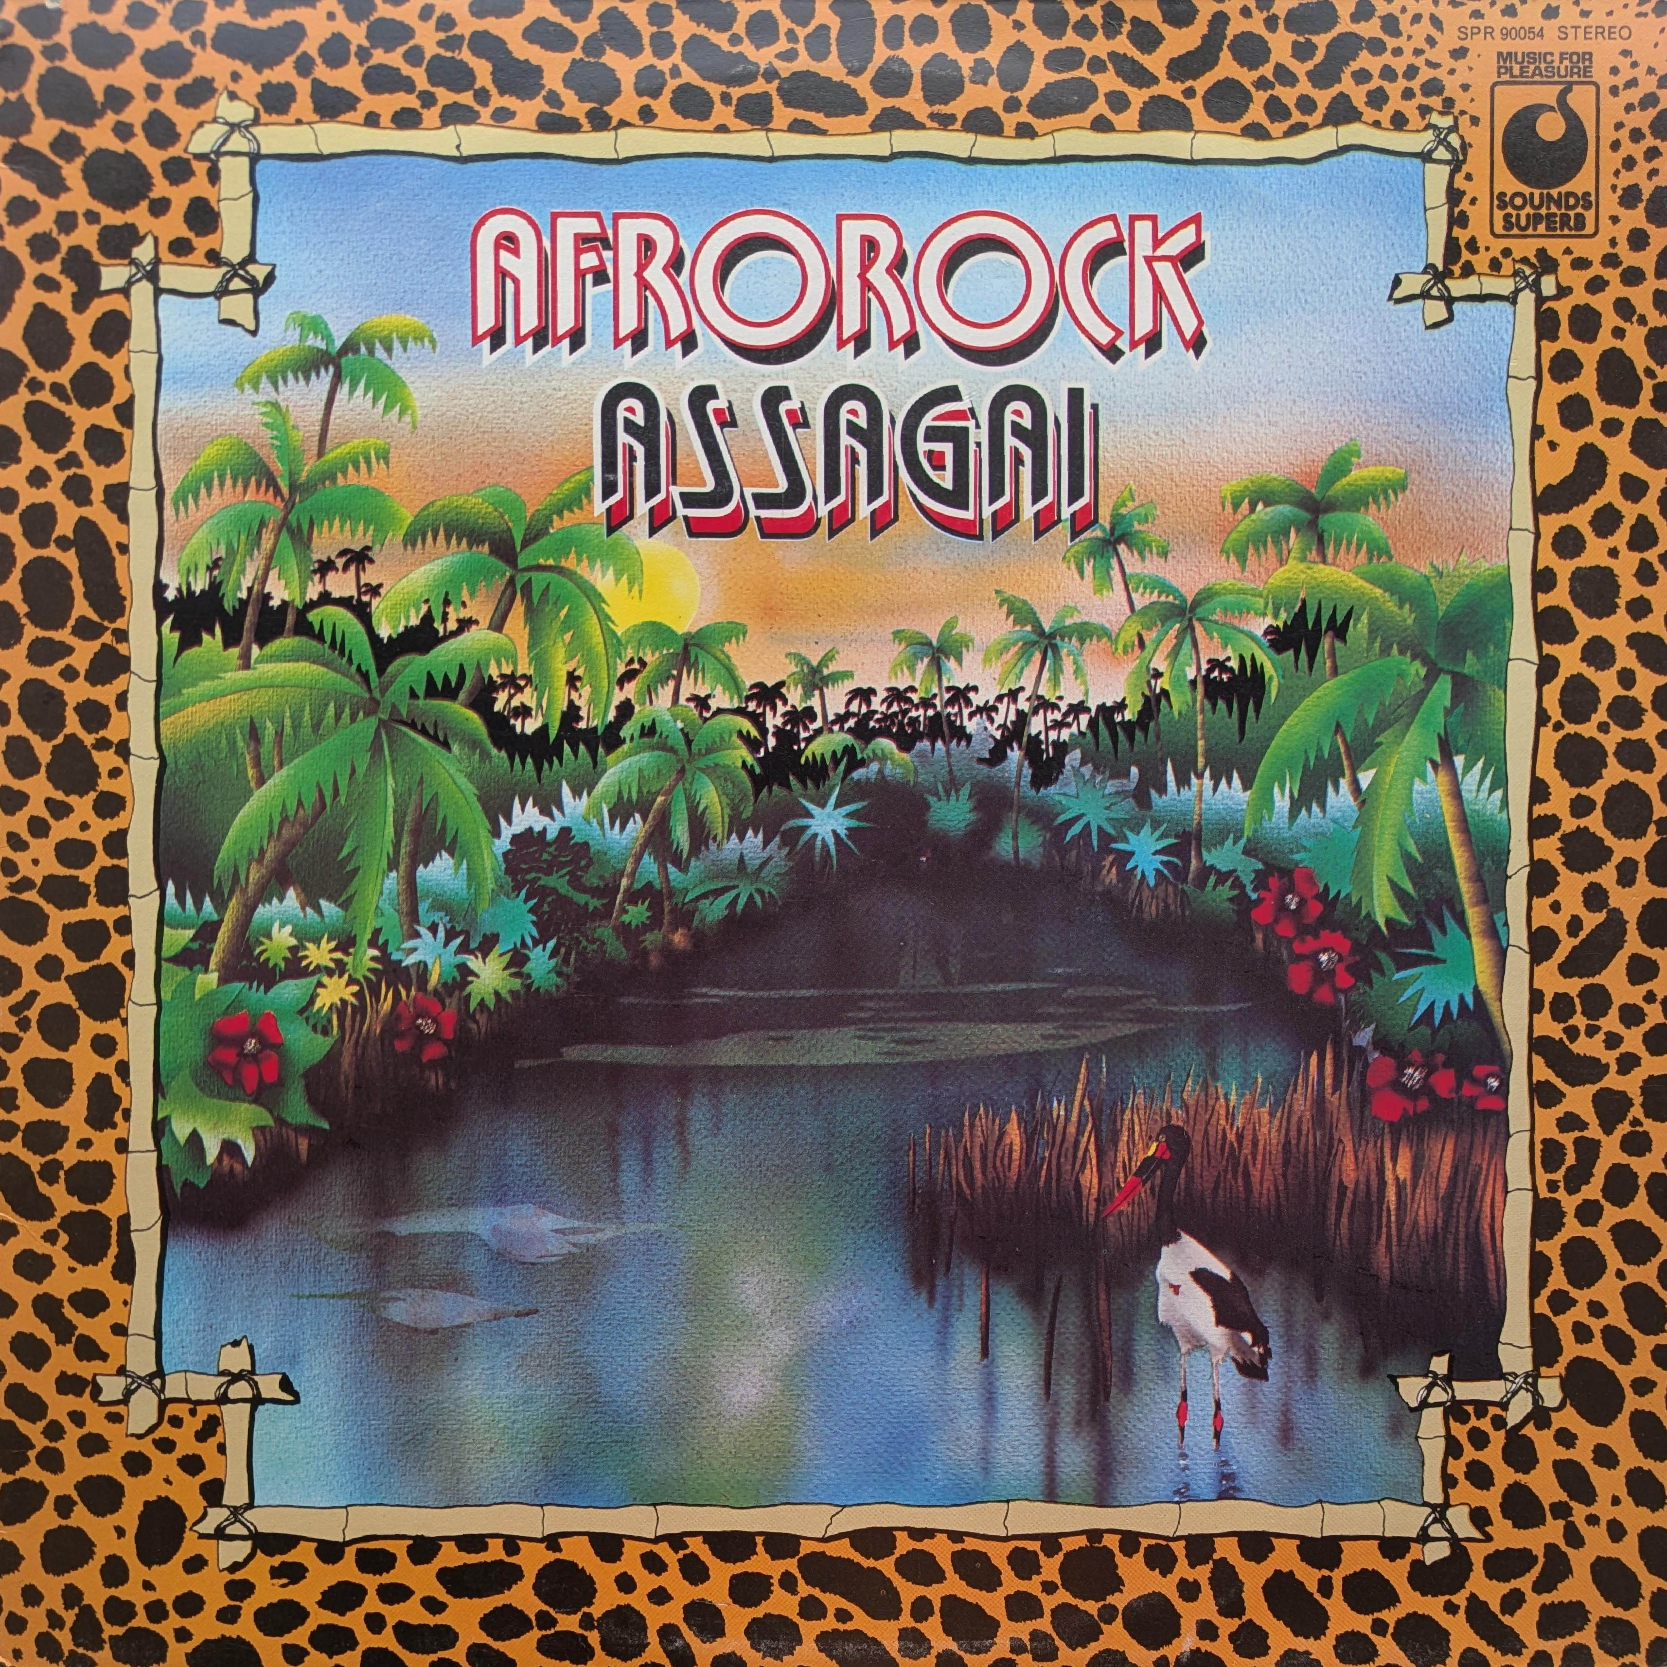
Assagai were a group of South African and Nigerian musicians working in London. Their line up included drummer Louis Moholo, trumpeter Mongezi Feza, alto saxophonist Dudu Pukwana, tenor saxophonist Bizo Mngqikana, and guitarist Fred Coker.

Assagai mixed African musical traditions with jazz and rock. The result was a distinctive, percussion-heavy sound shaped by the band's shared heritage, with congas, driving rhythms and vocals influenced by African folk styles. This record was originally released in 1971 with a completely different title, Zimbabwe, and artwork.

One of the key income streams that Music for Pleasure mined was the reissue. They would have had plenty of master tapes, and the rights to reissue them, sitting in the vaults. It often feels as though the selection process was something of a gamble, yet in 1974 they chose to reissue this album as Afrorock, priced at the budget rate of just 49p. Although the music was unchanged, they felt the need to alter the artwork. In place of the original psych-style sleeve was 70s kitschy packaging. The design choices would have been made solely with the intention of driving sales from the budget racks.

The reissue's title and artwork reflect the marketing assumptions of the mid-1970s, repackaging the same music in a form thought more commercially appealing. Today, based on Discogs statistics, roughly four times as many people own the MFP pressing as the original. Whether MFP's reissue broadened the audience for Assagai's music or simply reframed it for easier consumption is difficult to separate. Probably both.

Vuelo Químico (046-1215231)

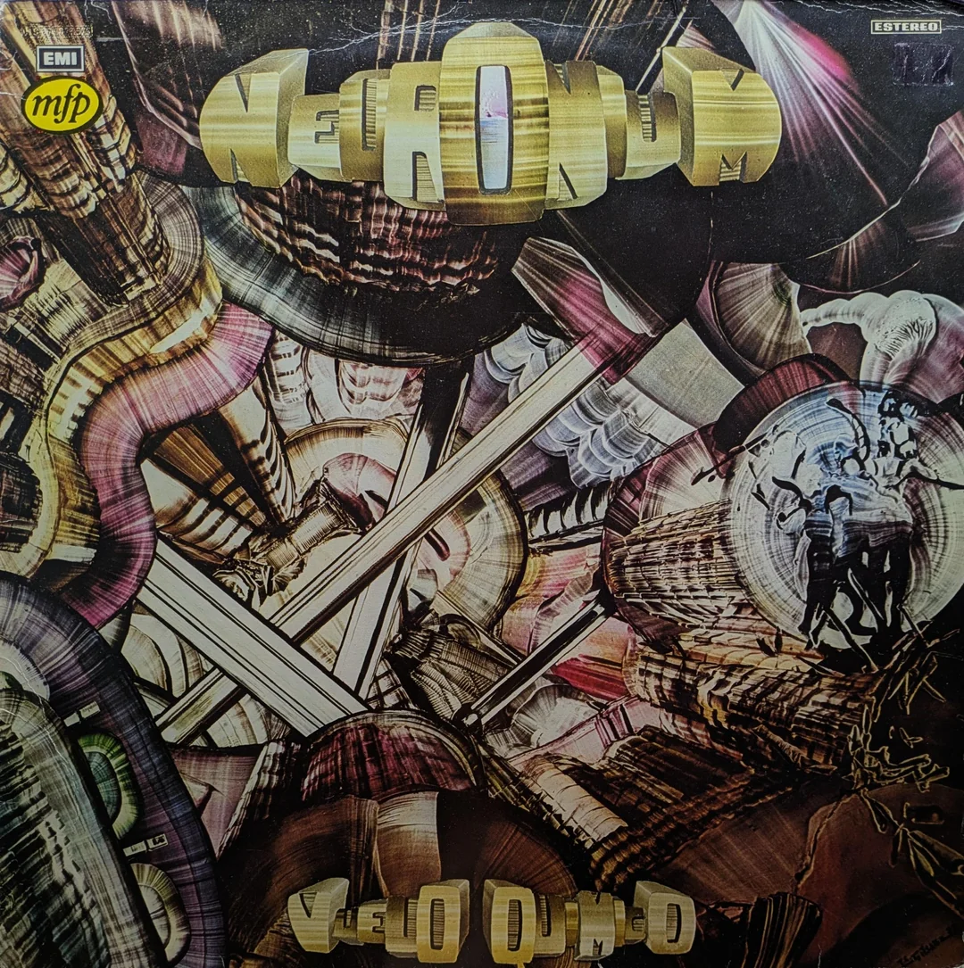
Originally released on Harvest this has to be one of the more eccentric MFP releases.

This is Neuronium’s second LP in the unusual world of Spanish 'cosmic music'. Michel Huygen was the founding member and driving force. The style, psychotronic music, was more about generating relaxation and imaginative states through floating, textured synthesis. This is not a pastiche of Kraftwerk or Vangelis - it is closest in style to psychedelic or progressive rock but using the tools of synthesis, and with very little percussion.

The album is dedicated to the poet Edgar Allan Poe. It also features a special guest appearance from Velvet Underground singer Nico, who vocalises some of his poetry. Her appearance, in a way, adds heft to the aim of altering states of mind with vocals that feel very other worldly. According to her biographer, Jennifer Bickerdike:

The collaboration came about by chance: she happened to be in the same recording studio during the sessions and was reportedly so moved by the music that she asked if she could take part.

It is a really cool record and a really relaxing album to just dip in and out of. A record that slips between genre cracks, not being a prog record or fully electronic. And it is not part of a wider movement it is very much a one off.

Perhaps the reason for the MFP reissue was down to the Nico connection? There are not to my knowledge any similar releases on the label.

Stereo Discotheque (4M 046-94.687)

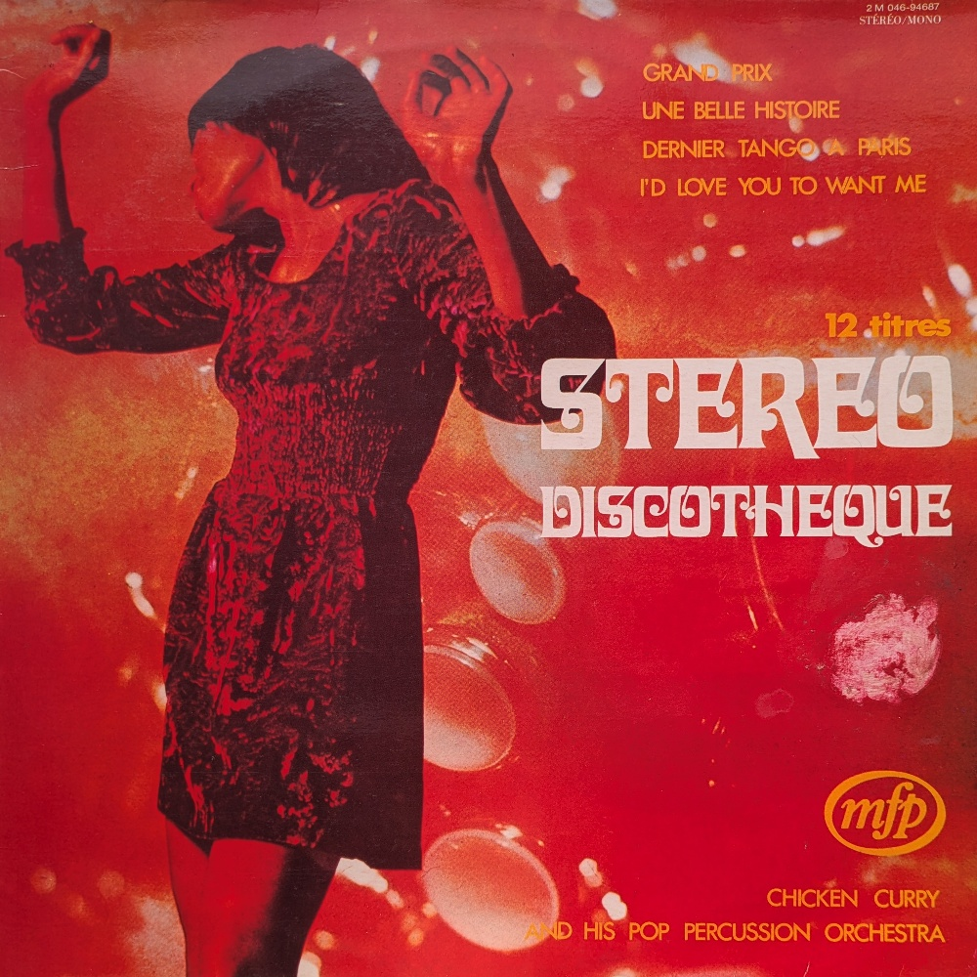
I don’t think the record is widely known which is a shame because it is a gem of the MFP catalogue, released only in France and Italy - which is perhaps why it is overlooked in the UK.

MFP’s launch in France in 1970 was met with strong opposition from record dealers, who feared the low-priced albums would undermine the traditional market. Jacques Le Calve, president of the French Syndicat des Disquaires, called for a semi-boycott of the Pathé-Marconi-backed label, arguing that customers accustomed to paying 11.50 francs for a quality LP would be reluctant to buy full-priced releases. Despite the resistance, MFP continued its expansion plans and thank goodness because it threw up this little treasure.

The album is credited to Chicken Curry & His Pop Percussion Orchestra; a fake French-market alias for El Chicles, a Belgian jazz-funk outfit whose two main members, John Sluszny and Ralph Benatar, were both prolific composers working within a tight-knit circle of Brussels session musicians who put out dozens of records under various pseudonyms throughout the early 1970s. One of the tracks on the album, Librium, also appears on the RKM library record Beat Action.
There is a significant crossover between the worlds of Music for Pleasure and that of the music library. There are some MFP consumer reissues of library albums, Tijuana Christmas was originally Christmas Party (KPM 1502), and a significant overlap of personnel across both budget label and production library output.
The track Malaria Fever on this album also appears on the MFP album Brasil, where it shows up as Malaria Febre, a slightly altered, even Moog-ier version of the track on this record.

Roger Webb Plays Gershwin
(MFP 50099)

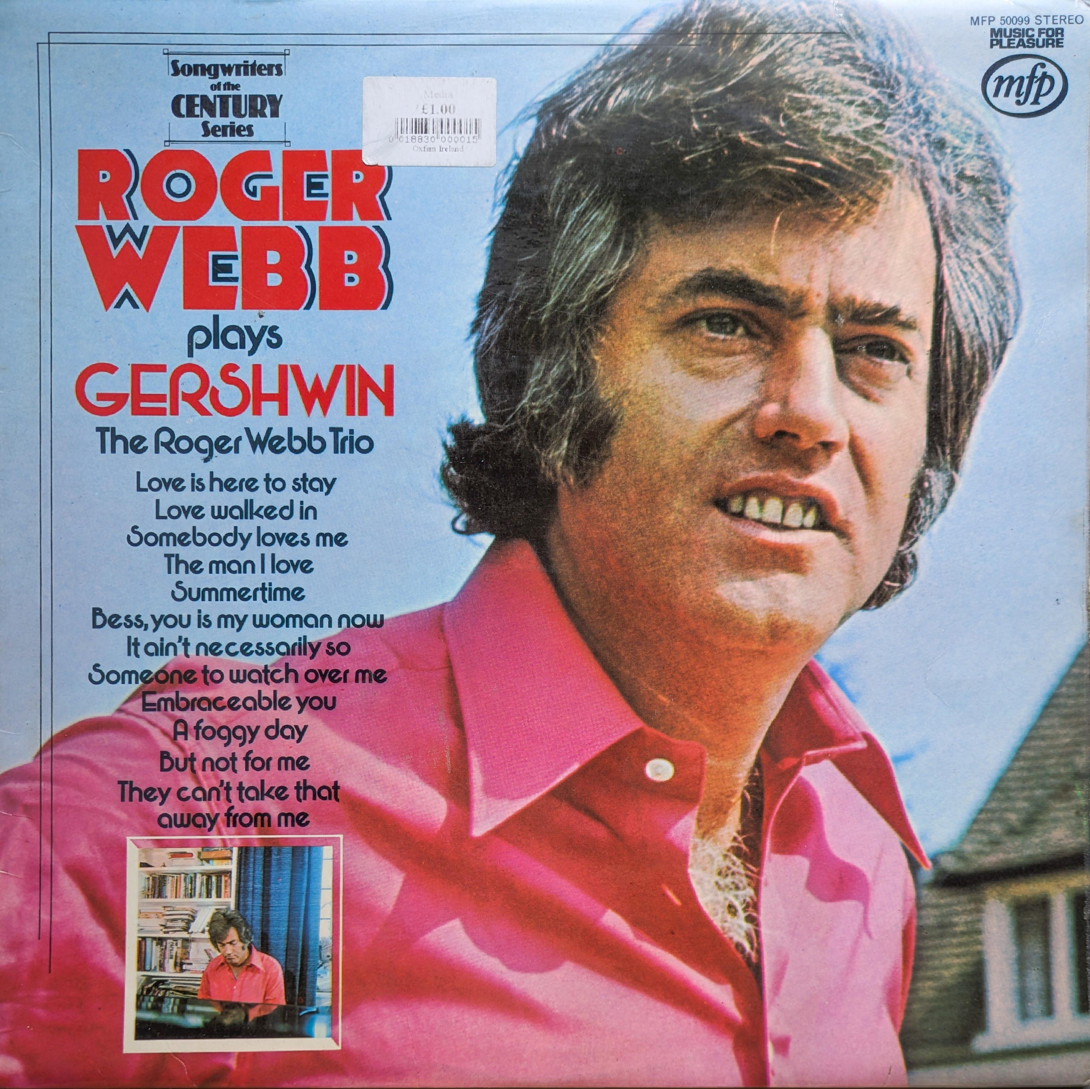
This album presents a suite of Gershwin arrangements by the Roger Webb Trio, a UK-based jazz ensemble led by the exceptionally talented pianist, composer, and arranger Roger Webb. I don’t think Roger Webb is generally well-known, his work in film and television (including the haunting score for Bartleby) is relatively hidden, although highly sought-after by collectors. Here his arrangements are both casually inventive, yet very respectful of the source material. It is, after all, a Music for Pleasure record so it is not way off piste; a pretty jazz outing and a very easy and enjoyable listen.

There is no denying the musicianship on these recordings; Webb and his trio bring a polished, studio-ready precision, likely honed through their work in stock and production music. The result is a record that, while not groundbreaking, is clearly well-crafted and very enjoyable, appealing to both jazz enthusiasts and casual listeners. Webb’s self-taught improvisation is sublime; this is particularly evident on the trio’s version of It Ain’t Necessarily So, where the piano is given free rein to go a-wandering.

One caveat, however, is the album’s cover art, which is, frankly, atrocious. Its garish design and clashing fonts do a disservice to the music, but don’t let that deter you. Had it been issued with a stylish mid-century modern jazz sleeve, I suspect it would be a far more sought-after record. Instead, it deserves to be judged solely by the music.

Sir Joseph Lockwood (1904–1991)

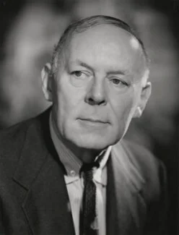
Sir Joseph Flawith Lockwood arrived at EMI in 1954, by what seems, in retrospect, an almost implausible route. Born in Southwell, Nottinghamshire in 1904, the son of a mill owner, he left school at sixteen without qualifications and built his early career on milling machinery, literally writing the book on the subject. When approached and asked to take charge of EMI, the company was losing around half a million pounds a year and was by all accounts drifting toward insolvency. Lockwood became chairman on his fiftieth birthday, and the company he left twenty years later was the largest record organisation in the world.
What he did at EMI is well documented and involved big decisions and a huge amount of change. By 1960, annual profits stood at five million pounds. He was knighted the same year.
His instinct throughout was to find audiences that weren't being reached and reach them. Hence Music for Pleasure makes a lot of sense. Chris Ellis, who worked in EMI's cataloguing and production operation during the mid-1960s, interviewed by Mark Berresford:

Then along came our Chairman, Sir Joseph Lockwood, who had recently been to America and had seen the first 'rack job' labels... they put them in anywhere that had room for a rack of 100 LPs. He came back and said we had to have a 'rack job' label, which caused great consternation... the fact we would be selling LPs at half the price of the cheapest record on the market.

Lockwood's idea was received internally with something between scepticism and alarm. However, Music for Pleasure ended up outlasting him by two decades, eventually absorbed into EMI Gold in 1995 and expiring quietly when EMI itself was broken up in 2012.

L'Oeil Ecoute (MFP 2M046-13266)

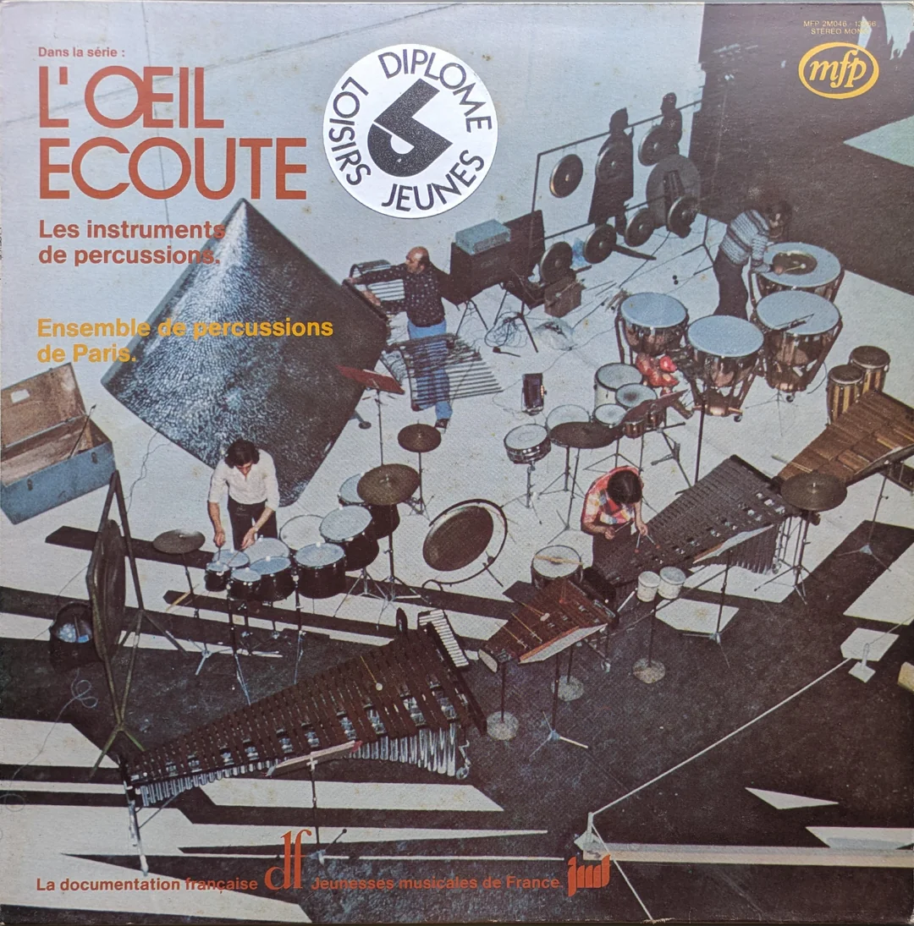
This is an educational record. When I started looking more deeply into the MFP catalogue this record stuck out because it appears very much to be a one off.

Vincent Gémignani is likely to be the driving force behind this release. The son of a sculptor and a musician, he was attracted by both disciplines, soon deciding on the second, perhaps discouraged by his father about his sculptural talent. He studied at the Conservatoire Supérieur de Musique and at the age of twenty, he founded, with some fellow students, L’Ensemble Percussion de Paris, better known as the Modern Pop Percussion.

It is an oddity, not just of the MFP catalogue; side one is just drum hits, presumably useful for sampling and the flip side is pleasant enough modern classical percussion pieces.

One thing that is very unusual is the last track of side one. A solo recording of the Bronte. This is a one-off instrument invented by Vincent Gémignani, combining both his sculpting and musicianship. It is one of the most unusual sounding percussion instruments, incredibly atmospheric and really eerie. The instrument can be heard in the background of, amongst others, Ophis Le Serpentaire (not included on this album), where it provides an ethereal presence over the whole piece.

The record was produced by Anton Kwiatkowski, prolific at MFP. Another of his albums, more widely known and definitely worth checking out, is Non-Stop Pepsi Party.

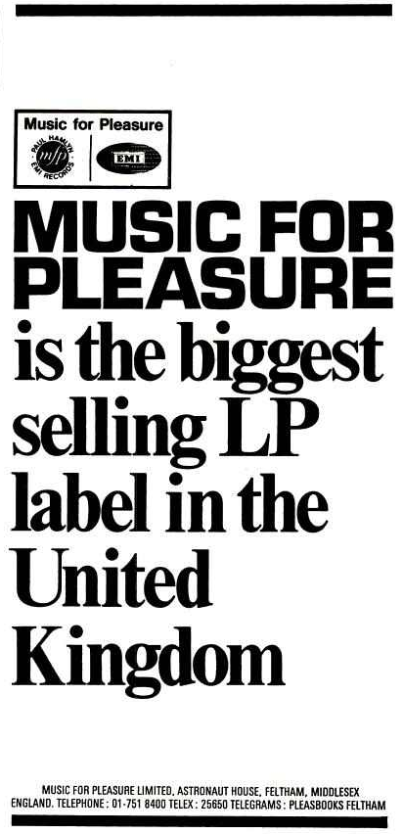
Curried Jazz (MFP 1307)

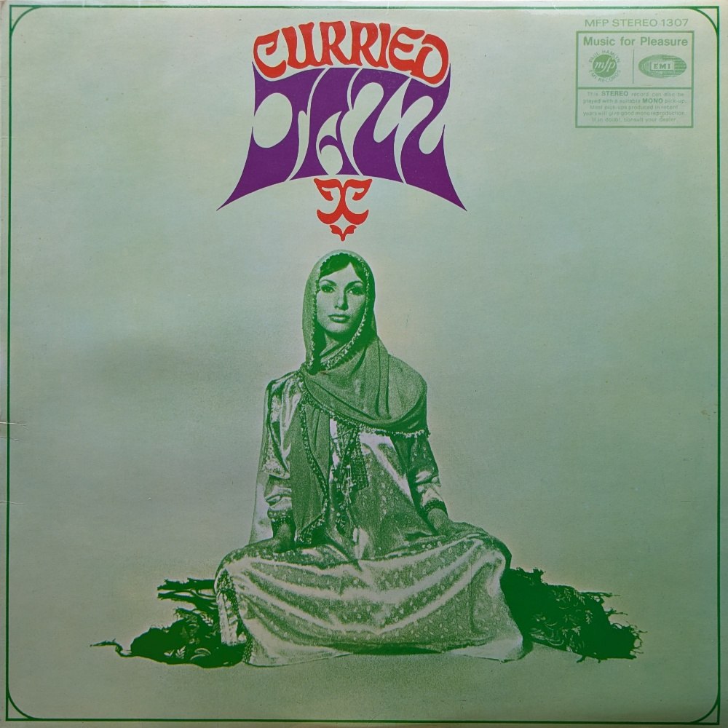
"Curried Jazz" is a very strange album. The budget label is moving into the creation of new and experimental recording. The record documents a unique attempt to bring together Indian classical music and jazz, two improvisational traditions that are structurally quite different.

Bandleader Ken Burgess noted that Indian classical improvisation unfolds against a drone and uses fluid timing, which is opposite to jazz's reliance on fixed chord sequences and counted bars. The challenge in the recording was about defining a structure that both sets of musicians could adhere to.

Arranger Victor Graham was brought in to create written parts that made the Indian drone patterns look like familiar chord charts for the jazz musicians, while leaving enough freedom for the Indian players. The result is a sort of separated coexistence of both genres of music; but without it sounding as if the players are in different rooms not really listening to one another.

The group was assembled informally; sitarist Dev Kumar, for example, was found through a chain of phone calls. The line-up was modest. In total just seven jazz and four Indian musicians were involved in the music on the project. Even though a 1969 Melody Maker column recommended "Curried Jazz" framing it as serious listening, it still would have been a kind of novelty record. One contemporary review used a rather naff analogy: “It’s strictly korma rather than vindaloo, but like good Indian food, it’s cheap!”

Ken Burgess reported that it sold 15,000 copies in its first month, even though MFP thought it wouldn't sell.

Paul Hamlyn (1926–2001)

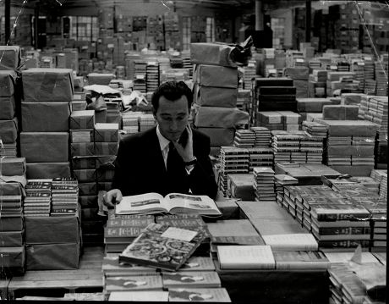
Paul Hamlyn, originally Hamburger, anglicised his name after arriving in the UK. The migration of his Jewish family was forced due to the rising Nazi power in Germany. Educated at St Christopher School in Letchworth. He left school without going to university and entered the book trade.
Paul Hamlyn began his publishing career selling books from a barrow in Camden, opening his first imprint, Books for Pleasure, in 1949. This was his modus operandi; classics sold through unconventional outlets; general shops and department stores rather than bookshops. His books were produced in large, cheap editions. His choice of printers in Czechoslovakia who could produce lavishly illustrated books at a rock-bottom price. The story may well be apocryphal but it is alleged that there were points at which Paul Hamlyn’s Books for Pleasure were using 100% of Czechoslovakia’s publishing capacity.
On 25 August 1965, Hamlyn, alongside EMI chairman Sir Joseph Lockwood announced the formation of Music for Pleasure. Hamlyn's contribution to MFP was structural: the distribution network into non-traditional retail that he had spent fifteen years building for books. EMI provided the catalogue and pressing capacity and Hamlyn provided the sleeve printing and route to market.
Hamlyn was appointed CBE in 1993 and made a life peer in 1998 as Baron Hamlyn of Edgeworth. He established the Paul Hamlyn Foundation in 1987.
By all accounts, unlike the media megalodons of today, he was a decent person. This is my favourite description, from David Owen, "not a politician, but by nature on the side of the underdog."

Big Terror Movie Themes
(MFP 50248)
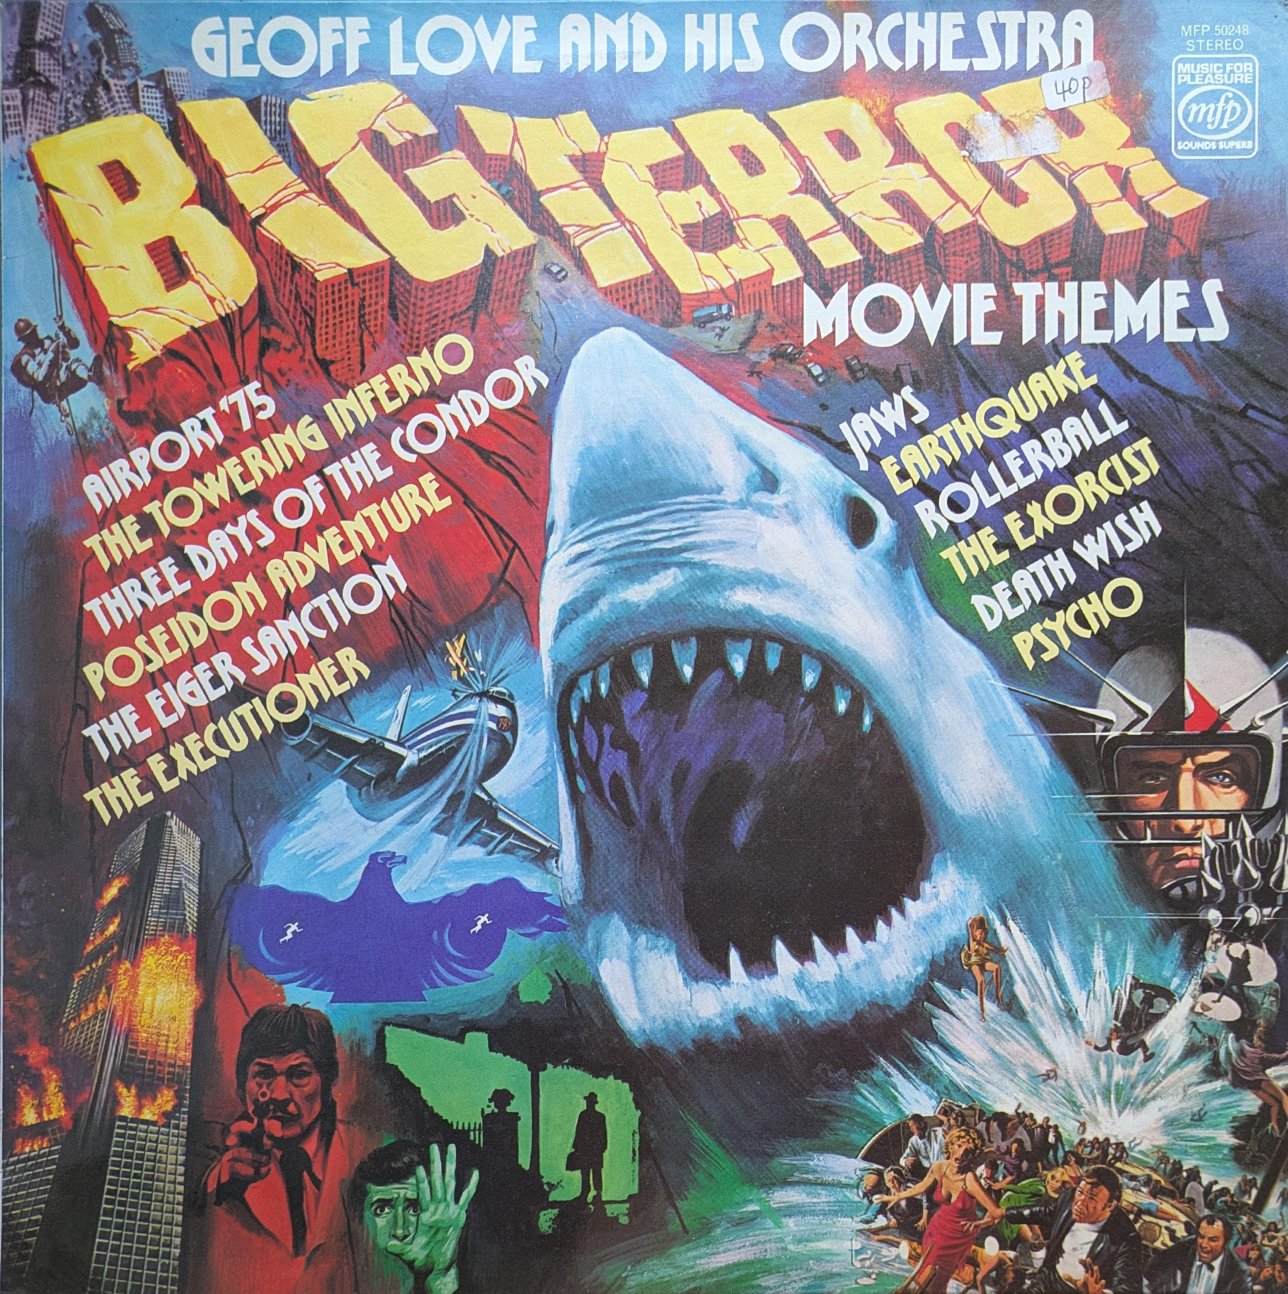
It perhaps took longer than people initially thought for the budget structure to undo itself. The shift was quite gradual but by the mid nineties you could buy all of the chart music on CD and cassette in a local Tesco. Up to the minute releases shared the same racks as the budget labels for a time and then they were all gone. Today it's unusual to see CDs sold in supermarkets at all.
We are in 2026 seeing the disappearance of cheap paperbacks. They too once fuelled a vast cultural engine. For example, a book about a terrifying shark becomes a blockbuster with an unmistakable score. Naturally then Geoff Love’s compilation of Big Terror Movie Themes would include the iconic Jaws theme. A neat little cultural loop of pulp fiction to pulp music.

In my mind Geoff Love is synonymous with MFP. His name and pseudonyms appear on scores of budget-label records. Trombonist turned arranger, by his own account praising and tough on musicians.

The London session musicians are the best readers in the world. And this is acclaimed... You walk in the studio in London, you put the music up which they've never seen in the life before; they'll play it. First time through, they'll play it, you might get a mistake. The second time through you don't expect a mistake. If there's a mistake on the third time, those guys don't work again.

His exactness, understandable given the economics, was evident on this album. Played through a good stereo system it'll sound incredible. Three Days of the Condor is a standout but this whole album is beautifully arranged. The top session musicians of the day recorded by London's best engineers in a great studio. This album has no business being as good as it is.
Some of the consensus that I come across online today is that these albums are a bit cheap and nasty. For example this comment on Reddit:

Just a tip from an experienced collector. Anything MFP is a budget pressing and often sounds poor (also all completely worthless)

These are undeniably budget records - marketed as such from start to finish but the UK records were pressed at Hayes; consistently sound great. As to the universal charge of worthlessness that says as much about the listener as the music. But I understand this, especially if the comparison were between something like Hot Hits 6 and Dark Side of the Moon. My thinking would be quite different, where Curried Jazz sits quite naturally alongside, say, a Caravan record.

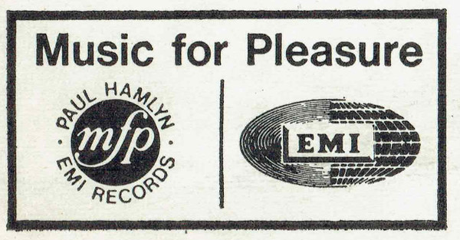
All of these albums were released at what is considered to be the golden era of the LP. There are all sorts of retrospectives of various genres and sub-cultures from this period, German cosmiche music, Italian film scores, obscure folk horror, the list goes on. Aside from the Sound Gallery and the odd piece picked up on various Soul Jazz compilations over the years I can’t think of any in depth retrospective of British budget labels. It must be worth looking into - just see the various different records brought together here. But it’s like MFP and Contour and Marble Arch and the like are so mundane and plentiful that they are overlooked, which is a real shame because I think it is likely that a big chunk of cultural history has vanished as a lot of people directly involved in the production of this music are no longer with us. However on the positive side these records are still here. And yes often they will generate a laugh, they might be a bit naff but there is real artistry that goes into them. These records are not shoddily produced and if for no other reason than sheer volume of catalogue they contain some brilliant recordings of music of the era.

