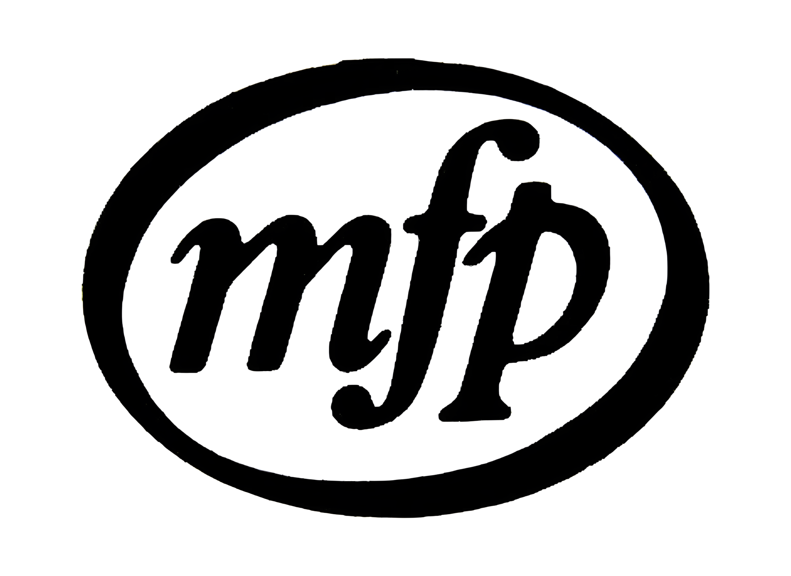

Music for Pleasure (MFP) was a British budget record label launched in October 1965. A great democratiser of recorded music: repackaging serious music cheaply and accessibly to the mass market.

This Fanzine has been researched to the best of my abilities but if you feel there are inaccuracies let me know:

mackaywill@gmail.com

