**User Manual**

**Plasmid Purification with NucleoMag Plasmid Kit**

1. Start the Opentrons OT2-Robot (toggle switch on the left side in the back) .
2. Turn on all necessary modules for the plasmid purification protocol (Magnetic Module).
3. Start the Opentrons App.
4. In the „Protocols“ tab find the “Plasmid Purification with NucleoMag Plasmid Kit (Magnetic Separation)” protocol.
5. 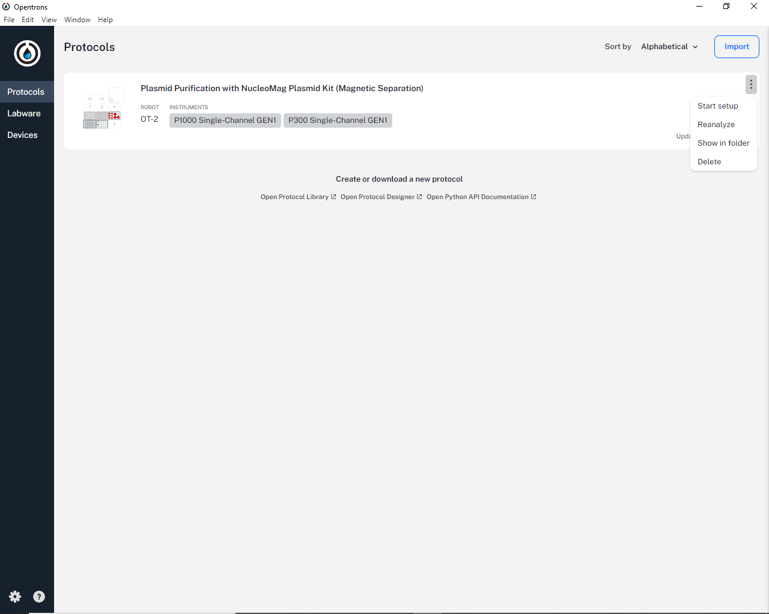For the protocol, press the three vertical dots at the upper right corner and select “Start setup”.
6. 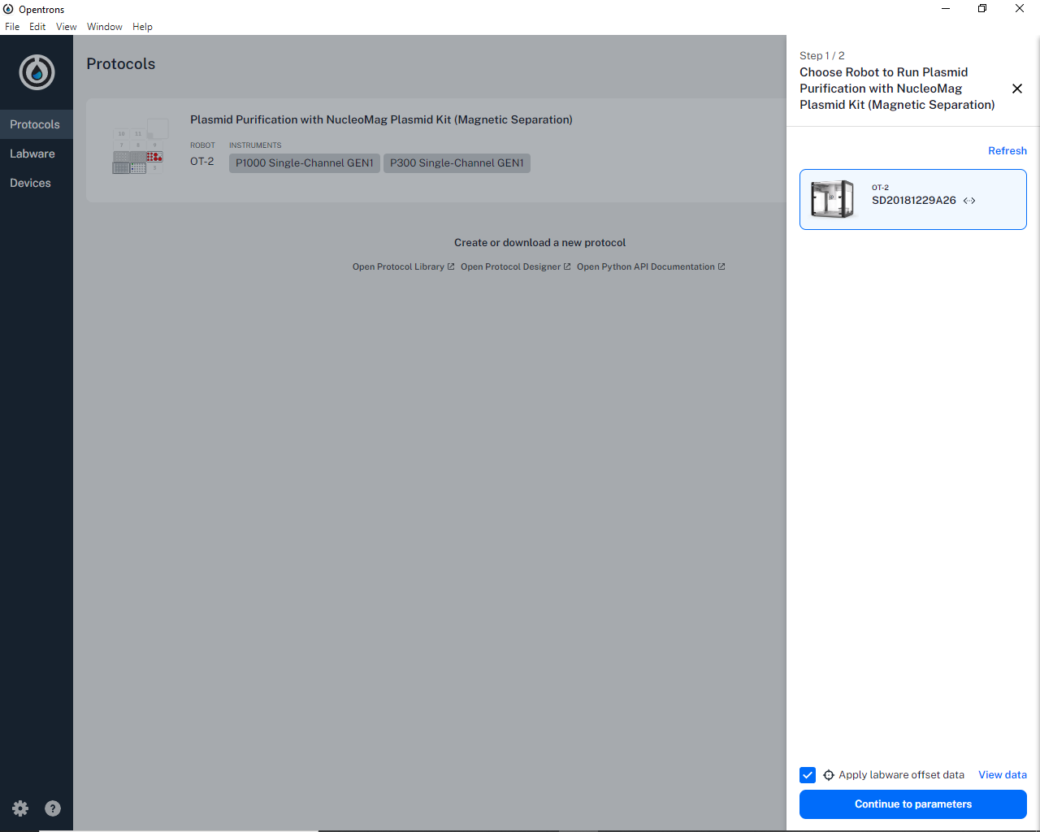A sidebar appears with the selected OT2-Robot and a ticked checkbox “Apply labware offset data”. **Keep the checkbox selected** and press “Continue to parameters”.
7. 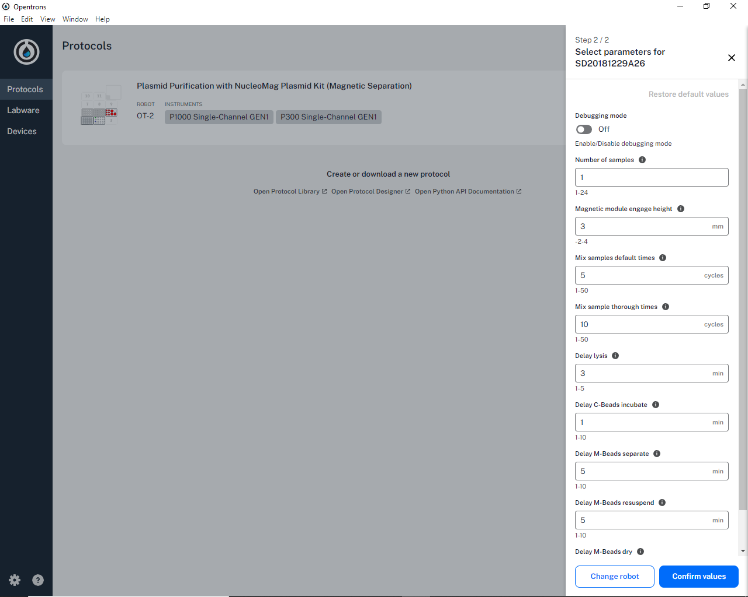The parameter selection sidebar appears. Here you can customize the protocol parameters. **Most important is setting the correct number of samples here.** Number of mixing steps, incubation times and other delays can also be changed, however, the default values should normally be suitable. After changing and confirming parameters press “Confirm values”.
8. 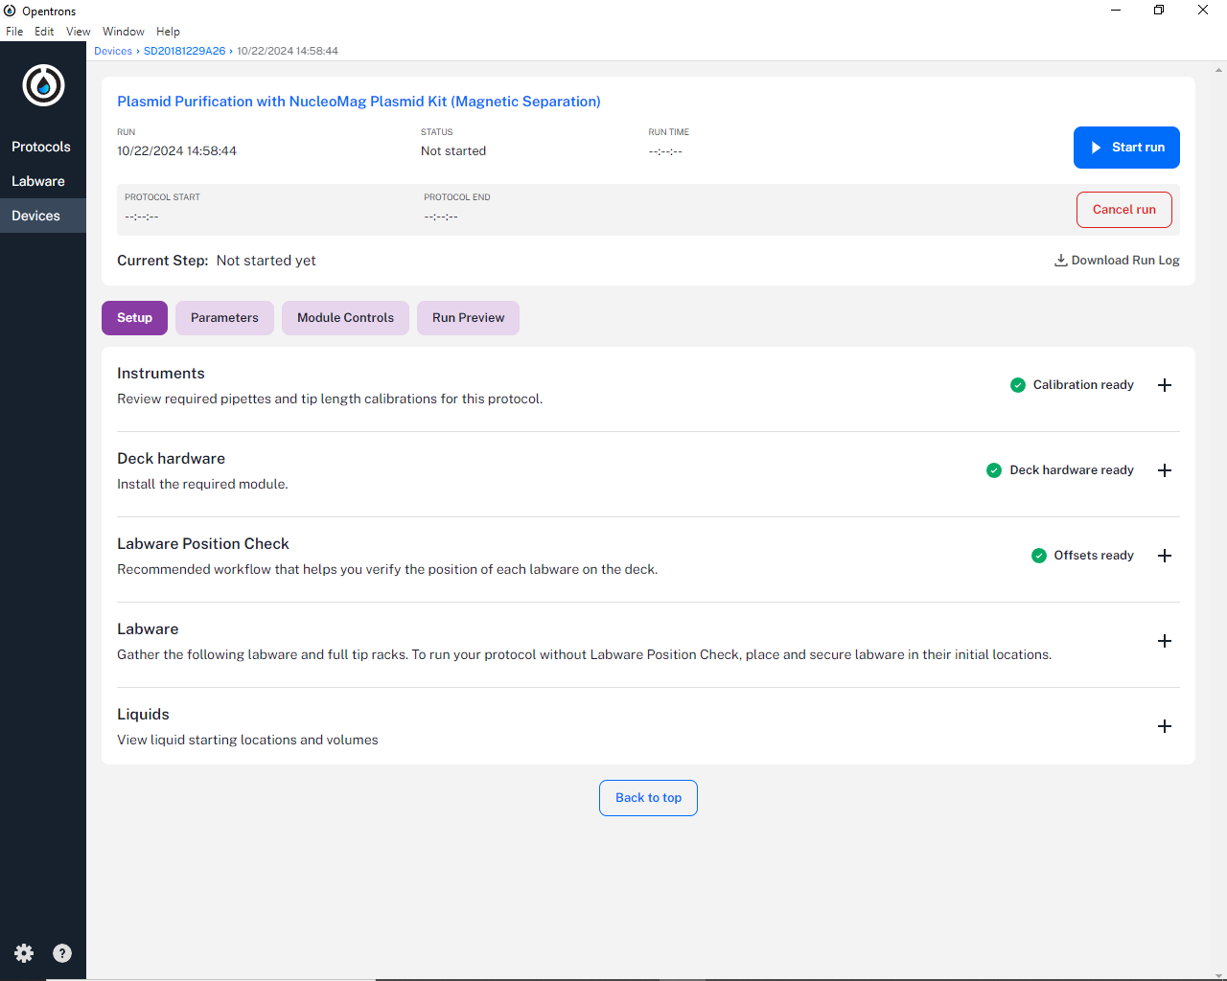Now the protocol is analyzed by the Opentrons App. This means it simulates the protocol and checks for programming errors and logical mistakes. This analyzation takes different amounts of time depending on the number of samples, so be patient. Only proceed after the blue button in the upper right corner says “Start run”. **DON’T START THE PROTOCOL YET!**
9. 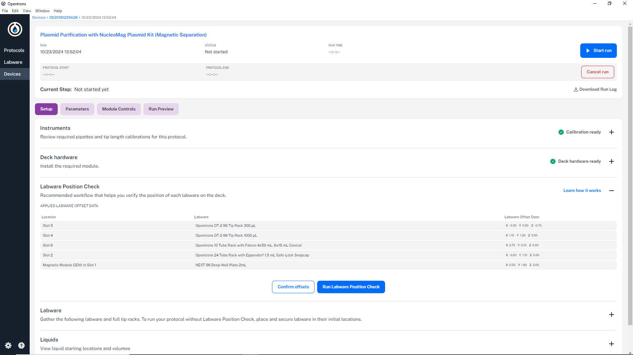Expand “Labware Position Check” by selecting the “+” symbol, and press “Confirm offsets” (if this button is disabled, the “Apply labware offset data” checkbox from manual step 6 was not ticked; in this case press “Cancel run” and reload the protocol with the checkbox ticked). **DON’T press “Run Labware Position Check”. If you did so call the Device Manager to recalibrate the labware for use of the protocol.**
10. 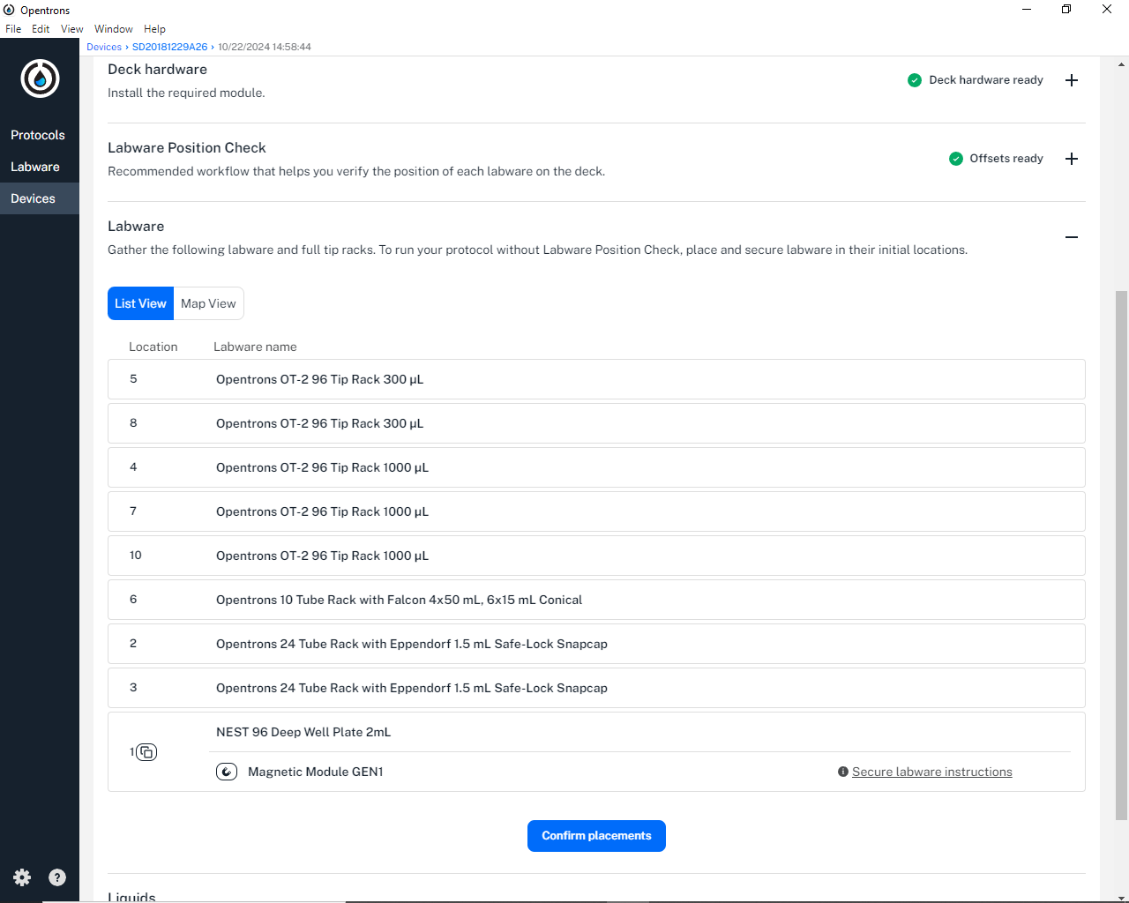Expand “Labware” by selecting the “+” symbol, check if the correct labware is at the correct location on the OT2 deck. **Be sure that the labware is correctly fitted into the corresponding location (check if the labware lies flat)**. Press “Confirm placement”. You can have a look at the printed OT2 deck layout at the OT2 side wall, showing the location positions on the deck (see also image on last page of manual).
11. Expand “Liquids” by selecting the “+” symbol, press “Map View” and check again if the correct labware is at the correct slots on the OT2 deck. Next you can click on each labware and check if the correct eppi/tube with the correct chemical (liquid) is placed at the correct well in the labware with the correct volume. The color coding is:
    1. Red: Checmicals
    2. Green: Bacterial Culture Pellets
    3. Blue: Empty eppis for purified plasmid storage

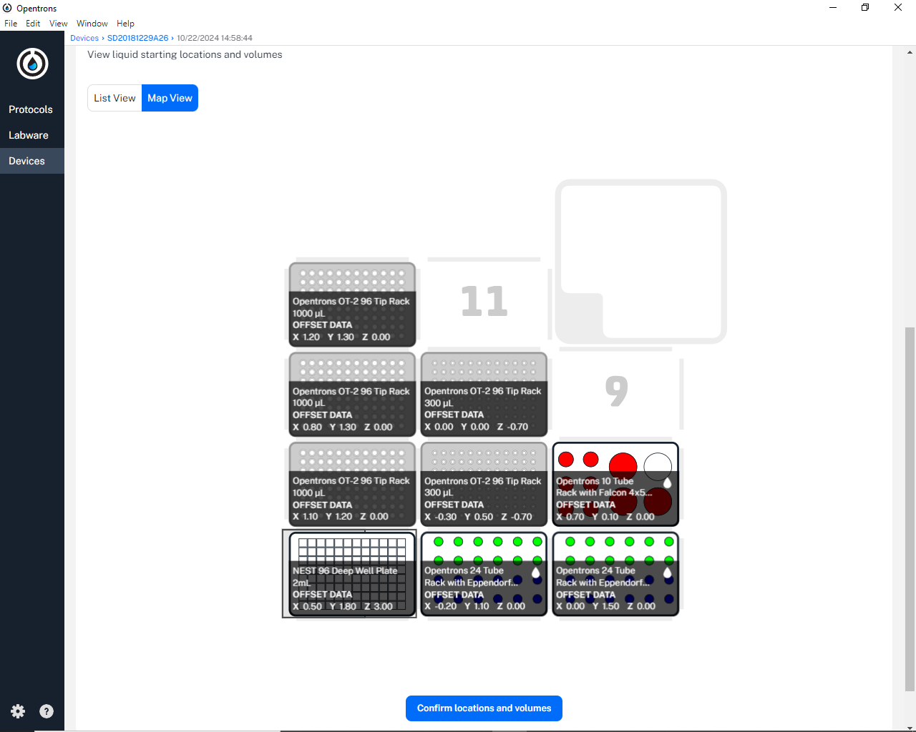After checking that everything matches between the OT2 deck and the protocol **close the front lid** and press “Confirm locations and volumes”.

1. 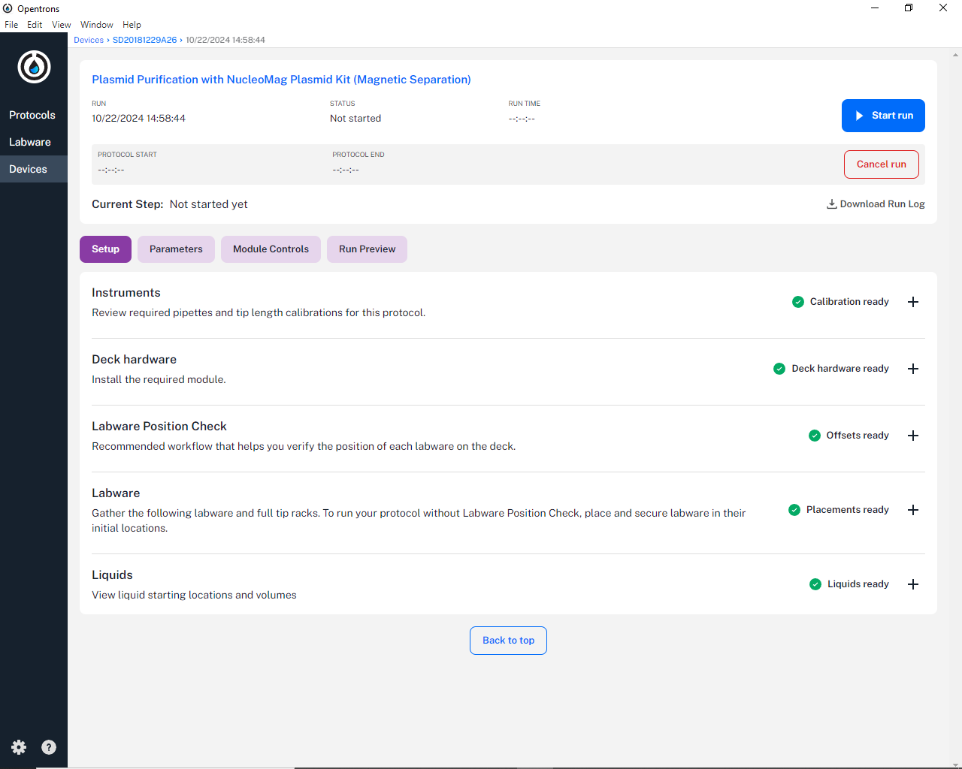There should now be a green tick at “Instruments”, “Deck hardware”, “Labware Position Check”, “Labware” and “Liquids”. If this is the case you are ready to run the protocol. Either press “Start run” or check optional steps 13-15 of this manual for extra checks. If not all categories are with a green tick, expand the category that doesn’t have a green tick and proceed with the preparations at the corresponding step of this manual. **If “Instruments” or “Deck hardware” is not ticked green call the Device Manager!**
2. 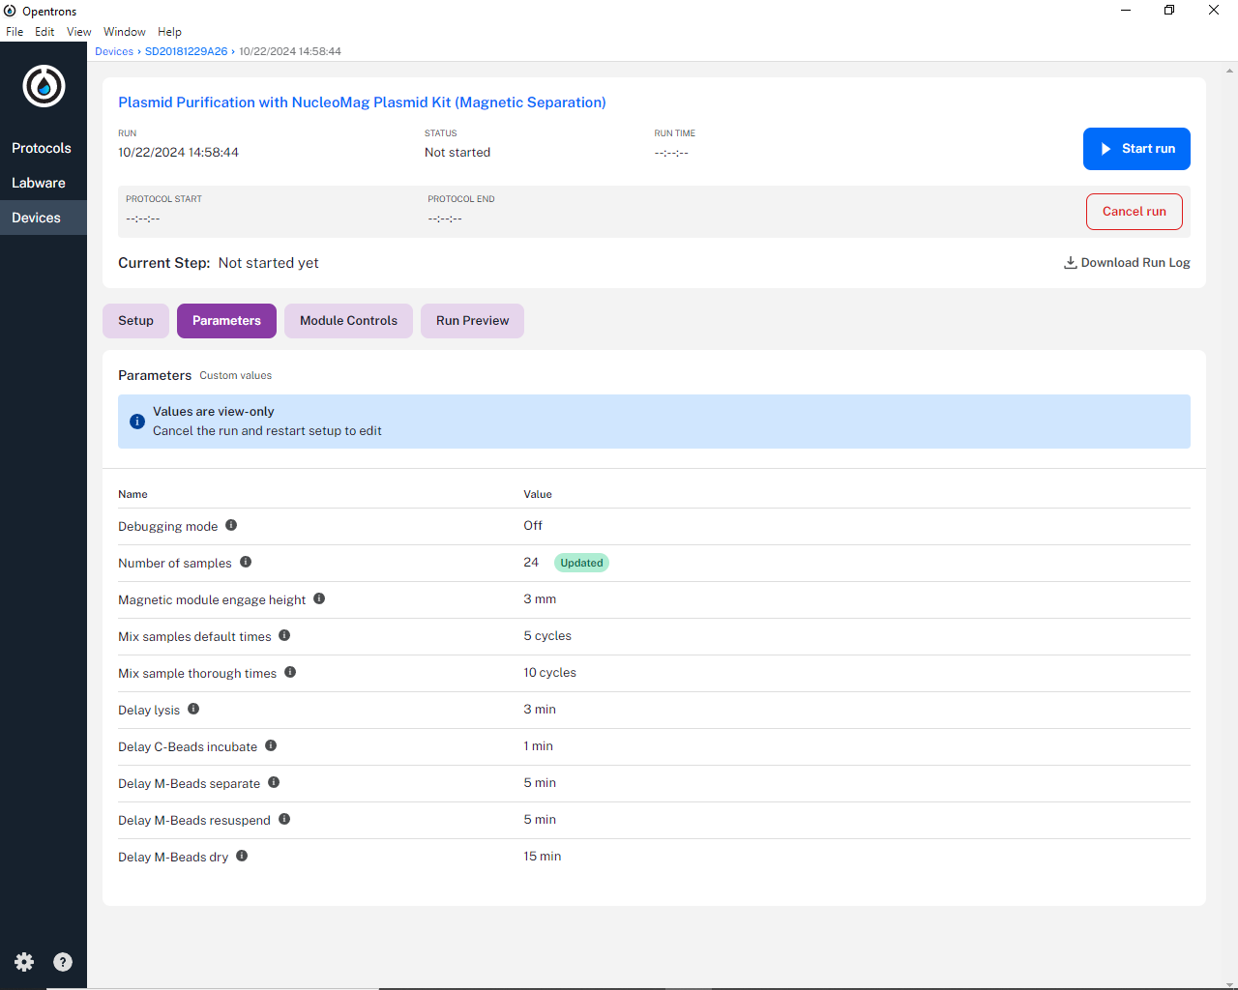Optional: If you want to be sure that the protocol parameters are correct (especially the number of samples) press the “Parameters” button and recheck them. The parameters that deviate from the default values are marked with the green “Updated” tag.
3. 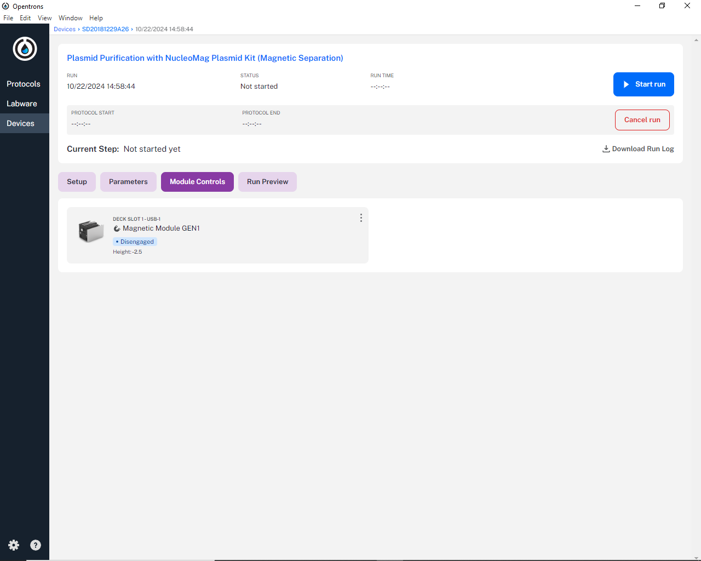Optional: If you are unsure of the status of the connected modules (here only the Magnetic Module) press the “Module Controls” button and check the status of the modules (the default status is “Disengaged”). If it shows that the module is unavailable, check if the module is turned on.
4. Optional: If you want to see exactly what the protocol will do (all steps in detail) press “Run Preview” and check the steps manually.

