DBMS Mini Project – Stock trading app
Name: Ashwath Rohan, Anmol Vyas
PES2UG24CS091, PES2UG24CS072
Team 10

Relational Schema:
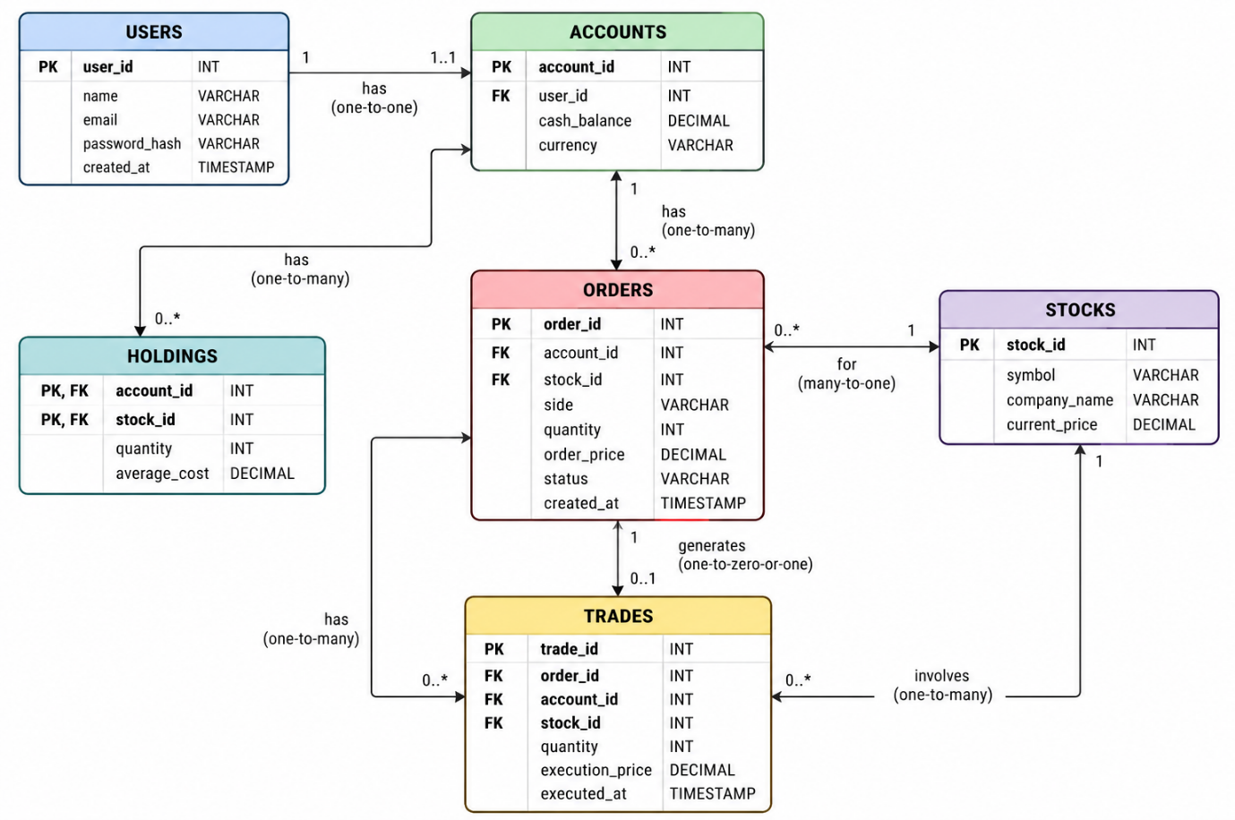

DDL Commands:
CREATE DATABASE trading_app;
USE trading_app;

CREATE TABLE users (
user_id BIGINT AUTO_INCREMENT PRIMARY KEY,
name VARCHAR(100) NOT NULL,
email VARCHAR(255) NOT NULL UNIQUE,
password_hash VARCHAR(255) NOT NULL,
created_at TIMESTAMP DEFAULT CURRENT_TIMESTAMP
);

CREATE TABLE accounts (
account_id BIGINT AUTO_INCREMENT PRIMARY KEY,
user_id BIGINT NOT NULL UNIQUE,
cash_balance DECIMAL(18,2) NOT NULL DEFAULT 0,
currency CHAR(3) NOT NULL DEFAULT 'USD',

FOREIGN KEY (user_id)
REFERENCES users(user_id),

CHECK (cash_balance >= 0)
);

CREATE TABLE stocks (
stock_id BIGINT AUTO_INCREMENT PRIMARY KEY,
symbol VARCHAR(20) NOT NULL UNIQUE,
company_name VARCHAR(255) NOT NULL,
current_price DECIMAL(18,4) NOT NULL,

CHECK (current_price >= 0)
);

CREATE TABLE orders (
order_id BIGINT AUTO_INCREMENT PRIMARY KEY,
account_id BIGINT NOT NULL,
stock_id BIGINT NOT NULL,
side ENUM('BUY', 'SELL') NOT NULL,
quantity INT NOT NULL,
order_price DECIMAL(18,4) NOT NULL,
status VARCHAR(30) NOT NULL,
created_at TIMESTAMP DEFAULT CURRENT_TIMESTAMP,

FOREIGN KEY (account_id)
REFERENCES accounts(account_id),

FOREIGN KEY (stock_id)
REFERENCES stocks(stock_id),

CHECK (quantity > 0),
CHECK (order_price >= 0)
);

CREATE TABLE trades (
trade_id BIGINT AUTO_INCREMENT PRIMARY KEY,
order_id BIGINT NOT NULL UNIQUE,
account_id BIGINT NOT NULL,
stock_id BIGINT NOT NULL,
quantity INT NOT NULL,
execution_price DECIMAL(18,4) NOT NULL,
executed_at TIMESTAMP DEFAULT CURRENT_TIMESTAMP,

FOREIGN KEY (order_id)
REFERENCES orders(order_id),

FOREIGN KEY (account_id)
REFERENCES accounts(account_id),

FOREIGN KEY (stock_id)
REFERENCES stocks(stock_id),

CHECK (quantity > 0),
CHECK (execution_price >= 0)
);

CREATE TABLE holdings (
account_id BIGINT NOT NULL,
stock_id BIGINT NOT NULL,
quantity INT NOT NULL,
average_cost DECIMAL(18,4) NOT NULL,

PRIMARY KEY (account_id, stock_id),

FOREIGN KEY (account_id)
REFERENCES accounts(account_id),

FOREIGN KEY (stock_id)
REFERENCES stocks(stock_id),

CHECK (quantity > 0),
CHECK (average_cost >= 0)
);

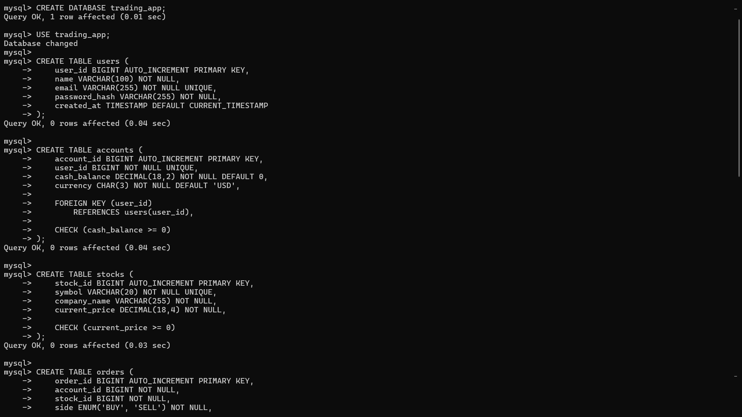
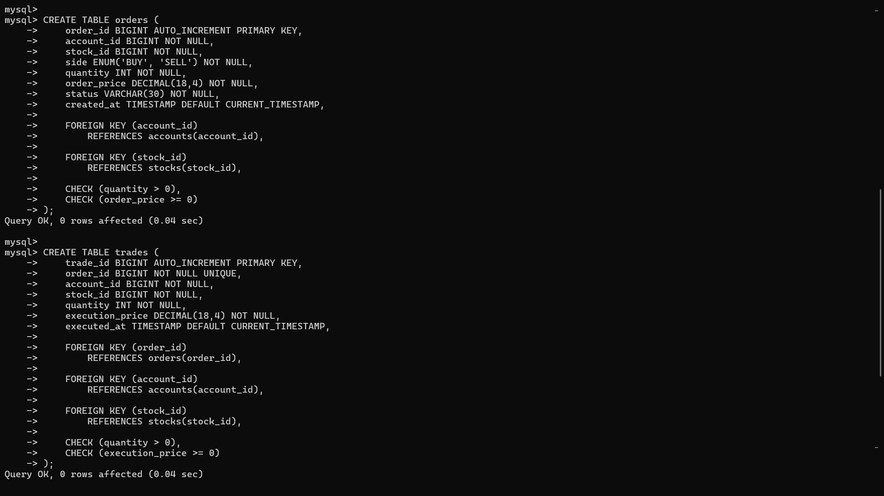
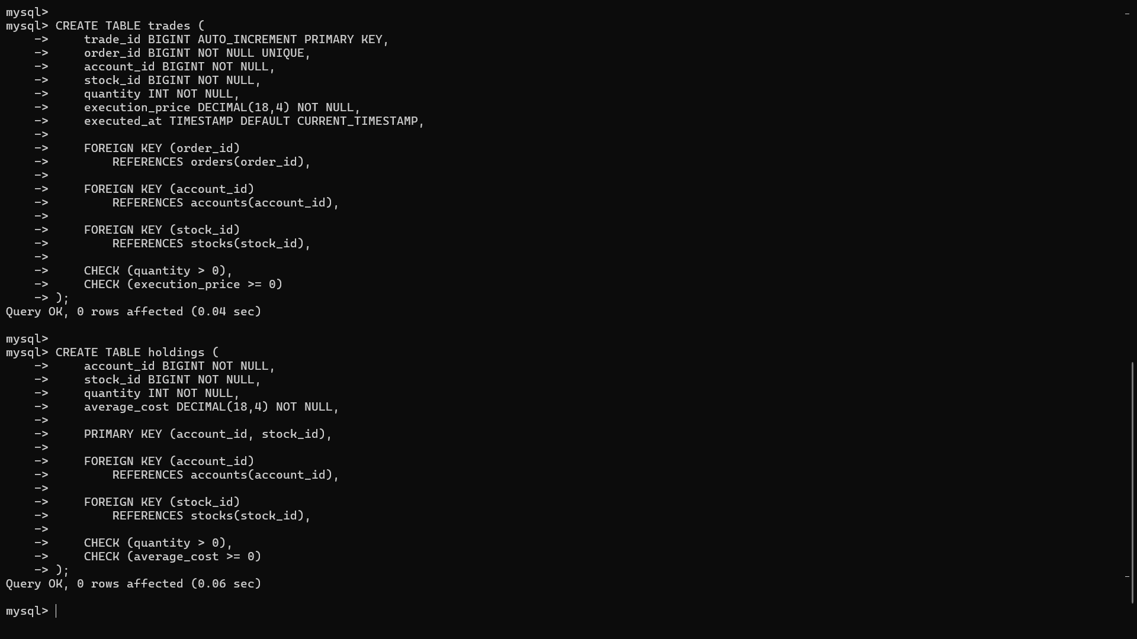

DML Commands:
USE trading_app;

-- Demo users. These password_hash values are placeholders for local testing only.
INSERT INTO users (user_id, name, email, password_hash) VALUES
(1, 'Demo Investor', 'demo.investor@example.com', '$2b$12$demo.investor.password.hash'),
(2, 'Aarav Sharma', 'aarav.sharma@example.com', '$2b$12$aarav.sharma.password.hash'),
(3, 'Diya Nair', 'diya.nair@example.com', '$2b$12$diya.nair.password.hash'),
(4, 'Rohan Mehta', 'rohan.mehta@example.com', '$2b$12$rohan.mehta.password.hash');

INSERT INTO accounts (account_id, user_id, cash_balance, currency) VALUES
(1, 1, 10000000.00, 'INR'),
(2, 2, 250000.00, 'INR'),
(3, 3, 500000.00, 'INR'),
(4, 4, 100000.00, 'INR');

INSERT INTO stocks (stock_id, symbol, company_name, current_price) VALUES
(1, 'RELIANCE', 'Reliance Industries Limited', 2945.6500),
(2, 'TCS', 'Tata Consultancy Services Limited', 4120.3000),
(3, 'INFY', 'Infosys Limited', 1785.2000),
(4, 'HDFCBANK', 'HDFC Bank Limited', 1688.7500),
(5, 'ICICIBANK', 'ICICI Bank Limited', 1245.9000),
(6, 'ITC', 'ITC Limited', 465.3500),
(7, 'SBIN', 'State Bank of India', 812.4500),
(8, 'WIPRO', 'Wipro Limited', 542.6000);

INSERT INTO orders
(order_id, account_id, stock_id, side, quantity, order_price, status)
VALUES
(1, 1, 1, 'BUY', 100, 2900.0000, 'EXECUTED'),
(2, 1, 3, 'BUY', 250, 1750.0000, 'EXECUTED'),
(3, 2, 2, 'BUY', 20, 4050.0000, 'EXECUTED'),
(4, 3, 4, 'BUY', 50, 1660.0000, 'EXECUTED'),
(5, 4, 6, 'BUY', 100, 460.0000, 'EXECUTED'),
(6, 1, 5, 'BUY', 75, 1230.0000, 'PENDING'),
(7, 2, 8, 'SELL', 30, 540.0000, 'CANCELLED');

INSERT INTO trades
(trade_id, order_id, account_id, stock_id, quantity, execution_price)
VALUES
(1, 1, 1, 1, 100, 2898.5000),
(2, 2, 1, 3, 250, 1748.7500),
(3, 3, 2, 2, 20, 4045.0000),
(4, 4, 3, 4, 50, 1658.2500),
(5, 5, 4, 6, 100, 459.8000);

INSERT INTO holdings (account_id, stock_id, quantity, average_cost) VALUES
(1, 1, 100, 2898.5000),
(1, 3, 250, 1748.7500),
(2, 2, 20, 4045.0000),
(3, 4, 50, 1658.2500),
(4, 6, 100, 459.8000);

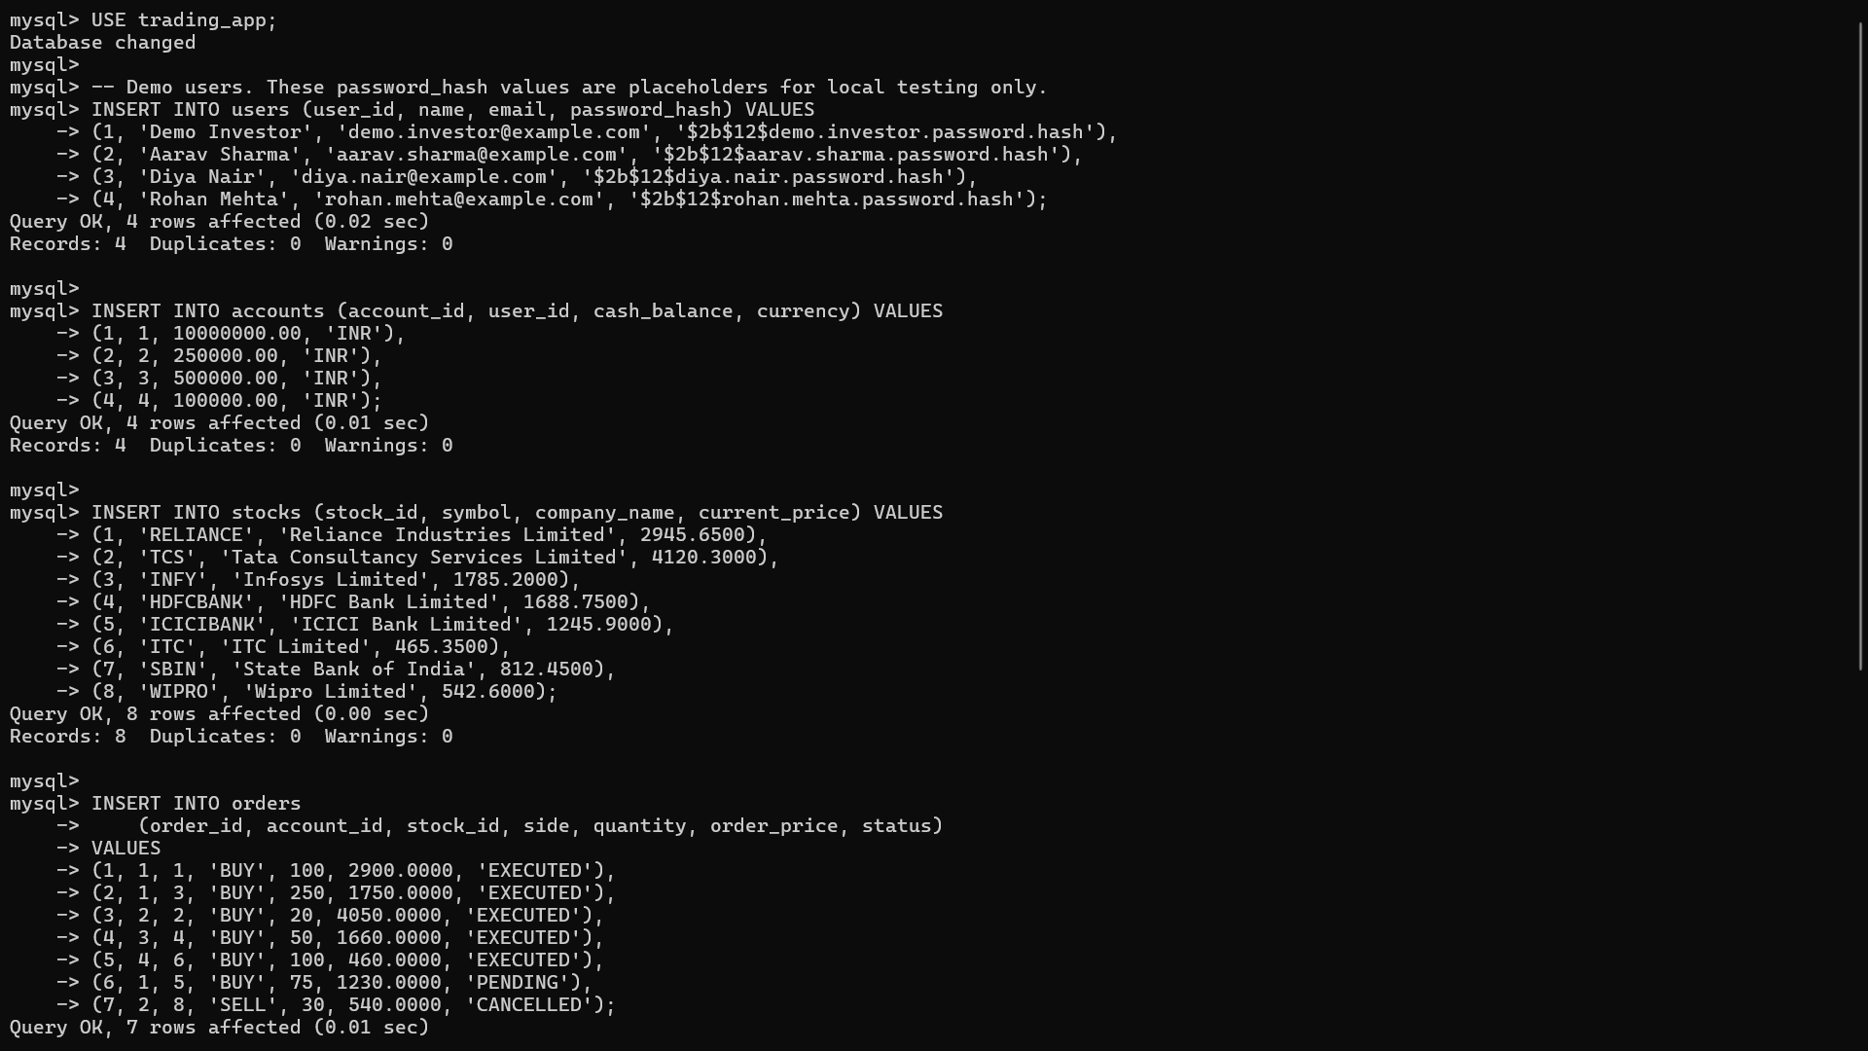
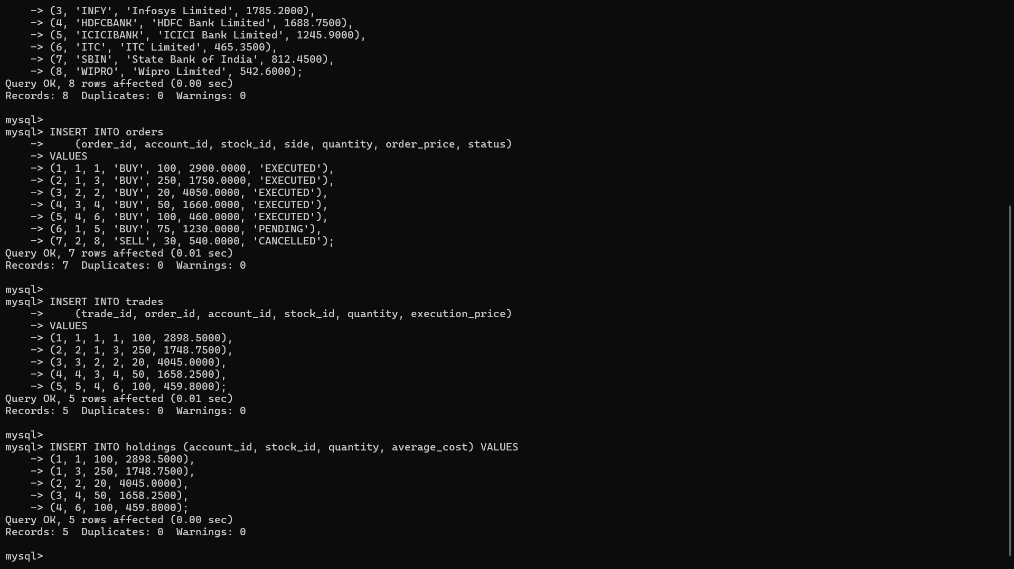

ER DIAGRAM:


