Software Requirements Specification
for
Library Management System
Version 1.0 approved
Prepared by Avtar Singh (20csu241)
The Northcap University
10/02/2023
Table of Contents
Table of Contents ii
Revision History ii
1. Introduction 1
1.1 Purpose 1
1.2 Document Conventions 1
1.3 Intended Audience and Reading Suggestions 1
1.4 Product Scope 1
1.5 References 1
2. Overall Description 2
2.1 Product Perspective 2
2.2 Product Functions 2
2.3 User Classes and Characteristics 2
2.4 Operating Environment 2
2.5 Design and Implementation Constraints 2
2.6 User Documentation 2
2.7 Assumptions and Dependencies 3
3. External Interface Requirements 3
3.1 User Interfaces 3
3.2 Hardware Interfaces 3
3.3 Software Interfaces 3
3.4 Communications Interfaces 3
4. System Features 4
4.1 System Feature 1 4
4.2 System Feature 2 (and so on) 4
5. Other Nonfunctional Requirements 4
5.1 Performance Requirements 4
5.2 Safety Requirements 5
5.3 Security Requirements 5
5.4 Software Quality Attributes 5
5.5 Business Rules 5
6. Other Requirements 5
Appendix A: Glossary 5
Appendix B: Analysis Models 5
Appendix C: To Be Determined List 6

Revision History
Name | Date | Reason For Changes | Version

Introduction

Purpose
The purpose of this document is to provide a detailed description of the software requirements for the Library Management System (LMS). The LMS is a software application designed to help libraries manage their day-to-day operations, including book management, member management, and circulation.

Document Conventions
This document uses following conventions
JAVA -> platform independence
•SQL -> Structured query Language
•
DFD -> Data Flow Diagram
•CFD -> Context Flow Diagram
JAVA -> platform independence
•SQL -> Structured query Language
•
DFD -> Data Flow Diagram
•CFD -> Context Flow Diagram
JAVA -> platform independence
•SQL -> Structured query Language
•
DFD -> Data Flow Diagram
•CFD -> Context Flow Diagram

DB | Data Base
DDB | Distributed Data Base
LMS | Library Management System
SRS | Software Requirement Specification
GUI | Graphic User Interface
Stack-Holder | The person who will participate in the system e.g. Customer, Supplier, Administrator
Modem | Modulator-demodulator, a devise that modulates an analog carrier signal to encode digital information, and also demodulates such a carrier signal to decode the transmitted information
Ethernet | A family of frame – based computer networking technology works
CSS | Cascading Style Sheet

Intended Audience and Reading Suggestions
The intended audience for a Software Requirements Specification (SRS) document for a Library Management System would typically include stakeholders such as library managers, librarians, library users, and developers.

Reading suggestions for an SRS document for a Library Management System would depend on the specific requirements and features of the system, as well as the needs of the intended audience. However, some general reading suggestions could include:

Understanding library operations and processes, including cataloging, circulation, and reference services.

Familiarity with library automation systems and the capabilities and features typically offered.

Knowledge of user-centered design principles, to ensure that the system is designed to meet the needs of library users.

Understanding of software development methodologies, to ensure that the SRS document is comprehensive and well-structured.

It's also important for the intended audience to have a clear understanding of the goals and objectives of the Library Management System, so that they can provide meaningful feedback and insights into the requirements and design of the system.

Product Scope
The scope of this document includes the requirements for the LMS, including functional and non-functional requirements. This document will provide a clear understanding of the capabilities, constraints, and assumptions of the LMS, which will serve as the basis for the development, testing, and maintenance of the system.

References
1. Shaw JN, De Sarkar T. A cloud-based approach to library management solution for college libraries. Information Discovery and Delivery. 2021 Nov 19;49(4):308-18.
2. Rafols, I., Porter, A. L., & Leydesdorff, L. (2010). Science overlay maps: A new tool for research policy and library management. Journal of the American Society for information Science and Technology, 61(9), 1871-1887.

Overall Description

Product Perspective
LMS is a replacement for the ordinary library management systems which depend on paper work for recording book and users' information.
LMS will provide an advanced book search mechanism and will make it easy to borrow, insert and index a book in the library.

Product Functions
2.2.1 Administrator

• Admin should be able to insert, modify and delete books.
• Can accept or reject a new user according to the library policy or payment methods.
• Increase the period for borrowing a book for specific type or group of users.
• Can get the information (status report) of any member who has borrowed a book.
• Add and edit book categories and arrange books by categories.
• Add and edit authors and publishers information.
• Can send lateness warnings to people who have exceeded deadline date.
• Can record books returned by users.

2.2.2 Users(Library Members)

• The member should be provided with the updated information about the books catalog.
• Members are given a provision to check their account's information and change it.
• Members have the ability to search through books by subject, title, authors or any information related to the book.
• Can extend the period of borrowing books according to the library policy.
• The customer may suggest a book to be brought to the library book collection..>

User Classes and Characteristics
We have 2 levels of users
• User module: In the user module, user will check the availability of the books.
- Book return
• Administration module: The following are the sub module in the administration module.
- Register user
- Entry book details
- Book issue.

Operating Environment
The product will be operating in windows environment. The Library Management System is a
website and shall operate in all famous browsers, for a model we are taking Microsoft Internet
Explorer, r,Google Chrome,and Mozilla Firefox.Also it will be compatiable with the IE 6.0. Most
of the features will be compatiable with the Mozilla Firefox & Opera 7.0 or higher version. The
only requirement to use this online product would be the internet connection.
The hardware configuration include Hard Disk: 40 GB, Monitor: 15" Color monitor, Keyboard:
122 keys. The basic input devices required are keyboard, mouse and output devices are monitors and Printers.

Design and Implementation Constraints
• The information of all users, books and libraries must be stored in a database that is accessible by the website.
• MS SQL Server will be used as SQL engine and database.
• The Online Library System is running 24 hours a day.
• Users may access LMS from any computer that has Internet browsing capabilities and an
Internet connection.
• Users must have their correct usernames and passwords to enter into their online accounts and do actions.

User Documentation
1) http://www.java2s.com/
2) http://www.javaworld.com/javaworld/jw-01-1998/jw-01-bookreview.html

Assumptions and Dependencies
The success of this system depends on
- Existence of an Internet service to all people in Gaza Strip.
- Are librarians and users comfortable with computers and have enough ability to work with
- the product?
- Website interface must be friendly and easy-to-use.
- The search mechanism should be simple and fast.

External Interface Requirements
It should be simple and easy for consumers to understand and use. It should also be an immersive interface. For the user and administrator, the device should prompt the login to the program and correct feedback parameters.

User Interfaces
The program offers a decent graphical interface for the user that can be run on the device by an administrator, performing the necessary tasks such as designing, reviewing, displaying the book information.

- Allows users to access quick reports in between real hours, such as Book Issues/Returned, etc.

- Based on various requirements, stock verification, and search service.

Hardware Interfaces
- Operating system: windows
- Hard disk:40 GB
- RAM: 256 MB
- Processor: Pentium(R)Dual-core CPU

Software Interfaces
- Java language
- Net beans IDE 7.0.1
- MS SQL server 2005.

Communications Interfaces
Windows

Functional requirements:

- Book-entry: We can store the information of the books in this module.
- Register student: We will keep the new student's information in this module.
- Book issue: This module is used to keep track of the specifics of book issues.
- Book Return: This module allows the return of books to be monitored.

Performance requirements:

The computer's capability depends on the software's efficiency. Provided the
database size is big enough, the program will take any amount of inputs. This
would be dependent on the memory space available.

Design constraints :

Whenever a library member wants to take a book, the book

System Features
This software package is developed using java as front end which is supported by sun
micro system. Microsoft SQL Server as the back end to store the database.
Operating System: Windows XP, windows 7 and higher versions.
Language: Java Runtime Environment, Net beans 7.0.1 (front end)
Database: MS SQL Server (back end)

System Feature 1
4.1.1 Description and Priority
The users of the system should be provided the surety that their account is secure.
4.1.2 Stimulus/Response Sequences
This is
possible by providing:-
> User authentication and validation of members using their unique member ID
4.1.3 Functional Requirements
> Proper monitoring by the administrator which includes updating account status,
showing a popup if the member attempts to issue number of books that exceed
the limit provided by the library policy, assigning fine to members who skip the
date of return 1
> Proper accountability which includes not allowing a member to see other |
member’s account. Only administrator will see and manage all member accounts |

System Feature 2
4.2.1 Description and Priority
Can be scalable to Windows, Linux and Mac OS platform..
4.2.2 Stimulus/Response Sequences
This is
possible by providing:-
> Application an cloud interface for getting a scalable environment
4.1.3 Functional Requirements
> Proper monitoring by the networking which includes getting the location data.
> Proper accountability which includes increasing instances according to loads.
|

Other Nonfunctional Requirements

Performance Requirements
The proposed system that we are going to develop will be used as the Chief performance system within the different campuses of the university which interacts with the university
staff and students. Therefore, it is expected that the database would perform functionally all the requirements that are specified by the university.

> The performance of the system should be fast and accurate

> Library Management System shall handle expected and non-expected errors in
ways that prevent loss in information and long downtime period. Thus it should

have inbuilt error testing to identify invalid username/password

> The system should be able to handle large amount of data. Thus it should
accommodate high number of books and users without any fault.

Safety Requirements
The database may get crashed at any certain time due to virus or operating system failure.
Therefore, it is required to take the database backup so that the database is not lost. |
Proper UPS/inverter facility should be there in case of power supply failure.

Security Requirements
> System will use secured database
> Normal users can just read information but they cannot edit or modify anything |

except their personal and some other information.
> System will have different types of users and every user has access constraints
> Proper user authentication should be provided
> No one should be able to hack users’ password
> There should be separate accounts for admin and members such that no member

can access the database and only admin has the rights to update the database.

Software Quality Attributes
» There may be multiple admins creating the project, all of them will have the right 3
to create changes to the system. But the members or other users cannot do
changes

» The project should be open source

» The Quality of the database is maintained in such a way so that it can be very user
friendly to all the users of the database

» The user be able to easily download and install the system.

Business Rules
A business rule is anything that captures and implements business policies and practices.
A rule can enforce business policy, make a decision, or infer new data from existing data.
This includes the rules and regulations that the System users should abide by. This
includes the cost of the project and the discount offers provided. The users should avoid -
illegal rules and protocols.
Neither admin nor member should cross the rules and regulations.

Other Requirements
- Performance Requirements
« The system shall accommodate high number of books and users without any fault.
« Responses to view information shall take no longer than 5 seconds to appear on the
screen.
- Safety Requirements
« System use shall not cause any harm to human users.
- Security Requirements
« System will use secured database
« Normal users can just read information but they cannot edit or modify anything except
their personal and some other information.
« System will have different types of users and every user has access constraints.
- Error Handling
+ LMS product shall handle expected and non-expected errors in ways that prevent loss in
information and long downtime period.
Appendix A: Glossary
A: Admin, Abbreviation, Acronym, Assumptions; B: Books, Business rules; C: Class, Client,
Conventions; D: Data requirement, Dependencies; G: GUI; K: Key; L: Library, Librarian; M:
Member; N: Non-functional Requirement; ~O: Operating environment; ~ P:
performance,Perspective,Purpose; R: Requirement, Requirement attributes; S: Safety, Scope,
Security, System features; U: User, User class and characteristics, User require- ment;.
Appendix B: Analysis Models
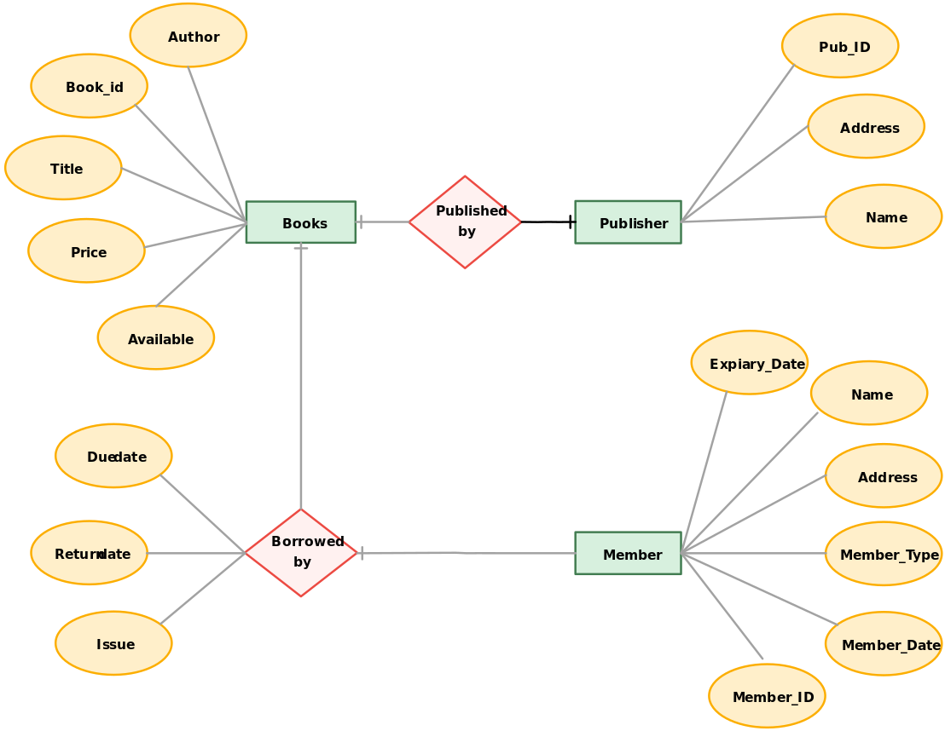
Appendix C: To Be Determined List
The following are the list of conventions and acronyms used in this document and the project
as well:
« Administrator: A login id representing a user with user administration privileges to the
software
« User: A general login id assigned to most users
« Client: Intended users for the software
« User Interface Layer: The section of the assignment referring to what the user interacts
with directly
« Interface: Something used to communicate across different mediums

