Scenario-1

BEGIN

FOR rec IN (

SELECT customer_id, interest_rate

FROM loans

WHERE customer_id IN (

SELECT customer_id FROM customers WHERE age > 60

)

)

LOOP

UPDATE loans

SET interest_rate = interest_rate - 1

WHERE customer_id = rec.customer_id;

END LOOP;

COMMIT;

END;

OUTPUT 🡪

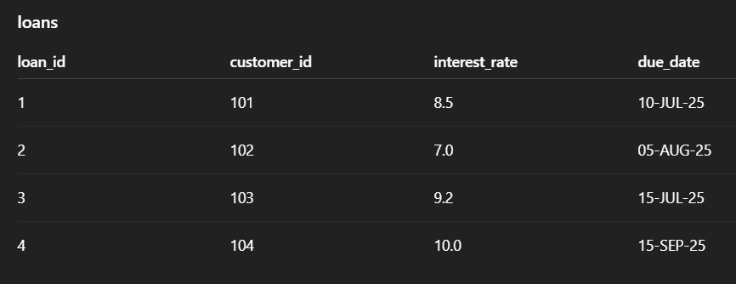

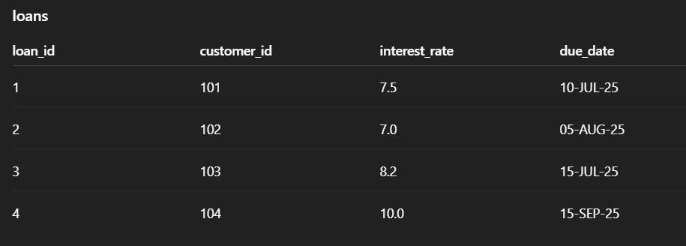

Scenario-2

BEGIN

FOR rec IN (

SELECT customer_id

FROM customers

WHERE balance > 10000

)

LOOP

UPDATE customers

SET isvip = 'TRUE'

WHERE customer_id = rec.customer_id;

END LOOP;

COMMIT;

END;

OUTPUT 🡪

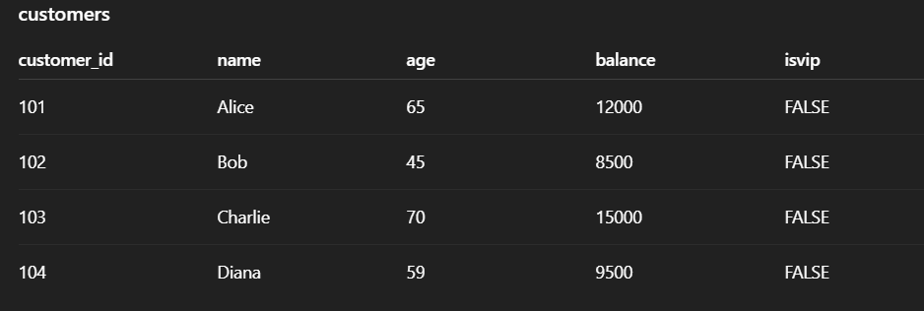

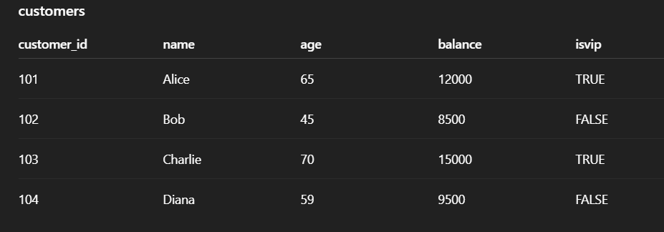

Scenario-3

DECLARE

v_due_date loans.due_date%TYPE;

v_cust_id loans.customer_id%TYPE;

BEGIN

FOR rec IN (

SELECT customer_id, due_date

FROM loans

WHERE due_date BETWEEN SYSDATE AND SYSDATE + 30

)

LOOP

DBMS_OUTPUT.PUT_LINE(

'Reminder: Loan for Customer ID ' || rec.customer_id ||

' is due on ' || TO_CHAR(rec.due_date, 'DD-MON-YYYY')

);

END LOOP;

END;

OUTPUT 🡪

