Scenario-1

CREATE OR REPLACE PROCEDURE ProcessMonthlyInterest IS

BEGIN

-- Update all savings accounts by applying 1% interest

UPDATE accounts

SET balance = balance + (balance * 0.01)

WHERE account_type = 'SAVINGS';

COMMIT;

END;

/

OUTPUT 🡪





Scenario-2

CREATE OR REPLACE PROCEDURE UpdateEmployeeBonus(

dept_id IN NUMBER,

bonus_percent IN NUMBER

) IS

BEGIN

UPDATE employees

SET salary = salary + (salary * bonus_percent / 100)

WHERE department_id = dept_id;

COMMIT;

END;

/

OUTPUT 🡪

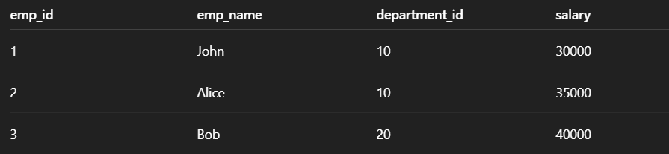

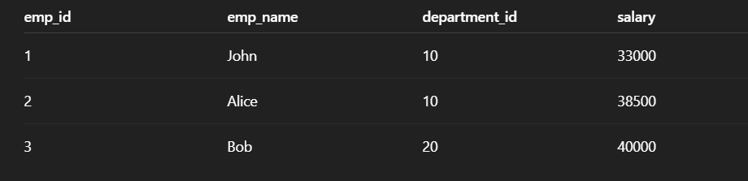

Scenario-3

CREATE OR REPLACE PROCEDURE TransferFunds(

source_account_id IN NUMBER,

destination_account_id IN NUMBER,

amount IN NUMBER

) IS

source_balance NUMBER;

BEGIN

-- Check source account balance

SELECT balance INTO source_balance

FROM accounts

WHERE account_id = source_account_id

FOR UPDATE;

IF source_balance < amount THEN

RAISE_APPLICATION_ERROR(-20001, 'Insufficient balance in source account.');

END IF;

-- Deduct from source

UPDATE accounts

SET balance = balance - amount

WHERE account_id = source_account_id;

-- Add to destination

UPDATE accounts

SET balance = balance + amount

WHERE account_id = destination_account_id;

COMMIT;

END;

/

OUTPUT 🡪

