1.

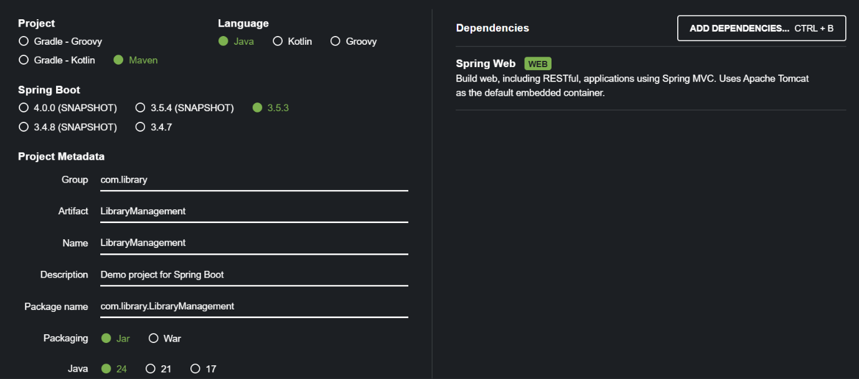

Dependencies ->

<dependency>

<groupId>org.springframework</groupId>

<artifactId>spring-context</artifactId>

<version>5.3.30</version>

</dependency>

2.

<?xml version="1.0" encoding="UTF-8"?>

<beans xmlns="http://www.springframework.org/schema/beans"

xmlns:xsi="http://www.w3.org/2001/XMLSchema-instance"

xsi:schemaLocation="http://www.springframework.org/schema/beans

http://www.springframework.org/schema/beans/spring-beans.xsd">

<bean id="bookRepository" class="com.library.repository.BookRepository" />

<bean id="bookService" class="com.library.service.BookService">

<property name="bookRepository" ref="bookRepository"/>

</bean>

</beans>

3.

//com.library.repository.BookRepository

package com.library.repository;

public class BookRepository {

public void saveBook(String title) {

System.out.println("Book '" + title + "' saved to the database.");

}

}

// com.library.service.BookService

package com.library.service;

import com.library.repository.BookRepository;

public class BookService {

private BookRepository bookRepository;

// Setter for Dependency Injection

public void setBookRepository(BookRepository bookRepository) {

this.bookRepository = bookRepository;

}

public void addBook(String title) {

System.out.println("Adding book: " + title);

bookRepository.saveBook(title);

}

}

4.

//com.library.App

package com.library;

import com.library.service.BookService;

import org.springframework.context.ApplicationContext;

import org.springframework.context.support.ClassPathXmlApplicationContext;

public class App {

public static void main(String[] args) {

// Load Spring context

ApplicationContext context = new ClassPathXmlApplicationContext("applicationContext.xml");

// Retrieve the bean

BookService bookService = (BookService) context.getBean("bookService");

// Use the service

bookService.addBook("The Great Gatsby");

}

}