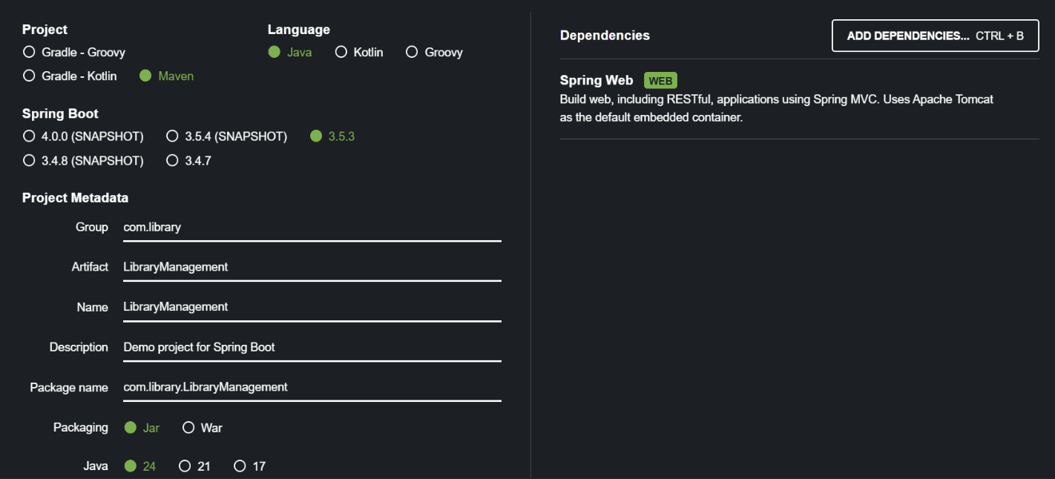

@SpringBootApplication

public class SpringLearnApplication {

public static void main(String[] args) {

SpringApplication.run(SpringLearnApplication.class, args);

}

}