// HelloController.java

package com.cognizant.springlearn.controller;

import org.slf4j.Logger;

import org.slf4j.LoggerFactory;

import org.springframework.web.bind.annotation.\*;

@RestController

public class HelloController {

private static final Logger LOGGER = LoggerFactory.getLogger(HelloController.class);

@GetMapping("/hello")

public String sayHello() {

LOGGER.info("START - sayHello()");

LOGGER.info("END - sayHello()");

return "Hello World!!";

}

}

//Country.java

package com.cognizant.springlearn.model;

public class Country {

private String code;

private String name;

// Getters and setters

public String getCode() { return code; }

public void setCode(String code) { this.code = code; }

public String getName() { return name; }

public void setName(String name) { this.name = name; }

}

//country.xml

<beans xmlns="http://www.springframework.org/schema/beans"

xmlns:context="http://www.springframework.org/schema/context"

xmlns:xsi="http://www.w3.org/2001/XMLSchema-instance"

xsi:schemaLocation="http://www.springframework.org/schema/beans

http://www.springframework.org/schema/beans/spring-beans.xsd">

<bean id="in" class="com.cognizant.springlearn.model.Country">

<property name="code" value="IN"/>

<property name="name" value="India"/>

</bean>

<bean id="countryList" class="java.util.ArrayList">

<constructor-arg>

<list>

<ref bean="in"/>

<bean class="com.cognizant.springlearn.model.Country">

<property name="code" value="US"/>

<property name="name" value="United States"/>

</bean>

<bean class="com.cognizant.springlearn.model.Country">

<property name="code" value="JP"/>

<property name="name" value="Japan"/>

</bean>

<bean class="com.cognizant.springlearn.model.Country">

<property name="code" value="DE"/>

<property name="name" value="Germany"/>

</bean>

</list>

</constructor-arg>

</bean>

</beans>

//CountryController.java

package com.cognizant.springlearn.controller;

import com.cognizant.springlearn.model.Country;

import com.cognizant.springlearn.service.CountryService;

import com.cognizant.springlearn.service.exception.CountryNotFoundException;

import org.slf4j.Logger;

import org.slf4j.LoggerFactory;

import org.springframework.context.ApplicationContext;

import org.springframework.context.support.ClassPathXmlApplicationContext;

import org.springframework.web.bind.annotation.\*;

import java.util.List;

@RestController

public class CountryController {

private static final Logger LOGGER = LoggerFactory.getLogger(CountryController.class);

private final CountryService countryService = new CountryService();

@RequestMapping("/country")

public Country getCountryIndia() {

LOGGER.info("START - getCountryIndia()");

ApplicationContext context = new ClassPathXmlApplicationContext("country.xml");

Country country = (Country) context.getBean("in");

LOGGER.info("END - getCountryIndia()");

return country;

}

@GetMapping("/countries")

public List<Country> getAllCountries() {

LOGGER.info("START - getAllCountries()");

ApplicationContext context = new ClassPathXmlApplicationContext("country.xml");

List<Country> countries = (List<Country>) context.getBean("countryList");

LOGGER.info("END - getAllCountries()");

return countries;

}

@GetMapping("/countries/{code}")

public Country getCountry(@PathVariable String code) throws CountryNotFoundException {

LOGGER.info("START - getCountry()");

Country country = countryService.getCountry(code);

LOGGER.info("END - getCountry()");

return country;

}

}

//CountryService.java

package com.cognizant.springlearn.service;

import com.cognizant.springlearn.model.Country;

import com.cognizant.springlearn.service.exception.CountryNotFoundException;

import org.springframework.context.ApplicationContext;

import org.springframework.context.support.ClassPathXmlApplicationContext;

import java.util.List;

public class CountryService {

public Country getCountry(String code) throws CountryNotFoundException {

ApplicationContext context = new ClassPathXmlApplicationContext("country.xml");

List<Country> countries = (List<Country>) context.getBean("countryList");

return countries.stream()

.filter(c -> c.getCode().equalsIgnoreCase(code))

.findFirst()

.orElseThrow(() -> new CountryNotFoundException("Country not found"));

}

}

//get all countries

localhost:8080/countries

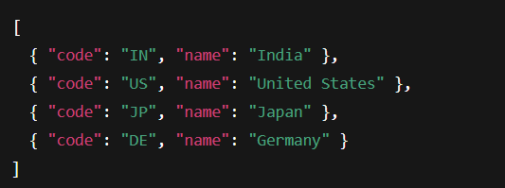

//get country by code

localhost:8080/countries/in

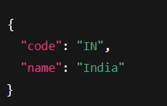

localhost:8080/countries/xyz

