1. SPA and its benefits

A web application that dynamically rewrites the current page rather than loading entire new pages from a server

Benefits ->

//fast loading time after initial load

//better user experience due to no full-page reloads

1. React and its working

React is a JavaScript library developed by Facebook for building user interfaces, especially SPAs

Working ->

//the UI uses components which are reusable blocks of code

//uses JSX

//uses a virtual DOM

1. SPA vs MPA

SPA – single page, faster, no delays

MPA – multi page, slower, longer delays

1. Virtual DOM

VirtualDOM is a lightweight JavaScript representation of the actual DOM. React updates the virtual DOM first, compares it to the previous version (diffing), and updates only the necessary parts of the real DOM. This makes updates efficient

Set Up of React App ->

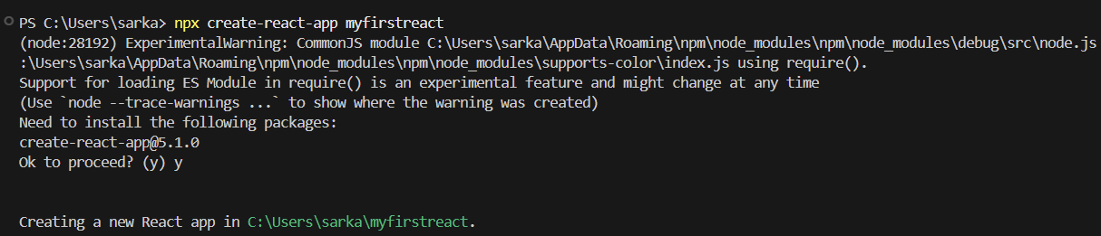

//App.js

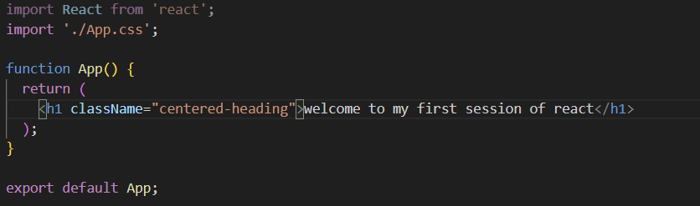

//App.css

