1. Need and Benefits of Component Lifecycle

React components go through a **lifecycle**, from creation, updates, to removal and these lifecycle methods allow developers to **hook into these stages** to run specific logic

Benefits ->

//clean data fetching

//error handling

1. Various Lifecycle Hook Methods

//mounting (initial setup)

//updating (when props/state change)

//unmounting (cleanup)

//error handling

Implement componentDidMount() and componentDidCatch()

//App.js

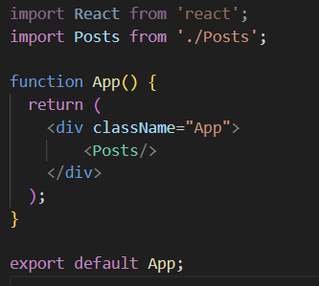

//Post.js

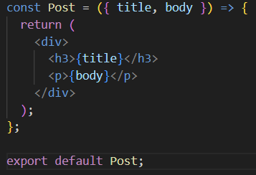

//Posts.js

