1. Explain React Events

React events are similar to DOM events (like click, change, submit, etc.) but follow a consistent React-specific structure

//onClick

//onChange

//onSubmit

//onMouseOver

//onKeyDown

1. Explain Event Handlers

Eventhandlers are functions that get triggered in response to user actions (like clicking a button or typing in an input)

1. Define Synthetic Event

A SyntheticEvent is React's wrapper around the browser’s native event system. It is part of React’s internal event delegation system which improves performance and compatibility

Implement Event Handling and Synthetic Event ->

//App.js

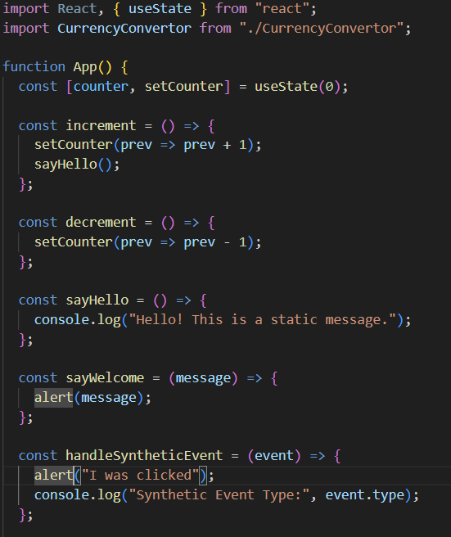

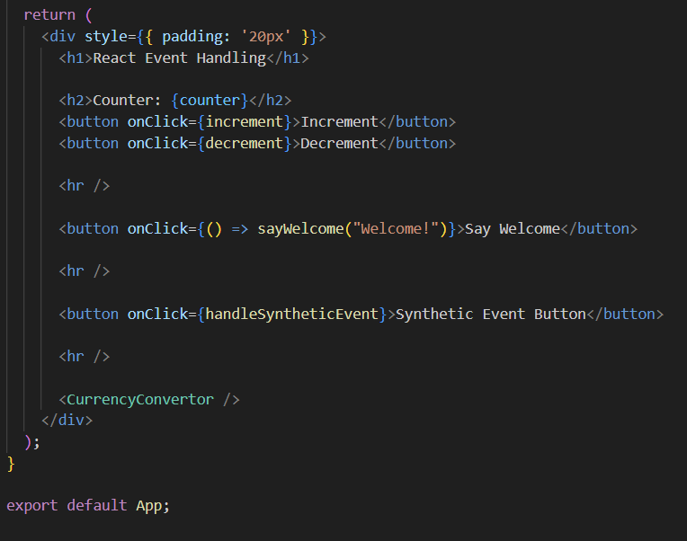

//CurrencyConvertor.js

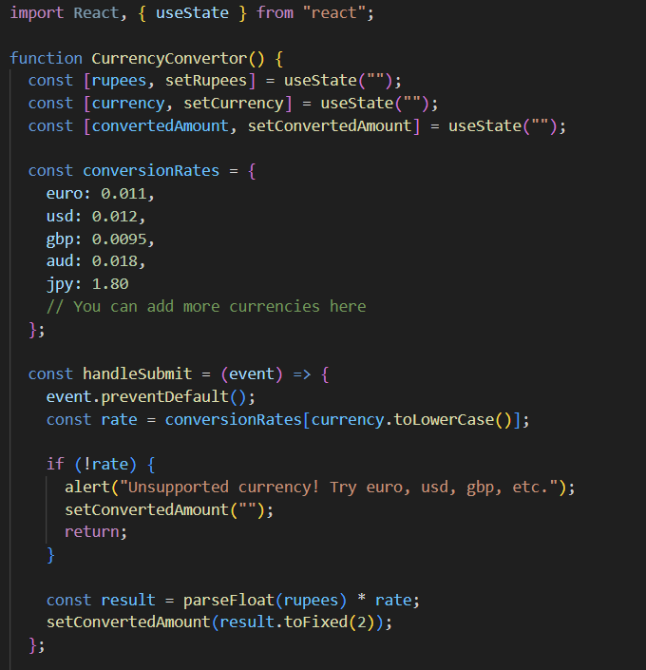

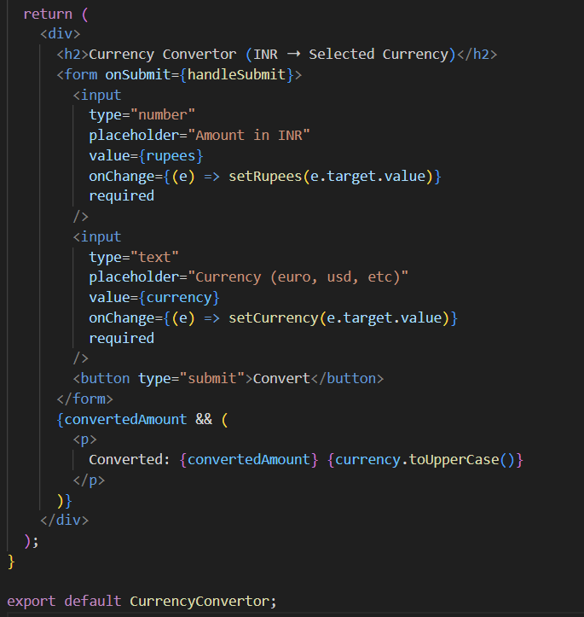

//currency convertor

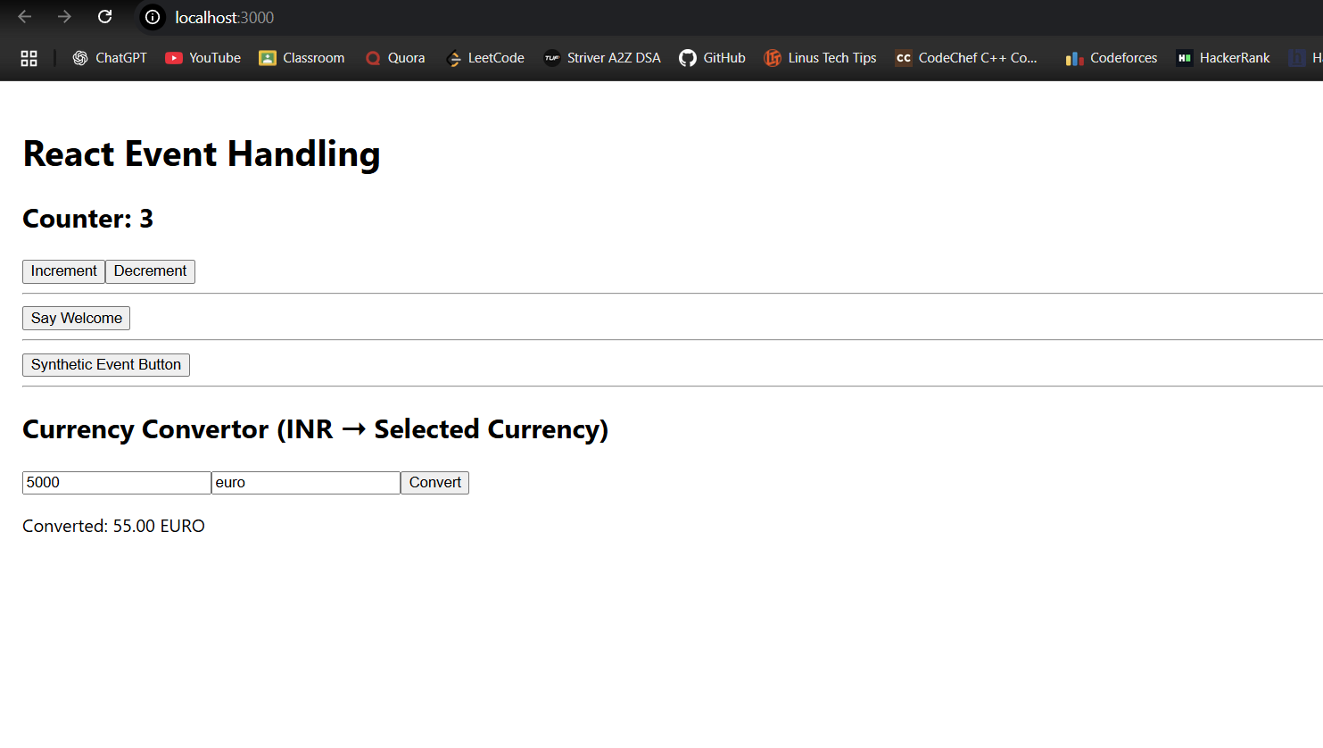

//synthetic event button

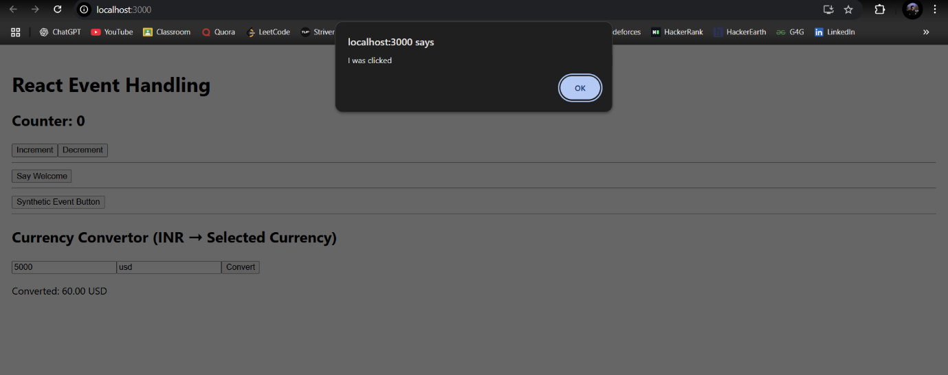

//say welcome button

